Youtube Link : https://www.youtube.com/watch?v=H32W-6CKdfk

Task A
sun  | rain   | clouds  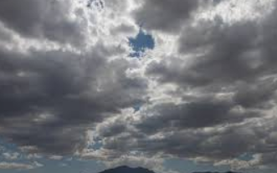 | cold  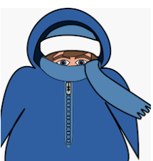
long days   | baby lambs born  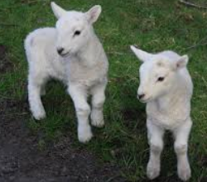 | boots  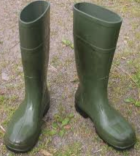 | t-shirt  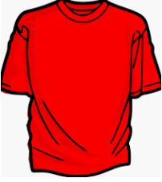
warm   | coat  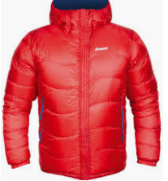 | leaves fall off trees  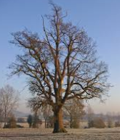 | short days  
snow  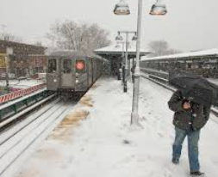 | rain coat   | new plants grow   | flip flops  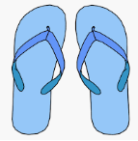

I think _____ belongs in spring because…
I think _____ belongs in summer because…
I think _____ belongs in autumn because…
I think _____ belongs in winter because
Task B:
Draw a picture of you outside your house in each season. What will you wear? What will it look like outside? What will change?
Winter | Spring
Summer | Autumn

Task C
How to make a windsock!
You will need:
A plastic bottle
PVA Glue
Tissue paper
String or ribbon

How to make it:
- Ask an adult to cut the top and bottom off of the bottle.
- Cut the tissue into strips and glue one end of the strip to the bottom opening of the bottle. If you are keeping it outside, it might be better to use ribbon in case it rains!
- Ask an adult to carefully cut two holes in the top end of the bottle with a hole punch or scissors on opposite sides.
- Tie the string onto each of the holes to create a loop to hang it up.
- Hand your wind sock outside, on a washing line, fence post or pole and watch to see which direction the wind is blowing.
How to make a rain gauge!
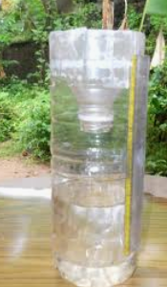
You will need:
Plastic bottle
Permanent marker
Scissors
How to make it:
- Ask an adult to cur the top off of the bottle.
- Mark lines the same distance apart all the way up the bottle, like a ruler. You could even measure it in centimetres if you like!
- Place your bottle outside (you might need to bury it a little bit to stop it falling over!)
- When it has rained, go outside and check how far up the rain has filled. Empty it, then check another day – did it rain more or less? Can you predict if there would be more or less rain each day?

