Watch the video lesson on gravity and fill in this sheet as you go!

Do you believe in gravity?
Yes No

Explain why:
____________________________________________________________________________________________________________________________________________________________________________________________________________________________________________________________________________________________________

Activity 1 – The Drop Test:
Objects | Trial 1 | Trial 2 | Trial 3 | First to the ground?

What do your results show you?

____________________________________________________________________________________________________________________________________________________________________________________________________________________________________________________________________________________________________
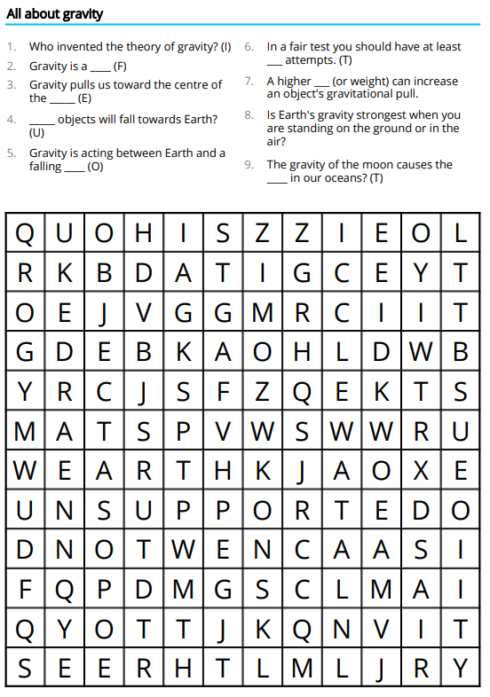

Complete this wordsearch to test your gravity knowledge!

