Living Things: Classification

Upper Key Stage 2

Activity: Can you sort these living things into different groups?
How many ways could you group them?
Can you group by the 5 kingdoms? Could you group animals into vertebrates and invertebrates?
Could you find examples and sort vertebrates into Fish, Amphibians, Reptiles, Birds and Mammals?
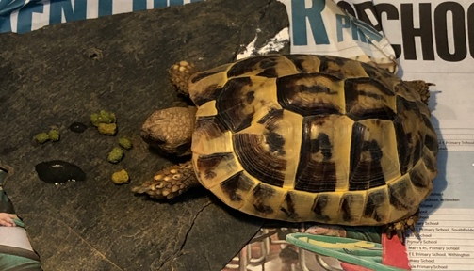
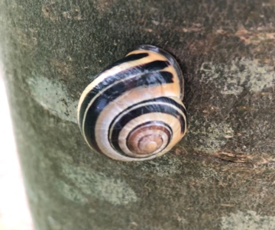
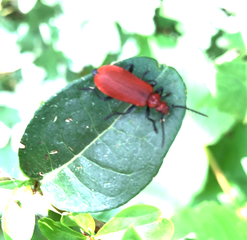
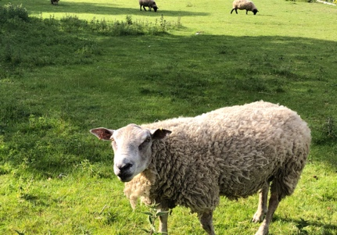
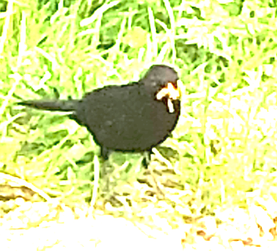
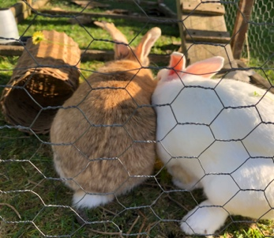
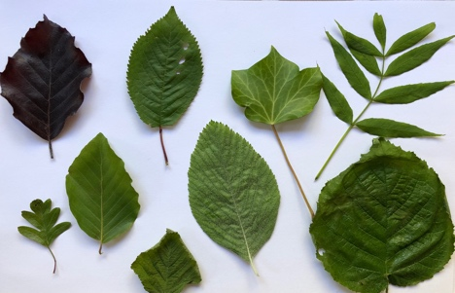
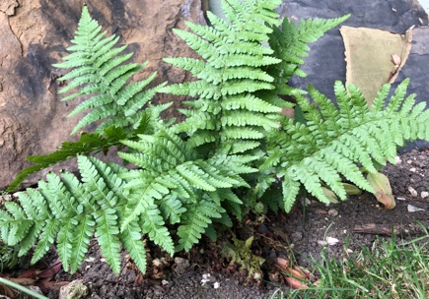
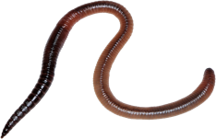
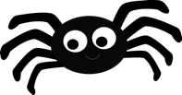
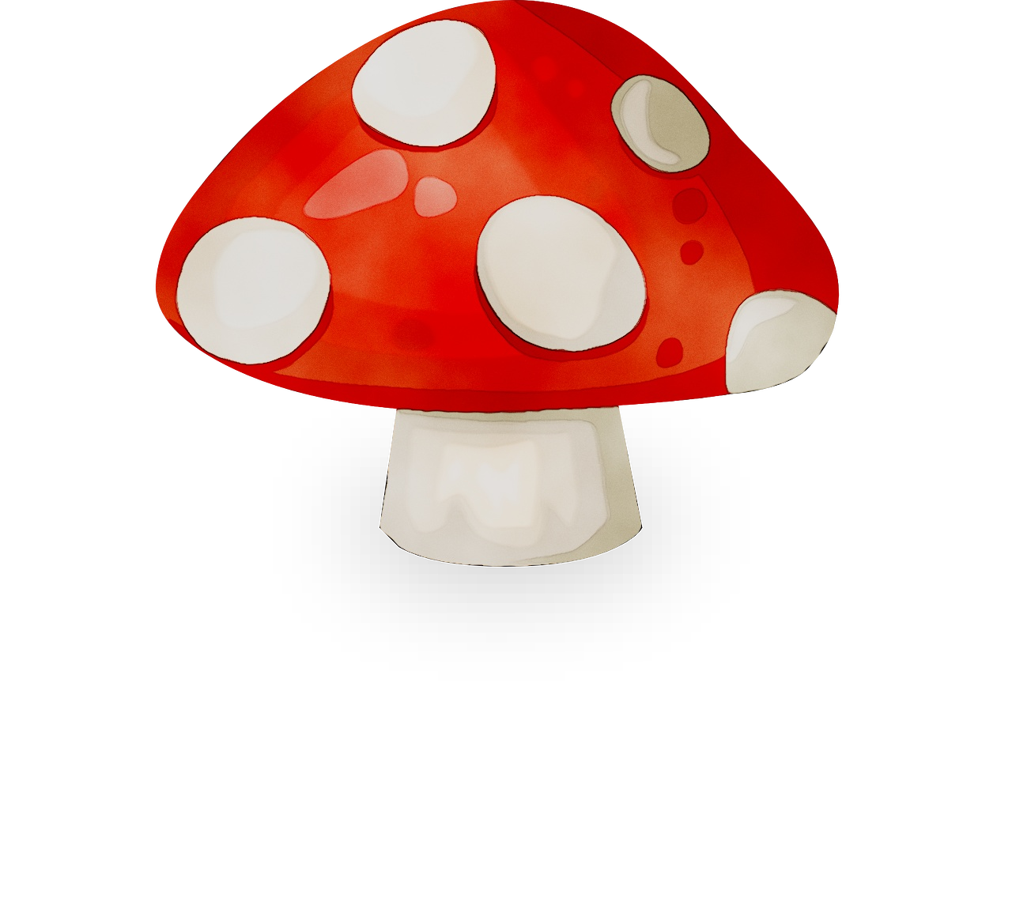
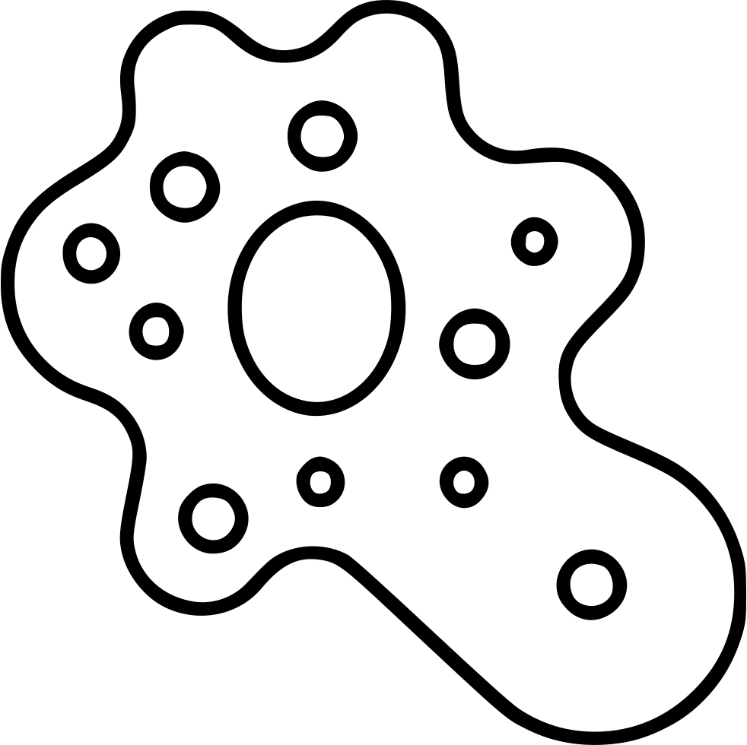
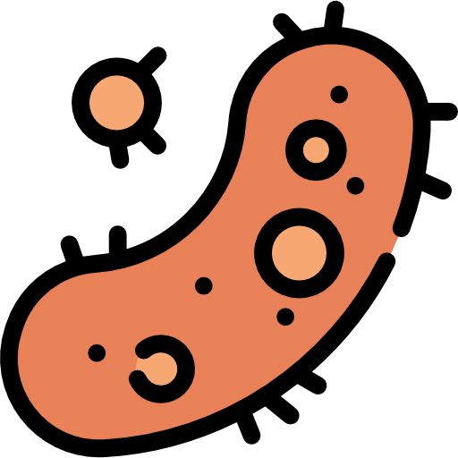
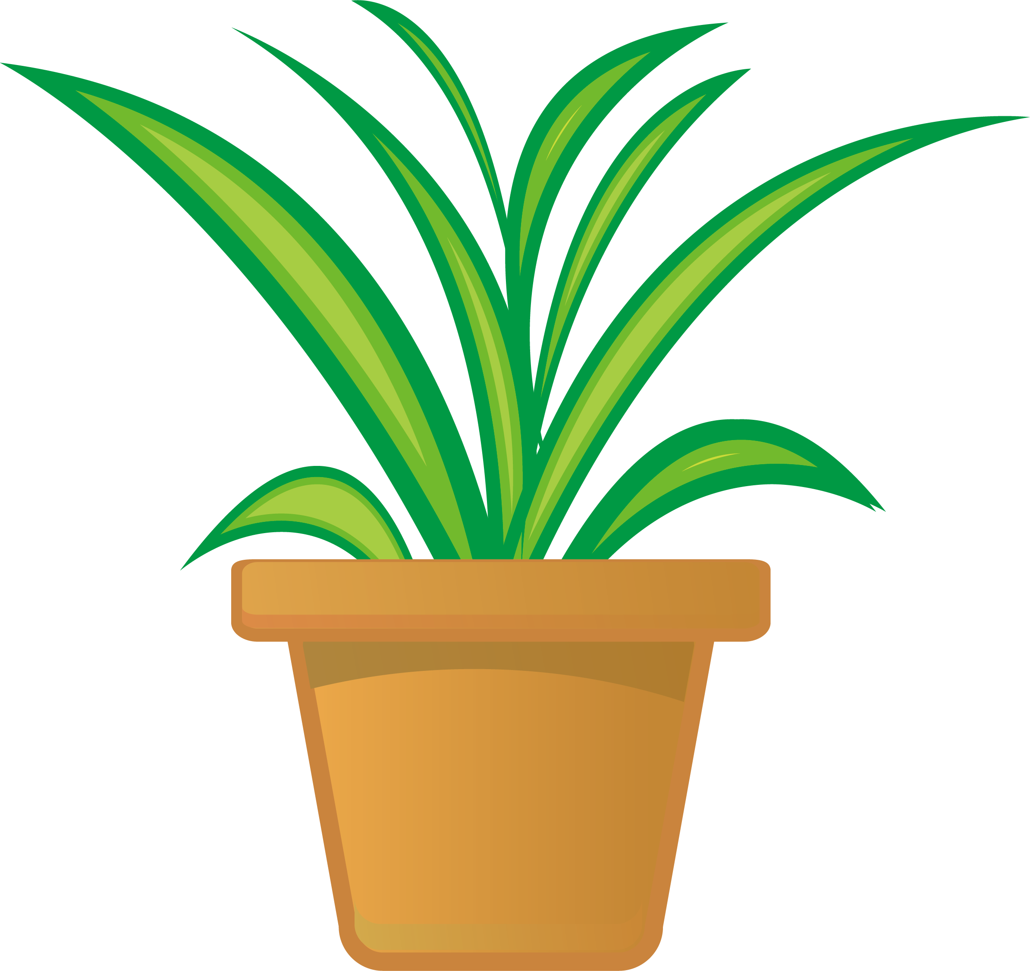
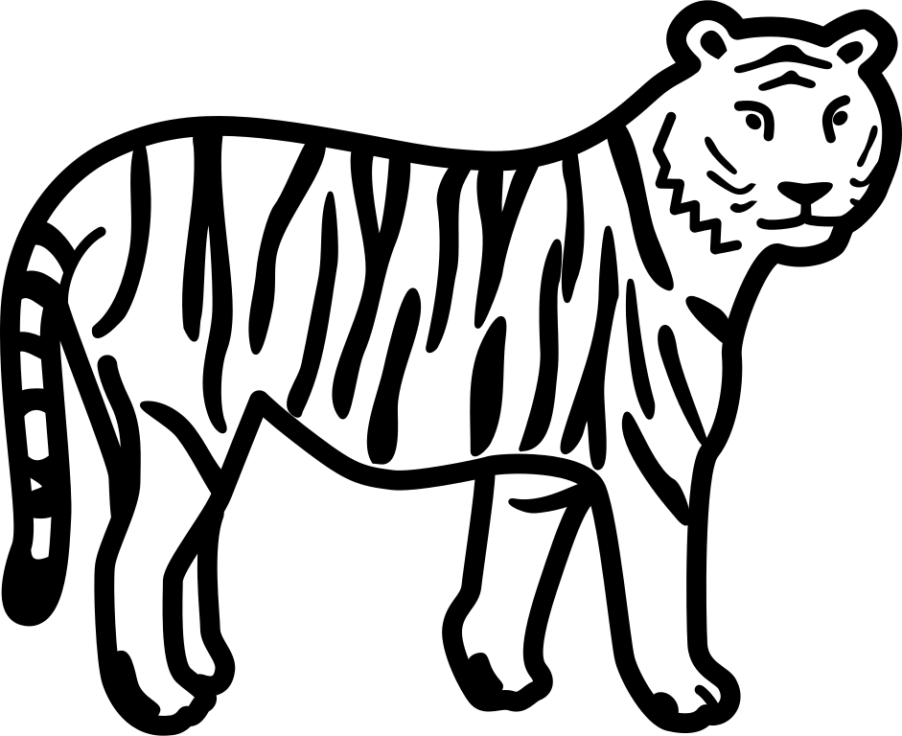
Could you sort by type of invertebrate? Or Flowering vs non-flowering plant?
Images: Jo Montgomery
Images: www.cleanpng.com

Activity: Learn the actions to the 5 Kingdoms
Watch the video again and learn the actions for each of the 5 Kingdoms to help you remember.



Image credits: cleanpng.com
- Bacteria (prokaryotes)
- Amoeba (protozoa)
- Fungi
- Plants
- Animals

Activity: Make a book about each of the 5 Kingdoms
Can you make a mini book, including pictures and information on each of the 5 Kingdoms:
- Bacteria (prokaryotes)
- Amoeba (protozoa)
- Fungi
- Plants
- Animals
You could use these instructions to fold a mini book from one piece of paper: https://www.wikihow.com/Make-a-Paper-Book

Activity: Further investigations
Find out more about Carl Linnaeus and taxonomy and classification
https://www.stem.org.uk/resources/elibrary/resource/465179/linnaeus-home
https://www.stem.org.uk/system/files/elibrary-resources/legacy_files_migrated/33286-carl-linnaeus-primary-poster-web.pdf
https://www.stem.org.uk/resources/elibrary/resource/448328/why-classify

