Living Things and Their Habitats Key Stage 1

Activity: Match the living thing to its habitat
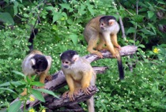
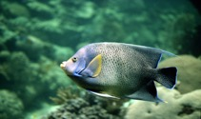
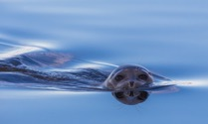
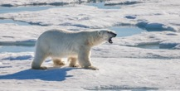
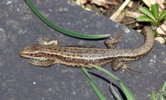
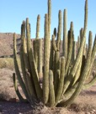
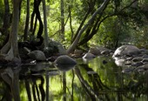
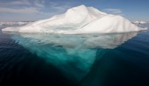
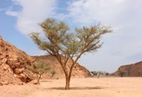
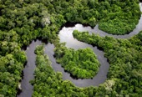
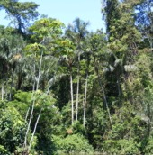
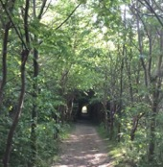
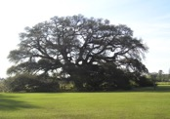
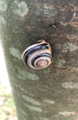
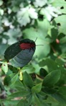
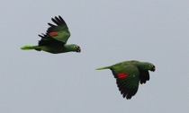
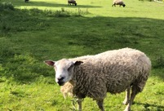
habitats
Living things

Image credits (previous page):
Oak tree - AlabamaGuy2007 commons.wikimedia.org; Rainforest - User Shao commons.wikimedia.org; Rainforest River - Jlwad CC commons.wikedia.org; Iceberg AWeith commons.wikimedia.org; Forest River stream - Kerala Tourism commons.wikimedia.org; Deset Wadi - By لا روسا - Own work commons.wikimedia.org; Woodland - Dr Jo Montgomery; Sheep - Dr Jo Montgomery; Squirrel monkeys - Lindadevolder commons.wikimedia.org; Tropical fish - CSIRO commons.wikimedia.org; Polar bear - Andreas Weith commons.wikimedia.org; Lizard - Charles J Sharp, Sharp Photography commons.wikimedia.org ; Birds - Charles J Sharp, Sharp Photography commons.wikimedia.org ; Seal - By Кирилл Уютнов - Own work commons.wikimedia.org; Snail - Dr Jo Montgomery; Cactus - Pretzelpaws commons.wikimedia.org ; Beetle - Dr Jo Montgomery

Activity: Find and identify living things in their habitats
Go on a bug hunt, see what you can find in your local area and identify what lives there and how they are suited to that habitat or micro-habitat
Further information Habitats: minibeasts
https://www.stem.org.uk/resources/elibrary/resource/33664/education-pack-minibeasts-invertebrate-survey

Activity: Draw and label a minibeast
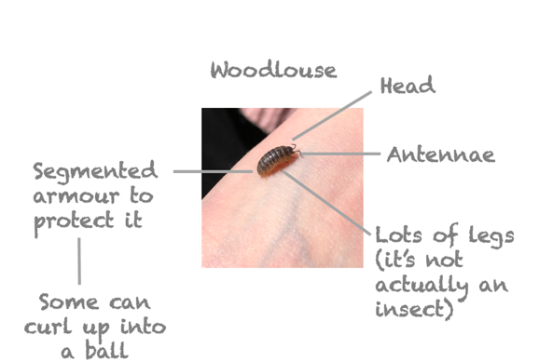
Either find a minibeast from your bug hunt, or look one up in a book or on the internet and label it
Example:

Activity: Create estate agents adverts for animals’ habitats

Can you think of the features of different microhabitats and create an advert for what might attract animals or plants suited to those habitats:
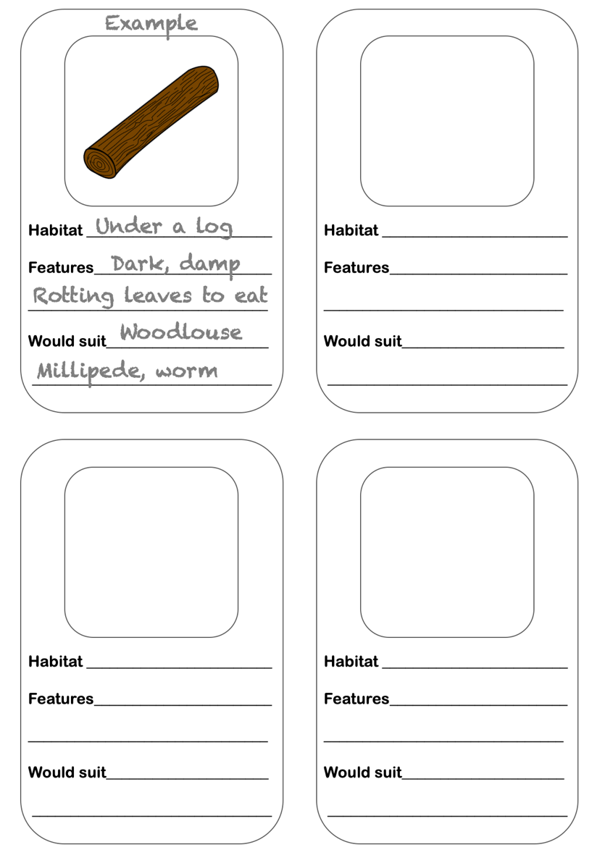

Activity: Food chains

Further learning on how animals and plants depend on each other

Teachers TV videos about food chains https://www.stem.org.uk/resources/elibrary/resource/32076/habitats-and-food-chains-fox-and-hedgehog

