Session 2: Spreading Seeds Part 2
Science curriculum area (2P): |  | Plants (2P)  i. observe and describe how seeds and bulbs grow into mature plants  ii. find out and describe how plants need water, light and a suitable temperature to grow and stay healthy
Working Scientifically (KS1 WS) |  | Working Scientifically (KS1 WS)  i) asking simple questions and recognising that they can be answered in different ways  ii) observing closely, using simple equipment  iii) performing simple tests  iv) identifying and classifying  v) using their observations and ideas to suggest answers to questions  vi) gathering and recording data to help in answering questions
Teaching Objectives |  | - To consider different ways in which plants can disperse their seeds.  - To consider why the design of the seed is crucial to the way it is dispersed.  - To make a burr and display in the classroom, with accompanying facts.
Key Vocabulary: seed, disperse, wind, pollination
Resources  'How to Make a Clay Burr' sheet, magnifying glasses, microscopes, different seeds (with different designs for dispersal - blowing, eating, exploding, floating, sticking), clay, clay tools, clay boards, newspaper, pipe cleaners, cling film, junk modelling materials. |  |  | Weblinks  http://www.vtaide.com/png/seed-dispersion.htm - Excellent information about different methods of seed dispersal.
Before the session: Collect different seeds of varying designs for children to look at through microscopes or magnifying glasses.
Whole class: Ask the chn if they remember the different ways that seeds travel and disperse (Blowing, Eating, Exploding, Floating, Falling, Sticking (BEEFFS). Then show them the different seeds on the tables. Ask them to sort the seeds into the five different dispersal categories of BEEFFS. Explain that to do this effectively they will have to look very carefully at the way they are designed. They should use magnifying glasses, etc. and talk to each other about what they can see. Ask the chn to share their ideas about what they might see in the seed designs by asking: What will be special and useful about the design of a seed that needs to float? (Light, have fluffy or flat parts to help with floating.) What about the ones that are designed to be spread through animals' eating them? (Will be edible, tasty.) And exploding ones? (Stream lined, all tightly packed and hard.) What about those that will float away? (They need to not sink in water, normally have thick outer layers – waterproof.) And finally, how can we spot the ones that will stick on animals and travel that way? (They usually have burrs or tiny hooks to help them attach to fur.) Show the chn the clay and junk modelling and tell them that their challenge is to make a model of a seed that can be dispersed by one of the five ways already talked about (BEEFFS).
Activities:
Explain that all the chn will make a clay model of a seed designed to attach to animals' fur - a burr with hooks. Explain that you (or another adult) will work with the clay group whilst the other chn work in small groups to design and make a junk model seed. Ask each group to decide what sort of dispersal their model seed will be designed for. When they have come to a collective decision, ask them to write their dispersal method on a large sheet of paper and to think of different design features their model seed could have. For example, if they choose 'Blowing' then their seed will need flat or feathery parts and will need to be lightweight. Encourage them to write any ideas and facts about their choice of seed dispersal on the large sheet of paper so you can display them with their junk model seed when they have finished it.
Plenary | Ask the chn to place their junk model and clay seeds on the tables in the classroom, or in a line on the hall floor, and take the chn on a Seed Seeing trip, guiding them around the models and praising them for their efforts. Ask the other chn questions such as: Can you tell which method of dispersal this seed is designed for? What clues can we spot on this seed model about how it is designed to travel?
Outcomes | Children will  - Understand that plants disperse their seeds in different ways  - Understand that the design of a seed is crucial to the way it is dispersed  - Make large seeds, talking about what designs they need to incorporate and writing facts about how they could be dispersed



Hamilton’s Science Scheme:
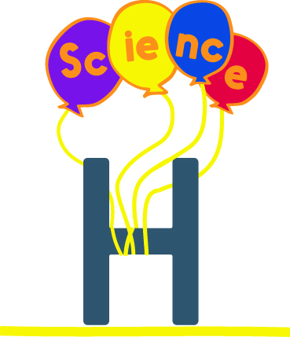
- Covers all statutory National Curriculum Science content
- Arranged in blocks of six sessions for half-termly teaching
- Differentiation within each year’s objectives
- Supportive teacher information
- Assessment activities & ideas
- Comprehensive resources
- Checked by experts
- Mixed year Science planning – NEW in 2017
And best of all, it’s all FREE!
Find out more at www.hamilton-trust.org.uk/stem

