
Key Stage 5
Organic pathways
Student worksheet
Vanilla comes from the seed pods of a type of orchid plant. It originated in Mexico, but is now also grown in other warm climates throughout the world.
The vanillin molecule
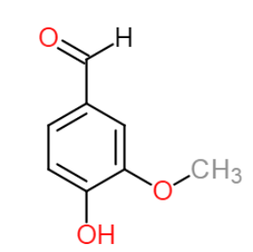
It is the second most expensive spice after saffron because its production requires a lot of work. Making 1 kg of vanillin requires approximately 500 kg of vanilla pods, from around 40,000 flowers.
Vanilla contains a mixture of different chemicals but the one that gives it its distinctive aroma and flavour is called vanillin.
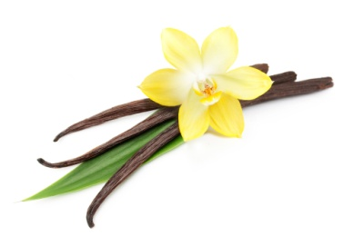
Natural vs artificial
Not all of the vanilla you eat comes from the vanilla plant. Only about 0.25% of vanillin sold originates from vanilla pods, while most of the remainder is made from other raw materials using chemical reactions. The most widely method involves using multi-step syntheses with benzene as the starter chemical.
Artificial vanillin produced in this way is sold for approximately £12 per kg, compared to prices of around £1500 per kg for natural vanillin.
Your task
1. Answer the following questions:
a. Calculate the relative formula mass (M_{r}) of vanillin. (A_{r} O = 16, C = 12, H = 1)
b. On the vanillin molecule circle and name the other two functional groups.
c. Explain why most of the vanilla flavouring we eat is made artificially.
methoxy group
2. You will now consider the synthesis of vanillin from benzene using the activity on page 2.
a. Cut round the dotted lines to give you 6 boxes containing the reactions A-F.
b. Put them in order to show the reaction pathway used to make vanillin.
c. Answer the questions about each reaction.
d. After you have completed this task, discuss the economic and environmental issues associated with making vanillin using benzene.

Key Stage 5
Organic pathways
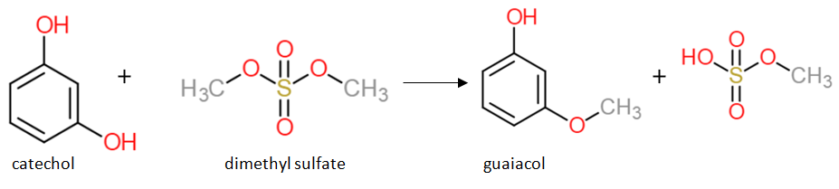
A
1. Predict which molecule is the useful product.
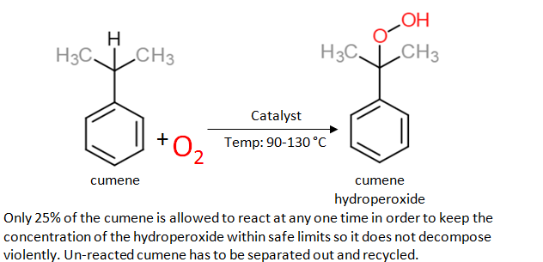
B
Pressure: 1-10 atm
1. Suggest two reasons why this reaction is expensive to carry out.
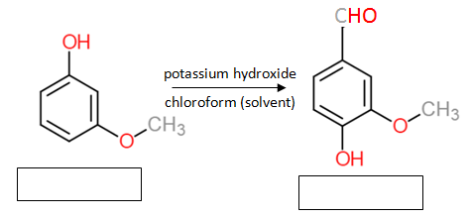
C
1. Write the names of the molecules (Hint: they are named in other steps).
2. Suggest some safety issues when carrying out this reaction.
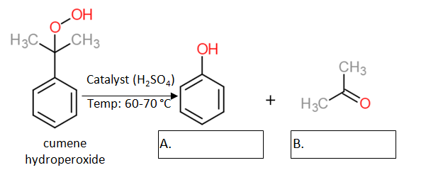
D
1. Write the names of the products.
2. Calculate the atom efficiency of the reaction if:
a. Product B is a waste product b. Product B is not a waste product
C₆H₅OH + H₂O₂ → C₆H₄(OH)₂ + H₂O
phenol + hydrogen peroxide catechol + water
E

1. Calculate the atom efficiency of making catechol in this reaction.
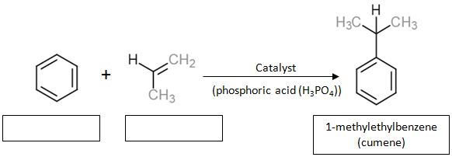
F
1. Write in the names of the reactants
2. Suggest issues that may arise because of the choice in catalyst.

