Key Stage 5 – Organic pathways
Notes for teachers
At a glance
Many of the chemicals we use as drugs, flavourings and perfumes originate from natural sources but often the most economical way of obtaining them is to produce them artificially on an industrial scale.
In this activity students find out about the chemical that gives vanilla its popular flavour - vanillin. They analyse the chemical pathway used to make vanillin from benzene and discuss the economic and environmental impacts of its manufacture.
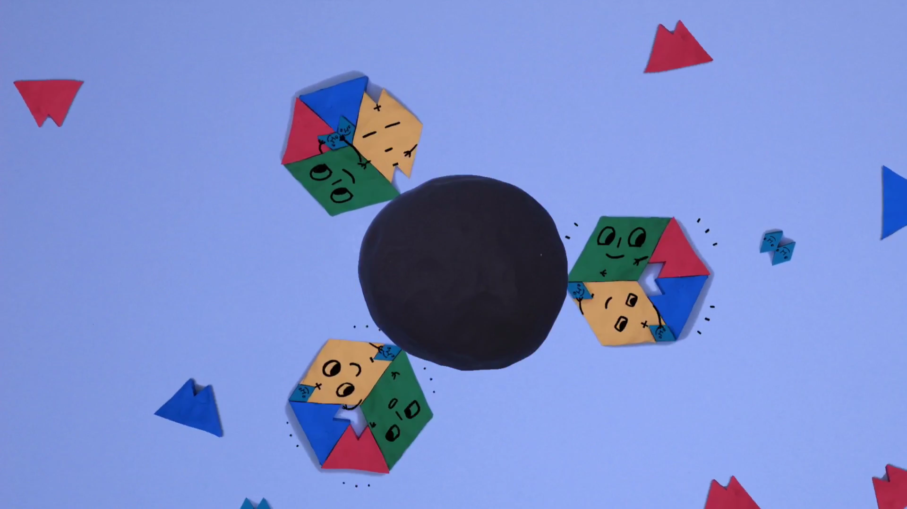
Learning Outcomes
- Students apply knowledge of organic synthesis to the manufacture of an unfamiliar molecule
- Students evaluate an industrial process.
Each student will need
- Copy of student worksheet pages 1 and 2
You will also need
- Bottles of real vanilla extract and artificial vanilla essence. Labels should be covered. (Optional)

Possible Lesson Activities
- Starter activity
  - Ask students if they know where vanilla comes from. After hearing their ideas, ask them to read through the information on page 1 of the student worksheet.
  - Show the students the animation ‘What can chemists learn from nature?’. This discusses why chemists aim to replicate natural chemicals, like vanillin, on an industrial scale and how they approach this.
  - Ask students to do a blind comparison and smell a sample of real vanilla extract and artificial vanilla flavouring to see if they can tell the difference.
  - Ask students to answer question 1 on the student worksheet and go through the answers to the questions:
a) (3 x 16) + (8 x 12) + (8 x 1) = 152
b) COH group at the top of the molecule is an aldehyde group. The ring plus the OH is a phenol group.
c) Most of the vanilla flavouring we eat is artificial because to extract real vanilla from the beans is a labour intensive and costly process. It is also very inefficient.

- Main activity: The pathway
  - Discuss the fact that vanillin is an organic compound, so can be made from the organic compound benzene using a series of chemical reactions.
  - Give each student a copy of page 2 of the student worksheet. They will now work alone, or in pairs, to complete question 2 part a on page 1. This asks them to work out the pathway used to make vanillin from benzene. They will also be asked questions about each stage which are designed to get students thinking about the economic and environmental impacts of each stage.
  - Check the answers with the students.
Order of steps: F, B, D, E, A, C
A.1. guaicol
B.1. A temperature higher than room temperature is used, pressure has to be increased, a catalyst is needed (which may be an expensive metal such as platinum), un-reacted cumene has to be separated out and recycled.
C.1. guaicol, vanillin 2. Potassium hydroxide is corrosive, chloroform is toxic
D.1. A: phenol, B: propanone 2. a.(94/152) x 100 = 62% b. 100%
E. 1. (112/128) x 100 = 87.5%
F.1. benzene, propene 2. corrosive, dangerous to handle, difficult to dispose, product has to be neutralised
  - Discuss how efficient multi-step syntheses like this are in terms of atom economy and percentage yield.

- Plenary
  - Ask students to complete question 2 part d. Here they will use what they have learnt about the pathway to discuss economic and environmental issues surrounding the use of benzene to create vanillin.
  - Possible answers could include:
- It is cheaper than extracting vanillin from vanilla plants and the percentage yield will be higher.
- The percentage yield could be increased if fewer steps could be used.
- Benzene is extracted from crude oil, which is a finite resource.
- The pathway produces toxic chemicals, such as phenol.
- Waste products are produced, which need to be disposed of.
- Energy is used to create high temperatures and pressures.
- Harmful solvents (chloroform) are used.
  - Invite students to share their thoughts with the rest of the class.
  - Discuss why scientists at the University of Oxford are researching into using enzymes to catalyse organic synthesis reactions such as these. (They are specific, operate at lower temperatures and use water as a solvent).
Weblinks
http://www.greener-industry.org.uk/pages/vanillin/1Vanillin_AP.htm
More information on vanillin and the chemical processes used to make it.

Get Curious with the University of Oxford
This animation was made to support the University of Oxford’s Curiosity Carnival: European Researchers Night. Sept 29 2017 will be a chance to find out what research is really all about, meet researchers, ask questions and discover how research affects and changes all our lives.
The night is a huge festival of curiosity – a city-wide programme of activities across the University of Oxford’s museums, libraries, gardens and woods. There will be a wide range of activities for all ages and interests – live experiments, games, stalls, busking, debates, music, dance and a pub-style quiz – most of which are free of charge.
To find out what’s on, how you and your students can get involved visit: www.curiousity carnival.org
Oxford’s Curiosity Carnival 2017 will join hundreds of other European cities in celebrating European Researchers’ Night on 29 September.

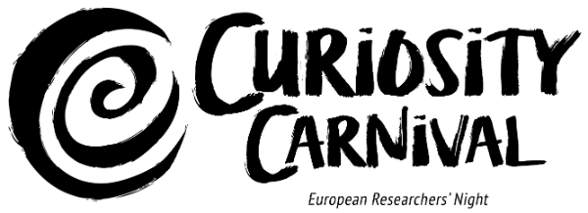

 This European Researchers' Night project is funded by the European Commission under the Marie Skłodowska-Curie actions.

