END OF UNIT TEST – HOW ENERGY IS GENERATED AND STORED
Answer all questions
The marks allocated for each question are indicated in brackets
You have 40 minutes
34 marks in total
Q1: Name two advantages of using solar energy [3]
- ………………………………………………………………………………………………………………………………………………………………………………………………………………………………………………………………………………………………………………………………………………………………………………………………………………………………
- ………………………………………………………………………………………………………………………………………………………………………………………………………………………………………………………………………………………………………………………………………………………………………………………………………………………………

Q2: Name the machine used to generate power from the wind: [1]
……………………………………………………………………………………………………………………………………………………………
Q3 The diagram below that illustrates Hydropower (hydroelectricity) [4] Place the following words in the correct order

Power lines reservoir generator turbine

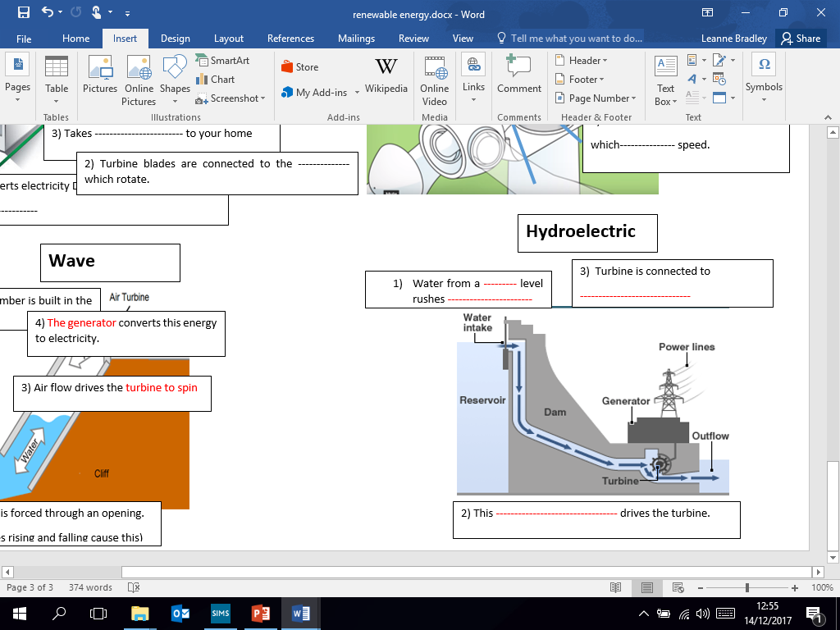

D
A
B
C
D

C
A

B

Q4: Name the gas that is created by rotting vegetation underwater [1]

------------------------------------------------------------

Q5: Name two renewable sources of energy [2]
- …………………………………………………………………………………………………………………………………………
- …………………………………………………………………………………………………………………………………………

Q6: What is a disadvantage of geothermal energy [1]
………………………………………………………………………………………………………………………………………………………………………………………………………………………………………………………………………………………………………………………………………………………………………………………………………………………………………………………………………………………

Q7: Describe how coal is created [3]
…………………………………………………………………………………………………………………………………………………………………………………………………………………………………………………………………………………………………………………………………………………………………………………………………………………………………………………………………………………………………………………………………………………………………………………………………………………………………………………………………………………………………………………………………………………………………………………………………………………………………………………………………………………………………………………………………………

Q8: Name three biomass fuel sources [3]
- …………………………………………………………………………………………………………………………………………
- …………………………………………………………………………………………………………………………………………
- …………………………………………………………………………………………………………………………………………

Q9: Name one fuel used in the generation of nuclear energy [1]
…………………………………………………………………………………………………………………………………………

Q10: The diagram below that illustrates how oil is formed. Place the following words in the correct order.

The sea rock layer crude oil sea bed oil rig

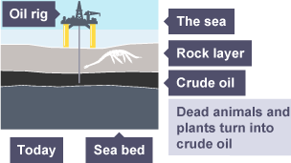
5)
4)

3)

2)

1)

Q11: Discuss the advantages and disadvantages of wind power in industry. (6)
………………………………………………………………………………………………………………………………………………………………………………………………………………………………………………………………………………………………………………………………………………………………………………………………………………………………………………………………………………………………………………………………………………………………………………………………………………………………………………………………………………………………………………………………………………………………………………………………………………………………………………………………………………………………………………………………………………………………………………………………………………………………………………………………………………………………………………………………
…………………………………………………………………………………………………………………………………………………………………………………
…………………………………………………………………………………………………………………………………………………………………………………
………………………………………………………………………………………………………………………………………………………………………………….…
……………………………………………………………………………………………………………………………………………………………………………………
………………………………………………………………………………………………………………………………………………………………………………….
Q12:
Study these trainers below, they contain an insole that provides two and a half hours of phone charge from a one hour walk.

i) What type of energy is used to generate the electricity? (1 mark)
…………………………………………………

ii) Explain what benefits this type of energy can have for the user. (3 marks)
…………………………………………………………………………………………………………………………………………………………………………………………………………………………………………………………………………………………………………………………………………………………………………
………………………………………………………………………………………………………………………………………………………………………………….
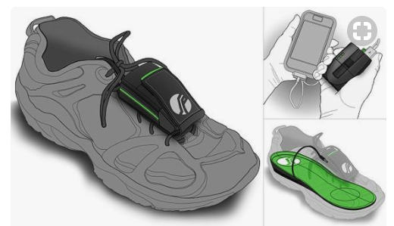
……………………………………………………………………………………………………………………………………………………………………………………
Total marks= your mark / 34 Percentage= Grade=

