END OF UNIT TEST – HOW ENERGY IS GENERATED AND STORED
Answer all questions
The marks allocated for each question are indicated in brackets
You have 40 minutes
34 marks in total
Q1: Name two advantages of using solar energy [3]

Solar energy is a renewable energy source
There are no fuel costs
No harmful polluting gases are produced (carbon dioxide)

Q2: Name the machine used to generate power from the wind: [1]
Wind Turbine
Q3 The diagram below that illustrates Hydropower (hydroelectricity) [4] Place the following words in the correct order

Power lines reservoir generator turbine

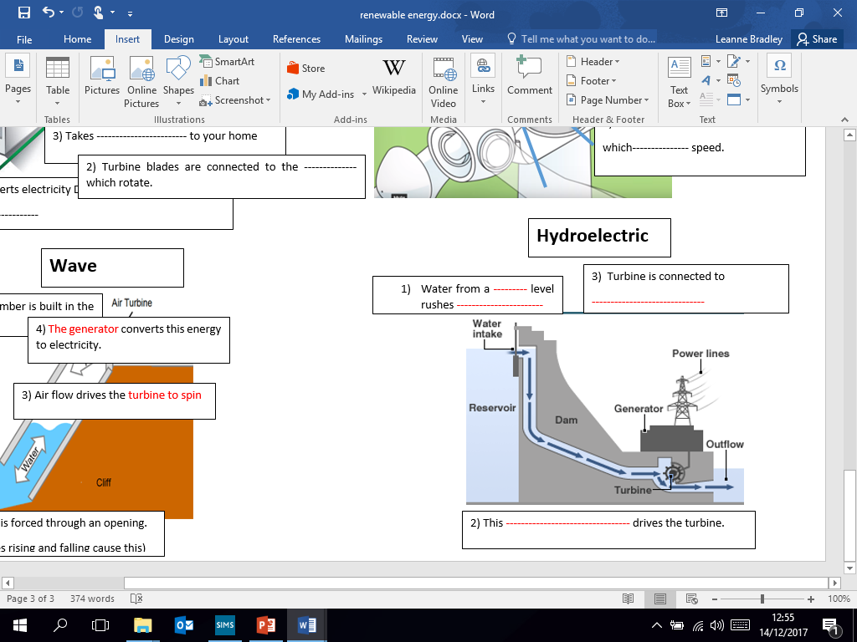

D
A | Reservoir
B | Turbine
C | Generator
D | Power lines

C
A

B

Q4: Name the gas that is created by rotting vegetation underwater [1]
Methane and CO2 (but carbon neutral)
------------------------------------------------------------

Q5: Name two renewable sources of energy [2]
Wind, sun, water, kinetic, wave, wood/organic matter, molten rock from earth’s crust (releasing the steam- geothermal)

Q6: What is a disadvantage of geothermal energy [1]
- Most parts of the world do not have suitable areas where geothermal energy can be produced.
- It is not 100% renewable as fossil fuels are required to power the heat pump.
- The initial outlay for installation can be very high.

Q7: Describe how coal is created [3]
Millions of years ago giant trees/plants died in swampy forests
Over millions of years the plants were buried under rocks and dirt
Heat and pressure turned them into coal

Q8: Name three biomass fuel sources [3]
Wood, crops, landfill gas, garbage/rubbish, fruit, organic matter, cow dung.

Q9: Name one fuel used in the generation of nuclear energy [1]
Uranium (a heavy metal)

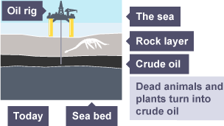
Q10: The diagram below that illustrates how oil is formed. Place the following words in the correct order.
4) The sea
5) Oil rig

3) Rock layer
2crude oil

1) Sea bed

Q11: Discuss the advantages and disadvantages of wind power in industry. (6)
Can have less than 3 points from each – eg
“Advantage is that wind is renewable energy source as better for environment - does not use non-renewable fuels” (this 1 advantage is explained well.

ADVANTAGES:
- Wind energy is a renewable energy source
- There are no fuel costs
- No harmful polluting gases are produced
DISADVANTAGES:
- Wind farms are noisy
- Wind farms may spoil the view for people living near them.
- If there is no wind, there is no electricity.

Q12:
Study these trainers below, they contain an insole that provides two and a half hours of phone charge from a one hour walk.

i) What type of energy is used to generate the electricity? (1 mark)
KINETIC

ii) Explain what benefits this type of energy can have for the user. (3 marks)
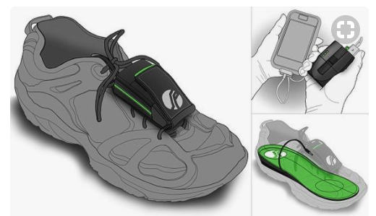
Able to charge phone if in a remote area (walking holiday for example) or at a festival with no electricity source. If the wearer is an active person, they can generate enough electricity to always have mobile charge, free of charge so less expensive. It will harness energy from the wearer’s motion and convert it into electric power.
Total marks= your mark / 34 Percentage= Grade=

