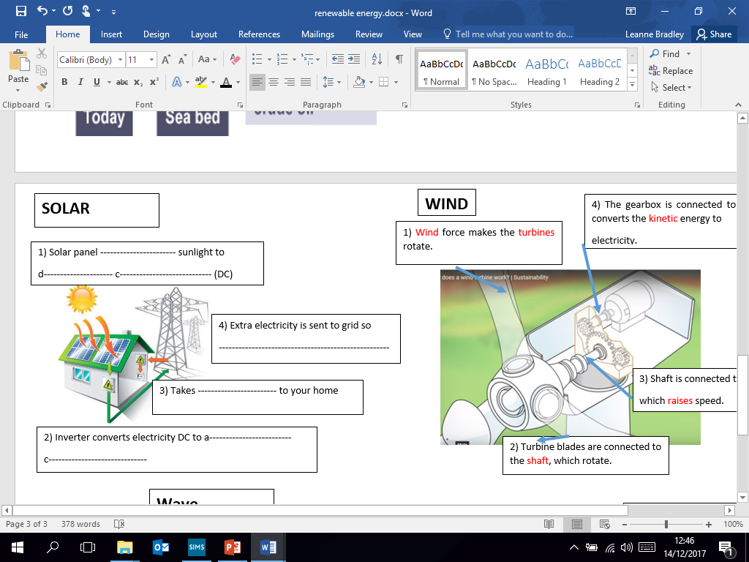 | Advantages  - ----------------------------------------------------------------------------------------  - ----------------------------------------------------------------------------------------  - ----------------------------------------------------------------------------------------  Disadvantages  - ----------------------------------------------------------------------------------------  - ----------------------------------------------------------------------------------------  - ----------------------------------------------------------------------------------------  Renewable or non-renewable
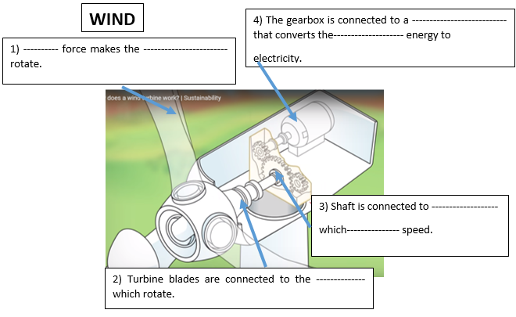 | Advantages  - ----------------------------------------------------------------------------------------  - ----------------------------------------------------------------------------------------  - ----------------------------------------------------------------------------------------  Disadvantages  - ----------------------------------------------------------------------------------------  - ----------------------------------------------------------------------------------------  - ----------------------------------------------------------------------------------------  Renewable or non-renewable
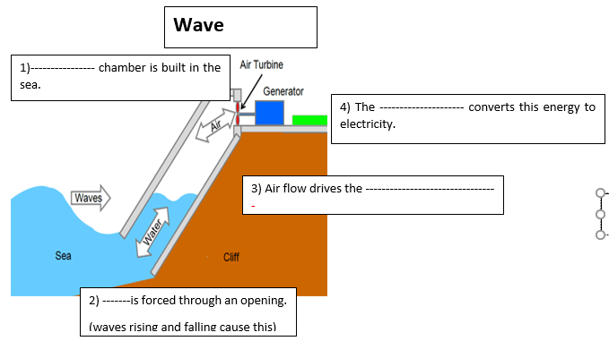 | Advantages  - ----------------------------------------------------------------------------------------  - ----------------------------------------------------------------------------------------  - ----------------------------------------------------------------------------------------  - ----------------------------------------------------------------------------------------  Disadvantages  - ----------------------------------------------------------------------------------------  - ----------------------------------------------------------------------------------------  Renewable or non-renewable
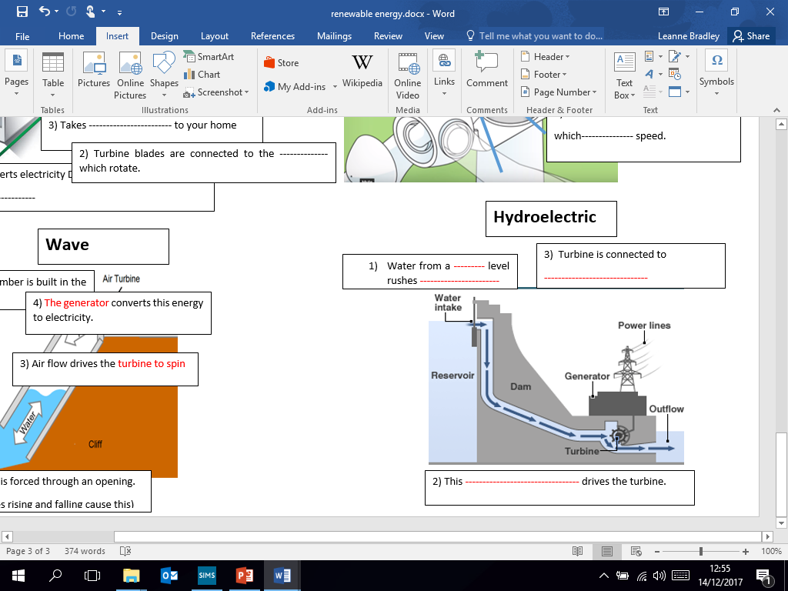 | Advantages  - ----------------------------------------------------------------------------------------  - ----------------------------------------------------------------------------------------  - ----------------------------------------------------------------------------------------  - ----------------------------------------------------------------------------------------  Disadvantages  - ----------------------------------------------------------------------------------------  - ----------------------------------------------------------------------------------------  - ---------------------------------------------------------------------------------------  Renewable or non-renewable
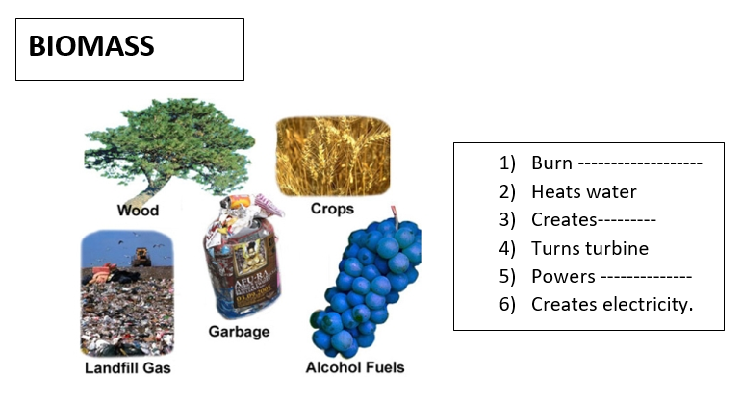 | Advantages  - ----------------------------------------------------------------------------------------  - ----------------------------------------------------------------------------------------  - ----------------------------------------------------------------------------------------  - ----------------------------------------------------------------------------------------  Disadvantages  - ---------------------------------------------------------------------------------------  - ---------------------------------------------------------------------------------------  - ---------------------------------------------------------------------------------------  Renewable or non-renewable
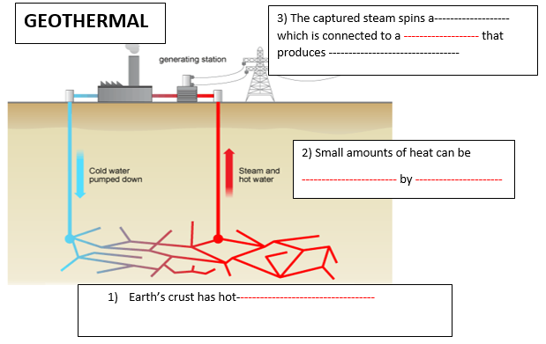 | Advantages  - ----------------------------------------------------------------------------------------  - ----------------------------------------------------------------------------------------  - ----------------------------------------------------------------------------------------  Disadvantages  - ---------------------------------------------------------------------------------------  - ---------------------------------------------------------------------------------------  - ---------------------------------------------------------------------------------------  Renewable or non-renewable
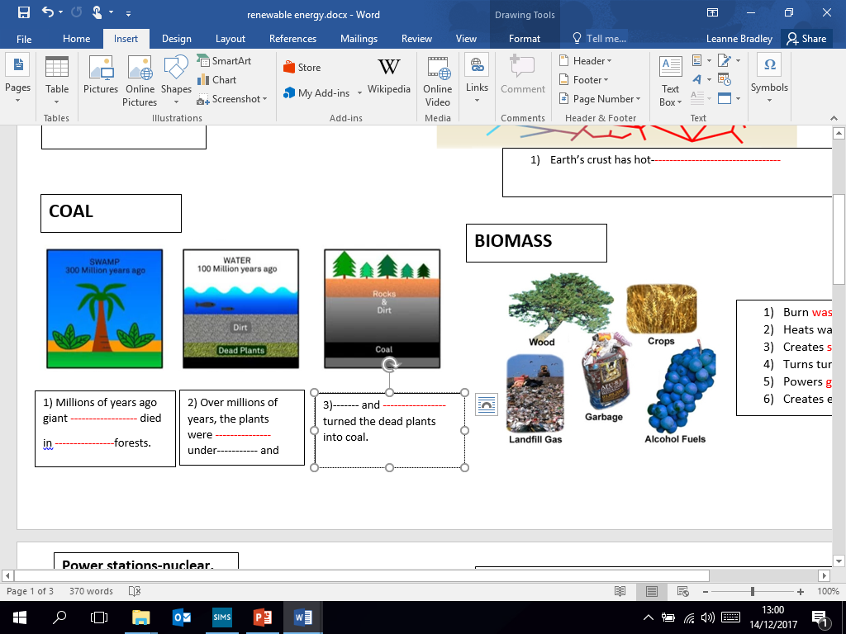 | Advantages  - ----------------------------------------------------------------------------------------  - ----------------------------------------------------------------------------------------  - ----------------------------------------------------------------------------------------  Disadvantages  - ---------------------------------------------------------------------------------------  - ---------------------------------------------------------------------------------------  - ---------------------------------------------------------------------------------------  Renewable or non-renewable
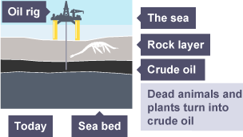  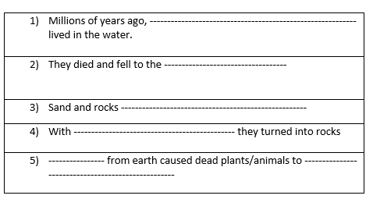 | Advantages  - ----------------------------------------------------------------------------------------  - ----------------------------------------------------------------------------------------  - ----------------------------------------------------------------------------------------  Disadvantages  - ---------------------------------------------------------------------------------------  - ---------------------------------------------------------------------------------------  - ---------------------------------------------------------------------------------------  Renewable or non-renewable
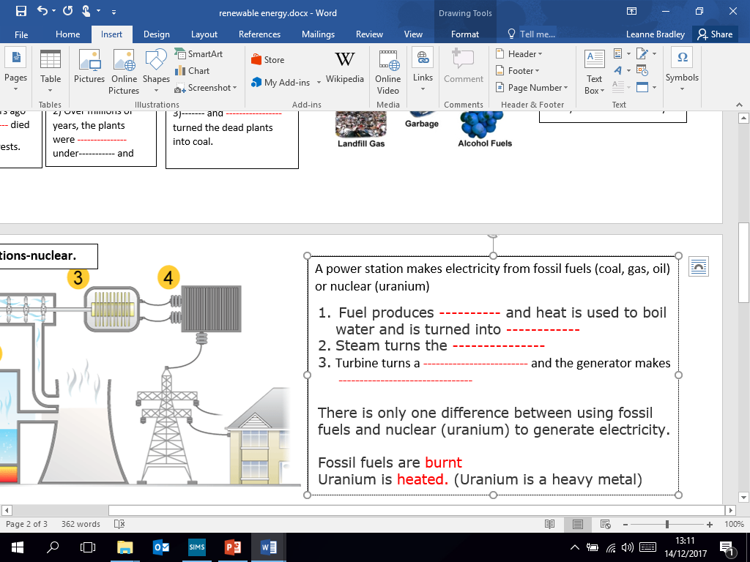  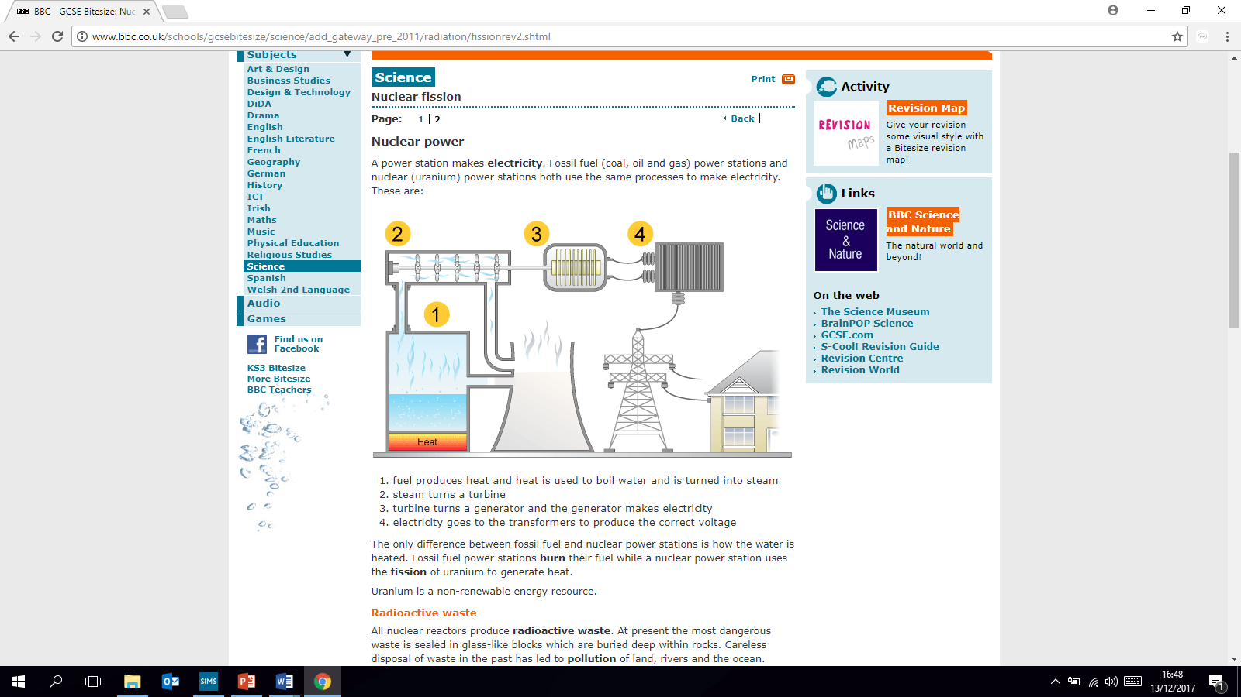  Power stations-nuclear. | A power station makes electricity from fossil fuels (coal, gas, oil) or nuclear (uranium)  Advantages  - ----------------------------------------------------------------------------------------  - ----------------------------------------------------------------------------------------  Disadvantages  - ---------------------------------------------------------------------------------------  - ---------------------------------------------------------------------------------------  There is only one difference between using fossil fuels and nuclear (uranium) to generate electricity.  Fossil fuels are ---------  Uranium is -----------. (Uranium is a heavy metal)
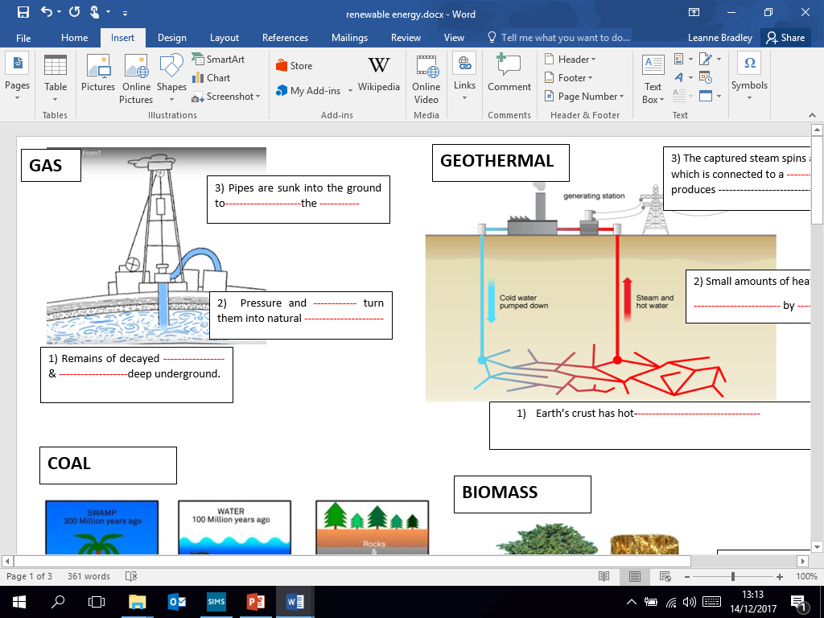 | Advantages  - ----------------------------------------------------------------------------------------  - ----------------------------------------------------------------------------------------  - ----------------------------------------------------------------------------------------  Disadvantages  - ---------------------------------------------------------------------------------------  - ---------------------------------------------------------------------------------------  - ---------------------------------------------------------------------------------------  Renewable or non-renewable

