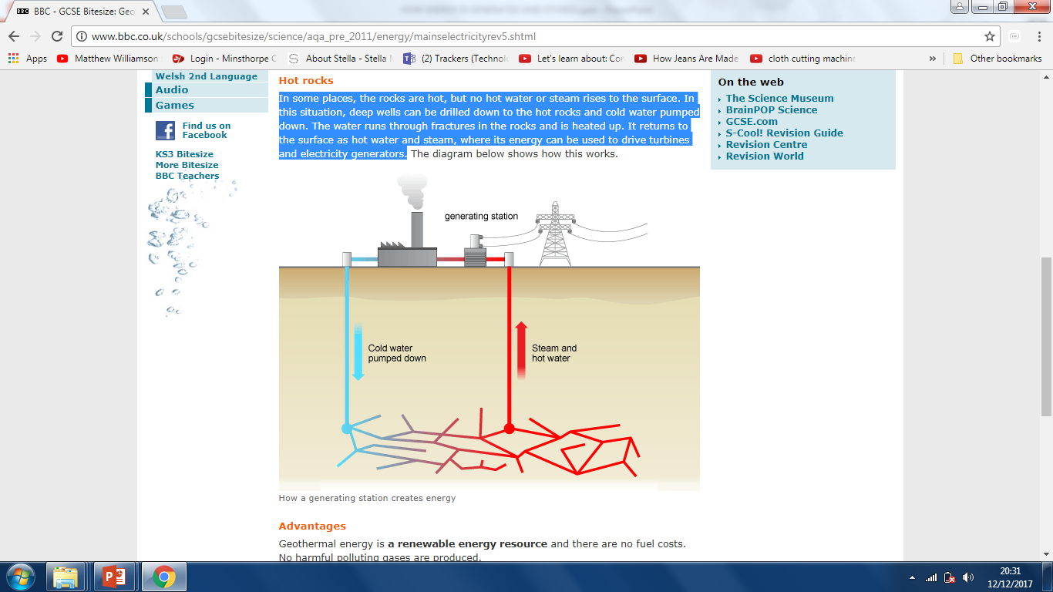
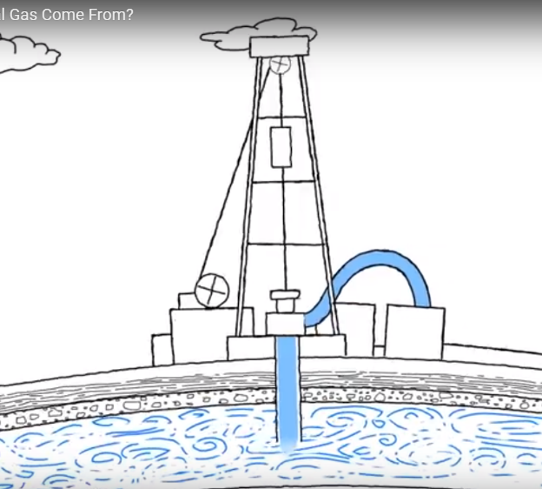
GEOTHERMAL
3) The captured steam spins a------------------- which is connected to a ------------------- that produces ---------------------------------
GAS
3) Pipes are sunk into the ground to---------------------the -----------

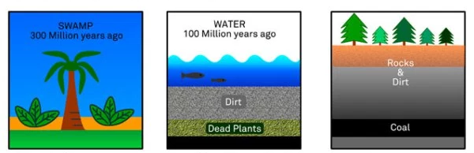
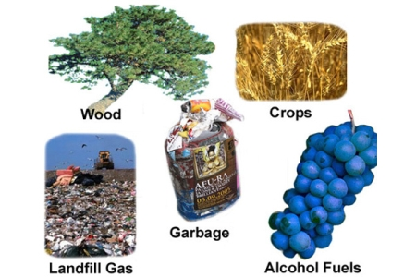
1) Remains of decayed ----------------- & -------------------deep underground.

2) Pressure and ------------ turn them into natural ----------------------

3)------- and -----------------turned the dead plants into coal.
1) Millions of years ago giant ------------------ died
in ----------------forests.
2) Small amounts of heat can be
------------------------ by ----------------------
- Earth’s crust has hot-----------------------------------

BIOMASS
2) Over millions of years, the plants were --------------- under----------- and dirt.
COAL
- Burn waste
- Heats water
- Creates steam
- Turns turbine
- Powers generator
- Creates electricity.
- Millions of years ago, ----------------------------------------------------------- lived in the water.
- They died and fell to the -----------------------------------
- Sand and rocks -----------------------------------------------------
- With ---------------------------------------------- they turned into rocks
- ---------------- from earth caused dead plants/animals to ---------------------------------------------------
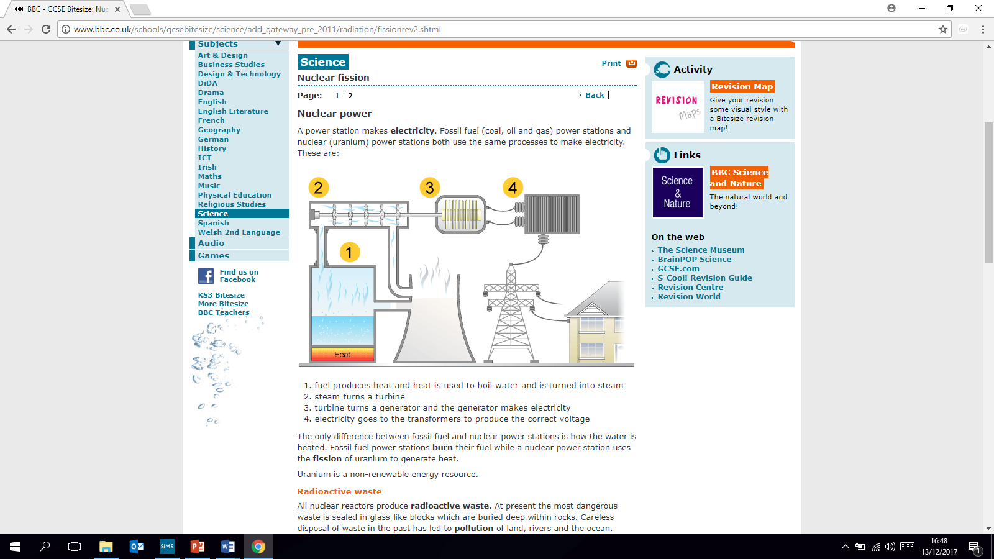
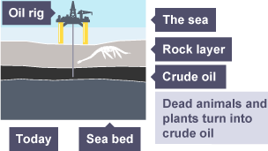
A power station makes electricity from fossil fuels (coal, gas, oil) or nuclear (uranium)
- Fuel produces ---------- and heat is used to boil water and is turned into ------------
- Steam turns the ---------------
- Turbine turns a ------------------------- and the generator makes
--------------------------------

There is only one difference between using fossil fuels and nuclear (uranium) to generate electricity.

Fossil fuels are burnt
Uranium is heated. (Uranium is a heavy metal)
Power stations-nuclear.
OIL
4) The gearbox is connected to a --------------------------- that converts the-------------------- energy to
electricity.

1) ---------- force makes the ------------------------ rotate.

1) Solar panel ----------------------- sunlight to
d--------------------- c---------------------------- (DC)

WIND
SOLAR

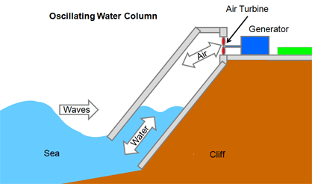
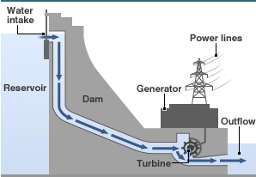
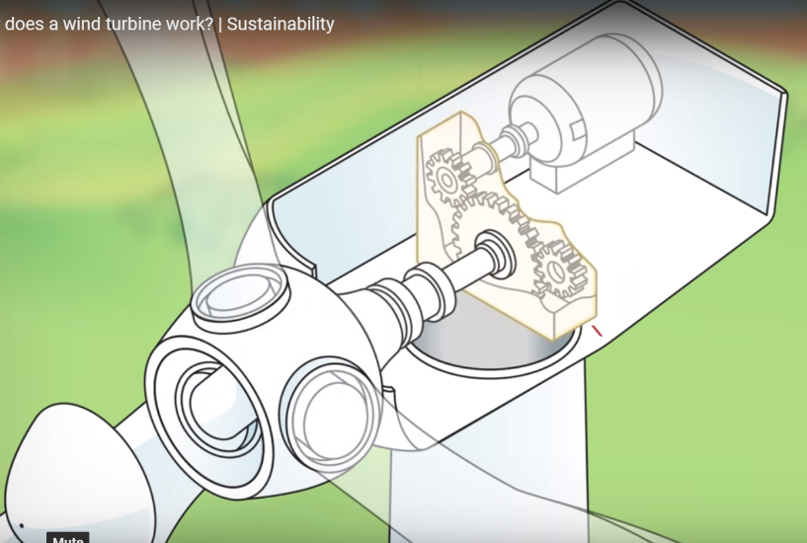
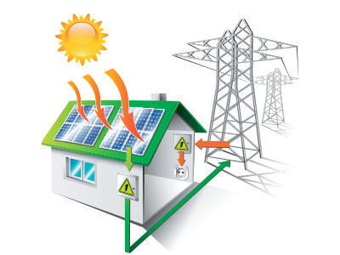
Hydroelectric
2) Turbine blades are connected to the --------------which rotate.

2) This --------------------------------- drives the turbine.
3) Air flow drives the turbine to spin

4) The generator converts this energy to electricity.

4) Extra electricity is sent to grid so
----------------------------------------------------

3) Shaft is connected to -------------------
which--------------- speed.

3) Takes ------------------------ to your home

2) Inverter converts electricity DC to a-------------------------
c------------------------------

1) Enclosed chamber is built in the sea.

3) Turbine is connected to
------------------------------
- Water from a --------- level rushes -----------------------

Wave
2) Air is forced through an opening.
(waves rising and falling cause this)

Renewable energy

