**Tools to help schools engage with research and in enquiry**

Matt Walker, Researcher, National Foundation for Educational Research

Email: [m.walker@nfer.ac.uk](mailto:m.walker@nfer.ac.uk)

**Abstract**

*There is a growing interest and desire amongst teachers, policy-makers and others for teaching practice to be better aligned to research findings. NFER has developed a range of products and services designed to help schools engage with research and in enquiry. In this paper, I provide an introduction to some of these services and look at some examples from schools already using these tools.*

**Introduction**

NFER has over ten years’ experience of researching and supporting the development of research-engaged schools. Today, we continue to be at the forefront of this work, and have developed a suite of products and services designed to help schools become more evidence informed. We also have an active research programme, with recent publications on [supporting the attainment of disadvantaged pupils](https://www.nfer.ac.uk/publications/PUPP02/PUPP02_home.cfm.com), [flipped learning](https://www.nfer.ac.uk/publications/NESM02/NESM02_home.cfm) and [NEET prevention](https://www.nfer.ac.uk/publications/RSRN02/RSRN02_home.cfm).

There is a real ground-swell of interest in this area. The recent success of organisations like ResearchED and resources such as the Education Endowment Foundation’s [Teaching and Learning Toolkit](https://educationendowmentfoundation.org.uk/evidence/teaching-learning-toolkit) are illustrative of a growing awareness of the power of research engagement in schools.

Whether you are just starting to use research or looking for more advanced, specialist techniques, NFER’s tools can help you on your research journey.

**What does a research-engaged school look like?**

Research-engaged schools are self-critical, evaluative and adaptive. Research is embedded in whole-school improvement processes and continuing professional development (CPD). They access and apply findings from others’ research, may conduct their own enquiry and often work in collaboration with other schools and/or researchers.

Working alongside teachers and other education professionals, NFER has identified eight key features of a research-engaged school:

1. Leadership and vision
2. Learning and participation
3. Managing resources
4. Setting priorities
5. Rigorous methodology
6. Measuring impact
7. Embedding and sustaining
8. Working collaboratively.

These features underpin our products designed to support schools to engage with research and in enquiry.

**What do we mean by engaging ‘with research’ and ‘in enquiry'?**

Teachers can be both ‘consumers’ and ‘producers’ of research. We believe that there is a place for both practices within an evidence-informed teaching profession. To highlight the related but distinctive nature of these two practices, we use the terms 'with research' and 'in enquiry'.

* When we say 'with research', we mean how you access, understand and apply academic or professionally produced research in your local setting.
* When we say 'in enquiry', we mean how you monitor and evaluate your own teaching and learning approaches and school-level developments, or how you encourage a culture of reflective practice through a systematic approach to CPD.

There is often a close relationship between engaging with research and in enquiry. To decide which is most useful, it can help first to think about its purpose. Research that is undertaken to support system development or sharing beyond one school will need to use robust, representative methods to ensure confidence in the findings. It will probably be led by a professional researcher or statistician, often in collaboration with schools. Such research can ascertain:

* whether or not an approach ‘works’
* what works best in what contexts
* why something does or does not work.

Enquiry that is undertaken to support individual school or teacher development need not be representative. It will often be conducted by teachers, researchers, or both in collaboration. It can help to:

* encourage reflective practice and professional development
* understand stakeholder views or local situations
* monitor and evaluate new innovations
* implement evidence-based approaches locally.

Research or enquiry findings can help schools and teachers to understand the effectiveness of different school practices, and to challenge these. Engaging with research and enquiry findings can save time and resources by avoiding duplication of effort when developing a new approach.

**Tools to help schools and colleges engage with research and in enquiry**

Whether you are just starting out or already working in a research-engaged school, NFER has developed a range of products and services designed to help schools engage with research and in enquiry.

1. **The NFER Self Review Tool**

NFER recently celebrated the 1,000th user of our Self-Review Tool ([www.nfer.ac.uk/selfreviewtool](http://www.nfer.ac.uk/selfreviewtool)). This is a free online tool that has been designed to help schools evaluate where they are with their engagement with research and enquiry.

**Figure 1: The NFER Self Review Tool**

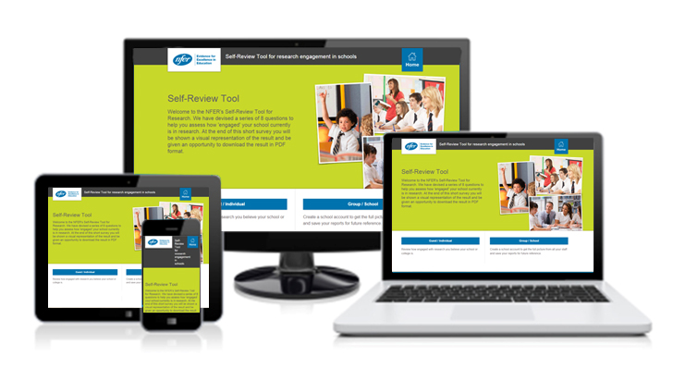

The development process started in September 2014 when NFER became aware of a gap in the market for a resource to help schools define research engagement, group it into simple statements and recognise that there are different stages. The concept was born.

This concept was tested internally with researchers and marketers and then taken externally to school leaders. The feedback was positive, so money was invested to develop the statements and the technology to create the tool. The statements are developed from a rich evidence-base of research-engagement in schools (credited within the tool).

The tool was tested with research leads both from a distance and by observation in the classroom. Feedback was also sought from education professionals and partner organisations. Tweaks were made to make it user-friendly. And finally, it was ready to launch in February 2015.

The tool can be used to do a ‘quick review’, or you can undertake a ‘full review’ by setting up an account for your school or college to involve all your staff and get a whole-school picture.

The tool provides:

* A set of eight key statements defining a research-engaged school or college
* A downloadable chart and report of your results, including suggested next steps
* Links to resources (from NFER and elsewhere) to help with your improvement plan.

1. **The NFER Research Mark**

Schools can apply for the NFER Research Mark ([www.nfer.ac.uk/resmark](http://www.nfer.ac.uk/resmark)) to gain recognition for the work they have done on research engagement. Supported by [Headteacher Update](http://www.headteacher-update.com/best-practice-article/research-mark-supporting-the-research-journey/86102/) and its sister publications SecEd and EYE, it gives recognition for your school’s engagement with research and enquiry. It asks a school to provide evidence in response to questions about the eight key features of a research-engaged school. An NFER research associate then visits the school to share expertise and insight, giving feedback and a report with recommendations for further engagement. Your report will state overall what stage (emerging, established or extended) of research engagement you are working within. Activity that has been done well will be highlighted, as well as recommendations on how to develop further.

Some 50 schools are currently working towards accreditation or have already achieved it. One of these schools is [Sir William Borlase’s Grammar School](https://www.nfer.ac.uk/schools/enquiring-schools/swbgs.pdf) in Marlow which has been awarded the NFER Research Mark at the extended stage. Their rationale for engaging in research is to address more thoroughly and expertly the learning needs of their students. The school has a considerable history of encouraging staff to engage with research and in enquiry, resulting in a compelling and well articulated vision for ensuring research is both a core value and a visible characteristic of the professional practice of teaching. It is a culture where research is valued and, according to Assistant Headteacher James Simpson, “it is perceived to be part of what good teachers do”.

1. **The NFER Enquiring Schools Programme**

The Enquiring Schools Programme offers a fresh approach to teacher development and school improvement built around enquiry-based projects carried out by teachers in your school, with support from NFER. By engaging in practical in-class action research, teachers are able to reflect, extend their teaching practice, and enhance their skills based on solid evidence.

Key benefits

* Supports school improvement by focusing on outcomes for your students
* Provides a sustainable approach to improving the quality of teaching and learning
* Includes guidance for teachers and SLT from a dedicated facilitator plus specialised training related to your projects
* Access to specially developed resources
* Offers the option to apply for the NFER Research Mark at no extra cost and gain public recognition for your work.

Teachers and SLT are guided through a seven step programme by a dedicated NFER facilitator. They work together to identify pupils’ needs and the changes they want to see in their students’ learning; review the latest evidence about effective practice to identify new strategies; design disciplined research projects and rigorously evaluate the results.

**Figure 2: NFER’s seven step methodology for Enquiring Schools**

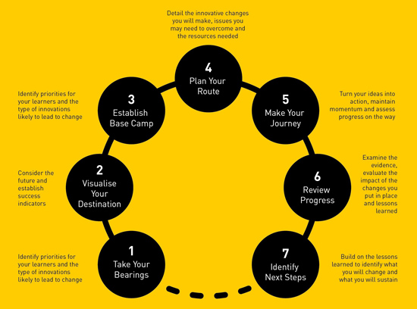

The programme can be tailored to meet your school’s needs whether exploring new approaches to the curriculum, addressing priorities in your school improvement plan or responding to issues highlighted by Ofsted.

We have found that the methodology of collaborative enquiry can be very powerful. It provides time, the most precious commodity in schools, for teachers to explore and absorb research, try something out and see how well it works. This is all done in a climate of trust and respect. The methodology feels more like valued professionals exploring the potential of a strategy rather than a top-down directive about an approach that must be implemented.

Staff at [Paget Primary School](http://www.nfer.ac.uk/schools/enquiring-schools/pp.pdf) in Birmingham used a number of evidence-informed projects over two terms through the Enquiring Schools Programme – work that has since earned the school the NFER Research Mark. In all, staff at Paget carried out five individual enquiry strands over two terms, divided according to age group. “We were keen for our staff to carry out their own research into what works, apply this through their own enquiries and to understand the difference this approach could bring to their classroom practice, and teaching and learning,” says Carole Thomas, Assistant Headteacher. “It was a way of empowering them to take control over teaching in their class and to find ways of improving it”.

**About NFER**

NFER is the UK's largest independent provider of research, assessment and information services for education, training and children's services. Our clients include UK government departments and agencies at both national and local levels, which benefit from NFER's full range of expert and professional services. Our purpose is to provide independent evidence which improves education and training and hence the lives of learners.

Drawing on our extensive research expertise, evidence and skills, we work with practitioners and leaders to develop their local capacity for gathering and using evidence effectively to drive improvement and to the direct benefit of practitioners.

We have over ten years’ experience of researching and supporting the development of evidence-informed schools. Our book, *Postcards from research engaged schools[1]*, was one of the first to document how school development could be enhanced through research-engagement. Today, we continue to be at the forefront of this work. We have an active research programme and have developed a suite of products and services designed to help schools and colleges become more evidence-informed.

1. Sharp, C., Eames, A., Sanders, D. and Tomlinson, K. (2005). Postcards from Research-Engaged Schools. Slough: NFER [online]. Available: <http://www.nfer.ac.uk/publications/ITR01/ITR01_home.cfm> [25 April, 2016]