Animals Including Humans Year 3: Skeletons Key Stage 2

Activity: Vertebrate or Invertebrate?
Can you group these animals in to vertebrates (animals WITH a backbone) or invertebrates (animals WITHOUT a backbone):
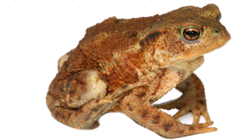
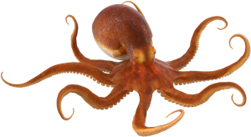
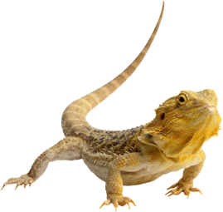
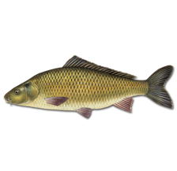
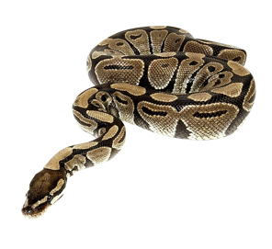
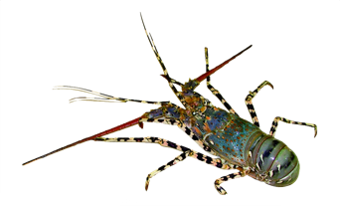
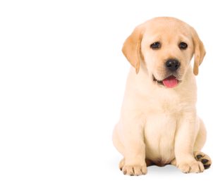
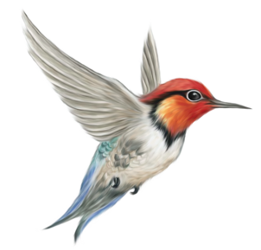
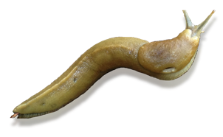
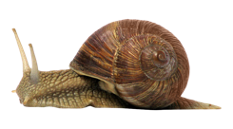
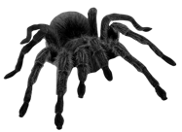
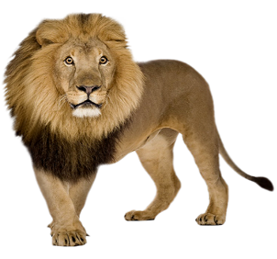

Images: cleanpng.com

Activity: Label the human skeleton
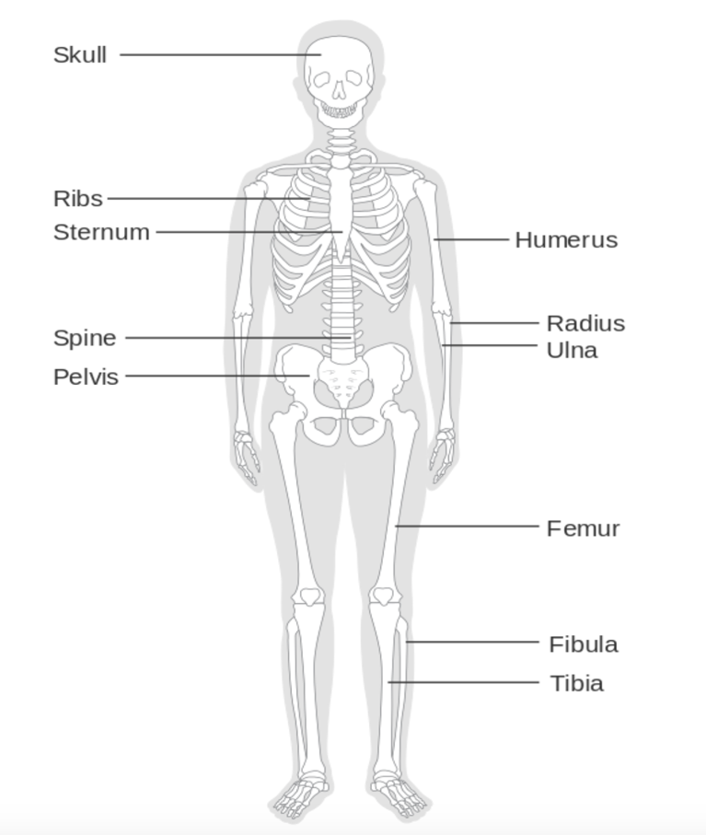
Label the skeleton with the correct names for the bones:

jaw | knee cap (patella) | humerus | thigh bone (femur) | skull
pelvis | spine or backbone (vertebrae) | tibia | fibula | sternum
rib | toes (metatarsels) | fingers (metacarpels) | radius | ulna

Image: CRUK

Activity: Other types of skeleton
There are a few types of ‘skeleton’ which help with movement, structure and protection of animals:
- Bony skeleton (bony fish, amphibians, reptiles, birds and mammals)
- Cartilaginous skeleton (sharks and rays)
- Exoskeleton
  - Invertebrates (arthropods) have a hard casing on the outside (insects, spiders, woodlice, shrimp, crabs and lobster)
  - Some animals have an external shell, such as snails and shellfish
- Soft bodied – hydrostatic skeleton – the pressure of the liquid inside their bodies helps them move (eg worms, octopus, jellyfish)
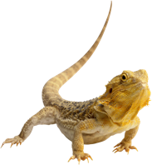
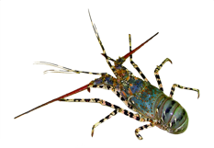
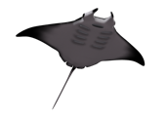
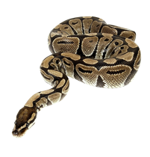
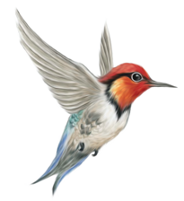
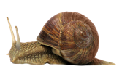
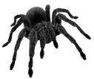
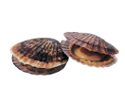
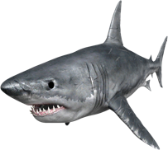
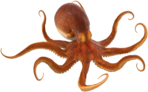
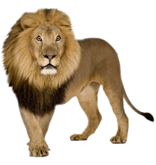
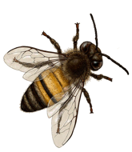
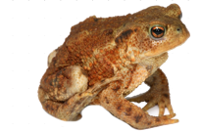
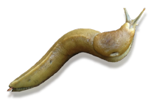
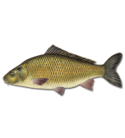
Can you identify which type of skeleton these animals have?
Images: cleanpng.com

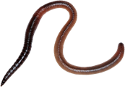

Activity: Make a model of the hand
Equipment:
- A piece of card the size of your hand (an empty cereal packet works well)
- A pen or pencil
- Scissors
- String
- Paper or plastic straws (or paper rolled into thin tubes)
- Sticky tape
Instructions:
- Take the piece of card and trace the outline of your hand with a pen or pencil
- Cut out the shape of your hand with scissors
- Cut the string into 5 pieces that are about the length of your hand
- Cut the straws into short sections - each the length of each part of your finger between the knuckles (the joints where the fingers bend) and stick onto the fingers and thumb
- Stick a piece of string to the tip of each finger and thumb, thread it through the straws and stretch it to the base of the palm
- Try pulling the strings from the base of the palm, what happens?
What's happening?
The muscles in your body are there to shorten or contract, a simple but very important task. They act on your bones to help you move.
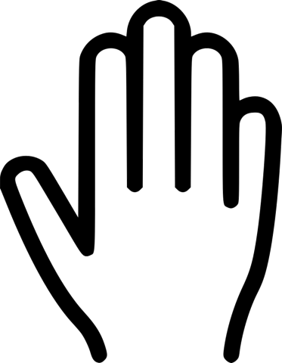
The muscles inside your forearm have long tendons running through ligament fibres, known as the carpal tunnel, in the wrist. These muscles allow you to flex your fingers, bending the tips towards your palm, as your fingers do when making a fist. This is what happens when you pull on the strings of your model hand.

Image: cleanpng.com

Activity: Muscles
Your muscles and bones work together to help you move. Muscles work in pairs. They can only contract and pull, they require a pair to pull in the opposite direction.
Investigate this push/pull of your muscle pairs in your upper arm.
- Hold a weight in your hand – a water bottle or tin of beans will do!
- First, bend your elbow upwards and move the weight towards your ear
- Repeat at least 10 times or until your arm gets tired
- Where does your arm ache?
- Swap hands
- This time, bend your elbow downwards and move the weight towards your arm pit
- Repeat at least 10 times or until your arm gets tired
- Where does your arm ache?
- Compare whether your arm aches at the top (bicep) or bottom (tricep) to see which muscles were working hard in each movement
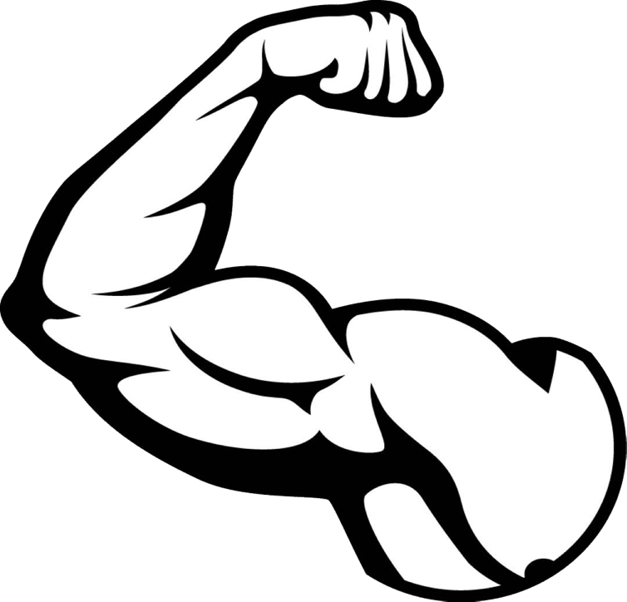
biceps
triceps

Image: cleanpng.com

Activity: Find out more
http://www.bbc.co.uk/education/clips/ztfnvcw Film on human skeleton with skeletons of other animals shown
http://www.bbc.co.uk/education/clips/zmj8q6f Film clip on invertebrate with exoskeletons
https://www.google.co.uk/webhp?sourceid=chrome-instant&ion=1&espv=2&ie=UTF-8#q=dem%20bones You tube clip of Dem bones with lyrics
http://www.bbc.co.uk/education/clips/zpp6n39 Film clip showing how muscles work in pairs.

