Certificate

Management system as per

DIN EN ISO 50001:2018

The Certification Body TÜV NORD CERT GmbH hereby confirms as a result of the audit, assessment and certification decision according to ISO/IEC 17021-1:2015, that the organization

Swarovski-Optik AG & Co KG.
Daniel-Swarovski-Straße 70
6067 Absam
Austria

operates a management system in accordance with the requirements of DIN EN ISO 50001:2018 and will be assessed for conformity within the 3 year term of validity of the certificate.

Scope

Development, manufacturing and distribution of long-range optical devices

Certificate Registration No. 44 764 137179 Audit Report No. 3542 4688 | Valid from 2026-11-17 Valid until 2029-11-16 Initial certification 2014

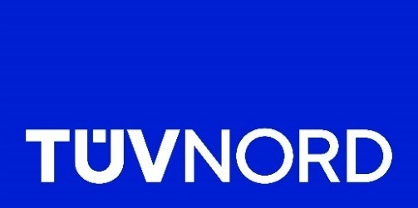

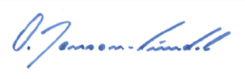
Certification Body at TÜV NORD CERT GmbH

Essen
,
202
6
-
10
-
08


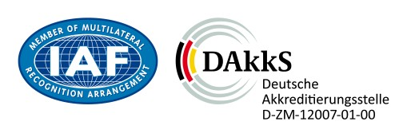

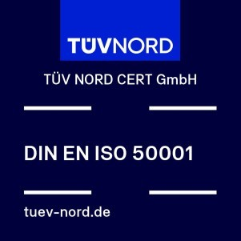
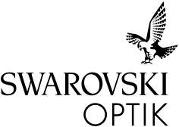

Visit our database to verify the validity of this certificate.

TÜV NORD CERT GmbH

Am TÜV 1, 45307 Essen www.tuev-nord-cert.com

TÜV®

