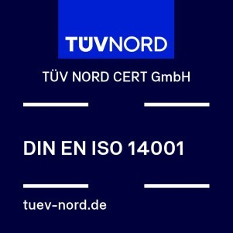

Certificate

Management system as per

DIN EN ISO 14001:2015

The Certification Body TÜV NORD CERT GmbH hereby confirms as a result of the audit, assessment and certification decision according to ISO/IEC 17021-1:2015, that the organization
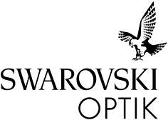
Swarovski-Optik AG & Co KG.
Daniel-Swarovski-Straße 70
6067 Absam
Austria

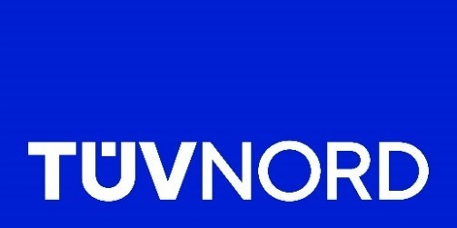
operates a management system in accordance with the requirements of DIN EN ISO 14001:2015 and will be assessed for conformity within the 3 year term of validity of the certificate.

Scope

Development, manufacturing and distribution of long-range optical devices

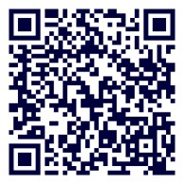
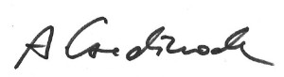
Certificate Registration No. 44 104 137179 Valid from 2026-11-17
Visit our database to
verify the validity of
this certificate.

Essen
,
2026
-
08
-
10

Certification Body at

TÜV NORD CERT GmbH

Audit Report No. 3542 4687 Valid until 2029-11-16
Initial certification 2000

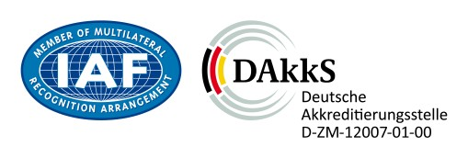

TÜV NORD CERT GmbH

Am TÜV 1, 45307 Essen www.tuev-nord-cert.com
®
TÜV

