Annex X - Security Questionnaire for Grant Recipients

Please answer as honestly as possible. Your responses will not affect your eligibility for the funding scheme you have applied for.

Your answers will be used to baseline the delivery of any assistance the UKSA can give you to grow your business securely and resiliently.

COMPANY NAME
CONTACT DETAILS
GRANT SCHEME

Governance
Please indicate
YES | NO | PARTIAL | QUESTION
 |  |  | Do you have an ongoing process in place to assess, document and understand your security risks in regards to this project?
 |  |  | Do you have a security policy in place which includes processes and procedures?
 |  |  | Do you have specifically assigned staff with security roles?
 |  |  | Do you have a policy which addresses security risks within your supply chain, 3rd party services such as Cloud and MSP’s, or any other organisations that has access to the company’s systems or data?
 |  |  | Do you have a policy in place to provide regular security related reporting to seniors within your organisation?
 |  |  | Is there board-level support and regular reviews of security in meetings with the board or senior leadership team?

Security culture and awareness
Please indicate
YES | NO | PARTIAL | QUESTION
 |  |  | Do you have a policy for employees and contractors defining their responsibilities for information security?
 |  |  | Do all employees and contractors receive information security training?
 |  |  | Do you have a security policy in place detailing staff responsibilities and requirements before granting access to sensitive areas of the business or sensitive assets?
 |  |  | Do you have a policy in place to control physical and electronic access to sensitive facilities?
 |  |  | Do you have an asset register that includes a list of all hardware devices and software that you use?
 |  |  | Do you undertake regular off-line back-up of systems?
 |  |  | Do you have response and recovery plans in place covering all of the security risks to your corporate and space activity/systems?

Cyber security
Please indicate
YES | NO | PARTIAL | QUESTION
 |  |  | Does your company currently hold any cyber security certification?
 |  |  | Do you have a policy in place regarding the use of removeable media, unauthorised and authorised software?
 |  |  | Do you have a policy and process in place covering the creation of new user and administrator accounts?
 |  |  | Do you have a policy in place regarding minimum requirements and confidentiality of passwords?
 |  |  | Is there a process in place for administration access over secure protocols, using multi-factor authentication?
 |  |  | Is a policy in place to control remote access to networks and systems?
 |  |  | Is a process in place to authenticate wireless connections?
 |  |  | Are application firewalls in place between corporate and space-related activity with processes in place to verify and validate traffic?
 |  |  | Is there a policy in place to monitor network behaviour and review computer security event logs for indications of potential incidents?
 |  |  | Is there a policy or process in place to undertake mitigation activity in response to an attempted cyber attack?
 |  |  | Is there a policy in place regarding the maintenance of patching and the ability to assess patching performance against this policy?

Physical security
Please indicate
YES | NO | PARTIAL | QUESTION
 |  |  | Do you have a process in place to verify credentials for all staff prior to employment and security vetting for employees working on this project?
 |  |  | Do you have controls in place to prevent unauthorised access to your facilities and assets?
 |  |  | Do you have a process in place for employees and contractors to report violations of information security policies and procedures, in confidence?
 |  |  | Do you have a disciplinary process to take action against employees who violate information security policies or procedures?
 |  |  | Is there a policy in place to secure organisational assets when individuals cease to be employed by your organisation?

Annex B – Resilience Direct (RD)

- To create an account on ResilienceDirect please navigate to https://www.resilience.gov.uk

- Choose the Collaborate icon from the services displayed which will take you to the registration page.

- Select “Register” and follow the on-screen instructions.
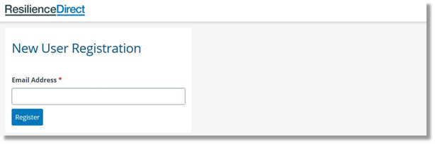
Please note: when registering for an RD account contact MUST be via an official company email address. Due to the sensitivity of content private/personal emails cannot be used.

4a. On the right-hand side of the page, you will notice the 'Select Group' field.
The Group is UK Space Agency RD Lite.

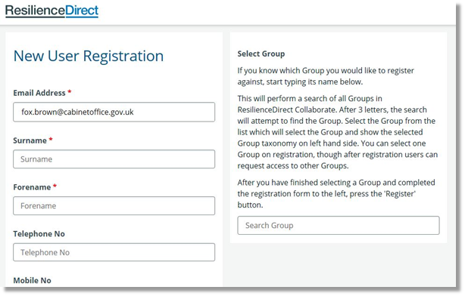

Complete your contact detail information, read the ‘End User Agreement’ and check the box to accept it.
Select ‘Register’.
Once you have created your account an email will be sent to your organisation Administrator asking them to confirm that you belong to that organisation. Once confirmed the RD Support Desk will finalise your profile, after which your login credentials will be generated and sent to you.

4b. If your organisation does not have an existing presence on RD, send a request to join the UK Space Agency RD Lite site to support@resilience.gov.uk. In these cases, the UK Space Agency will be asked to sponsor your membership of RD.

Once you have access to RD you will be able to:
- Login [note: details are Case Sensitive so ensure you enter the details as supplied to you]
- Click ‘collaborate’ on the dashboard
- Search for ‘UK Space Agency’ and request access (this is a one-off request which will come direct to the UKSA Space Security & Resilience Team). (You may not need to undertake this step if access has been granted via step 4b above)
- Edit your profile - Click on your name (top right) and on the dropdown list click edit your profile. Update this with as much info as possible. This will make it easier to find right people for the right things. Ensure you scroll to the bottom of the page to SAVE CHANGES.

