The Depot Charging Scheme has a two stage application process. Interested parties are invited to review the Find a Grant Advert content and submit an initial application form by clicking “Start new application”. 

Successful proposals from the initial application form, will be invited to submit a further detailed proposal and infrastructure plan evidenced with quotes from contractors and chargepoint suppliers. We would encourage applicants to familiarise themselves with both stages of the application and to prepare for the second stage while waiting to hear back on their initial submission.

For the purposes of this grant, fleet operator is defined as a company responsible for managing a group of HGVs, vans and/or coaches, used for commercial purposes. In this context, fleet operators are expected to be registered in the UK, and conduct road freight and logistics or passenger transport.

Depot is defined as the commercial site where HGVs, vans and/or coaches are housed and maintained, and from which they are dispatched for service.

## Initial application:

The initial application is open to all eligible parties, and can be accessed here.

### Section 1 - Eligibility

Before proceeding with the application, you will be asked to self-assess your eligibility against the minimum requirements for the scheme. Applicants confirm that:

* They are a registered fleet operator operating in the UK
* They have been operating in the UK for at least 1 year at the time of application
* They own or lease one or more depot in the UK
* They own, lease, or have/will order at least 1 Battery Electric van, HGV and/or coach as part of their fleet
* A senior leadership member of their organisation has signed off on their proposal
* They consent to participate in the ongoing monitoring and evaluation activities
* They consent not to apply for, or obtain, duplicate funding in respect of any part of the funded activities
* They consent to the primary users of the funded infrastructure being commercial vehicles
* If successful, they confirm that the funding will be used for the installation of charging infrastructure for Battery Electric vans, HGVs and/or coaches at their depot site(s) by 31 March 2026
* They confirm agreement to the terms and conditions of the Grant Funding Agreement as part of their application.

The department reserves the right to request further information to verify the information submitted.

Failure to meet these conditions will result in the rejection of your application.

### Section 2 - Due diligence Information

To prevent fraud and ensure compliance, all applicants must provide certain details that will allow us to conduct due-diligence checks.

* Organisation legal name
* Organisation type
* Registered address
* Charity Commission number (if applicable)
* Companies House number (if applicable)
* Anticipatory amount of funding requested
* Planned expenditure of the funding

### Section 3 - Proposal introduction

In this section you will be asked to provide:

* A brief description of your business for information purposes.
* Confirmation on which eligible commercial vehicles you own, lease or intend to purchase this financial year. At this stage evidence documents to support this are recommended but not required.
* Confirmation on the ownership of your depot(s), whether these are owned or leased.
  + Please note if you lease your depot, we will require evidence to indicate that you have a contract in place for at least three years following the projected completion of these infrastructure works.
  + Lessees will also need to confirm they have landlord permission to carry out the infrastructure works on site. Evidence of this will be required if invited to submit a second stage application.
* Confirmation of how many depots you seek support with, and their locations.

### Section 4 - Infrastructure plans

In this section, applicants will be asked to clarify:

* Current access to charging infrastructure on site(s).
* Existing arrangements with your local Distribution Network Operator(s)
* Current grid capacity at your depot(s)
  + If you do not have the required grid connection and grid capacity at the time of this application, you will be requested to submit proof that you will before **31/03/2026**. For most cases, this will require having already engaged and started the process with your DNOs.
* Current charging needs and expected future requirements for your fleet. This will be used to assess the reasonableness of your bid.
* Charging infrastructure needs, captured within the “Depot_Chargepoint_Template”.
* Their intended infrastructure delivery plan, describing the works they expect will be required at their depot(s) for successful installation before **31/03/2026**.

### Section 5 - Financing

Applicants will be asked to confirm:

* Predictive costs of the infrastructure project, if successful.
* How they intend to finance the remainder of the project.
* That they have the capability and the capacity to deliver the project by **31/03/2026**.

Should you be successful at this stage, you will receive an invitation to tender from [ggms_depot_cs@cabinetoffice.gov.uk](mailto:ggms_depot_cs@cabinetoffice.gov.uk). We aim to respond within an average of 5 working days.

**Invitation to submit a full proposal does not guarantee a grant award.**

## Full Proposal – Stage 2

The full proposal submission builds on information you have provided previously. Applicants will be asked to re-confirm certain details and build on information from the previous stage.

### Section 1 - Eligibility

Before proceeding with the application, you will be asked to self-assess your eligibility against the minimum requirements for the scheme. Applicants confirm that:

* They are registered and operate in the UK
* They have been operating in the UK for at least 1 year at the time of application
* They own or lease one or more depot in the UK
* They own, lease, or have/will order at least 1 Battery Electric van, HGV and/or coach as part of their fleet
* A senior leadership member of their organisation has signed off on their proposal
* They consent to participate in the ongoing monitoring and evaluation activities
* They consent not to apply for, or obtain, duplicate funding in respect of any part of the funded activities
* They consent to the primary users of the funded infrastructure being commercial vehicles
* If the infrastructure is to be shared with other fleet operators, they consent to the pricing model being designed on a cost recovery basis for at least 3 years following grant award.
* If successful, they confirm that the funding will be used for the installation of charging infrastructure for Battery Electric vans, HGVs and/or coaches at their depot site(s) by 31 March 2026
* They confirm agreement to the terms and conditions of the Grant Funding Agreement as part of their application.

The department reserves the right to request further information to verify the information submitted.

**Failure to meet these conditions will result in the rejection of your application.**

### Section 2 - Due diligence Information

To prevent fraud and ensure compliance, all applicants must provide certain details that will allow us to conduct due-diligence checks.

* Organisation legal name
* Organisation type
* Registered address
* Charity Commission number (if applicable)
* Companies House number (if applicable)
* Amount of funding requested
* Intended expenditure of the funding

### Section 3 - Confirmations and evidence

Applicants will be asked to provide evidence to demonstrate compliance to the eligibility criteria of the scheme. Applicants must:

* Upload a copy of their operator licence. Where they only operate vans and do not have a licence, applicants must upload complimentary evidence such as BVRLA membership, FORS accreditation and/or Logistics UK Van Excellence accreditation.
* Confirm their current and planned Battery Electric Van, HGV or Coach ownership / leasing status.
  + Applicants must provide a breakdown of their Battery Electric fleet using the “Depot_Charging_Scheme_EV Log”: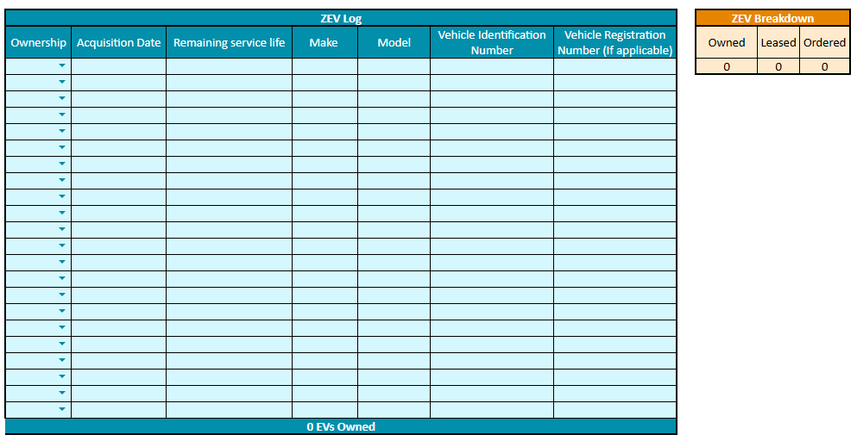
  + Where applicants already own battery electric HGVs, vans and/or coaches, they must provide vehicle registration numbers.
  + Where applicants have ordered vehicles, you must also upload proof of purchase information.
  + Where applicants intend to order one following award of the funding, you must upload a letter of intent from your board of directors or a senior leadership member of your organisation.
* Confirm ownership or leasing of your depot.
  + If owned, we require submission of evidence within the title register including *title deeds and other proofs where relevant.*
  + If leased, we require a lease agreement covering a minimum of 3 years from the start of the 2026/27 financial year, and permission from your landlord to conduct infrastructure works on site.
  + Both types of evidence will be checked to ensure the depot is a commercial site.
* Confirm the number of depots you seek funding for, and their GPS coordinates / address.
* Confirm whether you have previously received any funding from the Workplace Charging Scheme / EV Infrastructure Grant for Staff and Fleets / Local Authorities EV Infrastructure Fund / ScotZEB fund?
  + If yes, we require the postcode and serial numbers of previously funded infrastructure or chargepoints.

### Section 4 - Detailed infrastructure

Applicants will be required to provide further information to the following infrastructure questions:

* In 300 words or fewer, please provide an overview of your organisation's current Electric Vehicle (EV) transition strategy. If a formal strategy is not in place, please outline your future plans for fleet electrification.
* In 300 words or fewer, please provide details of any current infrastructure on site. How many chargers, power/speeds, size of parking bays and what chargepoint suppliers you use.
* In 300 words or fewer, please detail the grid connection and capacity that you currently have.
  + Please provide a copy of the Grid and/or Distribution Connection Agreement applicable which allows for such connection to the relevant Distribution System. This should allow for at least 75% of the planned chargers maximum load.
  + At minima, please provide a letter from the DNO confirming this capacity is available for the site.
  + If applicable, connection offer (with evidence of acceptance)
* Upload a finalised copy of the “Depot_Charging_Scheme_Vehicle_Chargepoint Registry” to detail all of your expected charging infrastructure needs, as exhibited below: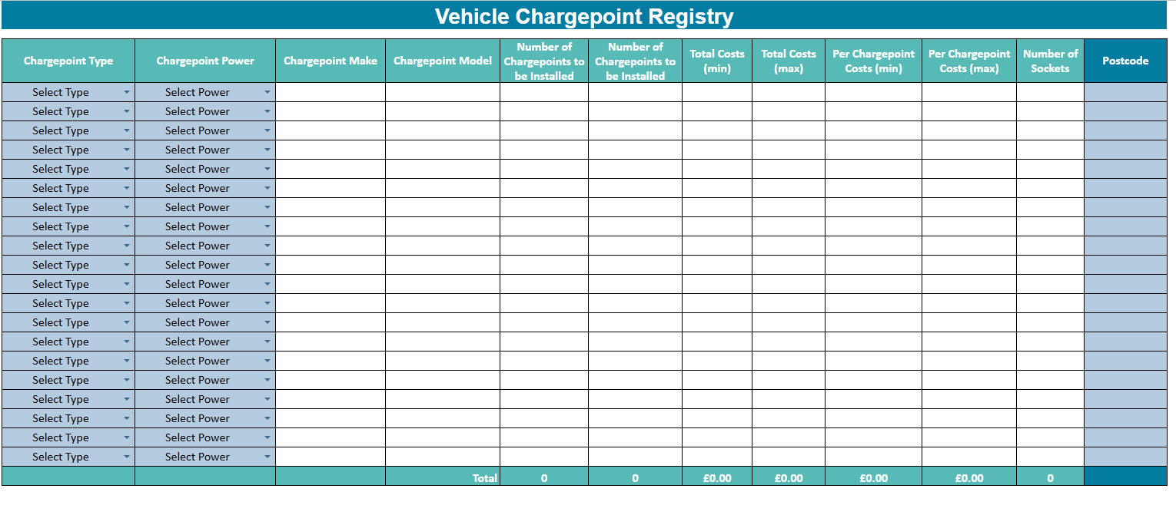
* In 400 words or fewer, clarify why you have chosen this charging approach, how does it fit your current needs or any future expansion plans?
* Confirm who your chosen Chargepoint supplier is, and provide evidence of quotes or contracts.
* In 400 words or fewer, outline the civil engineering and construction works required at your depot(s), to install the infrastructure.
* In 400 words or fewer, confirm your approach to procurement for this project. We would expect clarity on the parties carrying out the relevant works, how you selected them and assessed value for money.
* Confirm you have conducted due diligence on all your chosen contractors.
* Confirm the anticipated start date for infrastructure installation
* Confirm that you have the capacity and capability to complete installation by **31/03/2026**.
  + Evidence of this assurance must be provided. We expect contracts with providers with project plans and clauses related to completion date. You will also need to provide confirmation of senior leadership/ board approvals for the project, and evidence of financing such as loan or external investment documents where applicable. These will be assessed against potential conflicts of interest.
* Confirm the total eligible cost of the project, and provide a full budget for the delivery of the project using the below “Depot_Charging_Scheme_Budget_Sheet”.

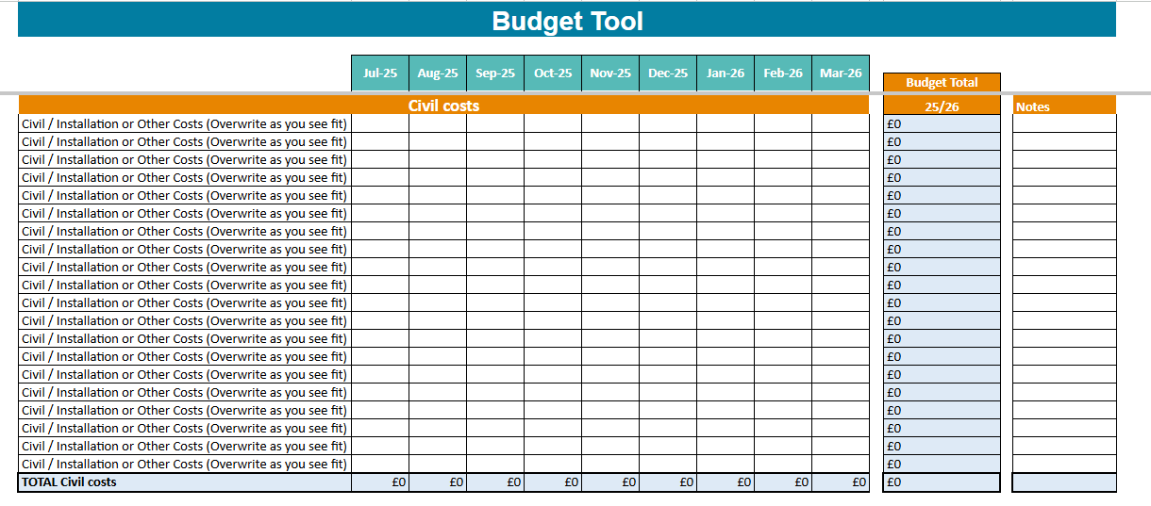

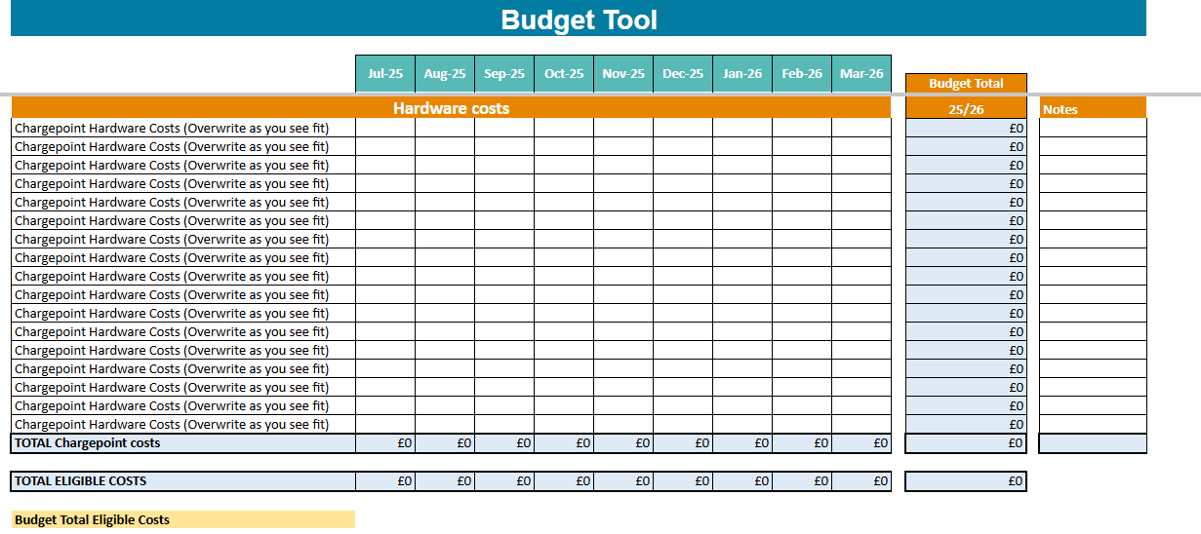

* + The total cost and budget sheet should only cover eligible costs that the grant might support. This answer should only cover hardware, civil and installation costs.
  + We will be assessing the reasonableness of your bid and associated costs as part of the application assessment.
  + Please note that, if your application is successful, this indicative costing will inform the funding amount offered through the Grant Funding Agreement. Therefore, if your final total costs are significantly higher than your indicative costing, you will not be able to claim funding for those additional costs.
* If you have or need to increase grid capacity on site, what are the expected grid reinforcement costs associated with this project?
  + These costs should not be included in the previous costing provided, as this is not eligible for grant spend.
* How are you planning on financing the remaining costs of the infrastructure project not covered by this grant? Please provide details on any loans or investments where relevant.
* Do you intend to share your charging infrastructure with other local fleet operators? If you do intend to share this infrastructure with other businesses, please provide details of how this arrangement will be carried out, (including what fee you may be charging and due regard to necessary legal requirements) in 400 words. If your application is successful, a full pricing model will need to be provided before 31 March 2026, designed in line with terms of the Grant Funding Agreement.
* You will be required to upload and maintain a risk register for the project. Please provide your initial register for the intended project.
* You will be required to document your operational and maintenance plan following the completion of the project. This will require you to identify the responsible party (whether they are in-house or contractor), outline the agreements for repairs, and confirm the warranty period for all funded hardware.

### Section 5 - Declarations

In order to submit your application, you will need to agree to the following:

* I agree to share information (including contracts) on chargepoint suppliers, contractors, and any other project partners with the Department for Transport and its Support Body for their review.
* I agree to provide more information on any aspect of the application if requested.
* If you intend on sharing the funded charging infrastructure with other businesses, please agree to share that usage data with the Government.
* I agree, upon completion of the project, to provide a project completion report as per the template contained within the Grant Funding Agreement.
* I agree to provide charging device usage data as well as any other data required by the Department as part of the project completion report and ongoing monitoring activities.
* I agree to keep the Support Body updated with any changes to the staff lead and contact details for this project.

Once complete, please review the content of the application form and confirm this application has been completed to the best of your knowledge.