The Depot Charging Scheme aims to support the uptake of zero emission HGVs, vans, and coaches by part-funding the installation of charging infrastructure at fleet depots. Following a successful 2025/2026 Pilot, we are now launching a £170 million multi-year funding programme from April 2026 up to 2030.

The scheme is open to public and private sector fleets, local authorities and non-profit organisations, located in England, Scotland, Wales and Northern Ireland. Operators in the Crown Dependencies (Isle of Man, Guernsey, and Jersey) are not eligible.

£66 million will be available to bid for in two application windows opening this year, with £28 million (window 1) to be spent in the 2026/27 Financial Year and £38 million (window 2) to be spent in the 2027/28 Financial Year.
The first application window for the multi-year scheme will open on 25 March 2026 with applications assessed on a first-come-first-served basis. The application window will close on 30 June 2026, or sooner if funding has been exhausted. Projects will have until 31 March 2027 to complete works.

This application cycle for projects implemented in 2026/27 will cover 70% of EV charger and civil costs incurred, up to a maximum of £1 million across all sites. There is no limit to the number of sites that can be applied for, but the scheme is limited to one application per organisation per application window.

Awards will be made by the 30 September 2026 at the latest. Successful applicants that have not signed their Grant Funding Agreement by this date will be asked to reapply to the scheme in the second application window (see below). Successful applicants will have until 31 March 2027 to complete works on their project.

The next application window will open on 28 October 2026 and close on 29 January 2027 for projects starting from April 2027, to be delivered by 31 March 2028. Grant rates for this phase of the scheme have not yet been confirmed.

Grant funding rates will reduce over the lifetime of the programme as charging infrastructure becomes more affordable. Grant rates and future application windows will be confirmed in due course.


Interested parties are invited to review the Find a Grant Advert content and submit an application form to the Depot Charging Scheme by clicking “Start new application”.

Applications will require the submission of a detailed proposal and infrastructure plan evidenced with quotes from contractors and EV charger suppliers and confirmation that sufficient capacity exists at an applicant’s depot/s. It is incumbent on applicants to provide high quality applications that provide the required information/evidence to enable a decision to be made. Applications that do not meet core eligibility requirements set out will be rejected. We would encourage applicants to familiarise themselves with the application process and the template of the application form, providing guidance on producing a high-quality application. Applicants are also encouraged to use the Scheme’s technical partner, Cenex and the Energy Savings Trust, for support and guidance on designing their projects and applying to the scheme.

For the purposes of this grant, fleet operator is defined as a company responsible for managing a group of HGVs, vans and/or coaches, used for commercial purposes. In this context, fleet operators are expected to be registered in the UK, and conduct road freight and logistics or passenger transport.

Depot is defined as the commercial site where HGVs, vans and/or coaches are housed and maintained, and from which they are dispatched for service.

Application requirements
The application is open to all eligible parties and can be accessed here.

Section 1 - Eligibility
Before proceeding with the application, you will be asked to self-assess your eligibility against the minimum requirements for the scheme. Applicants confirm that:
- Their fleet includes (or will include in future) at least one battery electric van, HGV or coach, and their application will quantify the impact of this on their EV charging needs.
- They are registered and operate in the UK* and their organisation and vehicle fleet has been operating in the UK for at least 1 year at the time of application.
- They own or lease one or more UK depot(s).
- A senior leader in their organisation has approved their proposal.
- They consent to participate in ongoing monitoring and evaluation activities, including physical site audits/visits.
- They consent not to apply for, or obtain, similar Government funding in respect of any part of the funded activities.
- They consent to the primary users of the funded infrastructure being commercial vehicles.
- If the infrastructure is shared with other fleet operators, the pricing model will be based on cost recovery for at least three years after the grant is awarded.
- If successful, and after they sign their grant funding agreement, they will use the funding to install charging infrastructure for battery electric vans, HGVs and/or coaches at their depot(s) by 31 March 2027.
*This does not include the Crown Dependencies (Isle of Man, Jersey or Guernsey).

The department reserves the right to request further information to verify the information submitted.

Failure to meet these conditions will result in the rejection of your application.

Section 2 - Due diligence Information
To prevent fraud and ensure compliance, all applicants must provide certain details that will allow us to conduct due-diligence checks.

- Organisation legal name
- Organisation type (e.g. limited company)
- Registered address
- Charity Commission number (if applicable)
- Companies House number (if applicable)
- Amount of funding required
- UK region where investment through your project will predominantly occur

Section 3 – Operational Profile
Applicants will be asked to provide evidence to demonstrate compliance to the eligibility criteria of the scheme. Applicants must:

- Describe their business in a few sentences.
- Upload a copy of their operator licence. Where they only operate vans and do not have a licence, applicants must upload complimentary evidence such as BVRLA membership, FORS accreditation and/or Logistics UK Van Excellence accreditation.
- Confirm their current and planned battery electric Van, HGV or Coach ownership / leasing status or their intent to acquire such a vehicle.
  - Applicants must provide a breakdown of their battery electric fleet using the Depot Charging Scheme Workbook template provided”:
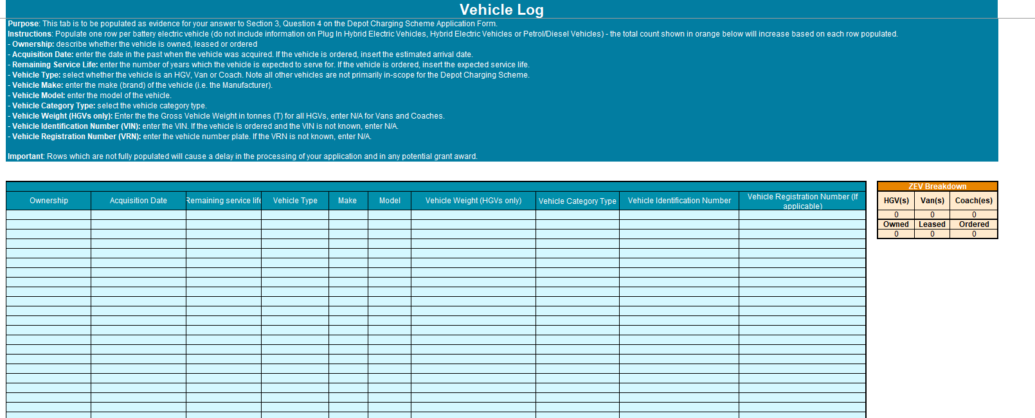
  - Where applicants already own battery electric HGVs, vans and/or coaches, they must provide vehicle registration numbers.
  - Where applicants have ordered vehicles, you must also upload proof of purchase information.
- Applicants must confirm how the number of vehicles in their fleet, now, or in the future, matches up to the number of EV chargers requested in their application. We expect applicants to show that they have or will have at least one battery electric vehicle for each charger, or mitigating circumstances which justify the need for more chargers than vehicles. As part of the application process, applicants will be required to declare if:
  - They have or will have a higher number of eligible battery electric vehicles in their fleet (currently or planned in the next 2-3 years) compared to the number of EV chargers requested.
  - They have a similar number of eligible battery electric vehicles in their fleet (currently or planned in the next 2-3 years) compared to the number of EV chargers requested (e.g. 1 battery electric vehicle to 1 EV charger), or that there are mitigating circumstances (e.g. a high number of depots in their application with vehicles needing to charge at different depots, or plans to share their EV chargers on a cost recovery basis).
  - They will be requesting more EV chargers than eligible vehicles planned and wish to discuss their plans with the scheme’s technical support partner (Cenex/EST).
- Where applicants intend to order one or more vehicles following award of the funding to justify the number of EV chargers they are applying for, they must upload a letter of intent (template available here) from their board of directors or a senior leadership member of their organisation.

- Confirm the number of depots you seek funding for, and their GPS coordinates / address in their “Depot Log” sheet as part of the “Depot Charging Scheme – Workbook”.
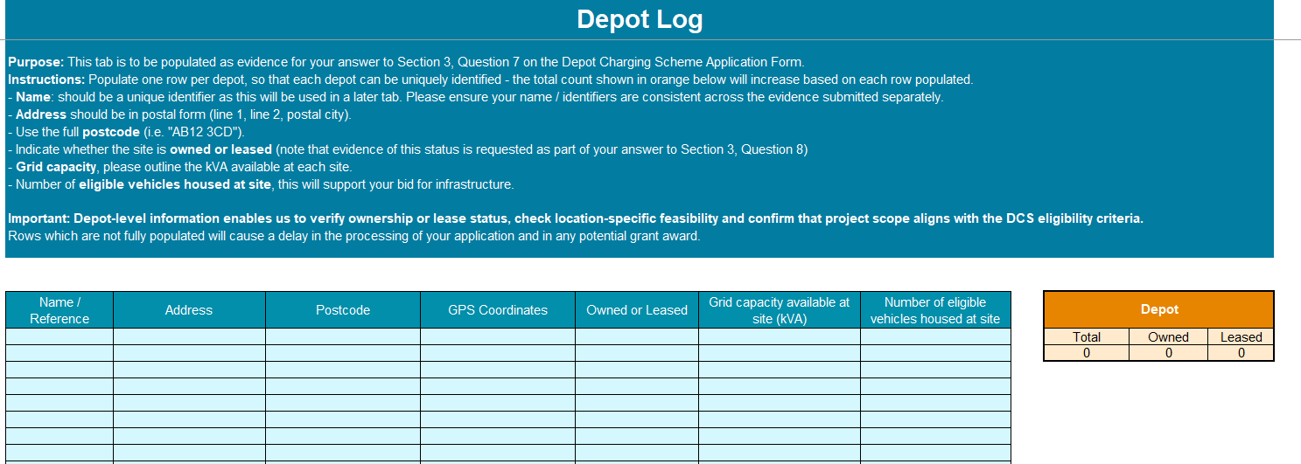
- Confirm evidence of ownership or leasing of your depot/s.
  - If owned, we require submission of evidence within the title register including title deeds and other proofs where relevant.
  - If leased, we require a lease agreement covering a minimum of 3 years from the start of the 2026/27 financial year, and permission from your landlord to conduct infrastructure works on site.
  - Both types of evidence will be checked to ensure the depot is a commercial site.
- Confirm whether you have previously received any funding from the Workplace Charging Scheme / EV Infrastructure Grant for Staff and Fleets / Local Authorities EV Infrastructure Fund / ScotZEB fund / Depot Charging Scheme?
  - If yes, we require the postcode and serial numbers of previously funded infrastructure or chargepoints.

Section 4 - Detailed infrastructure plans
Applicants will be required to provide information to the following infrastructure questions:

- Please provide details of any existing charging infrastructure on site. As a minimum please detail the number of EV chargers, distribution across depots, current EV charger operator and a max power descriptor for the chargers.
- In 300 words or fewer, please detail the grid connection and capacity that you currently have at the depot/s you are applying for.
  - Please provide a copy of the Grid and/or Distribution Connection Agreement applicable which allows for such connection to the relevant Distribution System. This should allow for at least 75% of the planned chargers maximum load.
  - As a minimum, please provide a letter from the DNO confirming this capacity is available for the site.
  - If applicable, connection offer (with evidence of acceptance)

- Confirm if you are planning battery energy storage systems or solar technologies as part of your project and will the primary purpose of such technologies be to support EV charging? Where applicable, please also describe how BESS/solar would either mitigate current grid limitations (e.g. peak shaving, load balancing), or support future-proofing (e.g. fleet growth, site expansion plans).
- Record all of your expected EV chargers), as exhibited below in the Depot Charging Scheme Workbook template provided:
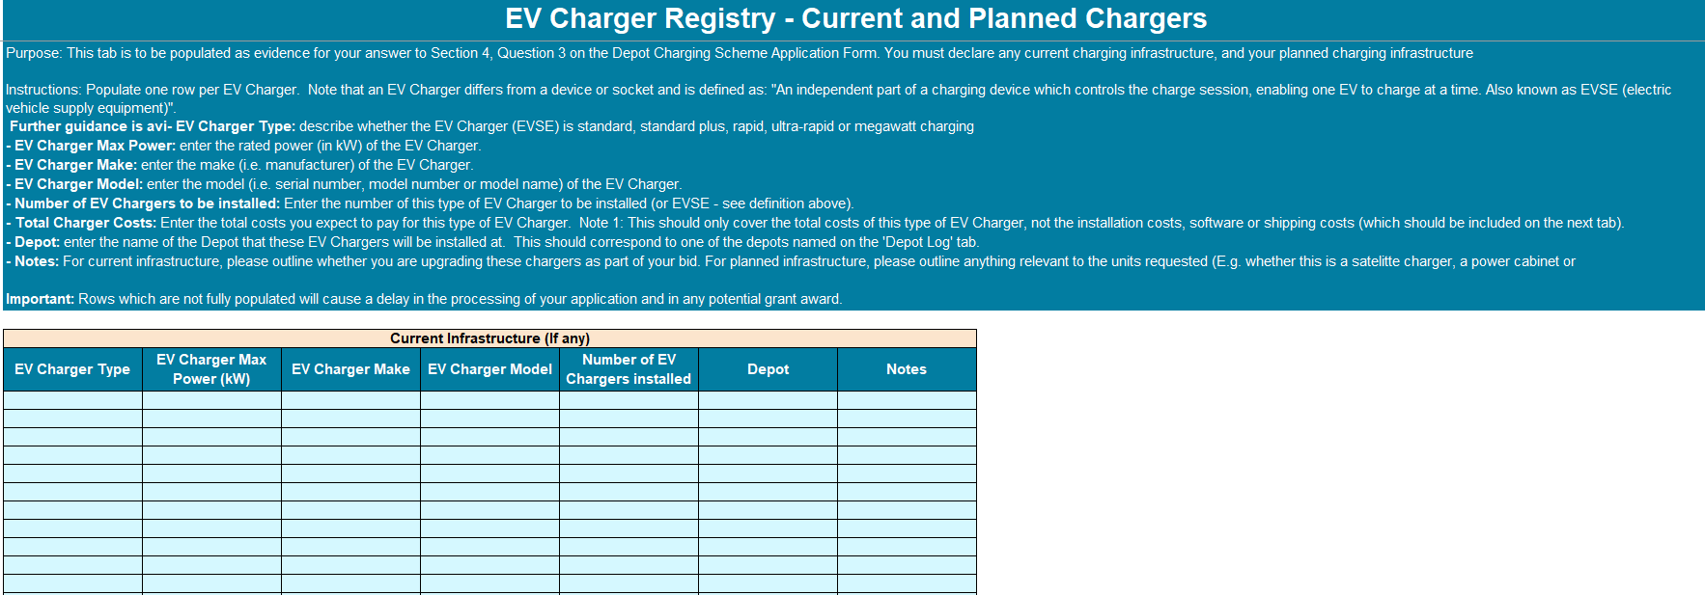
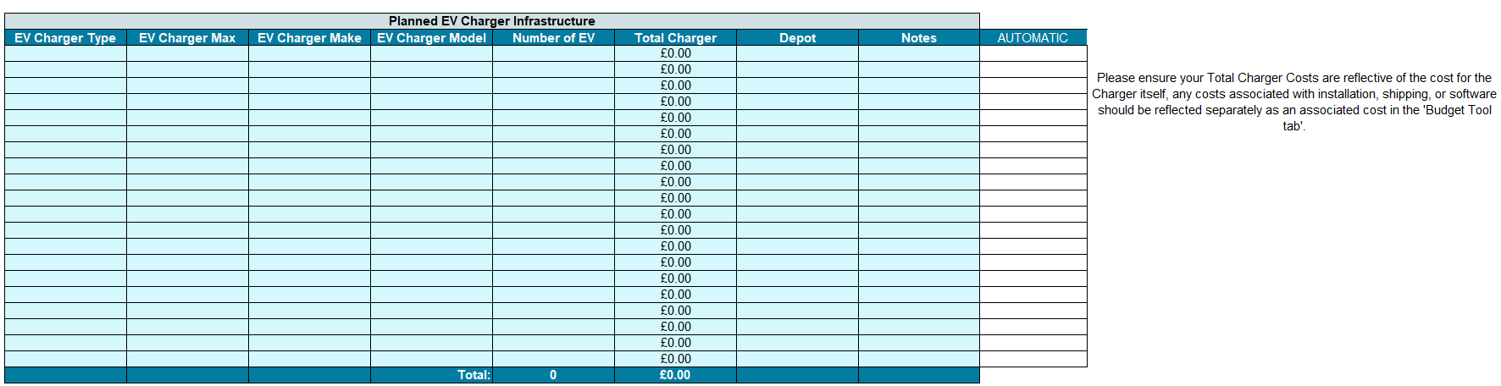
- Provide further detail on why you have chosen this charging approach, and how it fits your needs.
- Confirm who your chosen EV charger supplier and/or civils contractor is and provide evidence of quotes or contracts.
- In 300 words or fewer, outline the civil engineering and construction works required at your depot(s), to install the infrastructure.
- In 200 words or fewer, confirm your approach to procurement for this project. We would expect clarity on the parties carrying out the relevant works, how you selected them and assessed value for money.
- Confirm you have conducted due diligence on all your chosen contractors.
- Do you intend to share your charging infrastructure with other local fleet operators? If you do intend to share this infrastructure with other businesses, please provide details of how this arrangement will be carried out, (including what fee you may be charging and due regard to necessary legal requirements) in 200 words or less. If your application is successful, a full pricing model will need to be provided before 31 March 2027, designed in line with terms of the Grant Funding Agreement.

Section 5 – Project Financing and Delivery Assurance
- Confirm the total eligible cost of the project and provide a full budget for the delivery of the project using the Depot Charging Workbook template.

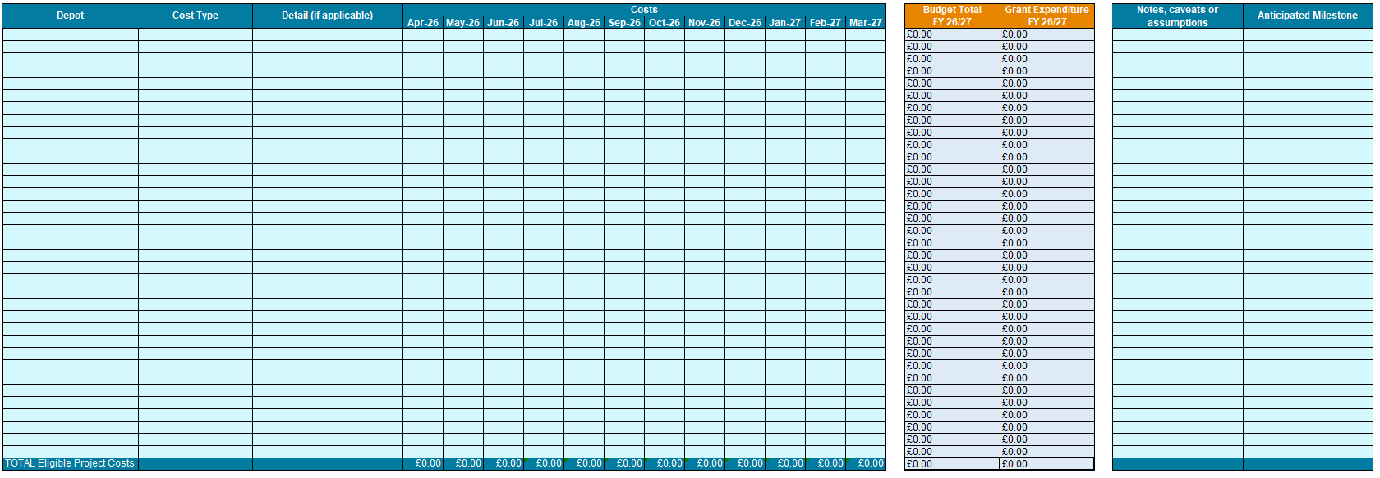
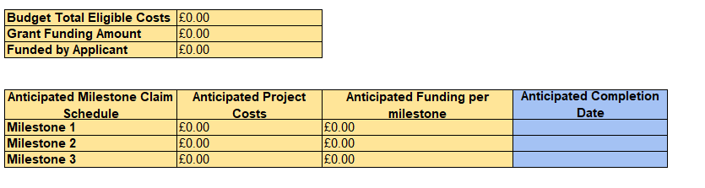
  - The total cost and budget sheet should only cover eligible costs that the grant might support. This answer should only cover hardware, civil and installation costs.
  - We will be assessing the reasonableness of your bid and associated costs as part of the application assessment.
  - Please note that, if your application is successful, this indicative costing will inform the funding amount offered through the Grant Funding Agreement. Therefore, if your final total costs are significantly higher than your indicative costing, you will not be able to claim funding for those additional costs.
- How are you planning on financing the remaining costs of the infrastructure project not covered by this grant? Please provide evidence that you have sufficient financing in place to deliver this project.
- Please provide evidence that you have sufficient financing in place to deliver this project. Sufficient evidence includes: Letter from senior leadership member/board stating available funding, bank statements, loan or external investment documents. Sufficient financing is defined as the ability to fund at minimum 30% of the eligible project costs.
- Please provide assurances that you can complete installation by 31/03/27. Please upload relevant evidence to support your assurance to complete installation by 31/03/27. We expect at minima, a project plan with quotes and timelines. Ideally, a contract with clauses related to completion date.
- If a project cannot deliver the required milestones by 31/03/27, funding may be withdrawn or the project may be placed on a compulsory remedial plan.
- You will be required to upload and maintain a risk register for the project.
- You will be required to document your operational and maintenance plan following the completion of the project. This will require you to identify the responsible party (whether they are in-house or contractor), outline the agreements for repairs, and confirm the warranty period for all funded hardware.

Section 6 – Contact Details and Workbook Upload
- Applicants will be asked to confirm their contact details and instructed to upload their Depot Charging Scheme Workbook providing details as highlighted above on:
  - Depot site ownership and location
  - Battery Electric fleet
  - Current and planned EV chargers
  - Full budget for the delivery of the project
  - Risk register

Section 7 - Declarations
In order to submit your application, you will need to agree to the following:

- Agree to share information (including contracts) on EV charger suppliers, contractors, and any other project partners with the Department for Transport and its Support Body for their review.
- Agree to provide more information on any aspect of the application if requested.
- Agree, upon completion of the project, to provide a project completion report as per the template contained within the Grant Funding Agreement.
- Agree to provide charging device usage data as well as any other data required by the Department as part of the project completion report and ongoing monitoring activities.
- Agree to keep the Support Body updated with any changes to the staff lead and contact details for this project.

Once complete, please review the content of the application form and confirm this application has been completed to the best of your knowledge.

