Annex 1 – Competition area
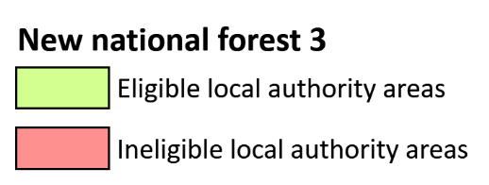
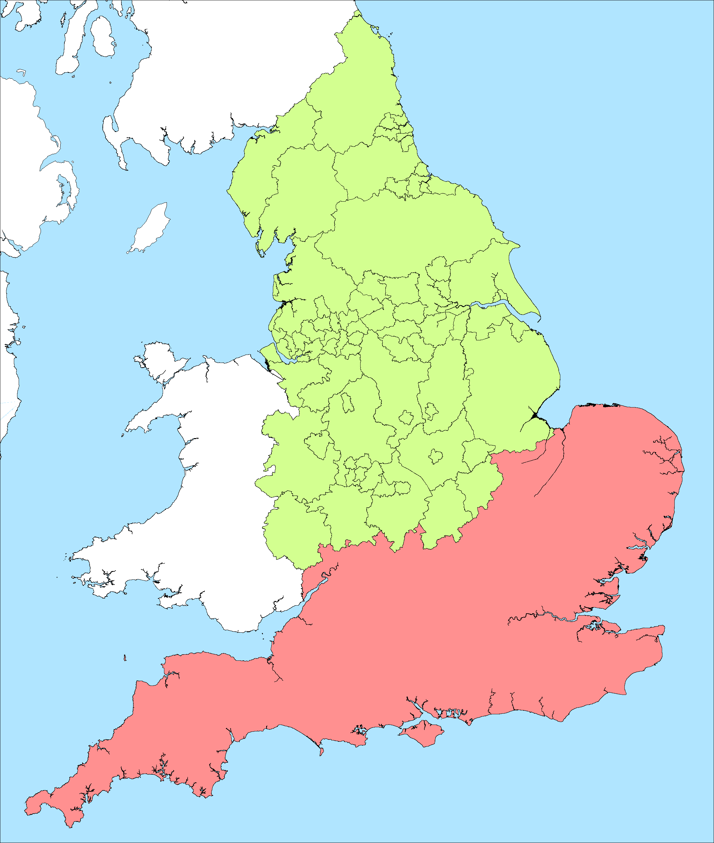
© Crown copyright and database right (2026). All rights reserved. Licence number: AC0000851271

