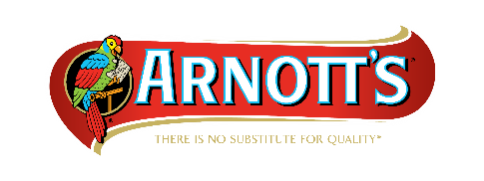

31 July 2019

MEDIA STATEMENT

Arnott’s currently sources cocoa liquor from several regions including West Africa and blends it in-house to make the signature chocolate for its iconic biscuits. Since 2010, as part of Arnott’s ethical sourcing programme, the West African cocoa liquor used by Arnott’s has been certified by Fairtrade.

In August 2019, Arnott’s ethical certification body for West African cocoa liquor will transition to UTZ.

West Africa has been recognised as facing some of the worst challenges in terms of poverty, child labour and trafficking. Arnott’s remains committed to purchasing certified, sustainable cocoa liquor from this region with funds used to make positive changes for the communities and families growing cocoa in West Africa.

For further information contact:
Renee McCarthy
Corporate Affairs Director Arnott’s Biscuits
Email: renee_mccarthy@arnotts.com
Mobile: 0417471056

