

Skills Bootcamp contracts
User guidance
July 2025
Contents
Skills Bootcamp contracts 1
Document history 4
Summary 4
Who this publication is for 4
Information required to complete the collection 4
Submission method 5
Accessing the Skills Bootcamp contracts collection 6
Adding a contract 8
Viewing saved contracts 14
Managing contracts 14
Exporting contract data 15
Giving providers access 16
Learning Aim References 16
Content of the return 17
ILR contract reference number 17
Skills Bootcamp name 17
Provider UKPRN 18
Your contract reference number 18
Contract funding wave 19
Calculation method 19
Contract start date 20
Contract end date 20
Unit cost 21
Qualifying period 21
Start payment percentage 22
Last date for start payment 22
Mid-course payment percentage 23
Last date for mid-course payment 23
Completion payment percentage 24
Last date for completion payment 24
Outcome payment percentage 25
Last date for outcome payment 25

Table of Figures
Figure 1 - DfE Sign In 8
Figure 2 - DfE Sign In - Request Access to a service 9
Figure 3 - Collection Overview Page 10
Figure 4 - Import Tab 10
Figure 5 - Example Schema 11
Figure 6 - File Upload & Import 11
Figure 7 - SBC Tile 12
Figure 8 - Online form adda contract overview 13
Figure 9 - Contract Details page 13
Figure 10 - Contract Wave 14
Figure 11 - Calculation Method 14
Figure 12 - Contract Dates and Unit Cost 15
Figure 13 - Payment Percentages and Dates 16
Figure 14 - Review information 17
Figure 15 - Contract complete page & ILR Contract reference number 17
Figure 16 - Saved contracts 18
Figure 17 - Manage contracts 18
Figure 18 - Export a contract file 19

Document history
Table 1: Document History
Version | Date Issued | Description
1.0 | 16/07/2024 | Initial version
1.1 | 26/03/2025 | V1.1
1.2 | 06/06/2025 | New sections:  - Giving providers access  - UKPRN  - Learning Aim References  - Bulk Upload instructions

Summary
This publication provides non-statutory guidance from the Department for Education. It has been produced to help devolved authorities to use the Skills Bootcamp contracts collection and set their bespoke contract rates. This will allow skills bootcamps funding to be calculated from providers ILR returns according to the rates set by the devolved authority.

Who this publication is for
This guidance is for Devolved authorities which includes but is not limited to:
- Mayoral Combined Authorities
- Local Authority
- Greater London Authority
- Local Enterprise Partnership
- County Councils
The Skills Bootcamp contracts collection is only accessible to devolved authorities. This guidance is not relevant to the providers who are in receipt of their funding from these devolved organisations. If you are searching for guidance on how to submit an ILR return, please refer to the guidance found here.

Giving providers access to submit ILR data
For providers associated with the Devolved Authority through devolved funding, who are submitting the ILR, it is the responsibility of the funding organisation (Devolved Authority, Local Authority, Local Council, LEP) to send an email to: datacollections.applicationmanagement@education.gov.uk detailing the providers UKPRN and Organisation Name.
This will allow the DfE to give the provider access to upload ILR files via Submit Learner Data.

Learning Aim References
Devolved Authorities must ensure that there associated providers are inputting the correct Learning Aim References within their ILR submission. To find details of learning aims please navigate to Find a learning aim (FALA) .
Find a learning aim

9 Series UKPRN
All devolved authorities have been issued with a UKPRN specific to their role as devolved authority. This will begin with 9 and is issued by the DfE and is not published on UKRLP. This is to distinguish between the organisation operating as a devolved authority and the same organisation operating as a provider (which some do). The organisation may also have a UKPRN beginning with 1 for use when they are operating as a provider.
Devolved Authorities must use their 9 series UKPRN when submitting contract reference data through the Skills Bootcamps Contracts collection or accessing their reports.
Example of 9 series UKPRN: 90033671
Example of 1 series UKPRN: 10033671

Information required to complete the collection
The Skills Bootcamp contracts collection will require the following information to be returned to save a valid contract.
- the Skills Bootcamp name
- the provider's UK provider reference number (UKPRN)
- your contract reference number (optional)
- the contract start date
- the contract end date
- the unit cost
- the calculation method
- the procurement wave
- if applicable, the last dates for start payments, mid-course payments, completion payments and outcome payments
- if applicable, the percentages for start payments, mid-course payments, completion payments and outcome payments
- if applicable, the qualifying period (in days) for start payments

Contract funding waves
Funding waves align with the financial year:
- Wave 3 = learner starts in FY2022-23
- Wave 4 = learner starts in FY2023-24
- Wave 5 = learner starts in FY2024-25
- Wave 6 = learner starts in FY2025-26

Information you will receive when a contract is complete
When a contract is saved into the database it will be assigned an ILR contract reference number (eg XSB-90001356-A000001). This reference number will need to be shared with the Skills Bootcamp provider.
In order to access the correct funding, the bootcamp provider is required to return this contract reference number within their ILR file.

Calculation Method
Devolved authorities must select the correct funding calculation for their specified bootcamp.
Calculation Method | Description
DSCB03 | Main calculation method for non-HGV Skills Bootcamps as of 1 August 2024
DHGV01 | HGV Pathways A-C: Novice drivers to category C.
DHGV02 | HGV Pathways D and H: Upgrades to C+E
DHGV03 | HGV Pathway E: Upgrade to ADR (including tankers).
DHGV04 | HGV Pathway F: Upgrade to ADR Tanker plus PDP.
DHGV05 | HGV Pathway G: Refresher into previous existing category.

Submission method
Skills Bootcamp contracts can be submitted through the Submit learner data portal (Submit learner data (submit-learner-data.service.gov.uk)

There are two options for submitting data: an online form journey and a CSV upload. Authorities may use either option or a combination of both.

The form is designed so that Skills Bootcamp contract reference data can be input and managed. Each contract can be completed in approximately 5 minutes. The form uses familiar web page buttons and check boxes and contains guidance throughout to prevent the submission of invalid information.

Accessing the Skills Bootcamp contracts collection
The Skill Bootcamp Contracts (SBC) Data Collection facility is hosted within the submit learner data (SLD) secure platform. Providers must have a Department for Education (DfE) sign-in account and associated profile to access the SBC data collection.
Users will then sign into DfE sign in account (Figure 1). Department for Education (DfE) sign-in Users will need a DfE sign-in account to access Submit Learner Data. Users can login or self-register for a DfE Sign-in.
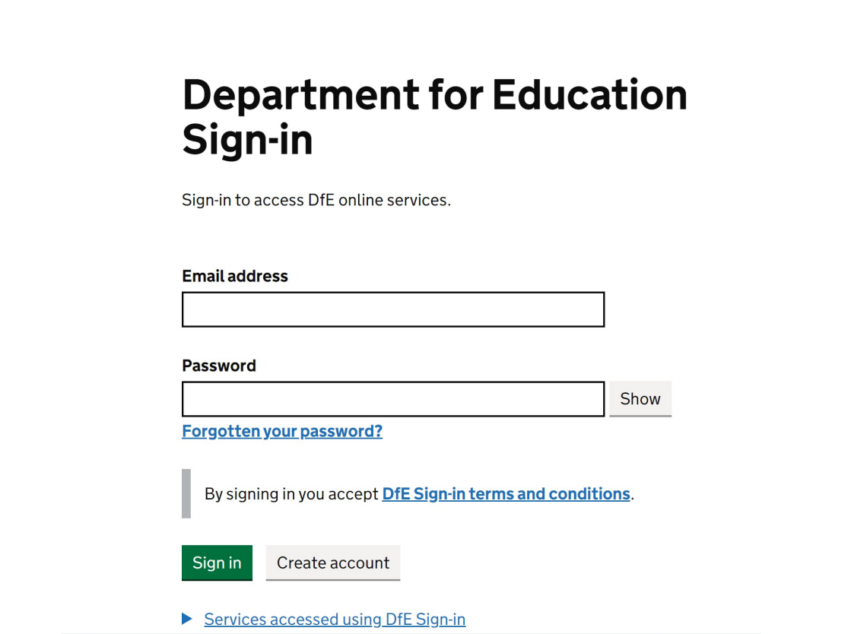
Figure 1 - DfE Sign In

If users do not have access to this role with in DfE Sign in, they will need to request the ‘Standard Submissions’ sub service from the approver within their organisation. This can be done by registering/signing in to DfE Sign In, selecting request services on my account (Figure 2)
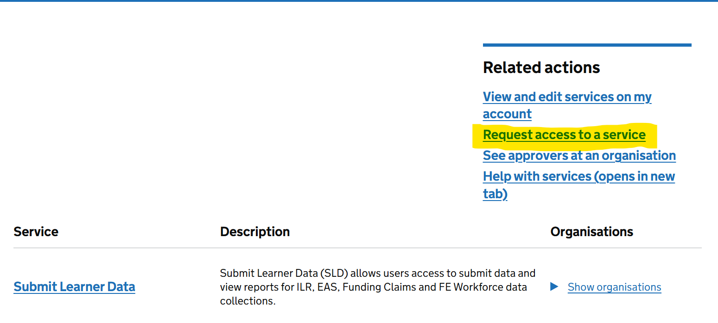
Figure 2 - DfE Sign In - Request Access to a service

Users will need to request the ‘Submit Learner Data – Standard Submissions’ role from their organisation’s super user to access the collection.
For users who do not have account, refer to gov.uk for details on how to create DfE sign-in account. Users who are unable to access their account need to complete the Contact us Form for assistance from Service Desk.
Organisations with a DfE sign-in account and a user assigned with the ‘Submit Learner Data – Standard Submissions ’ role, can access the staff data collection using the Submit learner data sign in process: Submit learner data
The collection can be accessed via the Skills Bootcamp contracts collection (SBC) tile on the submission options page of the Submit learner data portal.

Adding a contract - Bulk Upload
Providers have the option to bulk upload contract data via CSV. This allows providers to upload multiple contracts at once. Follow these steps to bulk upload contract data.
- Login to the submit learner data portal and click the Skills Bootcamp contracts tile.
Read the information about the collection and click Continue.
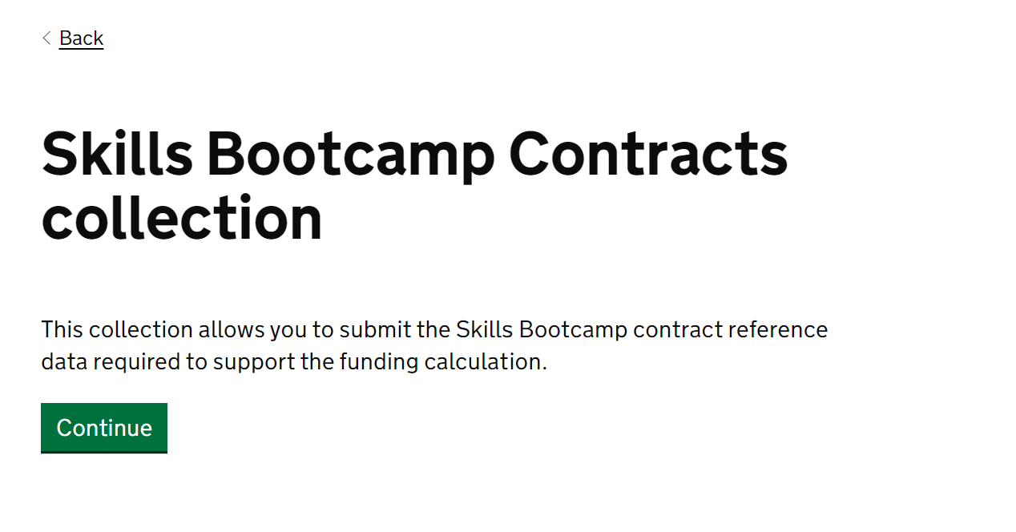
Figure 3 - Collection Overview Page

- Then Select the import tab
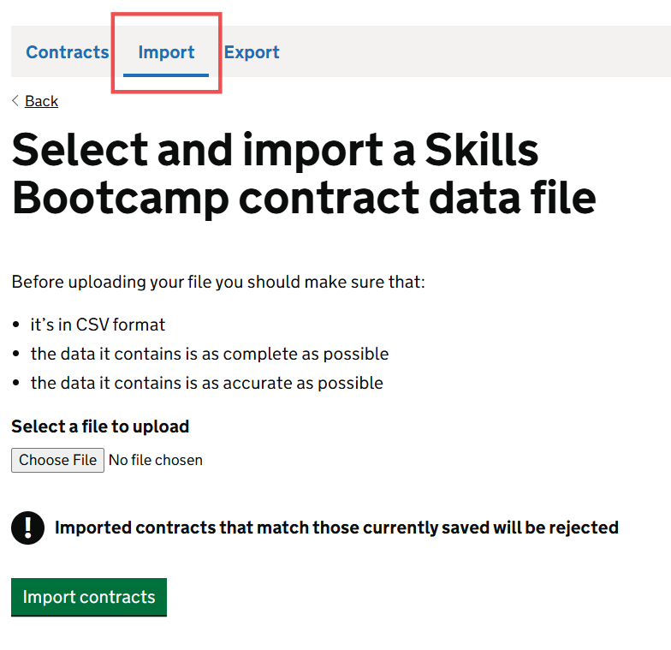
Figure 4 - Import Tab
You will then be taken to the ‘Select and import a Skills Bootcamp contract data file’ page. Note any files matching those currently saved via the online form method will be rejected.

- You will then prepare a Skill Bootcamp Contract CSV file with the following schema:
Figure 5 - Example Schema

- After the file is prepared, the file can then be submitted by selecting your file, within the upload tab, and pressing import contracts.
Note: multiple contracts can be submitted in the same CSV file 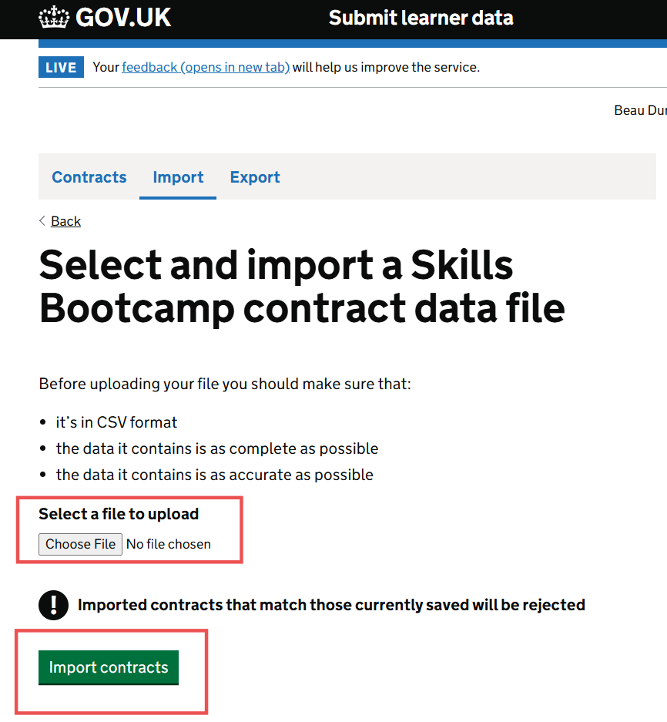
Figure 6 - File Upload & Import

Adding a contract – online form
Follow these steps to input reference data for a Skills Bootcamp contract.
- Login to the submit learner data portal and click the Skills Bootcamp contracts tile.
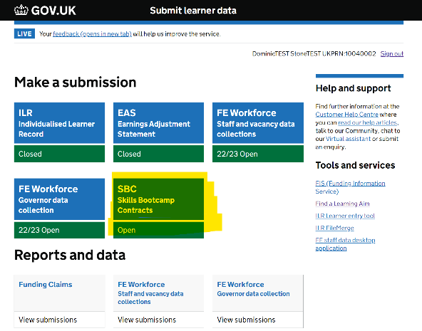
Figure 7 - SBC Tile

Read the information about the collection and click Continue.
- When you land on the Manage Skills Bootcamp contract reference data page, click the “Add a contract” button
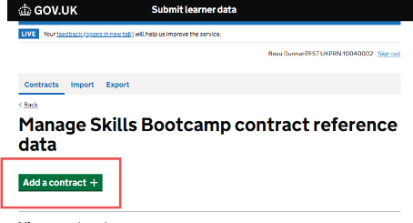
Figure 8 - Manage SBC reference data – add a contract

- Read the information outlined and then press continue
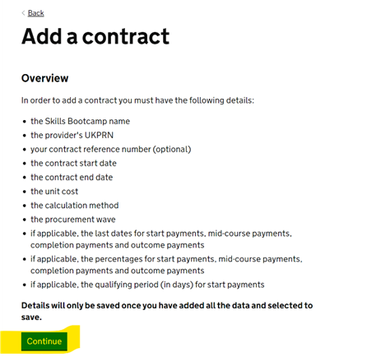
Figure 9 - Online form add a contract overview

- Enter the name of the Skills Bootcamp, the UKPRN of the bootcamp provider and your contract reference number (if applicable) into the Contract details page. Then press continue.
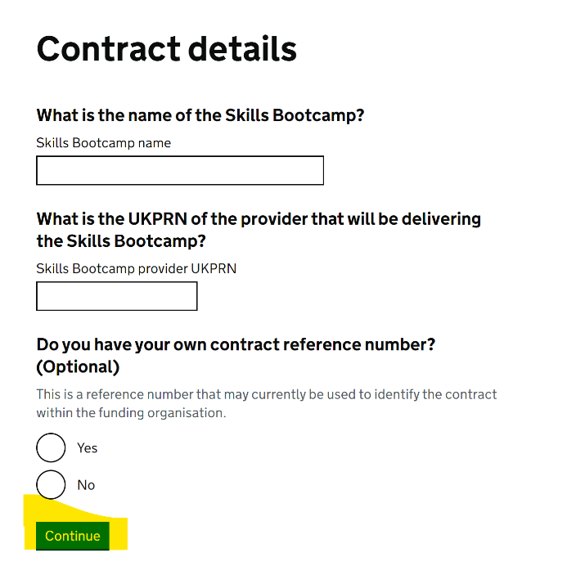
Figure 10 - Contract Details page
- Select the contract funding wave that applies to the contract. (The options displayed are examples and may not be relevant to the live collection)

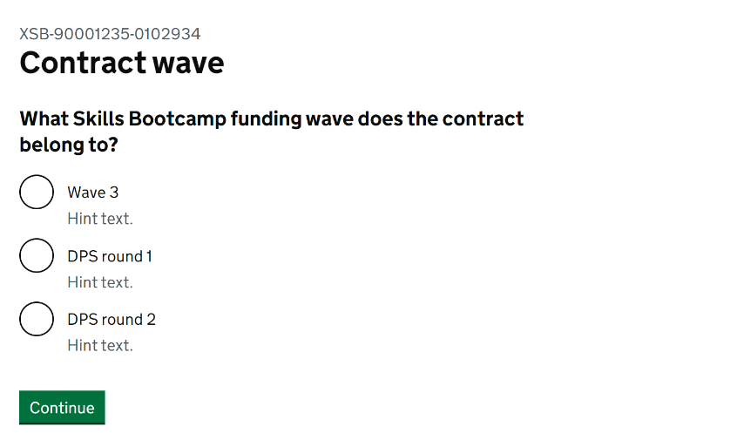
Figure 11 - Contract Wave

- Select the calculation method that applies to the contract. (The options displayed are examples and may not be relevant to the live collection)

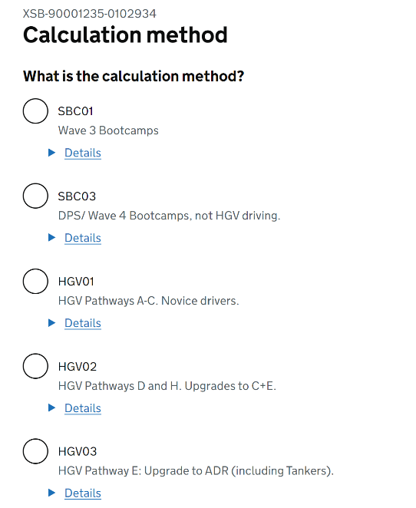
Figure 12 - Calculation Method

- Enter the contract dates and unit cost of the contract
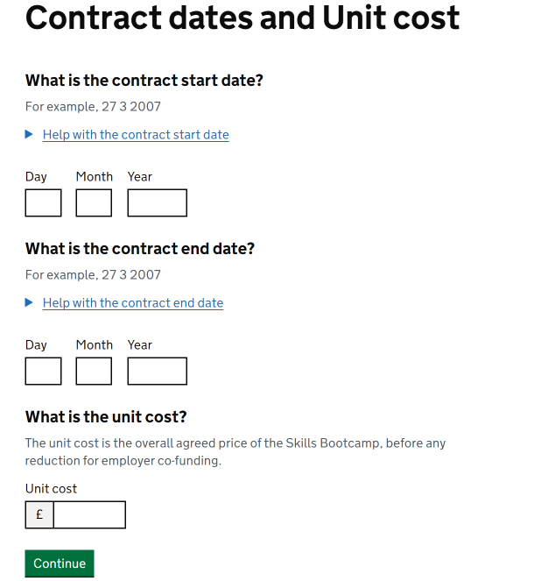
Figure 13 - Contract Dates and Unit Cost

- Enter the payment details information that are relevant to the contract. The variables displayed on this page are governed by the calculation method that has been selected previously. The variables that could be shown on this page are displayed below:
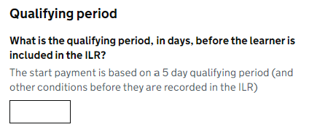
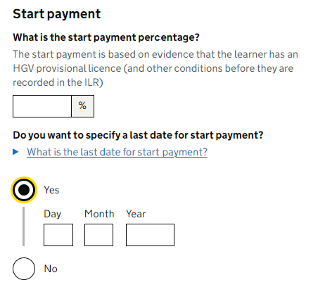

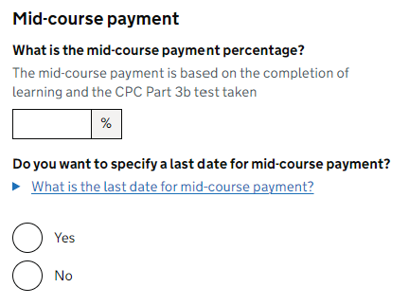
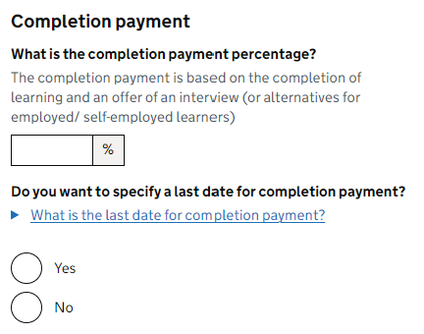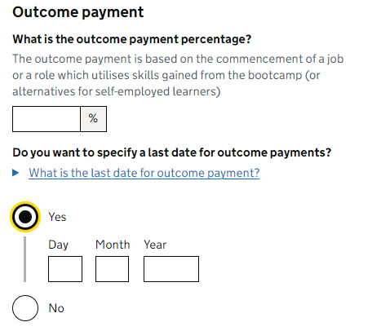

Figure 14 - Payment Percentages and Dates

- Review the information that you have entered for the contract. If correct click Save contract.
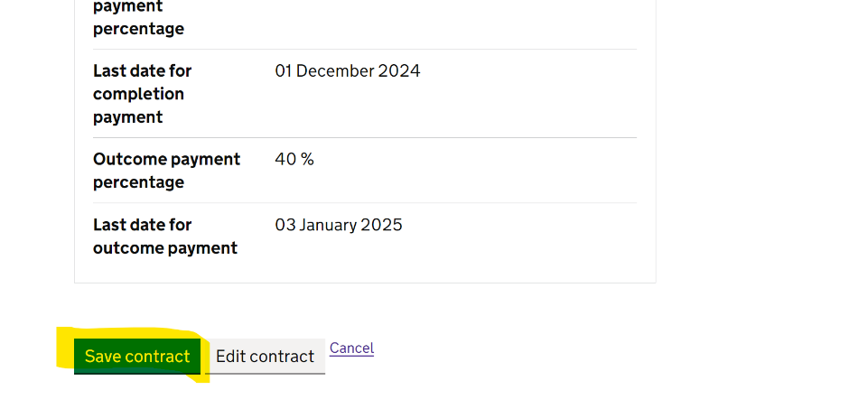
Figure 15 - Review information

- When a contract is saved you will be directed to a confirmation page displaying the ILR contract reference number that has been assigned to this contract.

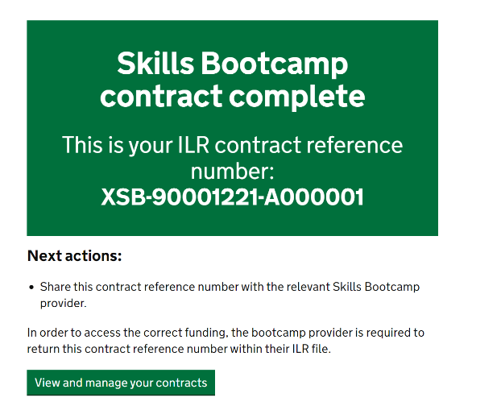
Figure 16 - Contract complete page & ILR Contract reference number

Viewing saved contracts
All contracts that have been saved to the database are displayed in the “View contracts” section of the “Manage Skills Bootcamp contract reference data”
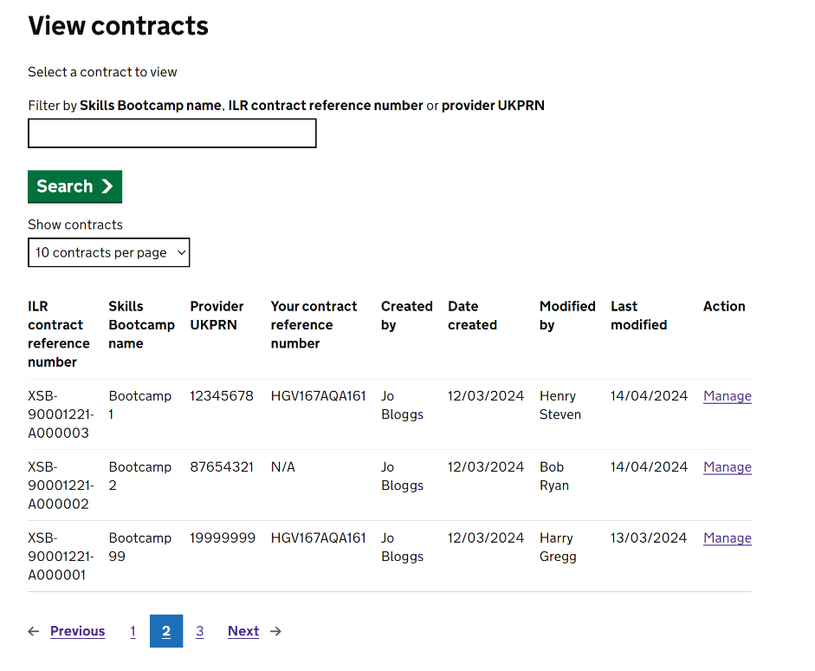
Figure 17 - Saved contracts

Contracts are displayed from most recent to oldest and the tale can be filtered by the Skills Bootcamp name, ILR contract reference number and the provider UKPRN.

Managing contracts
The contracts can be viewed, edited and deleted through the Manage link within each row of the View contract page.
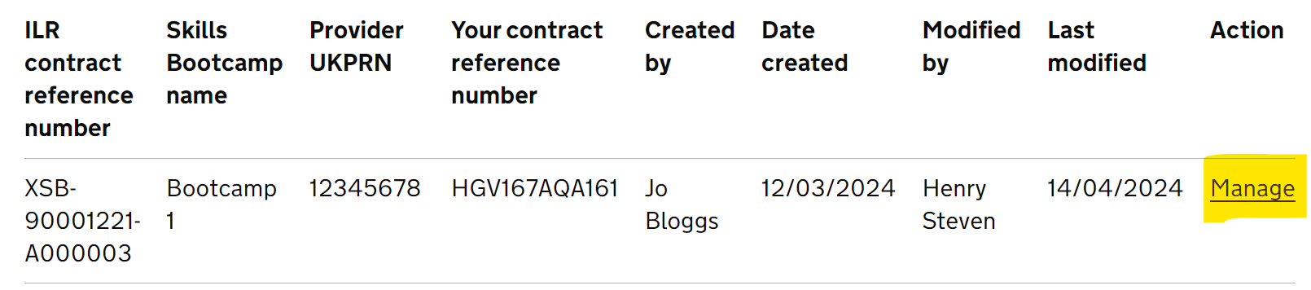
Figure 18 - Manage contracts

Deleting contract reference data
If a contract is deleted from the SBC collection, then a provider will not be able to successfully return the associated ILR contract reference number within their ILR submission and therefore will not receive the correct funding.

Exporting contract data
The reference data of all your contracts can be exported as a .csv file through the Export tab.
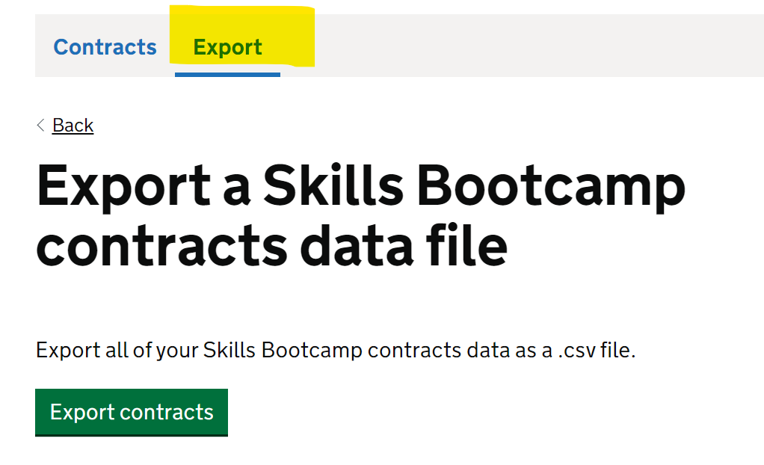
Figure 19 - Export a contract file

Content of the return

ILR contract reference number
Table 2: ILR contract reference number
Data Element Details
Question/page header | N/A
Definition | This contract reference number needs to be input by the provider into their ILR submission in order to receive the correct funding.
Collection Requirements | Mandatory data item.
Data type | Varchar(20)
Format | XSB-[UKPRN of the contract provider]-[ANNNNNN]
Notes | This value is automatically assigned to a contract once it is saved.  Eg. XSB-90001256-A000001

Skills Bootcamp name
Table 3: Skills Bootcamp name
Data Element Details
Question/page header | What is the name of the Skills Bootcamp?
Definition | The name of the Skills Bootcamp course
Collection Requirements | Mandatory data item.
Data type | Varchar(100)

Provider UKPRN
Table 4: Provider UKPRN
Data Element Details
Question/page header | What is the UKPRN of the provider that will be delivering the Skills Bootcamp?
Definition | The UKPRN of the organisation who is delivering the Skills Bootcamp
Collection Requirements | Mandatory data item.
Data type | Integer
Format | [0-9]{8}

Your contract reference number
Table 5: Your contract reference number
Data Element Details
Question/page header | Do you have your own contract reference number?
Definition | This is a reference number that may currently be used to identify the contract within the funding organisation.
Collection Requirements | Optional data item.
Data type | Varchar(50)
Notes | This value has no predefined format.

Contract funding wave
Table 6: Contract funding wave
Data Element Details
Question/page header | What Skills Bootcamp funding wave does the contract belong to?
Definition | Funding wave aligns with the period for which the grant offer letter covers. This may be referred to as “Wave X” or “FY20XX-XX”.  Funding waves align to financial years:  - Wave 3 = learner starts in FY2022-23  - Wave 4 = learner starts in FY2023-24  - Wave 5 = learner starts in FY2024-25  - Wave 6 = learner starts in FY2025-26
Collection Requirements | Mandatory data item.

Calculation method
Table 7: Calculation method
Data Element Details
Question/page header | What is the calculation method?
Definition | The calculation method that determines the parameters which are used to calculate the correct funding milestones for each Skills Bootcamp.
Collection Requirements | Mandatory data item.

Contract start date
Table 8: Contract start date
Data Element Details
Question/page header | What is the contract start date?
Definition | The date when a provider can start activity under your contract with them.
Collection Requirements | Mandatory data item.
Data type | Date

Contract end date
Table 9: Contract end date
Data Element Details
Question/page header | What is the contract end date?
Definition | The last date of activity for which a provider can be paid under your contract with them. This should include the last possible date for outcome milestones where you will make a payment.
Collection Requirements | Optional data item.
Data type | Date

Unit cost
Table 10: Unit Cost
Data Element Details
Question/page header | What is the unit cost?
Definition | The unit cost is the overall agreed price of the Skills Bootcamp, before any reduction for employer co-funding.
Collection Requirements | Mandatory data item.
Data type | Decimal(13,2)

Qualifying period
Table 11: Qualifying period
Data Element Details
Question/page header | What is the qualifying period, in days, before the learner is included in the ILR?
Definition | Number of days the learner must remain on the programme to be funded. These should be entered as calendar days. The calculation does not try to determine working days or holidays. Default qualifying period is 14 days for non-HGV bootcamps.
Collection Requirements | Optional data item.
Data type | Integer
Notes | This field is only necessary if it is specified as part of the selected calculation method.

Start payment percentage
Table 12: Start payment percentage
Data Element Details
Question/page header | What is the start payment percentage?
Definition | This is the percentage of the total funding which is paid where the learner is eligible for a start payment. This is normally based on qualifying days but other conditions apply for HGV novice driving.
Collection Requirements | Optional data item.
Data type | Integer
Notes | This field is only necessary if it is specified as part of the selected calculation method.  The sum of all the payment percentages must equal 100 %

Last date for start payment
Table 13: Last date for start payment
Data Element Details
Question/page header | Do you want to specify a last date for start payment?
Definition | This is the last date we will generate a start payment for any bootcamps within this contract. This is the date by which the learner's activity should take place, not the date by which it should be recorded in the ILR. If a learner meets the criteria for the start milestone based on their activity after this date, we will not generate a start payment.
Collection Requirements | Optional data item.
Data type | Date

Mid-course payment percentage
Table 14: Mid-course payment percentage
Data Element Details
Question/page header | What is the mid-course payment percentage?
Definition | The mid-course payment is assigned for certain types of bootcamps (currently HGVs) and is based on the completion of learning. For HGV other conditions apply, please see bootcamps technical guidance.
Collection Requirements | Optional data item.
Data type | Integer
Notes | This field is only necessary if it is specified as part of the selected calculation method.  The sum of all the payment percentages must equal 100 %

Last date for mid-course payment
Table 15: Last date for mid-course payment
Data Element Details
Question/page header | Do you want to specify a last date for mid-course payment?
Definition | This is the last date we will generate a mid-course payment for any bootcamps within this contract. This is the date by which the learner's activity should take place, not the date by which it should be recorded in the ILR. If a learner meets the criteria for the mid-course milestone based on their activity after this date, we will not generate a mid-course payment.
Collection Requirements | Optional data item.
Data type | Date

Completion payment percentage
Table 16: Completion payment percentage
Data Element Details
Question/page header | What is the completion payment percentage?
Definition | The completion payment is based on the completion of learning and an offer of an interview (or alternatives for employed/ self-employed learners). For HGV other conditions apply, please see bootcamps technical guidance.
Collection Requirements | Optional data item.
Data type | Integer
Notes | This field is only necessary if it is specified as part of the selected calculation method.  The sum of all the payment percentages must equal 100 %

Last date for completion payment
Table 17: Last date for completion payment
Data Element Details
Question/page header | Do you want to specify a last date for completion payment?
Definition | This is the last date we will generate a completion payment for any bootcamps within this contract. This is the date by which the learner's activity should take place, not the date by which it should be recorded in the ILR. If a learner meets the criteria for the completion milestone based on their activity after this date, we will not generate a completion payment.
Collection Requirements | Optional data item.
Data type | Date

Outcome payment percentage
Table 18: Outcome payment percentage
Data Element Details
Question/page header | What is the outcome payment percentage?
Definition | The outcome payment is based on the commencement of a job or a role which utilises skills gained from the bootcamp (or alternatives for self-employed learners)
Collection Requirements | Optional data item.
Data type | Integer
Notes | This field is only necessary if it is specified as part of the selected calculation method.  The sum of all the payment percentages must equal 100 %

Last date for outcome payment
Table 19: Last date for outcome payment
Data Element Details
Question/page header | Do you want to specify a last date for outcome payment?
Definition | This is the last date we will generate an outcome payment for any bootcamps within this contract. This is the date by which the learner's activity should take place, not the date by which it should be recorded in the ILR. If a learner meets the criteria for the outcome milestone based on their activity after this date, we will not generate an outcome payment.
Collection Requirements | Optional data item.
Data type | Date



© Crown copyright 2024
This publication is licensed under the terms of the Open Government Licence v3.0, except where otherwise stated. To view this licence, visit nationalarchives.gov.uk/doc/open-government-licence/version/3.

Where we have identified any third-party copyright information, you will need to obtain permission from the copyright holders concerned.

About this publication:

enquiries https://www.gov.uk/contact-dfe
download www.gov.uk/government/publications
Follow us on Twitter: @educationgovuk
Connect with us on Facebook: facebook.com/educationgovuk

