

Higher Education Classification of Subjects
User guidance
April 2025
Contents
Higher Education Classification of Subjects 1
Document history 3
Summary 3
Field Definitions 3
Filename 4
LARS CSV 5
HECoS Validation 5
Filename Validation 5
Field Level Validation 7
Business Rule Validation 8
Making the return 9

Table of Figures
Figure 1: DfE Sign In 11
Figure 2: Submit Learner data – HECoS tile 11
Figure 3: Submit Learner Data – HECoS Overview page 12
Figure 4: Submit Learner data – Export HECoS template page 13
Figure 5: Example HECoS template file 14
Figure 6: Example completed HECoS file 14
Figure 7: Submit Learner Data - HECoS file upload page 15
Figure 8: Submit Learner Data - HECoS file submitted page 16
Figure 9: Submit Learner Data – Upload with reports 17

Document history
Table 1: Document History
Version | Date Issued | Description
1.0 | 10/03/2025 | Initial version
1.1 | 22/04/2025 | V1.1

Summary
For the 2024/25 academic year providers who are registered with the Office for Students who submit ILR data (excluding providers who already submit student to HESA (part of Jisc)), there is an extra return on the Submit Learner Data portal for providers to submit the percentage taught by HECoS code. This collection replaces the previous collection of percentage taught by LDCS in 2023/24.
Only the Learning Aim References that have been submitted within a providers ILR file will be accepted within this collection.

Field Definitions
Campus Identifier (cell A)
- Name: CampID
- Field length: 8
- Field values: ([A-Za-z0-9]{1,8})
Learning Aim Reference Number (cell B)
- Name: LearnAimRef
- Field Length: 8
- Field values: ([A-Za-z0-9]{1,8})
HECoS Code (Cell C)
- Name: HECoSCode
- Field Length: 6
- Field Values: Integer
Percentage (Cell D)
- Name: Percentage
- Field Length: 5
- Field Values: 0 – 100.0

Filename
A submission using the new collection is required before submitting the ILR file, however providers can upload updated files during the academic year. The file is a .csv file with the file name in the following format:
- ukprn-HECOS-timestamp.csv
The filename must be in the agreed following format: LLLLLLLL-HECOS-YYYY-yyyymmdd-hhmmss.csv Where: LLLLLLLL is the UK provider reference number (UKPRN) , HECOS is fixed text, YYYY is the academic year matching the return period the file is being submitted against and yyyymmdd-hhmmss is Date/time stamp

Further Information
Where multiple campus sites exist, there is a possibility the percentage breakdown of the HECoS information may differ for the same Learning Aim i.e. same course maybe delivered differently. By collecting this information, we can capture where this is the case.
HECoS codes are a set of codes for the classification of subjects associated with Learning Aim references, there can be between 1 and 5 codes for each Learning Aim Reference. These HECoS codes can be accessed using the FALA service. Providers must review each code associated with a Learning Aim Reference and submit the percentages taught across these HECoS codes. The percentages for one Learn Aim Reference must be equal to 100%.

LARS CSV
Using the LARS LearningDelivery Table from the CSV download you can identify the percentage against the HECoS code field. It is expected that the CSV will contain the relevant percentage taught for that course being delivered.

HECoS Validation
The HECoS collection has its own set of validation rules which can be accessed from the following download which can be used if you are having issues submitting a file through the SLD system.

Filename Validation

Version | Status | Rule Name | Rule Description | Error Message | Error/Warning
1 | Active | Filename_01 | The provider’s UKPRN in Submit Learner Data must match filename UKPRN. | The UKPRN in the filename does not match the UKPRN associated with your account. | Error
1 | Active | Filename_02 | The UKPRN in the filename must be valid and exist in the ORGS database | The UKPRN in the filename is invalid | Error
1 | Active | Filename_03 | The filename must be in the agreed following format: LLLLLLLL-HECOS-YYYY-yyyymmdd-hhmmss.csv Where: LLLLLLLL is the UK provider reference number (UKPRN) , HECOS is fixed text, YYYY is the academic year | The filename is not in the correct format | Error
1 | Active | Filename_04 | A filename cannot be used more than once | A file with this filename has already been processed | Error
1 | Active | Filename_05 | The date/time in the filename must be on or before current date/time | The date and time in the filename must not be later than today’s date and time | Error
1 | Active | Filename_06 | The file must be a csv file | The file extension must be csv | Error
1 | Active | Filename_07 | The date/time of the file must be greater than any previous transmissions by the same provider (UKPRN) | The file extension must be csv The date/time of the file is not greater than a previous submission | Error
1 | Active | Filename_08 | The academic year must match academic year of the return period being used to submit the file | The academic year in the filename is not valid for the selected return period. The academic year for the selected return period is [YYYY] | Error

Field Level Validation

Version | Status | Rule name | Rule description | Error message | Error/Warning
1 | Active | FD_CampId_AL | Where it has been entered, the Campus Identifier must be between 1 and 8 characters long | The length of the value returned for CampId is not between 1 and 8 characters | Error
1 | Active | FD_LearnAimRef_MA | The LearnAimRef is mandatory. Error where there is just null/empty/whitespace. | The CampId does not match the validation pattern | Error
1 | Active | FD_CampId_AP | Where it has been entered, the CampId must match the validation pattern in the ILR specification | The CampId does not match the validation pattern | Error
1 | Active | FD_LearnAimRef_MA | The LearnAimRef is mandatory. Error where there is just null/empty/whitespace. | The LearnAimRef has not been returned | Error
1 | Active | FD_HECOSCodeLen | HECOS code must be 6 characters | The length of the value returned for HECOS must be 6 characters | Error
1 | Active | FD_HECOSCode_MA | The HECOS Code is mandatory for each LearnAimRef. Error where there is just null/empty/whitespace. | No HECoS code has been returned for the LearnAimRef | Error
1 | Active | FD_HECOSCode_Num | The HECoS Code must be only contain numbers | The HECoS code must only contain numbers | Error
1 | Active | FD_Percentage_MA | A percentage is mandatory for each HECOS Code. Error where there is just null/empty/whitespace. | a percentage must be returned for each HECOS Code. | Error
1 | Active | FD_PercentageLen | The percentage taught in a HECOS subject must not be more than 1 decimal place | The percentage taught in a HECOS subject 1must not be more than 1 decimal place | Error
1 |  | FD_Percentage_HECOS | The percentage taught on one HECOS code must not be greater than 100% | The percentage taught on one HECOS code must not be greater than 100% | Error

Business Rule Validation
Version | Status | Rule name | Rule description | Error message | Error/Warning
1 | Active | CampId_01 | The CampId must be a valid lookup on the Campus identifier table ([Org].[dbo].[CampusIdentifier]). | The CampId is not valid | Error
1 | Active | CampId_02 | The master UKPRN in the Campus identifier table must be the same as the UKPRN in the filename | The UKPRN is not valid for the CampId | Error
1 | Active | LearnAimRef_01 | The LearnAimRef must be a valid lookup on LARS | The LearnAimRef is not a valid lookup on LARS | Error
1 | Active | LearnAimRef_02 | The LearnAimRef must exist in the provider's ILR valid.learningdeliveyHE data and Learning Delivery | The LearnAimRef does not exist in your ILR | Error
1 | Active | HECOS_01 | The sum of the HECOS Percentages (between 1 and 5) returned for one LearnAimRef must equal 100% | The total of the five percentages taught in HECOS subject fields must equal 100% | Error
1 | Active | HECOS_02 | If there is a learn aim reference for a provider within the LARS Database then at least one HECOS code must be provided. | you must provide at least one HECOS code for each learning aim reference. | Error

Making the return
Follow these steps to input reference data for a Skills Bootcamp contract.
- The HECoS Data Collection is hosted within the submit learner data (SLD) secure platform. Providers must have a Department for Education (DfE) sign-in account and associated profile to access the HECoS collection.
Begin the data return process from the submit learner data (SLD) start page. https://submit-learner-data.service.gov.uk .
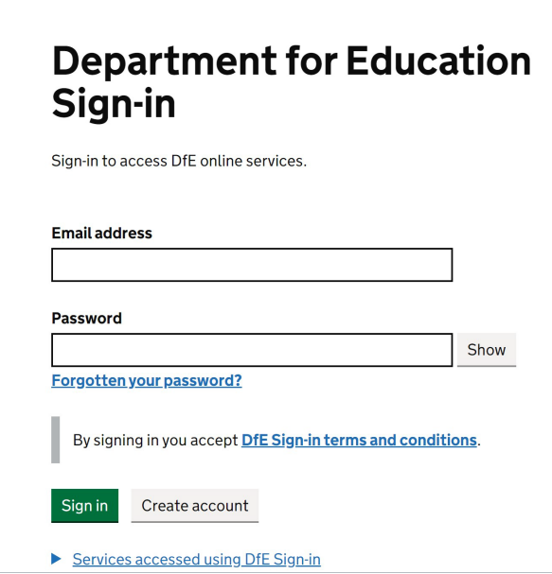
Figure 1: DfE Sign In

- Users will then need to select the HECOS tile to begin the collection.

Figure 2: Submit Learner data – HECoS tile

- Users will then be navigated to the Overview page. On the overview page the user should click continue to proceed to the export template tab
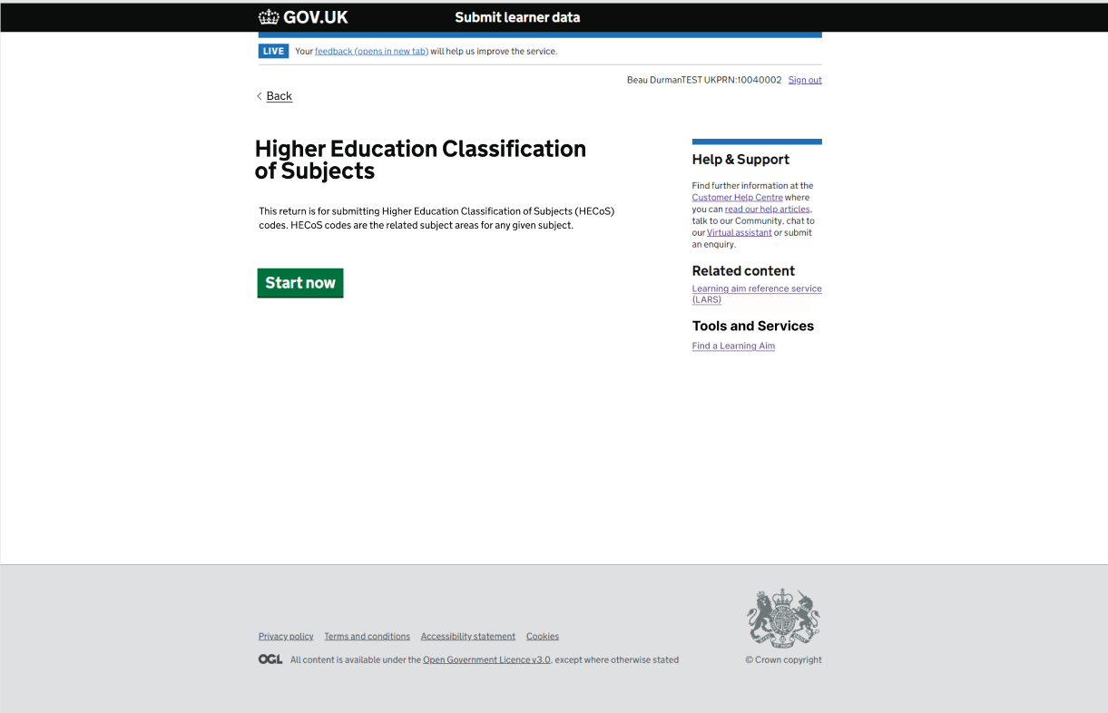
Figure 3: Submit Learner Data – HECoS Overview page

- On the export tab the user should select the ‘Export Template’. This will download a CSV file populated with the: CampID, LearnAimRef and HECoS codes for the providers UKPRN. There will be a fourth empty column called percentage where providers will input the percentage data.

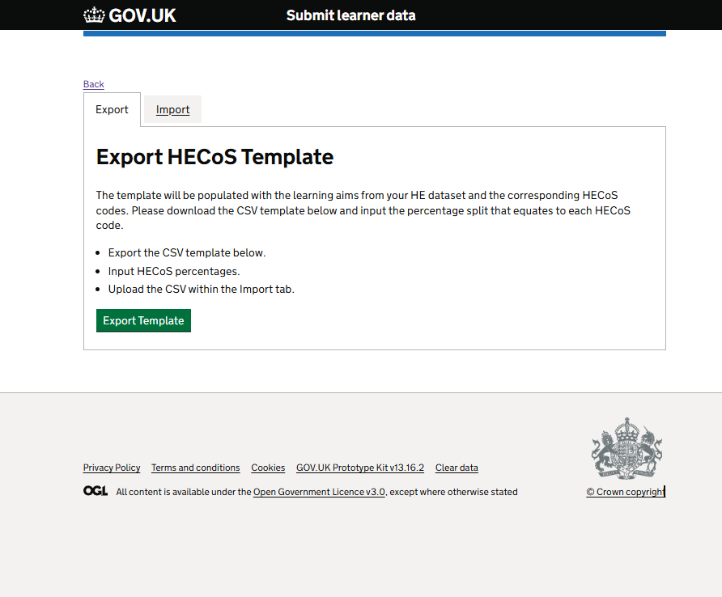
Figure 4: Submit Learner data – Export HECoS template page

- Example downloaded template file

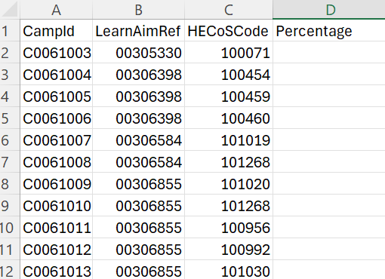
Figure 5: Example HECoS template file

- The user will then complete the percentage column
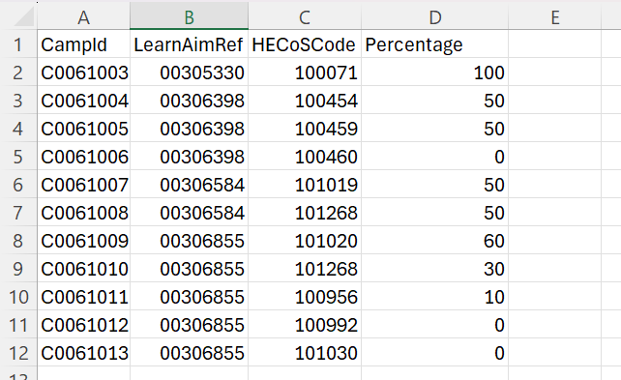
Figure 6: Example completed HECoS file

- Once the file is complete the user will navigate to the ‘import’ tab. On the Select and Upload page, choose a valid file and then press upload.
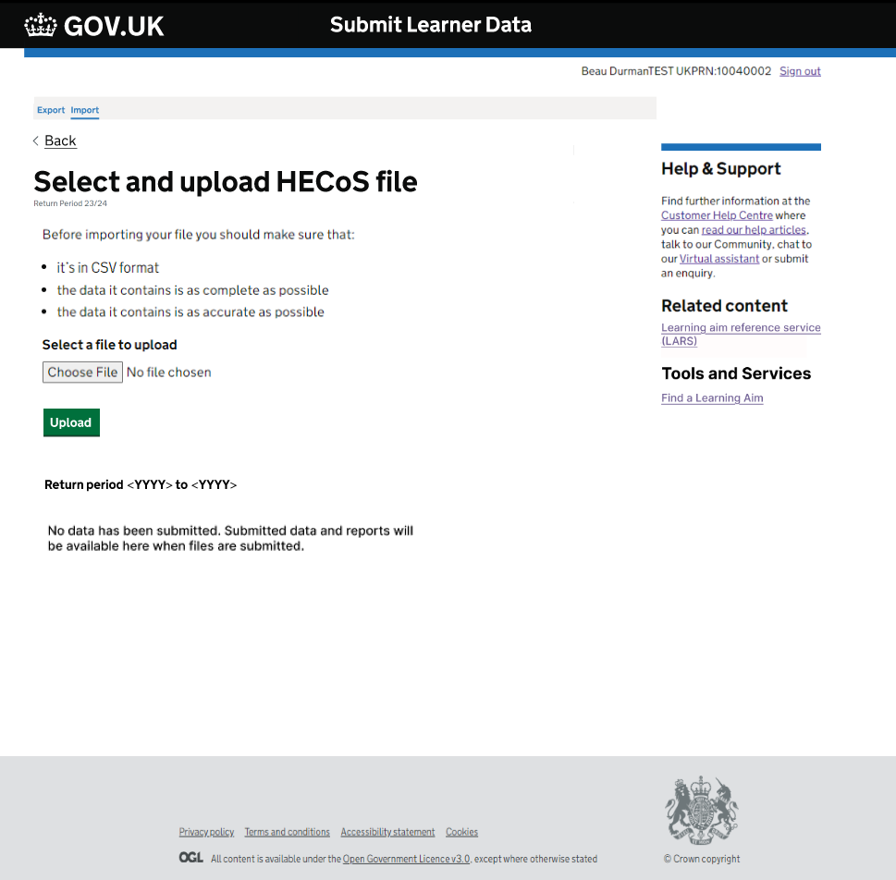Figure 7: Submit Learner Data - HECoS file upload page

- When a valid file is chosen and uploaded the user will be navigated to the submission confirmation page depicted below and a confirmation email will be sent. On the submission confirmation page, the user can press view submissions to navigate back to the upload page where reports will now be present
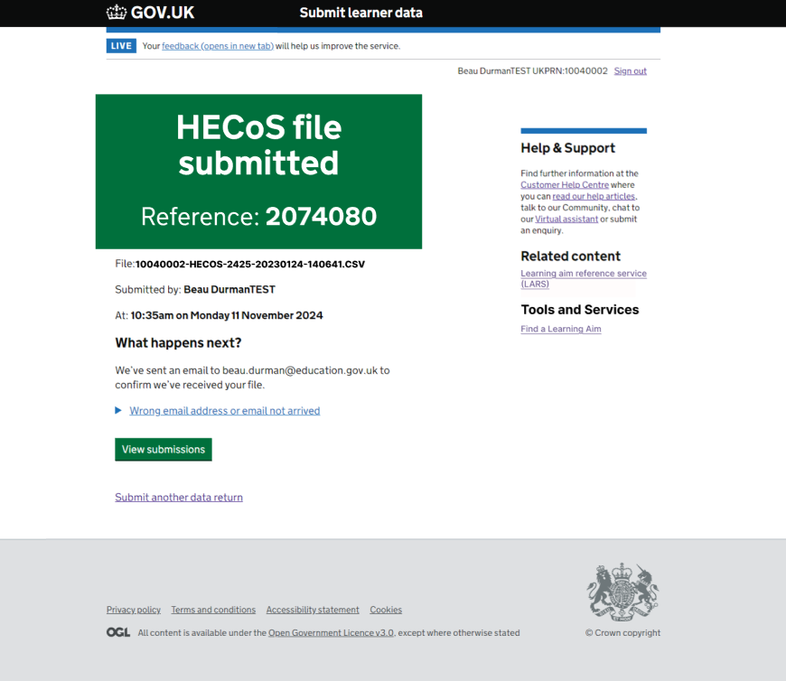
Figure 8: Submit Learner Data - HECoS file submitted page

- Reports are now available on the select and upload page
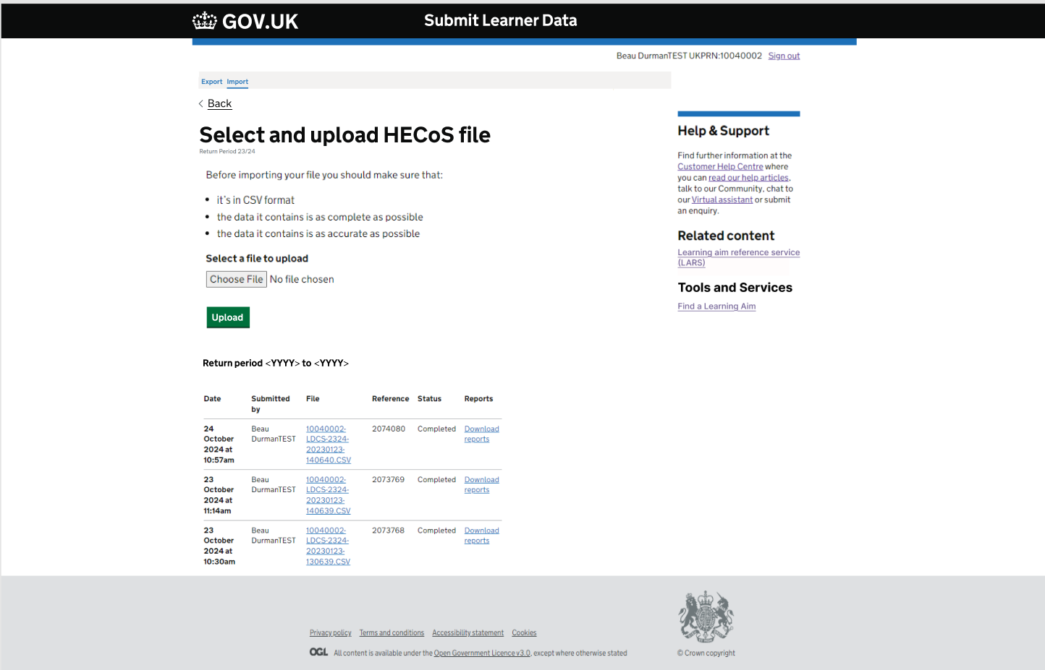
Figure 9: Submit Learner Data – Upload with reports

© Crown copyright 2025
This publication is licensed under the terms of the Open Government Licence v3.0, except where otherwise stated. To view this licence, visit nationalarchives.gov.uk/doc/open-government-licence/version/3.

Where we have identified any third-party copyright information, you will need to obtain permission from the copyright holders concerned.

About this publication:

enquiries https://www.gov.uk/contact-dfe
download www.gov.uk/government/publications
Follow us on Twitter: @educationgovuk
Connect with us on Facebook: facebook.com/educationgovuk

