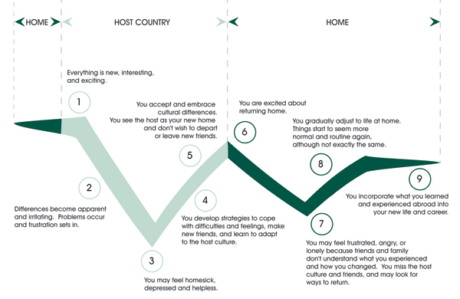
When thinking about your re-entry experience, 1) identify the feelings experienced with a circle. 2) Use the blank lines to include any we may have missed. 3) Draw a line under the most prominent feeling(s) you’re experiencing currently:

Tiredness | Lethargy | Confusion
Disorientation | Disappointment | Unfulfilled
Frustration | Irritability | Isolated
Discouragement | Resentment | Unsettled
Anxiety | Insecurity | Safe
Embarrassment | Impatience | Anger
Disgusted | Disillusionment | Superiority
Dissatisfaction | Hurt | Fear
Withdrawal | Uncertainty | Uselessness
Stressed | Contempt | Loss of motivation
Guilt | Displaced | Rejected
Elated | Relieved | Overwhelmed
Sorrow | Unfocussed | Released
Regret | Sick | Excitement
Exhaustion | Spiritually dry | Settled
Lost | Misunderstood | Free
Incompetent | Bored | Not myself
_________________ | _________________ | _____________________
When you look back over your whole experience in preparing, being in, and returning from your host culture, what caused you stress?

STRESS

50 common signs and symptoms of stress

1. Frequent headaches, jaw clenching or pain | 18. Sudden attacks of life threatening panic | 35. Nervous habits, fidgeting, feet tapping
2. Gritting, grinding teeth | 19. Chest pain, palpitations, rapid pulse | 36. Increased frustration, irritability, edginess
3. Stuttering or stammering | 20. Frequent urination | 37. Overreaction to petty annoyances
4. Tremors, trembling of lips, hands | 21. Diminished sexual desire or performance | 38. Increased number of minor accidents
5. Neck ache, back pain, muscle spasms | 22. Excess anxiety, worry, guilt, nervousness | 39. Obsessive or compulsive behaviour
6. Light headedness, faintness, dizziness | 23. Increased anger, frustration, hostility | 40. Reduced work efficiency or productivity
7. Ringing, buzzing or “popping sounds | 24. Depression, frequent or wild mood swings | 41. Lies or excuses to cover up poor work
8. Frequent blushing, sweating | 25. Increased or decreased appetite | 42. Rapid or mumbled speech
9. Cold or sweaty hands, feet | 26. Insomnia, nightmares, disturbing dreams | 43. Excessive defensiveness or suspiciousness
10. Dry mouth, problems swallowing | 27. Difficulty concentrating, racing thoughts | 44. Problems in communication, sharing
11. Frequent colds, infections, herpes sores | 28. Trouble learning new information | 45. Social withdrawal and isolation
12. Rashes, itching, hives, “goose bumps” | 29. Forgetfulness, disorganization, confusion | 46. Constant tiredness, weakness, fatigue
13. Unexplained or frequent “allergy” attacks | 30. Difficulty in making decisions | 47. Frequent use of over-the-counter drugs
14. Heartburn, stomach pain, nausea | 31. Feeling overloaded or overwhelmed | 48. Weight gain or loss without diet
15. Excess belching, flatulence | 32. Frequent crying spells or suicidal thoughts | 49. Increased smoking, alcohol or drug use
16. Constipation, diarrhoea, loss of control | 33. Feelings of loneliness or worthlessness | 50. Excessive gambling or impulse buying
17. Difficulty breathing, frequent sighing | 34. Little interest in appearance, punctuality

While stress is a normal part of everyday life, if you, or those you love, are experiencing several, ongoing symptoms associated with stress without improvement, seek professional help. A good stress-management plan of healthy diet, regular exercise, and good sleep is essential. Prolonged stress alters the brain chemistry and may require medication to set things back in order. Your GP can help to assess this and advise a plan that works for you.

Assessing Expectations:
Expectations play a huge role in how well and how quickly we adjust to new situations and circumstances. However, they are often not realised until they are UNMET. This can leave us feeling unsettled, disappointed, and frustrated. Identifying your expectations during times of transition and communicating those when appropriate will help alleviate some of the hidden stress that can ultimately contribute to burnout.

Take a moment to think back to the expectations you had before you arrived in your host culture. List them here:

Now think about the expectations you had for your ministry overseas. List some here:

Finally, think about the expectations you had about returning home. List them here:

WORTH NOTING…Your Re-entry feelings will be stronger in the following situations:
- Where you had a lot of stress
- Where you have changed a lot.
- Where your home culture has changed a lot while you were away.
- Where you have spent a lot of time away from your home culture.
- Where your host culture is vastly different from your home culture.
- Where you unexpectedly left your host culture.
- Where your personality adapts slowly to change.
- Where you are unsure of what you will do in your home culture.
- Where those who receive you have difference of inner values.
- Where you are leaving the mission that arranged things like homes, transport, insurance, and utilities.

Who Am I?

Identity begins before birth— consider Jeremiah 1:5; Psalms 139:13-18
God is conforming our identity-- consider Romans 8:28-30; 2 Corinthians 3:17-18
Our journey is part of that process—consider

Our identities are made up of many parts. These parts can change throughout the course of our lives. Even if the parts change, we are still the same person—only different! As we journey through life, we learn, change, and grow. We are always in a process of “becoming”. All of our past experiences contribute to this process. We are all unique, complex individuals. This is something to be celebrated!

On the opposite page, start by writing your name in the centre of the cloud. Draw solid lines from the cloud and label each one with a different aspect of your identity (past & present); if you want to include future aspects of your identity, connect those with a dotted line.

