**U.S. Inbound (Import) Transportation Guide**

**SHIPPING INSTRUCTIONS FOR U.S. *IMPORTED* MATERIALS**

[NOTE:This Guide is intended for shipments handled by a freight forwarder, NOT by an express courier. If a shipment is hanlded by an Express Courier such as Fed Ex, DHL Express, etc, the information provided here is not applicable.]

1. **DHL Global Forwarding** is the preferred freight forwarder and Import Broker for Eli Lilly and Company.

Shipper or buyer should contact DHL Global Forwarding to arrange transport from the country of departure when terms of purchase (i.e. Incoterms) require Lilly to arrange the transporation and act as U.S. Customs Importer or Record. Always give DHL Global Forwarding any special requirements for the handling of the material. Example: refrigerated item, frozen material, hazardous material, etc.

Shipper must include both email addresses listed below as Notify Parties on air waybills, and prealerts with documents:

[**CAE.EliLilly@dhl.com**](mailto:CAE.EliLilly@dhl.com) for entry processing;

[**CHB.IND@dhl.com**](mailto:CHB.IND@dhl.com) for monitoring upon departure from origin thru delivery and dispatching for delivery upon release.

The email boxes are monitored from 0800-1730 Eastern time M-F.

Place “Eli Lilly” at the beginning of the subject line.

The DHL Global Forwarding  U.S. Lilly lead point of contact for all Brokerage or US Customs status inquiries is:

**Kim Welch**

**Customs Brokerage Product Specialist**

**DHL Life Sciences & Healthcare**

**DHL Global Forwarding**

**Direct Line: 317-204-6721**

[**CHB.IND@dhl.com**](mailto:CHB.IND@dhl.com)

The secondary point of contact is:

**Alice Elmore**

**Customs Brokerage Product Specialist**

**DHL Life Sciences & Healthcare**

**DHL Global Forwarding**

**Direct Line: 317-204-6722**

[**CHB.IND@dhl.com**](mailto:CHB.IND@dhl.com)

**Escalation contacts are:**

Jane Bennett

DHL Customer Program Manager – Eli Lilly

Direct Line: 317-204-6715

Mobile: 1.317-403-3870

[**jane.bennett@dhl.com**](mailto:jane.bennett@dhl.com)

Thurman Walker

Station Manager – IND

Direct Line: 317-204-6718

Mobile: 317-695-8417

[**Thurman.Walker@dhl.com**](mailto:Thurman.Walker@dhl.com)

1. For all inbound U.S. shipments handled by a freight forwarder, notify Lilly Import Compliance, [USImportRequests@lists.lilly.com](mailto:USImportRequests@lists.lilly.com), prior to shipment in order to avoid any delay due to the Customs clearance process. The Lilly US Import Compliance will provide guidance and/or instruction required for the Customs clearance process, this is separate from the transporation piece handled by the freight forwarder.

|  |  |  |
| --- | --- | --- |
| **U.S. Import Compliance​** | | [USImportCompliance@lists.lilly.com](mailto:USImportCompliance@lists.lilly.com) |
| **Nicole Pierce**, Associate Consultant | (317) 276-4014 | [pierce_nicole@lilly.com](mailto:pierce_nicole@lilly.com) |  |
| **​Rebecca Domeck,** Associate Consultant | (317) 276-7964 | ​[domeck_rebecca_s@lilly.com](mailto:domeck_rebecca_s@lilly.com) |  |
| ​**Tammy Gilliam**, Senior Analyst | (317) 276-7964 | ​gilliam_tammy_k@lilly.com |  |

1. Provide copies of shipping documentation listed below to the follow to [USImportRequests@lists.lilly.com](mailto:USImportRequests@lists.lilly.com) and CHB.IND@dhl.com

HAWB/HBL (or MAWB/MBL  if back to back)

Commercial Invoice(s)

Packing List(s)

Any other commercial or regulatory documentation

(USDA Guideline, FDA Data, TSCA, etc.)

NOTE: Reminder - this applies to all shipments handled by a freight forwarder such as DHL Global Forwarding, Bollore, Panalpina, etc. but not for express courier shipments handled by Fed Ex, etc.

1. Instruct the exporter/supplier/shipper to complete the AWB with the following information:
   1. Notify Party /Customs Broker:

DHL Global Forwarding

[CHB.IND@dhl.com](mailto:CHB.IND@dhl.com)

1. Commercial and shipping invoices should be consigned to Eli Lilly and Company with the complete shipping address for the product.
   1. Supply the name of the ultimate consignee.

**Example:** ATTN: Joe Smith, Dept. XYZ, Bldg. 123

Phone: (###) ###-####

1. The majority of Eli Lilly and Company’s air shipments land in Chicago. They are trucked or flown to Indianapolis for customs clearance. **Indianapolis will be the Port of Importation.**

**Extra Information For Imported Material**

1. DHL Global Forwarding is also the import broker for Lilly and will clear the material through US Customs on Eli Lilly’s behalf.
   1. The time for US Customs clearance varies. It helps to have all the documents in order. Most of the US Customs documents are transmitted to Customs Electronically.

For any Brokerage or US Customs status, the DHL CAE contacts are Kim Welch and Alice Elmore, email [**CHB.IND@dhl.com**](mailto:CHB.IND@dhl.com)**,**  phone 1-317-204-6721 or 1-317-204-6722.

1. On occasion DHL Global Forwarding is asked to carry documents directly to Customs. When documents are required, it is often a random check of imports.
2. If the shipment needs Food and Drug Administration release, this is separate from the US Customs release. It is possible to have one agency release and be waiting on the other agency release. In general goods will not move from the port of entry/arrival until each agency has completed the review and release required for U.S. import purposes. In special cases it is possible to move goods that are only awaiting FDA release, but this requires the receiving site to make arrangements to hold the material until FDA release is granted.
3. Once a shipment has completely cleared, the DHL Global Forwarding representative will request delivery. If the shipment clears later in the day, it may not be delivered until the next day. This depends on the volume of inbound shipments. Because goods arrive in Chicago (or other airports outside Indy) and remain there until the customs clearance process is complete, there could be several days between the date when the shipment lands and the delivery to Lilly. Plan project timelines with consideration to such “delays” that are a normal part of global business.

**Special Ocean Instructions**

1. If shipment is coming from a non-Lilly site we recommend that we negotiate DDP (Delivered Duty Paid) INCO terms with the supplier. In this case the terms would be DDP at place of delivery (for example DDP Indianapolis, IN). If DDP terms are not negotiated and Eli Lilly and Company will be responsible for the freight charges, we want to take possession of the material at the foreign port of export. The shipping term used when taking responsibility for insurance at the port of export is **“Freight On Board” (FOB).**

**Process Flow**

The below illustration shows the process flow for US Imports:

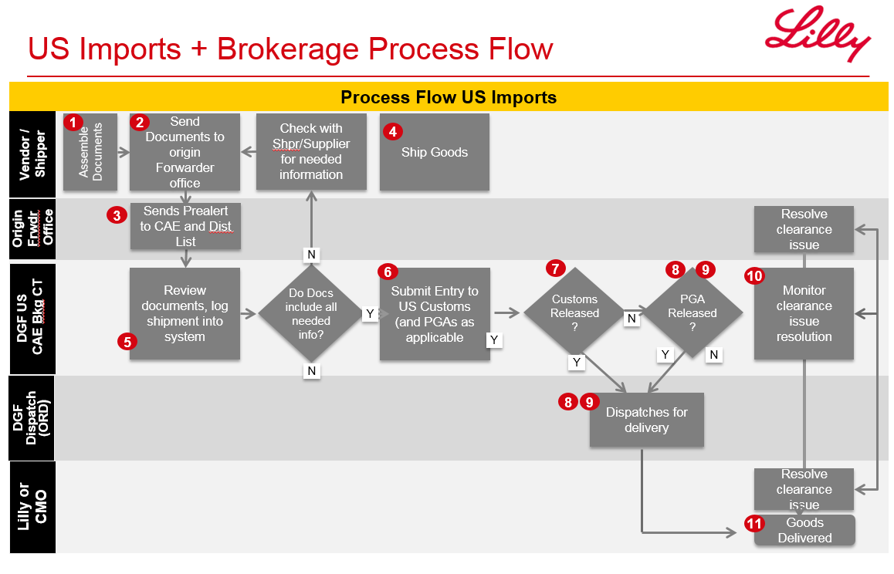

**Extra Instructions**

**3rd Parties/ Suppliers**

1. Insurance
   1. *Do not* purchase or sign for additional insurance or declare a value beyond the carrier’s normal liability. Eli Lilly and Company maintains a very robust and competitive insurance program and will not pay for the additional insurance.
2. Processing Multiple Orders and/or Pieces
   1. Where possible, consolidate multiple orders shipping on the same day, to the same address on one air bill or bill of lading and include each Lilly purchase order number on the air bill or bill of lading.
   2. Label each multiple piece/bundle with the destination and number, 1 of 3, 2 of 3, 3 of 3. The numbering must appear on the label or in close proximity to the shipping label.
3. Hazardous Material
   1. You *must* ship in accordance with the United States Code of Federal Regulations, IATA and IMCO regulations.

**Risk Management**

**Claims Procedure:**

If a shipment is lost or damaged, a claims procedure can be found at the Corporate Risk Management collaboration site: [Eli Lilly and Company Cargo Claim Procedure](http://lillynetcollaboration.global.lilly.com/sites/LillyCorporateRiskManagment/programs/cargo/Pages/Cargo-Claim-Instructions.aspx). This online form allows you to submit all the necessary information to beginthe claims process.

**Contact Information:**

Chris Edwards

Advisor, Corporate Risk Management

Corporate Risk Management

Eli Lilly & Company

edwards_christopher_t@lilly.com

(317)433-8166

**Compliance: *Import* Instructions**

**Important Notice:**

Several Federal agencies regulate the import of foreign-sourced merchandise into the U.S. and Puerto Rico. The primary agencies that regulate and monitor Lilly’s import activities into the United States and Puerto Rico include U.S. Customs and Border Protection (CBP), the Food and Drug Administration (FDA), the U.S. Department of Agriculture (USDA), and the Environmental Protection Agency (EPA).

Eli Lilly and Company has a long-standing company policy, reflected in the *Red Book – Standards of Business Conduct*, to comply with all laws applicable to its business. The *Eli Lilly and Company Policy on Import and Export Laws*, *U.S. Customs and Importation Policy*, and *U.S. Operations Import* implement this long-standing company commitment.

To ensure that Lilly proactively meets its compliance obligations, Procurement representatives who initiate the purchase of foreign-sourced merchandise must understand the import compliance considerations relevant to their sourcing activities.

**Who does this affect?**

All Procurement representatives who are involved in negotiating or initiating purchases of foreign-sourced merchandise must understand and adhere to the requirements contained in these references.

**What does this mean?**

All affected parties need to determine if the contract or purchase order on which they are working needs an import compliance review to ensure that U.S. import requirements are appropriately considered.

If you are:

1. A Sourcing Associate
2. issuing a purchase order for tangible goods
3. working on a contract to procure tangible goods for Lilly
4. currently in one of these stages:
   1. **Master Service Agreement**
   2. **Work Order**
   3. **Renegotiation of a Master Agreement**

Please answer the following question:

1. Does the purchase include foreign-sourced, tangible merchandise that will be delivered to the U.S. (i.e., Are you purchasing a tangible good that is physically coming to the U.S. from OUS?)?

If you answered **YES** to this question you **NEED** to include the appropriate import language from the **MOAT**, and contact your local U.S. import compliance coordinator, or the U.S. Import Compliance group, for further review.

If you answered **NO** to this question, your contract does involve imported into the U.S. and language from the “Imports” section of the **MOAT** does **NOT** need to be included in your contract.

**Contact Information**

* Members of the U.S. Import Compliance group may be are found on the U.S. Import / Export Compliance website:

<http://lillynet.global.lilly.com/sites/ImportandExportCompliance/contacts/Pages/default.aspx>

* If you need any other compliance information it can be found at the U.S. Import/Export compliance website:

<http://lillynet.global.lilly.com/SITES/IMPORTANDEXPORTCOMPLIANCE/Pages/default.aspx>