

Coffee Shop
Business Plan

Getting Started

A coffee shop business plan provides you with the opportunity to organize your vision and ensure that nothing is overlooked when opening a coffee shop for the first time.

For every step of opening a coffee shop, your business plan will be there to guide you. The operations of your coffee shop will run more smoothly if you use a detailed business plan as a north star.

Instructions for Your Coffee Shop Business Plan Template
Start with the cover page. Insert your company logo as well as your name, address, phone number, and email address.

Then, continue to the business plan itself. As you’re filling out each chapter in this business plan template, there are prompts and directions in italics below each section header. Your writing
starts in the regular text below the prompts. Simply delete “Start...” and begin writing. Each coffee shop concept is different, which is why we chose to give you space to explain your individual concept in detail.

Finally, when you’re ready to show your business plan to the world, simply delete everything in italics, as well as the first page and the last page. Your business plan will start with the cover page and end with your financial analysis. To print, click File > Print and to download, click File > Download As and choose your preferred format.

Ready? Let’s get started!



Joe Harper
101 Main Street, Chicago, IL
555-555-5555
jow@yum.com

Table of Contents

1. Executive Summary
2. Company Overview
a. Sample Menu
b. Team and Management
3. Market Analysis
a. Target Market
b. Location Analysis
c. Competitive Analysis
4. Marketing Plan
5. Operations Plan
6. Financing and Loans
7. Sales Forecasts and Operating Expenses

Executive Summary
The first section of your coffee shop business plan is an executive summary – a concise introduction to your coffee shop’s concept. The executive summary introduces key elements of your business plan, such as an overview of the budget, the business’s mission, market, and core values, and a coherent vision for your product and style of coffee service.

Most coffee shops are counter-service restaurants focused on quality coffee, but some function as kiosks, or drive-throughs, or even full-service cafes. Knowing what market space you want your shop to occupy in relation to the local competition is crucial.

As you write the executive summary for your coffee shop’s business plan, imagine your reader and how you might capture an interest of theirs and persuade them to keep reading and potentially invest.

Start…

Company Overview
The differences between a company overview and an executive summary may seem subtle, but the company overview is more of a glossary for the rest of your business plan rather than a summary – more practical than attention-grabbing.

In this section, introduce the type of restaurant, ownership structure, and customer experience. In the case of a coffee shop, the company overview will define the brewing processes, coffee and food products, location, and labor and hiring practices for baristas.

The company overview section is also your chance to communicate the more conceptual visions for your brand to investors. Consider including information about how your coffee shop’s name, logo, color scheme, and presence make your customers feel and contribute to the experience.

Start…

Sample Menu
A sample menu is a unique feature of a business plan for a restaurant. Second and third-wave coffee shops, however, are expected to offer certain beverages while you might set your shop out from the competition with offerings unique to your shop.

Drip coffee, iced coffee, espresso beverages, teas – these are all standard. Coffee shops craft uniquely flavored beverages, partner with high-quality roasters, or create an ambiance that is in demand in an area to set themselves apart from the inevitable competition from second-wave corporations.

The sample menu will also force you to think concretely about how you plan to produce and serve the coffees and tea drinks and sandwiches or pastries on that menu. How will you store milk, brewed coffee, kegs for cold brew and nitro, and what brewing equipment will you need?

If you need some inspiration while coming up with your coffee shop concept, check out this list of restaurant concepts, this article on creating new menu items, and this set of menu templates.

Start…

Team and Management
Management and staffing in coffee shops can be highly specialized and competitive, and it’s important to make decisions about team structure and management before you start hiring. Baristas are often asked to be salespeople, line cooks, and a beverage development team in addition to producing coffee drinks.

Who will be in charge of research and development for coffee drinks and brewing methods? Will you be outsourcing for food, cross-training baristas to make food, or hiring a kitchen staff? Are you hiring someone to do marketing and PR online and on social media, or do you expect your manager to fill that role as well?

Also consider including information about what kind of jobs you plan to create, whether they are full-time or part-time, how you will hire or train workers with the right skill set, and how you plan to provide benefits and good pay. Your staff will factor into other crucial elements of your business plan, such as the budget and food/beverage production, so it’s important to have a concrete picture of your staffing needs.

Start….

Market Analysis
Competition in the coffee industry is stiff and finding an opening in the market is crucial to the success of any foodservice business. Investors will typically ask about three core aspects of the market in which you operate: the target market, location, and competition. Cover those three things in this section, as well as any additional market or industry factors you think are important to include.

Start…

Target Market
There is always a demand for coffee – but, does what you want to offer meet a gap in what other local coffee shops offer. Maybe there is a space in the market for a coffee shop with a nice patio or one that has a robust menu for the inevitable customer that makes your coffee shop their office or the lunchtime coffee drinker.

In this section, describe the target market and how it compares to the restaurant industry as a whole in terms of demographics, characteristics, and behaviors.

Start…

Location analysis
Concerning location, it’s not uncommon to see two coffee shops as neighbors – one serving sweet second wave drinks and the other brewing pour overs for adherents of third-wave coffee culture.

In this section, focus on the general area or city you plan to locate your coffee shop and why you chose that specific area. Note things like growth of the local economy and infrastructure projects nearby. Compare the existing market conditions to your intended target market. Potential investors will look at this section of the business plan carefully to make sure that the market in the proposed location aligns with the ideal customer profile.

Start…

Competitive Analysis
That second-wave shop next door isn’t your competition nor are you theirs because you attract a different segment of the coffee-drinking population. What you should be concerned about are the other specialty cafes or coffee roasters in the area that might be competing for the same customers. Maybe your shop is set apart, then, by walkability, superior quality, or ambiance.

In this section, explain the existing competitive landscape, paying particular attention to businesses with similar concepts. Investors will want to understand the specific aspects of your concept that will give you a competitive advantage.

Start…

Marketing Plan
In this section, write about how you’ll spread the word about your business.

Many coffee shops focus on digital marketing: they stay very active on social media and ensure they have a robust web presence with a great website. Because there is so much competition in the coffee market, a clear, cohesive brand is crucial to helping you attract customers but consistent, quality coffee and service will create regular customers.

You might also think about what opportunities you have to draw customers in by opening your coffee shop as a venue for performers or artists – lots of coffee shops allow local artists to hang prints, paintings, or macramé on the walls, or host open mic nights.

If there’s a space in the market for something like that in your community, it might be a good chance to create a loyal, local customer base while supporting local arts. Investors and customers alike, especially if they are locals, will be impressed by your plans to enhance the community.

To learn more about coffee shop marketing, check out our full length post on creating a coffee shop marketing strategy and download the Restaurant Marketing Plan.

Start…

Operations Plan
In this section of your business plan, include information about customer service, the point of sale, sales and inventory tracking, accounting, and the supply chain of the products on your menu.

Do you plan to be an owner/operator in your coffee shop, acting as the general manager and the owner, or do you plan to hire management staff to handle everything from payroll to production? Will you need a seasoned barista to develop brewing methods and beverage recipes or a kitchen manager to make pastries and sandwiches?

Because coffee shops can offer such a range of food and drinks, it’s important to plan for the complexities of how management and production will work, how employees are expected to guide customers through the experience, and how you will balance quality, consistency, and speed in production.

These myriad responsibilities are complicated further when spread across the handful of employees on a coffee shop payroll. Balancing employees, products, customers, inventory, and finances can be a daunting task and the business operations section is your opportunity to tell investors that you’re up to it.

Start…

Financing and Loans
If you are seeking to secure funding, have already secured partial funding, or have a plan to fund your coffee shop, it is crucial to include that information in your business plan. Provide potential investors with information about other investors and detailed financial plans about projections and expenses.

Some coffee shops go with SBA loans, others get microloans or work with alternative lenders, and others work with brick and mortar banks. Whatever route you choose — and there are so many different funding options! — provide your audience (and potential investors)
If you’re trying to figure out how you’ll finance your coffee shop business, check out this financing guide, which goes into more detail about some of your options.

Start…

Sales Forecasts and Operating Expenses
It’s especially important when starting a coffee shop to consider management and labor when considering costs: coffee shops are small storefronts with relatively low profit margin, depending on demand, and can easily go in the red when juggling an inventory for a small kitchen in addition to all the necessities for serving coffee and tea drinks.

In this section of your business plan, include a break-even analysis, which compares how much sales are required to break even with the cost of expenses each month. Investors will be interested in the potential for profit and loss before they contribute to your business, but to produce a profit and loss statement for a business that isn't open yet will require some educated projections.

Finally, a cash flow analysis will detail how you will spend money on labor, supplies, and operations which will show investors that the coffee shop can support itself without additional investment. Consider how the process of coffee beans, teas, pastry, your own and your employees’ salaries, and the costs of maintaining the coffee shop and brewing equipment balance at the end of each fiscal quarter.

Start…

Built for coffee shops. Built for you.
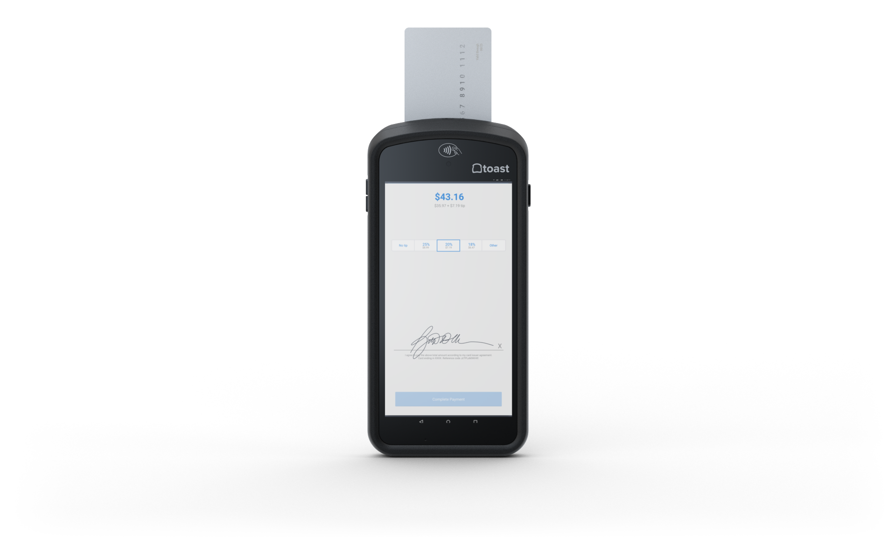

With an easy and intuitive POS system, your baristas and cafe managers can spend less time worrying and more time brewing lattes.

Fulfill orders fast with Toast, an easy-to-use solution built for serving more guests and eliminating the wait. Choose only what you need - and buy it your way.

To learn more about Toast’s Starter Kit package, click ‘Shop Now’ below.

Shop Now

Are you looking for more than 1-2 terminals?
Schedule a free demo

DISCLAIMER: All of the information contained on this site (the “Content”) is provided for informational purposes only and not for the purpose of providing legal, accounting, tax, career or other professional advice. The Content is provided “as-is” without any warranty of any kind express or implied, including without limitation any warranty as to the accuracy, quality, timeliness, or completeness of the Content, or fitness for a particular purpose; Toast assumes no liability for your use of, or reference to the Content. By accessing this site, you acknowledge and agree that: (a) there may be delays in updating, omissions, or inaccuracies in the Content, (b) the Content should not be relied upon or used as a substitute for consultation with professional legal advisors, (c) you should not perform any act or make any omission on the basis of any Content without first seeking appropriate legal or professional advice on the particular facts or circumstances at issue and (d) you are solely responsible for your compliance with all applicable laws. If you do not agree with these terms you may not access or use the site or Content.

