Communications 101 Boot Camp for Canadian Public Servants
  - Workbook



Table of contents

Lesson 2 – Identifying issues with communications products and advice 3
Lesson 4 – Role-Play: Collaborating with partners for best results 6
Lesson 8 – STAR / Accomplishment in Current Work Role 8
Lesson 8 – Build Your STAR Repertoire 9
ANSWER KEY 14

Lesson 2 – Identifying issues with communications products and advice
Using the information you have learned in lesson 2, review the following three communication products, identify issues and propose solutions.
Scenario 1: Identify issues with this social media post and propose solutions.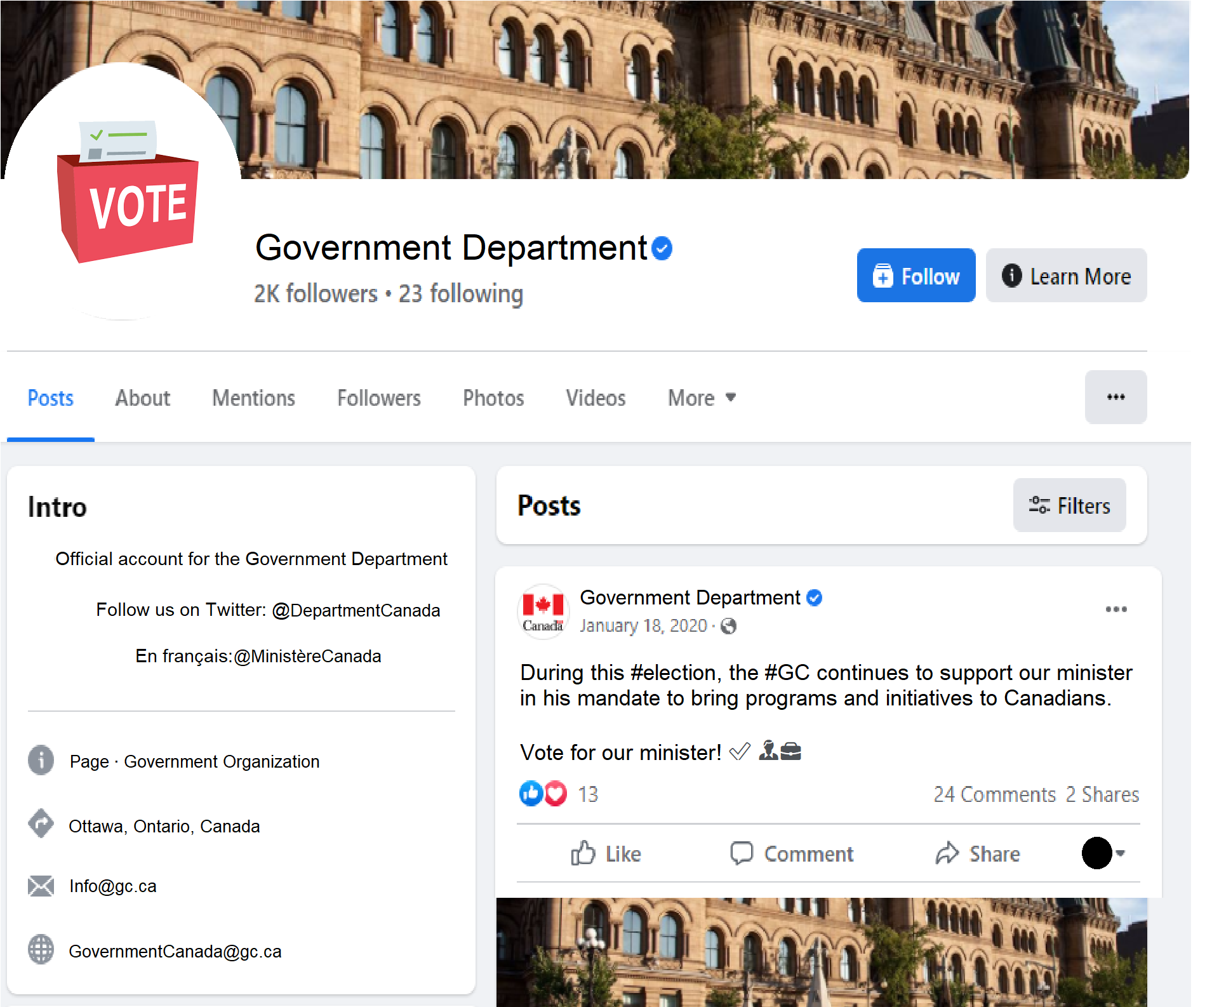
(Enter your answer here)

Scenario 2: Identify issues with this section of the communications plan and propose solutions.
(Enter your answer here)

Communications plan
Objective: Inform target audiences about the programs and funding available for projects to protect marine coastlands.
Target audiences: Marine ecology scientists; non-governmental organizations; Indigenous communities living in coastal regions.
Key messages:
- The Government of Canada takes its commitment to educating children in Saskatchewan about marine coastlands seriously.
- To learn more about funding programs, visit the Canada.ca website.

Scenario 3: Identify issues with this internal email and propose solutions.
(Enter your answer here)

From: Internal Communications Team
To: Entire Department (all buildings)
Subject: Protest
Please note that there is a protest in progress outside the main building at XYZ Street. For safety reasons, we ask all personnel entering or leaving the building to use the back entrance situated on WXY Street. All other doors will be locked until further notice. For inquiries, please reach out to securitybureau@department.gc.ca or call in 1-555-555-5555.
***
Faire attention sur la rue XYZ. Appeler au 1-555-555-5555 pour toutes questions.
The Security Bureau / Bureau de sécurité

Lesson 4 – Role-Play: Collaborating with partners for best results

Instructions: To practice building relationships and collaborating with partners, review the scenarios below and explain what questions you would ask, what strategic considerations you would highlight and what advice you would provide.

Scenario 1: You are in a meeting with a program partner and there is a request to produce a new video to promote the program benefits and information to Canadians. A communication strategy currently exists, including an information webpage, weekly social media graphics and posts, and an animated video. Analytics and quarterly evaluation have determined that there is moderate to good engagement and traffic on social media and the web.
(Enter your answer here)

Scenario 2: Your department is about to start promoting a new program. It is a major initiative that requires significant promotion to explain the program and increase visibility and uptake. The program is targeted to youth. The program manager wants to have a unique new logo designed that does not look like other government communications products, which likely wont appeal to the target audience. The communications activities will involve web pages, web ads, publications, posters in shopping malls and bus shelters and national television advertising. The program manager has asked you to start developing the logo and the look for this program. How do you handle this situation?
(Enter your answer here)

Lesson 8 – STAR / Accomplishment in Current Work Role

Practice the STAR interview technique by writing an accomplishment statement.

Instructions
- Write a full statement of one of your accomplishments. Think about your current position and the value you bring to the organization. Identify a specific contribution you have made. Then, describe what you did to make that contribution, starting with an action verb and explaining the impact of your actions. Ask yourself what value was created because of your actions.

- Use the STAR framework to structure your responses:

• What was the Situation?
• What was your Task?
• What Action did you take?
• What was the Result?

(Enter your answer here)

Lesson 8 – Build Your STAR Repertoire
Exercise from the Health Canada Interview Toolkit

The purpose of this exercise is to help you think about the kinds of examples you would share with an interviewer. Read the example below and then complete as many of the exercise items as you need to get the feel of giving STAR responses. The example below contains a complete STAR response, as a candidate would give it to an interviewer. Exact wording has been captured to convey all the elements of a typical STAR response.

However, you do not need to write in as much detail to complete this exercise. You are the only one looking at your responses, so use keywords, phrases, bullet points and abbreviations that mean something to you – just enough to jog your memory. Make sure that when you are actually in the interview, you use clear and precise wording.

Example: “Tell me about a time when you went out of your way to satisfy a customer.”

Situation/Task: I was working in the production department of a large publishing company. We received a letter from a nine-year-old girl who was unhappy because the gold design had worn off the cover of a book we had published. She wanted a refund. My boss gave the complaint to me to handle.

Action: I immediately requested a refund check from our accounting department. I also called our printer, who investigated and identified one run of books in which the covers had been improperly printed. I obtained a copy of the book with a properly printed cover, and sent the book, the refund check, and a personal letter to the girl, thanking her for pointing out the problem and apologizing for the inconvenience.

Result: The girl’s mother called to thank me for the response. She told me that she was going to recommend our books to all her friends with children.’’

Now it’s your turn. For each question below, use the STAR technique to describe an example from your work experience.

Continuous Learning and Growth: “Tell me about a time when you had to learn something totally new.” Hint: Detail the steps you took to learn and tell how you applied what you learned.
(Enter your answer here)

Tenacity: “Give me an example of a time when you faced a lot of obstacles to achieve a goal.”
Hint: What were you trying to accomplish? What were some of the obstacles you faced? How did you address them? Were there some failures along the way and how did you learn from them? What were the steps you took to achieve your goal? How did things turn out? Based on what you learned, what would you do differently next time?
(Enter your answer here)

Planning and Organizing: “Tell me about a situation (personal, academic or professional) in which you were responsible for planning and organizing an event.”
Hint: How did you get the assignment? How did you approach the task? How did you keep track of things? What tools did you use (to do list, organizer, etc.) to help you? How did you work with others when organizing the event? What was the first thing you did? What steps did you follow? How did you feel when the event took place? What were the results?
(Enter your answer here)

Stress Tolerance: “Give me an example of a stressful situation you’ve experienced.”
Hint: What was happening? What made it stressful? Were you in the situation alone or with others? How did you interact with the others? What did you do in this situation? Were you in control of events (for example, taking an exam), or did you require outside help (for example, being trapped in an elevator)? What did you do to manage your stress? How was the situation resolved? How did you feel afterward?
(Enter your answer here)

Leadership and Influence: “Tell me about a time when you guided individuals toward achieving a goal.” Hint: Were you assigned as leader, or did you step up to the task? Why was achieving this goal important? What did you do to make sure everyone worked together? What interpersonal challenges or conflicts did you face? How did you help people overcome them?
(Enter your answer here)

Initiative: “Tell me about a project or role that you’ve taken on that is outside your job description.” Hint: What initiative did you take and why? What was the end result? Describe a job or role that you changed substantially while you held it.

(Enter your answer here)

Communication: “I’d like to hear about a time when you had trouble seeing eye to eye with a colleague.”
Hint: Clearly explain the situation and walk through the steps you took to resolve the problem. Include any lessons learned and explain how you would handle things differently in the future if this type of situation.
(Enter your answer here)

Teamwork/Building Partnership/ Collaboration: “Tell me about a time when you worked with a group or team of people to complete a project.”
Hint: Describe your role and what specific actions you took to ensure the project’s success. What team problems arose, and how were they resolved? What did you learn from the experience (i.e. what worked well, what didn’t work well) and how would you apply these lessons when working on a project in the future?
(Enter your answer here)

Decision-Making: “Tell me about a time when you were faced with a difficult decision and describe how it turned out.”
Hint: What alternatives did you consider? If a similar situation arose in the future, would you handle things the same way or differently, and why?
(Enter your answer here)

Diversity and Inclusion: The federal public service is committed to building a more diverse, equitable, and inclusive workforce that is representative of all the Canadians we serve. Canadians have different lived experiences and backgrounds based on race, ethnic origin, religion, age, sexual orientation, gender identification and expression, and ability, among others. What have you done, or what would you do, as an individual, to contribute to a more inclusive and equitable work environment, where all of your colleagues feel a sense of inclusion and belonging in the workplace?

Hint: What steps did you take? What were the outcomes for your personal development? How did your action impact your colleagues or your workplace overall?
(Enter your answer here)

Reference

Government of Canada. (n.d.). Health Canada Interview Toolkit. GCconnex. (GC network only)

ANSWER KEY

Lesson 2: Identifying issues with communications products and advice
Scenario 1: Some possible answers include:
  - The post does not respect the Policy on Communications and Federal Identity or the directives around non-partisan communications. The solution is to talk to your manager about correcting or removing the post.
  - Emojis should be avoided, as they are not accessible.
  - The Federal Identity Program(FIP) is not respected on the Facebook page, specifically the part about custom avatar. Custom avatars must be developed in consultation with the Communications and Federal Identity Policy Centre at TBS and approved by the department’s head of communications. The solution is to have the avatar updated with the correct FIP which would come from your departmental FIP coordinator.
Scenario 2: Some possible answers include:
  - The first key message does not meet the needs of the target audiences, specifically Marine ecology scientists; non-governmental organizations; Indigenous communities living in coastal regions. The solution is to create a key message per target audience.
  - The second key message lacks information, such as the Program names, who can apply, and what the program is about. The solution is to rework it to include relevant information that aligns with target audiences.
Scenario 3: Some possible answers include:
  - The email is not completely translated in both official languages. The solution is to ensure that the email contains the same information in both French and English.
  - In addition, the email is addressed to all staff but it only pertains to one building. An all-staff message is not the right communications approach.

Lesson 4: Role play: Collaborating with partners for best results

Here are some possible answers to both scenarios.

Scenario 1:
- Recommend to the partner that you work together so you can provide the best strategic considerations, advice and solutions.
- Ask questions to see why the partner would like a second video. Perhaps they are not aware that one already exists, or maybe the video doesn’t meet the needs.
- If appropriate, you can recommend looking at creative ways to maximize the current video’s exposure.
- You can ask whether there are there any stakeholders with large followings that could post the video and share your social media posts on their platforms?
- You can recommend exploring other options, that are not a video, to generate more user engagement and traffic to the application webpage.
- You can provide the partner data from your analytics and quarterly evaluation to support your advice.
- As the evaluation of the web traffic indicates a good number of people are viewing the webpage, you recommend looking at what is happening when a visitor arrives on the page. Some probing questions to ask yourself and your partner include:
  - Has feedback been collected on the application process?
  - Are visitors getting the information they need?
  - Is it a complicated application process?
  - Are there barriers to accessibility that might be reducing the number of applicants?
  - Is the web page mobile friendly and accessible?

Scenario 2:
- Ask the partner why they don’t want a traditional logo. You may find out that the target audience is distrustful of government. Or perhaps there are other reasons they can explain.
- Ask the partner what success looks like.
- You discuss the Policy on Communications and Federal Identity and see what compromises can be made.
- One strategic consideration to highlight is that a unified federal identity that is applied consistently ensures that the public can easily recognize the Government of Canada and its programs, services, facilities, assets, activities and uniformed officials. FIP supports the principle of government accountability by clearly identifying areas of federal responsibility and the allocation of public funds.
- There is flexibility to create a unique look and feel, as long as it includes the FIP (e.g., the departmental signature or Government of Canada signature and the Canada wordmark).

-END OF WORKBOOK-

