**Ways of working agreement**

[Name/title of the role]

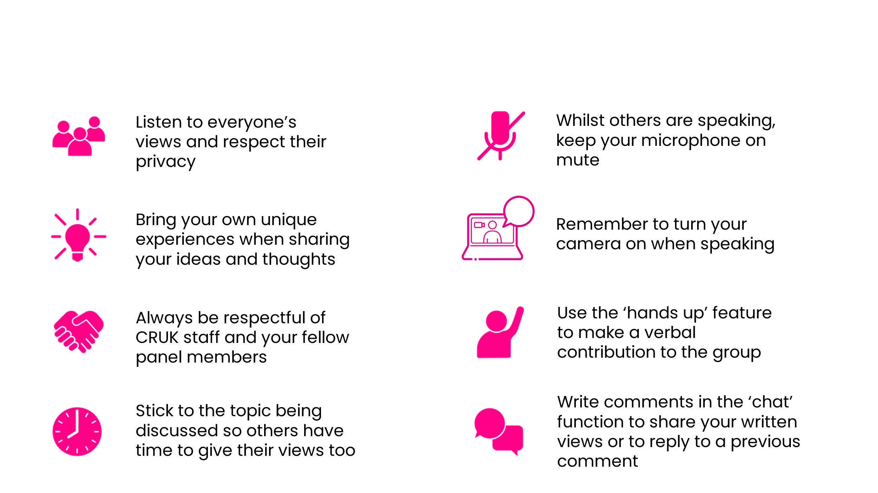**Code of conduct for meetings**

**Values and behaviours**

For the duration of your involvement, we promise we will:

* Acknowledge your expertise as someone affected by cancer.
* Always maintain your confidentiality.
* Give you a safe and confidential space to share your views openly.
* Listen to your unique ideas, views and thoughts and take these on board without judgement.
* Celebrate everyone’s diversity and differences.
* Give plenty of notice for scheduled meetings, give you enough time to prepare for them, and clearly communicate any deadlines with you.
* Provide all the information you need for you to contribute effectively.
* Support you as and when required for the duration for your role.
* Update you on the impact of your involvement and the difference you have made.
* Address any accessibility needs to ensure you can fully participate.
* Regularly ask for feedback and respond to your suggestions and concerns.

While working together, we expect you to:

* Maintain confidentiality around our work and of other patient representatives when working together.
* Bring your unique experiences when sharing your ideas and thoughts (these can be personal, professional or both).
* Respect staff and fellow patient representatives when working together (this includes verbally or in writing) and provide any comments in a constructive manner).
* Take accountability for your behaviour and actions and be open to receiving feedback.
* Let us know if there are any changes in your personal circumstances that may affect your involvement.
* Commit to our aims and values.
* Support and act in accordance with our policies and procedures. This includes raising any issues or concerns and reporting any incidents.
* Share feedback with us about your experience of being involved. Let us know if you have any problems so that a solution can be found together.