

Credentialling Workbook for Procedural Guidance

Contents
- Introduction Page 2
- Checklist for submission Page 3
- Instructional educational program Page 4
- Procedural guidance protocols Page 5,6,7
- Logbook requirements Page 8
- Assessment forms Page 8, 9, 10
- Certificate of completion Page 11
- Maintenance Page 12

Introduction
Procedural Guidance Ultrasound is the assistance of Ultrasound in any needle guided procedure. Ultrasound Guidance for procedures is a crucial skill in order to increase accuracy and success rate of a procedure, decrease needle attempts and redirections, and decrease complication rates of the procedure. It includes Vascular access, Regional Anaesthesia and Thoracoabdominal Cavity and Joint Procedures.
The basic pathway to competency follows a structure of: theory and introductory phase, supervised practice, experience and exit assessment of competence, the details of which can be found in this booklet.
The credentialing process requires candidates to:
- Complete an appropriate instructional educational program
- Perform and record a requisite number of supervised and logged emergency department ultrasounds
  - A minimum of 25 successful needle guided procedures must be performed. Ideally this will include a mix of procedures including peripheral vascular access, central vascular access, arterial lines, pleural or peritoneal aspiration and nerve blocks
  - A minimum of three directly supervised procedures must be performed for both in-plane and out-of-plane needle guidance (total of six). Up to three of the directly supervised procedures can be on simulators if necessary.
  - There should be a minimum of two formative assessments completed (these can count towards the six supervised scans, but must be completed on patients).
- Pass a summative assessment
- Once credentialed, meet ongoing maintenance requirements
  - At least three hours of ultrasound training per year
  - Perform or supervise a minimum of 25 successful needle guidance procedures per two-year cycle and maintain a logbook to prove this for audit purpose

- Personal Details
Credentialling in Procedural Guidance
Unit Completion form

Family name:
Given names:
Email Address:
- Educational Program

☐Introduction to ED POCUS course certificate
☐USS physics course certificate
☐Procedural guidance theory course certificates: Introduction to procedural guidance, vascular access, thoracoabdominal cavity and joint procedures, regional anaesthesia
☐Procedural guidance practical course component met, and certificate provided
- Experience phase
☐ I have used a logbook and the scans have been reviewed by a credentialled scanner/supervisor
☐ My logbook contains: A minimum of 25 successful needle guided procedures. This includes a mix of procedures including peripheral vascular access, central vascular access, arterial lines, pleural or peritoneal aspiration and nerve blocks
☐ There are three directly supervised procedures for both in-plane and out-of-plane needle guidance (total of six). At least 50% of these directly supervised procedures are on patients.
☐ The above requirements are clearly labelled and identifiable within my logbook.
- Demonstration of Competence
☐ I have completed 2 formative assessments and 1 summative assessment, all of which are completed on patients
☐ Assessments are not completed on the same date
☐ All assessments are signed by both my supervisor and me.
- Maintenance Requirement
☐ I acknowledge that to maintain these credentials I will undertake at least three hours of ultrasound training per year
☐ I acknowledge that to maintain these credentials I must perform or supervise a minimum of 25 successful needle guidance procedures per two-year cycle and maintain a logbook to prove this for audit purposes
Instructional Educational Program for Procedural Ultrasound
- Basic Ultrasound Knowledge: A formal course should include education on the Physics of Ultrasound and Instrumentation. Online Ultrasound Courses that provide this basic knowledge include the Australasian College for Emergency Medicine (ACEM) Ultrasound Course modules. Anyone can access these modules by creating an ACEM login. The Introduction to POCUS and Physics course can be found at Course: Ultrasound (acem.org.au) or https://elearning.acem.org.au/course/view.php?id=951
  - Physics: Piezoelectric effect; Wave characteristics – cycle, frequency, period, wavelength, amplitude; Echogenicity; Image resolution; Attenuation; Doppler effect; Impedance; Artefacts; Bio-effects
  - Instrumentation: Transducer types and selection; Transducer manipulation; Image labelling; Focu; Gain; Time gain compensation; Orientation; Scan planes; Image measurement; Infection control; Machine care and maintenance

- Procedural Guidance Theory: A formal course should instruct on normal anatomy, views obtained, possible findings, clinical algorithms and integration, limitations/pitfalls and reporting. ACEM provides Procedural Guidance learning modules (Introduction to Procedural Guidance; Vascular Access; Thoracoabdominal Cavity and Joint Procedures; Regional Anaesthesia Course: Ultrasound (acem.org.au) or https://elearning.acem.org.au/course/view.php?id=951
  - Introduction to procedural ultrasound: Relevant anatomy; Indications/ contraindications and complications; Limitations/ pitfalls; Reporting; Practical sessions using phantoms
  - General Principles: Direct vs. indirect method; In-plane vs. out-of-plane method; Principles of infection control; Reporting
  - Vascular access: venous and adjacent anatomy; arterial and adjacent anatomy; Limitations/pitfalls; Reporting
  - Pleural and abdominal aspirations: anatomy; fluid identification; loculation identification; Limitations/pitfalls; Reporting
  - Foreign body: Identification; Methods of removal; Limitations/pitfalls; Reporting
  - Nerve and fascial plane blocks: Regional anatomy; Local anaesthetic toxicity; Limitations/pitfalls; reporting

- Procedural guidance Practical ultrasound sessions. It is essential that practical ultrasound sessions include:
  - Demonstration of correct application protocol for emergency indication.
  - Minimum time – two hours
  - Maximum student: instructor ratio – 5:1
  - Live ultrasound models for scanning sessions, preferably including both normal subjects and patients with demonstrable pathology. Patients or professional-grade simulators are preferable for abnormal anatomy (ultrasound cineloops showing the same pathology may be substituted for models). Practical sessions for Procedural guidance should include phantoms for vascular access, pleural and abdominal aspirations and foreign body identification and removal.
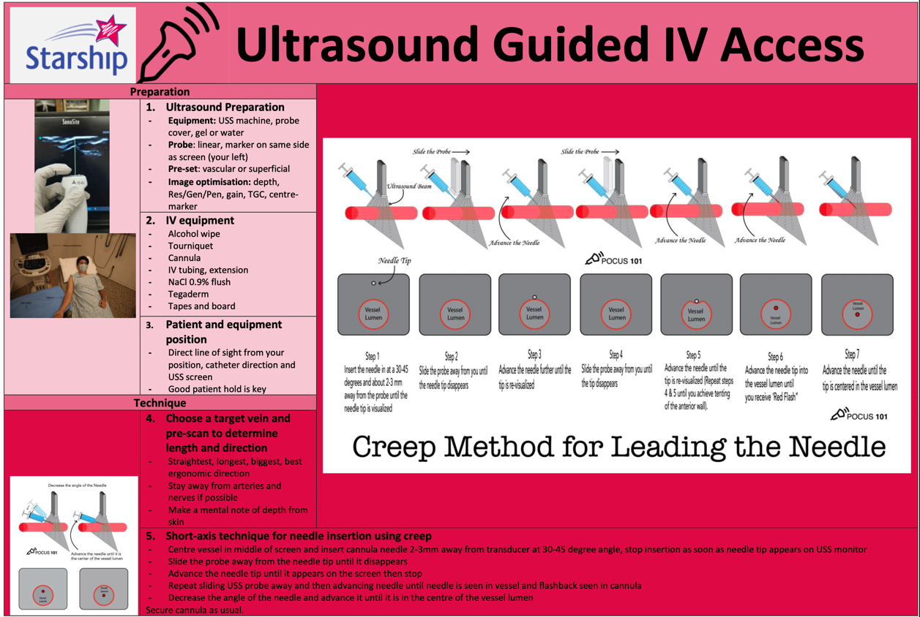
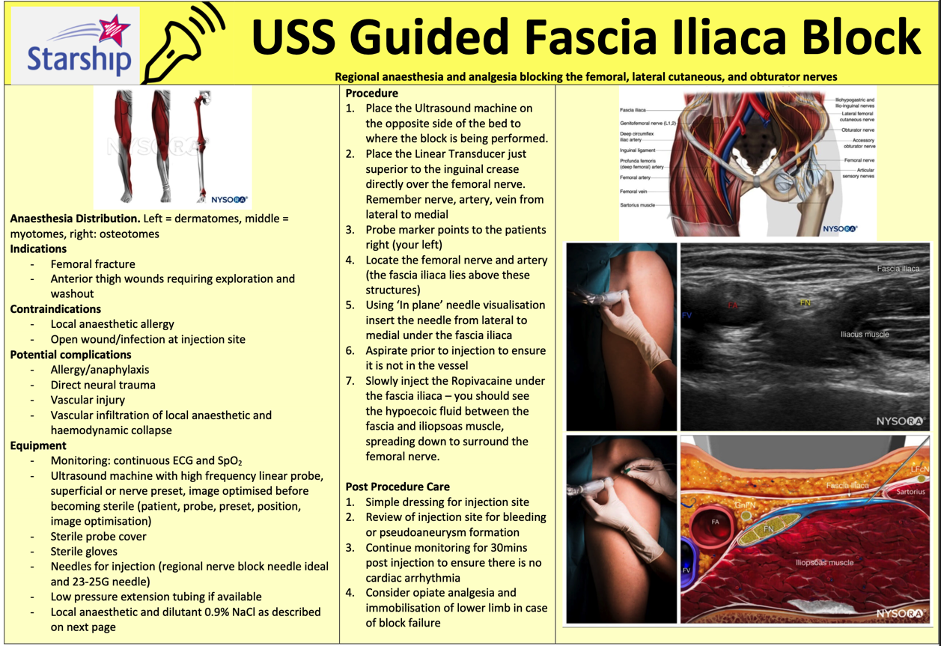
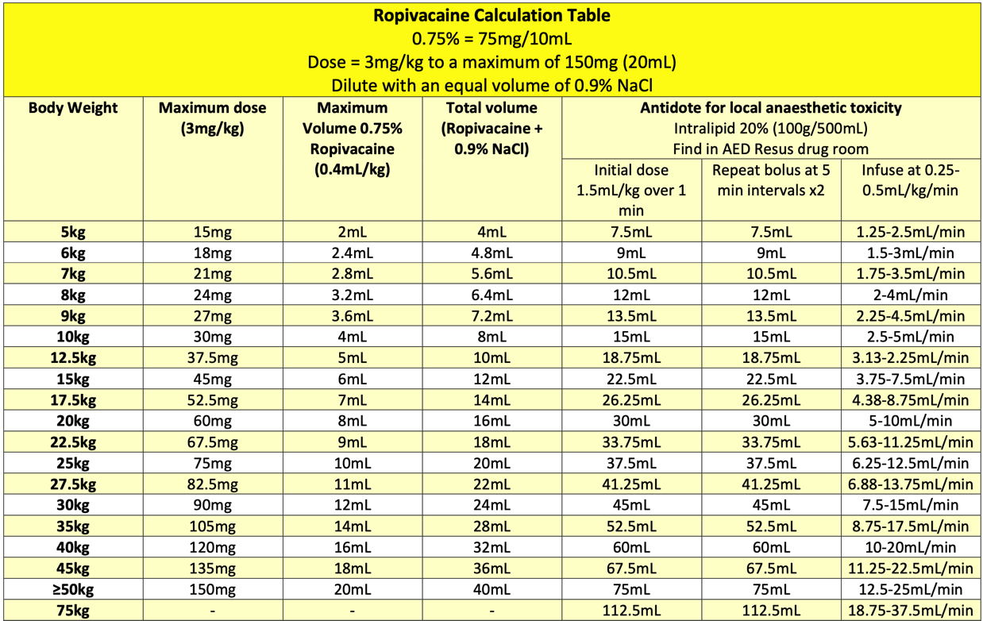Logbook requirements
Patients must be informed that the ultrasound examination is being performed for credentialing purposes and verbal or written consent obtained.
Ultrasound examinations must be documented in an appropriately secure logbook. The entry should include:
- Clinical details
- Date and type of ultrasound examination performed
- Findings
- Candidate’s interpretation of those findings
- The findings and interpretation should subsequently be compared to other clinical data and a notation made as to whether the scan findings were accurate.
- Where the scan was not supervised there should be confirmatory evidence of the accuracy of the examination (via additional studies or clear clinical evidence).
- All logbook scans should be either directly proctored, or the images reviewed at a later date by one of the trainee’s supervisors.
We encourage you to perform as many of your logbook scans as possible with a credentialed clinician in order to gain feedback.
A logbook template can be found on the CED Credentialling page under “Credentialling Resources”

Assessments
For each modality, at least two directly supervised formative assessments must be completed prior to a final summative assessment. Assessments forms can be found on the next page or on the CED Ultrasound website.
The final summative assessments and credentialing process must be overseen by a clinician who is themselves credentialed in that modality. They will observe the candidate performing the ultrasound examination and will not give any feedback during this examination. This may be undertaken simultaneously as a Direct Observations of Procedural Skill (DOPS) assessment for FACEM Trainees.
Once the examination requirements are satisfied, the emergency medicine practitioner will be credentialed for the appropriate ultrasound module. The emergency medicine sonologist may then document the results of his/her ultrasound scans in the medical record and incorporate the results into clinical decisions. ACEM has a formal link with the Australasian Society for Ultrasound Medicine. ACEM accepts successful completion of the Certificate in Clinician Performed Ultrasound (CCPU) as appropriate demonstration of competence.

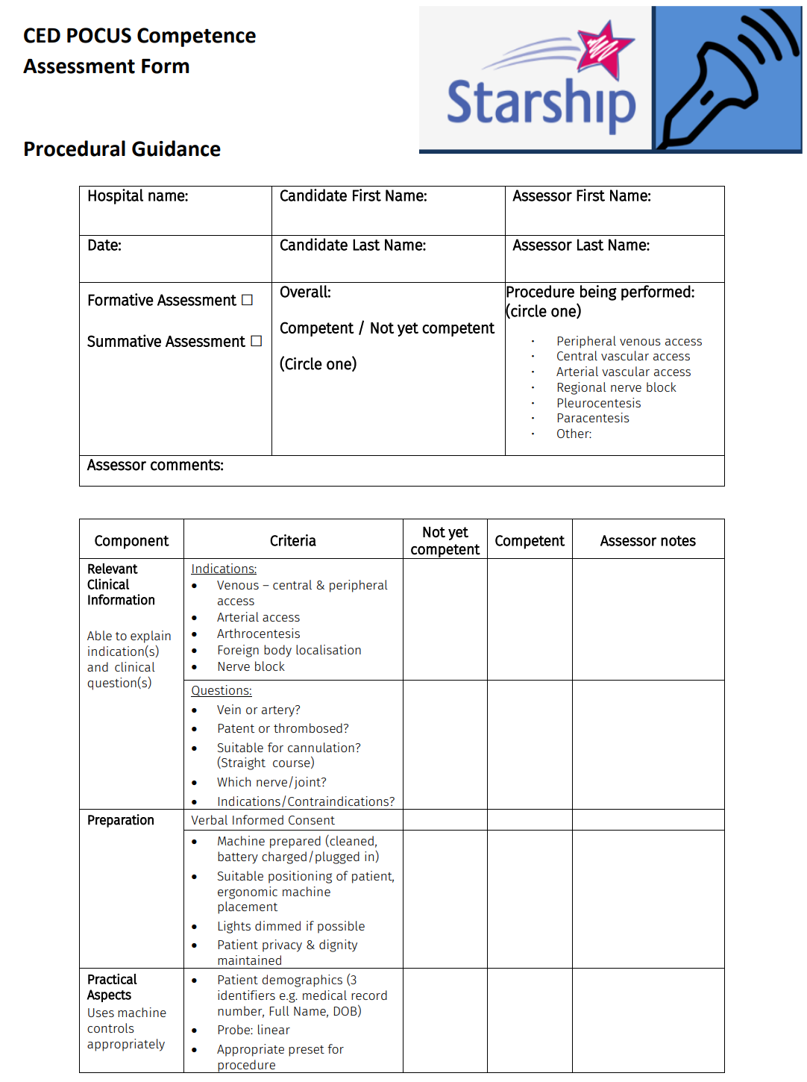

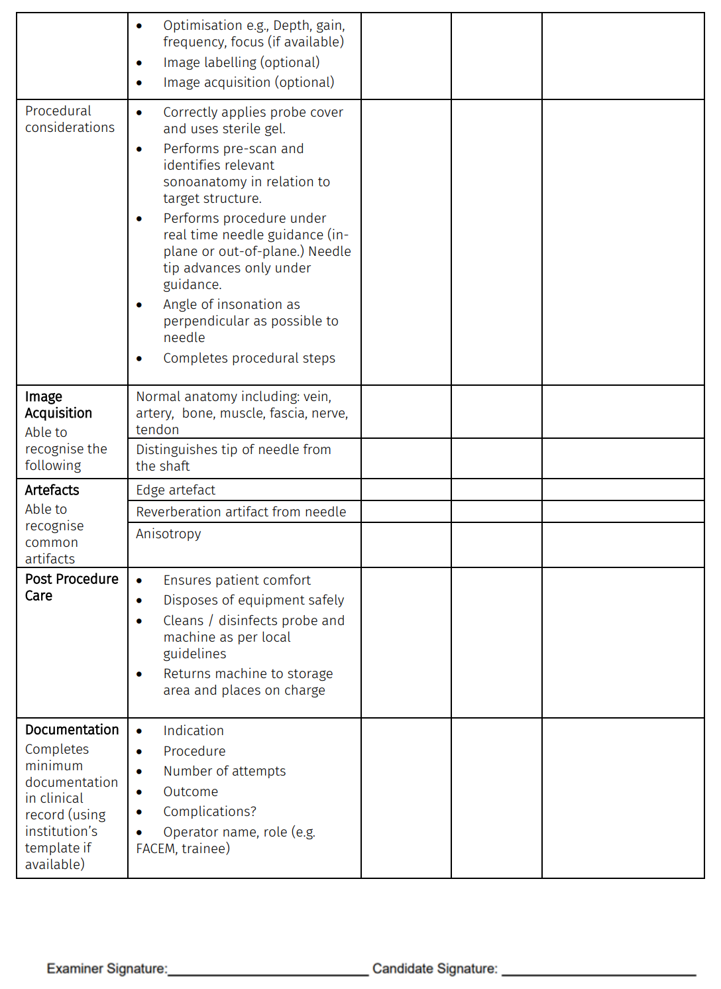

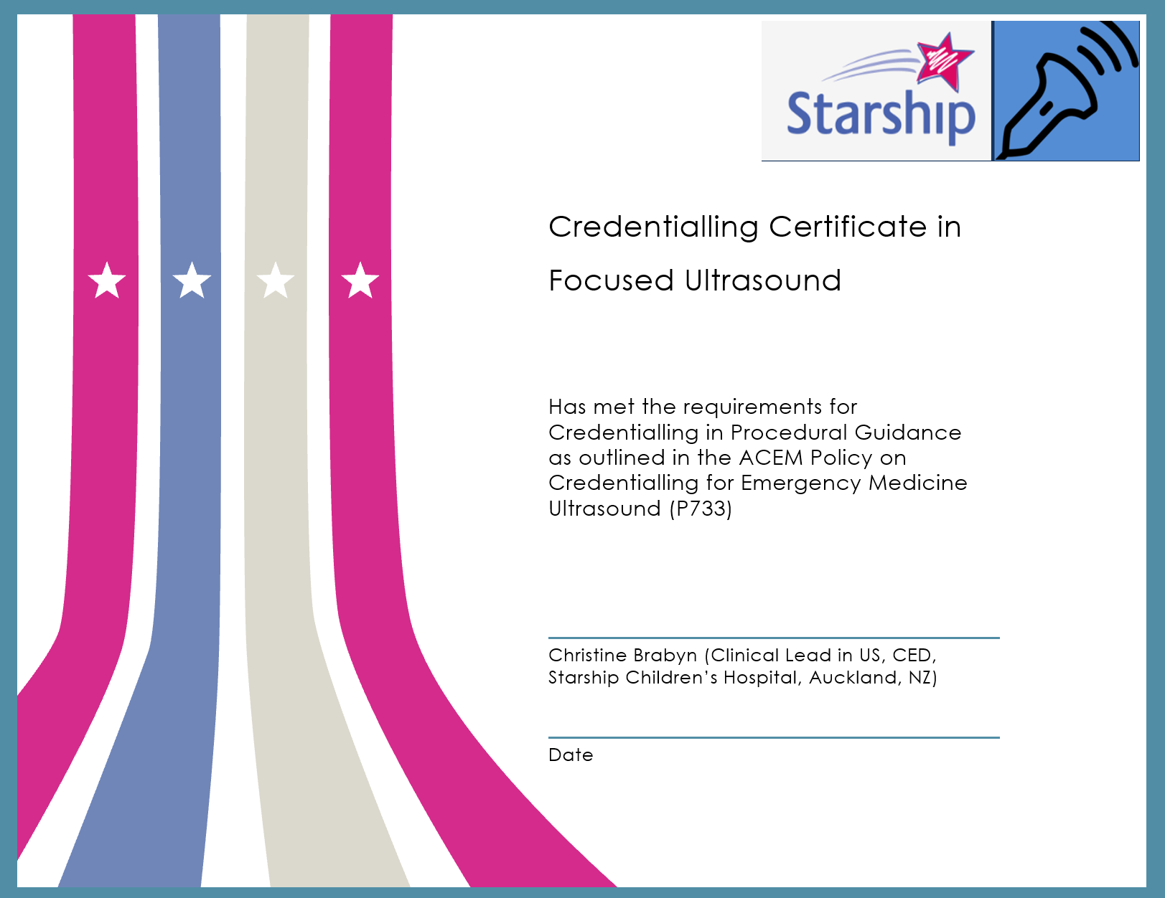

Credentialling Maintenance
To maintain his/her credentials, the emergency medicine sonologist should undertake at least three hours of ultrasound training per year. This may include:
- 1:1 training with a qualified Sonographer Educator in ED (SEED);
- attending or presenting at an ultrasound webinar/workshop or conference;
- teaching on an accredited course;
- participation in ultrasound quality assurance and retrospective image review; and
- reading Ultrasound journals or textbooks.
For the Procedural Guidance module, the emergency medicine sonologist must perform or supervise a minimum of 25 scans per two-year cycle. It is recommended these are logged in a logbook for audit purposes. An example logbook could contain the following columns:
- Date
- Case for 14 years and under?
- Supervised scan? (Did you supervise this scan, rather than personally perform?)
- Trainee’s name (if supervised scan)
- Clinical Indication (indicate the symptoms or condition that substantiates the necessity for further investigation by an ultrasound scan)
- Positive?
- Interpretation and Clinical Findings
- Comparison with further imaging or clinical outcome

