Certificate of Completion

This Certifies that

Name
has successfully completed the online self-paced course
Alternative and Augmentative Communication (AAC) Guided Pathways
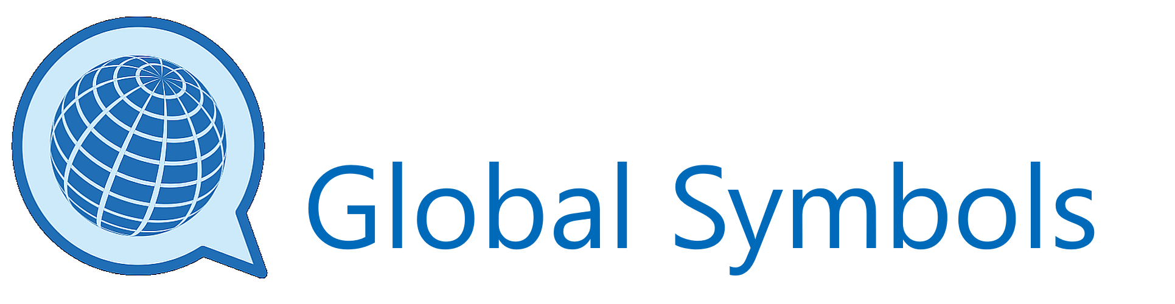

Date Signed

