We can lead this too!

The Annunication

Theme: Solemnity of the Annunication (date: 25 March)
Purpose: to help children reflect on the meaning of the Annunciation. This resource can be adapted to use for collective worship or for an assembly. It is designed so that pupils can lead.
Liturgical colour: white
Materials Required: accompanying PowerPoint, copy of prayers/script for readers
Suggested hymns: As I kneel… (Laudate 360), Holy Virgin… (Laudate 366), My soul is filled with joy… (Laudate 339) An angel came from heaven (Laudate 330)

Note: if the Annunciation falls within Lent or the Easter Octave it moves to the Monday of the second week of Easter

Time allocation: 10-20 minutes (optional slides)

Slide | Script | Ideas
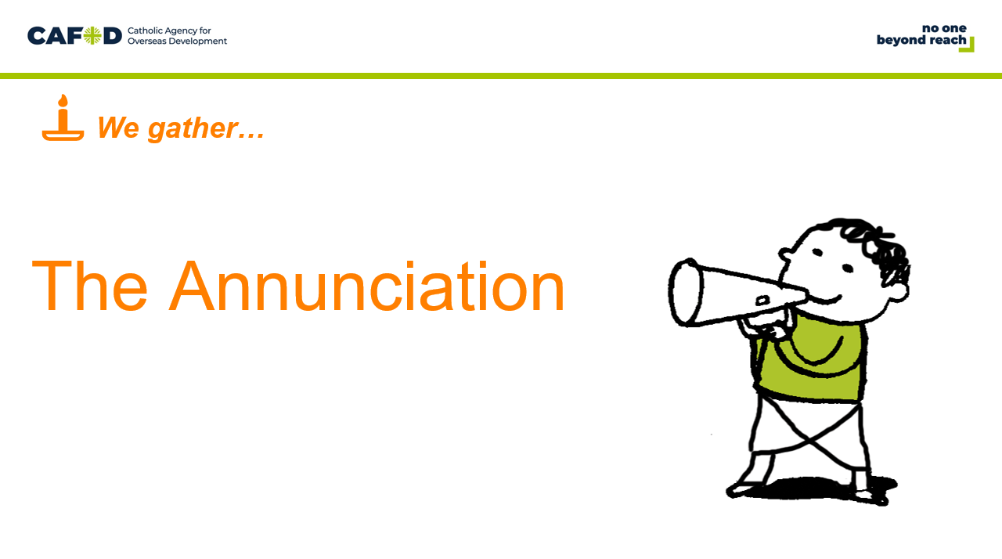 | Reader: In the name of the +Father, and of the +Son, and of the +Holy Spirit Amen.  We gather today to celebrate a very special day, called ‘The Annunciation’.  Can you guess what this special day might be about, from the sound of the word, annunciation?  Reader: The Annunciation is about an announcement. In fact, it’s an announcement about something incredible!  Reader: It’s the day when we celebrate that Mary said a generous yes to God and that her son Jesus, who is God, became a member of our human family and came into our world, to live with us and to show us how to live. | Play quiet music  Light a candle
We gather: We come together as part of God’s family.

Slide | Script | Ideas
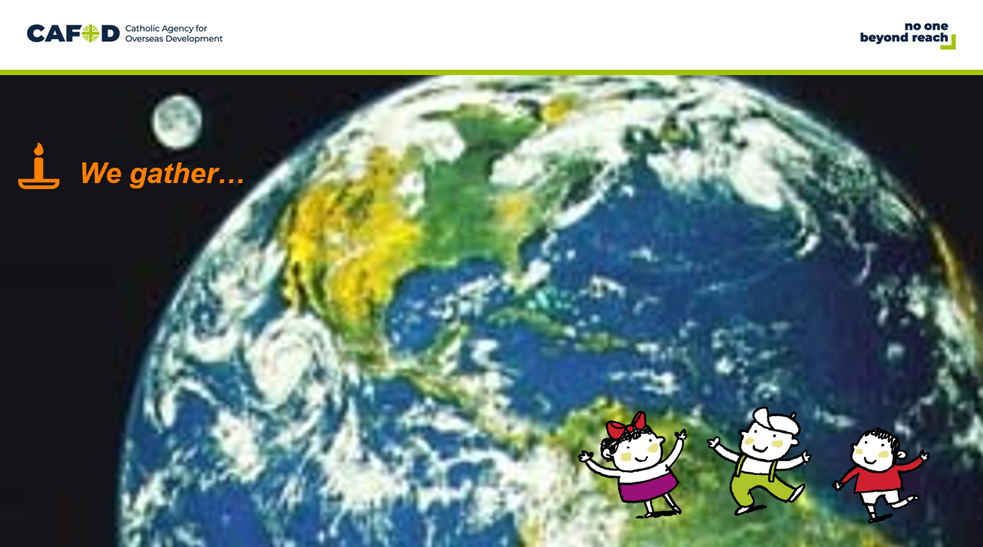 | Reader: About 50 years ago, in May 1969, when Neil Armstrong became the first person to set foot on the surface of the moon, one of the newsreaders said that this was the most momentous event since the creation of the world.  Reader: Even though this was an incredible moment, the most momentous event is when Jesus, who is God, became a person like us.  Reader: Of course, it couldn’t have happened without Mary. Mary was so special that she was chosen by God to bring his son into the world. Amazing!  Reader: Mary loved God so much that she said ‘yes’ straight away to his plan (click on slide for yes to appear). Today we celebrate her love and generosity.

We listen: God speaks to us and we listen

Slide | Script | Ideas
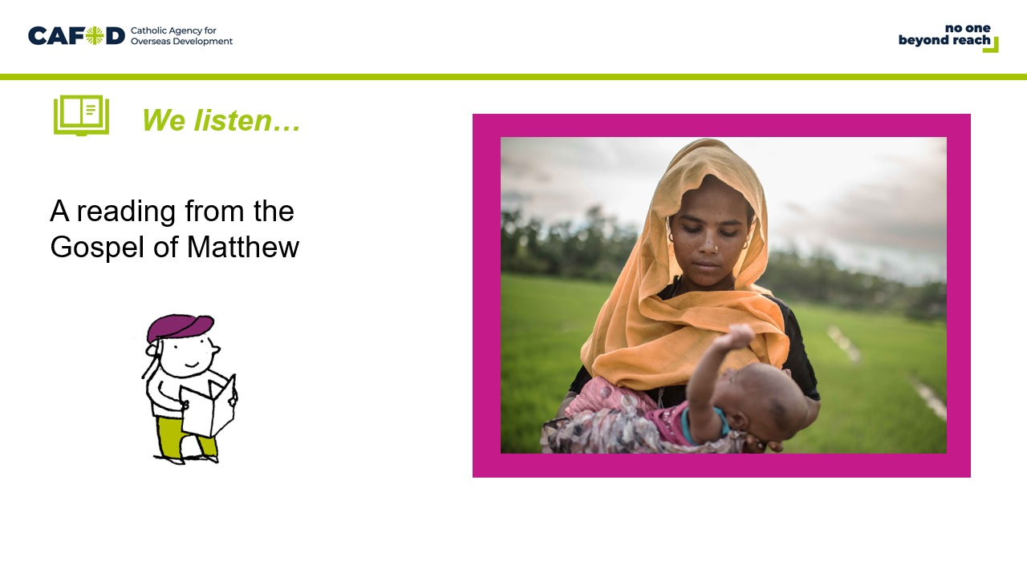 | Reader: In the Gospel of Luke, we hear the story of when Mary said a big yes to doing what God wanted.  Reader: A reading from the Gospel of Luke  The angel Gabriel was sent by God to a town in Galilee called Nazareth, to a young girl who was promised in marriage to a man named Joseph…and the young girl’s name was Mary.  The angel said to Mary, “Hail, full of grace! The Lord is with you. Do not be afraid, you have won God’s special favour. You are to conceive and give birth to a son and call him Jesus. He is the Son of God”  Mary said, "Behold, I am the handmaid of the Lord. May it be done to me according to your word.“  The Gospel of the Lord  All: Praise to you Lord Jesus Christ.  (Luke 1: 26-38) | Display the Bible

We respond: We respond to the Word of God
Slide | Script | Ideas
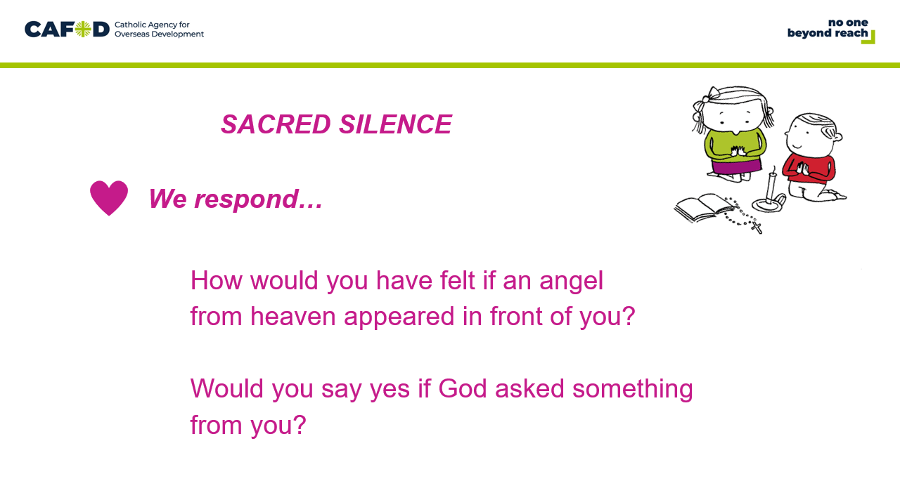 | Reader: Although she was confused by the angel’s message, Mary replied, “I am the Lord’s servant, and I will do whatever the Lord wants me to do.”  Reader: Imagine you were in Mary’s position. How would you have felt if a huge angel from heaven appeared in front of you?  Reader: Do you think you would say yes if God asked something from you? | Sacred Silence
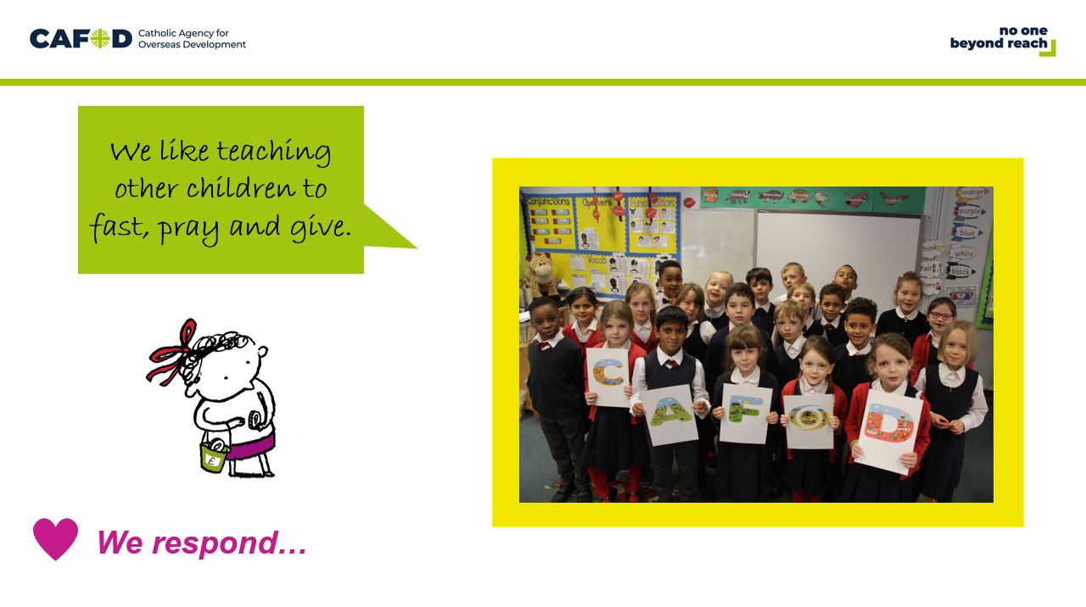 | Reader: These children are from a primary school in Woodford Green. They were invited to start a CAFOD group. They chose to say a big, generous yes.  Reader: They meet every week at lunchtime for their CAFOD group. They start each meeting with the sign of the cross, a prayer and a song. They then do lots of different activities. The CAFOD group have been encouraging the whole school to get involved.
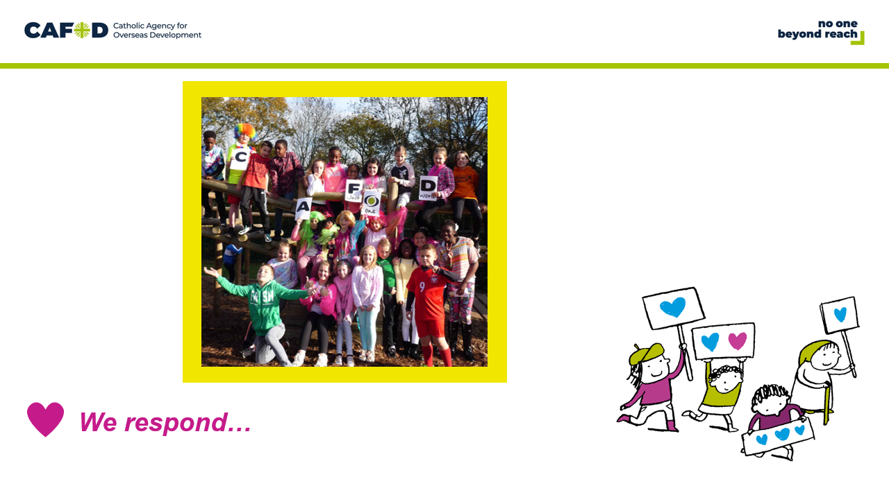 | Reader: These children are from English Martyrs Catholic Primary School in Reading. After hearing about CAFOD’s work in El Salvador at a Harvest assembly they decided to say a big generous yes to fundraising.  Reader: The school decided to have a Brighten Up fundraising day where the children could come to school dressed in their brightest clothes, and buy brightly decorated cakes.
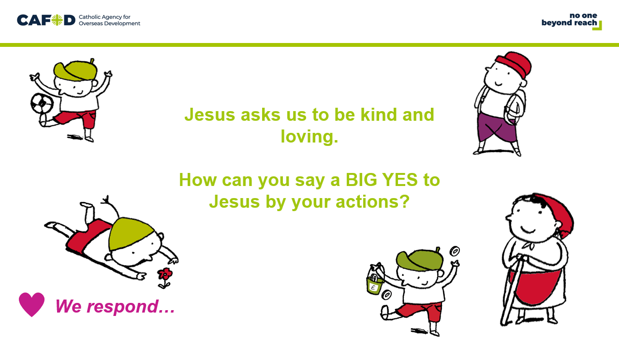 | Reader: Jesus also asks us to help him by being kind and loving. Mary said a BIG YES when God asked for her help.  Reader: How can you show a BIG YES to Jesus by your actions? | OPTIONAL SLIDE- additional detail for a KS2 assembly

Going Forth: We want to share the Good News!

Slide | Script | Ideas
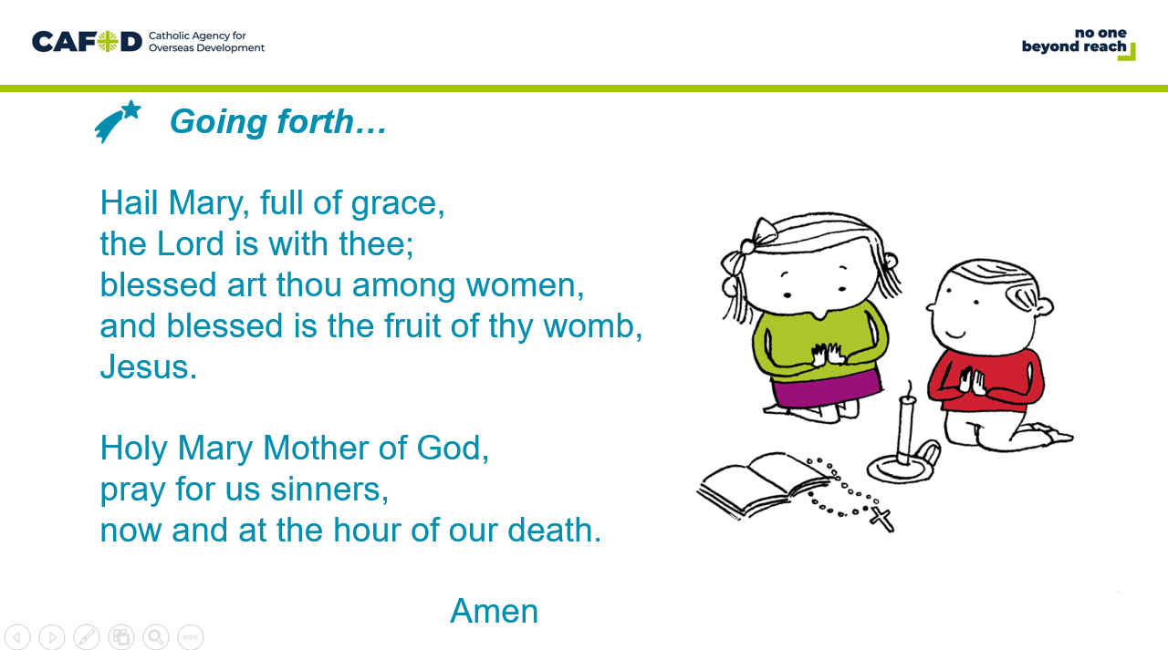 | Reader: Let us pray…  All: Hail Mary…
OPTIONAL CLASSROOM ACTIVITIES:

At the end of the liturgy discuss and decide an action with the children to follow for the week ahead. For example, try to say yes to doing good things in the coming week, or pray the Hail Mary every day for our sisters and brothers around the world, that they may live in peace.
As the Annunciation is a solemnity, when it occurs during Lent, our penance obligations are lifted. Children could celebrate the day with some special food such as angel food cake for the archangel Gabriel and then decorate it with blue frosting for Mary (check for allergies).
Another suggested food could be waffles (again, check for allergies). In most of Europe, waffles are a traditional feast day food, but on the feast of the Annunciation in Sweden this is THE "Waffle Day" (Vaffeldagen), where waffles are served either for breakfast, lunch or dinner.

As a class, you could fundraise for a healthy mum and baby World Gift £30 (£1 per pupil). The amazing charity gift can ensure access to medical treatment for pregnant mothers and newborn babies, and also provide extra food for children who are at risk of becoming malnourished: https://worldgifts.cafod.org.uk/

