Dare to care about clean water

“Access to clean, fresh water is a fundamental human right that must be defended.”
Pope Francis,
Message for World Water Day 2019

Can you imagine trying to follow coronavirus hand-washing advice if you had no running water at home? The United Nations estimates that two out of five people in the world do not have a basic hand-washing facility with soap and water.

You can find out more about world leaders’ progress to increase people’s access to clean water, at the United Nations website on Sustainable Development Goals.

The dare this week is to dare to care about where your water comes from.

There are three options, depending on your circumstances.
Option one: Keep a record of the number of times you use water in a single day. Then walk 500 steps (1/4 mile) for each time you have used water. The United Nations has estimated that, on average, women in Malawi walk approximately four miles a day to collect water. In many places people walk even greater distances.

Option two: If you have no outside space that you can use, but you can get to a builders’, DIY or pet store for clean gravel and sand, try making a model water filter.
If you’re interested to find out more, there’s a diagram, video and information on this page.

Option three: If you have outside space, make and use a ‘tippy tap’ to wash your hands for the day. To find out how, watch the demonstration, filmed by a community in Malawi. Or you can use the simple instructions on this week’s home learning page.
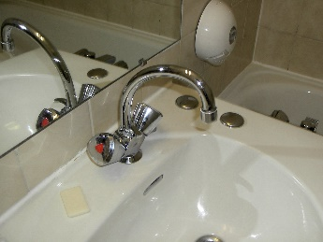

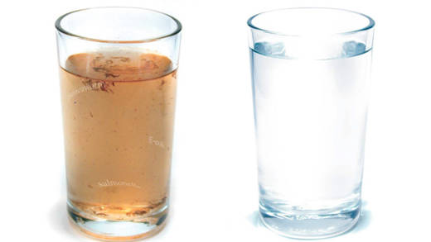
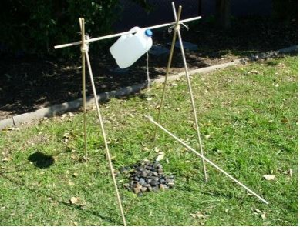

Afterwards, reflect on how it felt. Have you any new insights into people’s difficulties in protecting themselves from coronavirus when they have no running water near their home?

We’d love to hear your thoughts and how you got on: youth@cafod.org.uk.
Check back next week for a new dare!

