Lent 2025 Celebration of the Word

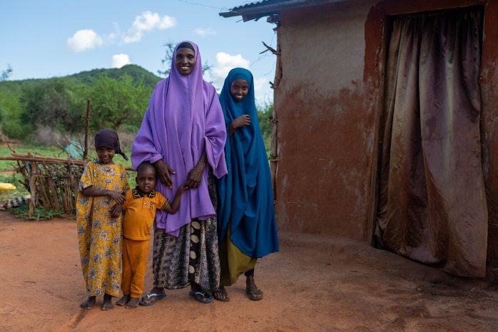
This liturgy is written to be used at the start of Lent.
It could be used as your liturgy for Ash Wednesday,
if this falls within your school’s term time.

Length: 30 mins

You will need:
- A prayer focus, eg. table with purple cloth, crucifix, Bible, daffodils, candles
- CAFOD Lent poster for schools (download at cafod.org.uk/secondary)
- A display board, with pins or blu tac, near the poster (people attach prayers to this)
Khera and her family in Marsabit, Kenya.
- Quiet music or hymns
- A slip of paper for each participant. Readers
- If this is your Ash Wednesday service: Ashes

You might have music or a hymn for gathering and settling, such as: King of Kings by Brooke Ligertwood, Come back to me, by Gregory Norbert; Lord, I need you, by Matt Maher;

Leader: In the name of the Father, and of the Son, and of the Holy Spirit.

All: Amen.

[Pause until everyone settles into silence]

Lent explained

Reader: The Christian season of Lent is beginning.
Lent is 40 days when we pray, fast and give as we prepare to celebrate Easter.
In prayer, we put aside time to be with God and to let God love us.
In fasting, we give up something we want, so that we can be open to what God wants.
In almsgiving, we give generously to others, as God has been generous to us.

Opening prayer

Reader: Let us pray. [Pause]
Loving and compassionate God,
We believe that change is possible. And we believe that we can help to change the world.
As Lent begins, we pray that, through our Lenten journey,
you will change our hearts and help us to build a better world,
where every person’s dignity is respected, and everyone can live life to the full.
We make this prayer, with faith, through Christ our Lord.

All: Amen.

Scripture reading (part of the first reading for Ash Wednesday, taken from the Missal)

Leader: Let’s listen to our scripture reading for the first day of Lent, from the prophet, Joel.

Reader: ‘Now, now – it is the Lord who speaks – come back to me with all your heart, fasting, weeping, mourning.’ Let your hearts be broken, not your garments torn. Turn to the Lord your God again, for he is all tenderness and compassion, slow to anger, rich in graciousness, and ready to relent.

The word of the Lord.

All: Thanks be to God.

Reflection on scripture

Leader: In the days of the prophet Joel, his people had strayed away from God. Joel called them to be sorrowful because they had not been open to God’s love: “Let your hearts be broken”, in other words, “opened”.

Sometimes we try to protect our hearts by saying, “I’m okay, I don’t need any help”. But if we can open the door of our hearts to God in prayer this Lent, then God who is “all tenderness and compassion”, will come into our hearts. God will begin to heal us, so that we can allow ourselves to be loved and can better love other people.

The reading also calls us to fast. Lent fasting is one way to let God love others through us. When we give up crisps, chocolate or something else that we enjoy, we stand in solidarity with people who do not have enough. It’s like saying, “I want to stand beside you in your need”.

Lent is also a time to give. For example, this Lent, CAFOD is asking schools to fundraise to help communities in our global family to thrive. With CAFOD, Catholic schools and parishes in England and Wales can support communities around the world.

May our prayer, fasting and giving this Lent help to build a world where everyone is safe and can flourish.

CAFOD story

Leader: Let’s find out about Khera in Marsabit, Kenya.

Show our Lent video for secondary schools or use slides from our Lent assembly powerpoint. Both are at cafod.org.uk/secondary/lent.

Khera’s village is in Marsabit in Kenya. The area suffered as a result of a serious drought. Khera, and her children were forced to walk long distances in the heat of the day to collect water but they couldn’t carry enough. Eventually, the livestock died and Khera lost her main source of income.

This Lent, CAFOD challenges the schools of England and Wales to join The Big Lent Walk to help communities around the world have access to the other sources of income and support necessary for the community to thrive.

Khera and her friends worked together and formed The Glitter Group. CAFOD and Caritas Marsabit trained the women on how to raise new improved chickens. The chicken’s don’t glitter but hope does. Khera says; ‘I hope for my family to have a better future’.

Our [school/year/class] [sponsored Big Lent Walk / other fundraiser] will be on [date] at [time]. Please think about how you can join in and who could sponsor you so that we can make a huge difference.

Distribution of ashes and/or writing a pledge

Leader: We now have a minute or two for reflection. You are invited, in silence, to write on your paper the commitment you are making to help others in our global family this Lent. You can also include a prayer for people whose crops, homes and lives are being threatened by climate change including droughts.

Quiet music could be played during this time.

If ashes are being distributed:  You now have an opportunity to receive your ashes. The ashes remind us that God made us, that we sometimes turn from God, and that we need to turn again towards God this Lent.  Please wait in silence until you are called forward and take this opportunity to speak and listen to God in your heart.  After receiving the ashes, attach your paper to the display as a sign that, this Lent, we want to support people threatened by the climate crisis to protect themselves and our world.  Pupils come up in turn to receive ashes then attach their paper to the display. | If ashes are not being distributed:  Please wait in silence until you are called forward to attach your prayer to the display as a sign that, this Lent, we want to support people threatened by the climate crisis to protect themselves and our world.  Take this opportunity to speak and listen to God in your heart.  Pupils come up in turn to attach their paper to the display.

Show slides from the Lent assembly to aid reflection while people wait to come forward.

Prayers of intercession

Leader: Let us bring all our prayers to God, our loving Father. The response is: Hear our prayer.
(Each prayer can be read by a different person.)

Loving God, we pray for ourselves as we begin this season of Lent. Help us to open our hearts to you so that you can show us your love.
Lord, in your mercy: Hear our prayer.

Merciful God, we pray for our school community. As we pray, fast and give to others, help us also to be generous and forgiving towards one another.
Lord, in your mercy: Hear our prayer.

Creator God, we thank you for our world, which produces enough food and resources for everyone to share. Inspire us by the example of Khera’s village, to stand in solidarity and care for the resources you have entrusted to us.
Lord, in your mercy: Hear our prayer.

God of justice, we pray for communities like Khera’s, who experience the worst impacts of the climate crisis. Through our fundraising, help us to support communities in their work to safely provide for their families, protect their environment and to adapt to the effects of climate change.
Lord, in your mercy: Hear our prayer.

Let us take a moment of silence for our own prayers (pause for a slow count of ten).

Father God, we pray together for all these intentions, using the words your Son gave us:

Our Father…

Final prayer

If ashes have been distributed:  Reader: Lord, may these ashes remind us what really matters during Lent.  In our prayer, deepen our awareness of God’s love within us.  In our fasting, make us more aware of other people’s needs.  In our giving, help us to build a better world.  May our Lenten prayer, fasting and giving renew us to celebrate Easter with joy.  All: Amen | If ashes have not been distributed:  Reader: Lord, bless us during Lent.  In our prayer, deepen our awareness of God’s love within us.  In our fasting, make us more aware of other people’s needs.  In our giving, help us to build a better world.  May our Lenten prayer, fasting and giving renew us to celebrate Easter with joy.  All: Amen

Leader: In the name of the Father, and of the Son, and of the Holy Spirit.

All: Amen.

To find out more about Khera’s community and how to join The Big Lent Walk, visit cafod.org.uk/secondary/lent

