World Gifts Secondary Assembly 2020
Themes: World Gifts, global neighbours

Materials Required: PowerPoint presentation, (optional World Gifts catalogues)

Preparation: Read through the script and check the PowerPoint.

Time allocation: 10 minutes

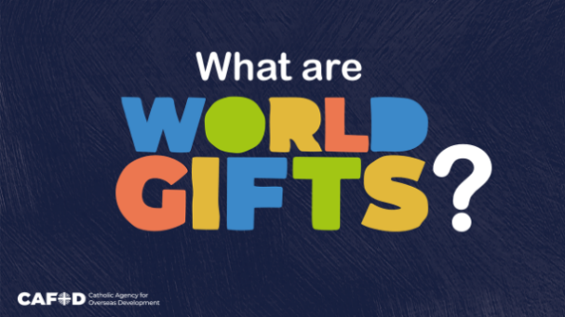 |  | Slide 1: Good morning/afternoon everyone.  Today we will find out how we can transform lives around the world.
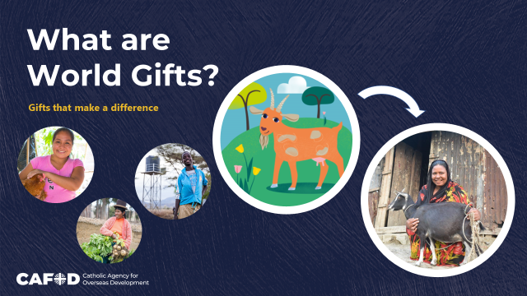 |  | Slide 2:  World Gifts are gifts that we can give to friends and family. They also help people living in poverty.  While we find out more, we challenge you to think - how could our school work together to fundraise for as many gifts as possible?
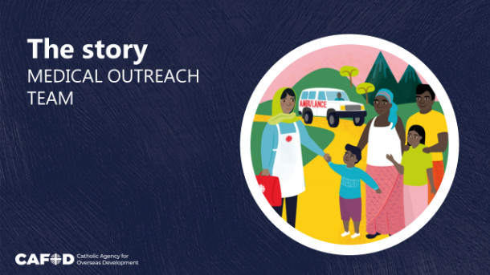 |  | Slide 3:  Here’s a reminder of what our fundraising is for.  The gift of a medical outreach team brings essential healthcare services to remote communities. It also informs and trains people on vital health issues.
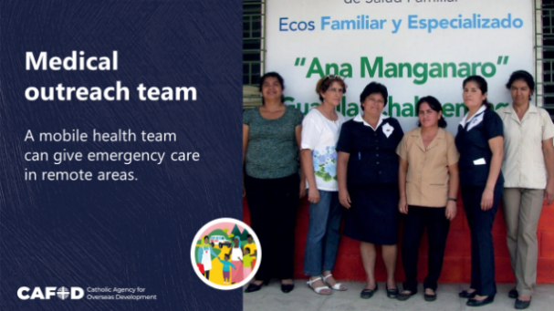 |  | Slide 4:  During the civil war in El Salvador, people from Guarjila fled to Honduras. When they returned home, they needed health care services, and decided to set up a clinic. CAFOD helped to train some of the community health workers. Today, CAFOD still supports valuable outreach work from the clinic.
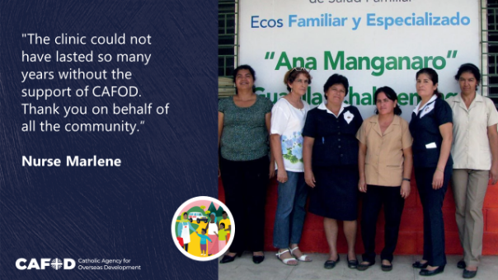 |  | Slide 5:  Nurse Marlene, was one of the original community health workers. She said: "The clinic could not have lasted so many years without the support of CAFOD. Thank you on behalf of all the community. We wouldn't have got to where we are today without you".
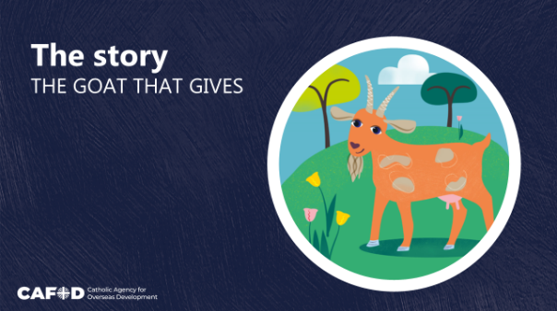 |  | Slide 6:  The Goat is a gift that keeps on giving!
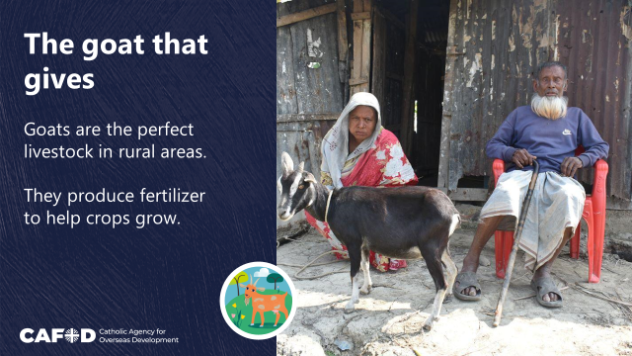 |  | Slide 7:  Rubina’s husband is disabled and unable to work. Rubina’s family rely solely on her income. In the past, they had no land to grow food on and Rubina had to beg for money to buy food.  Goats are the perfect livestock for many families in rural areas. They are easy to look after and they breed quickly.
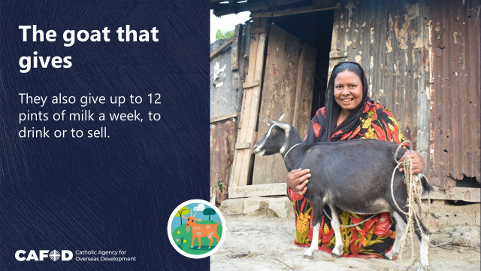 |  | Slide 8:  They also provide up to 12 pints of nutritious milk a week.  Rubina’s family have received a nanny goat, goat feed, and training on how to care for their goat. With baby goats on the way, Rubina should have plenty of goats to keep or sell. She can also sell excess milk at the local market to help provide a steady income.
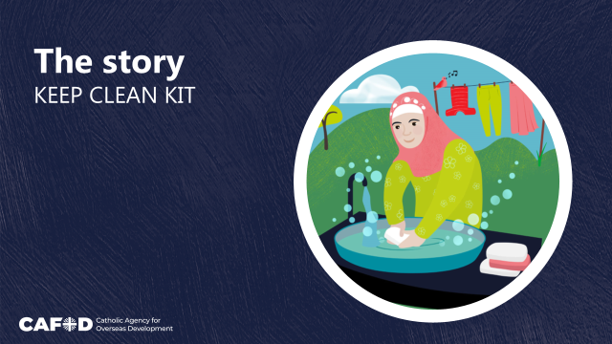 |  | Slide 9:  The coronavirus pandemic has highlighted that everyone needs access to the basic items that keep us clean and safe.  The Keep clean kit shares with vulnerable families the peace of mind that comes from cleaning our hands and wearing a facemask.
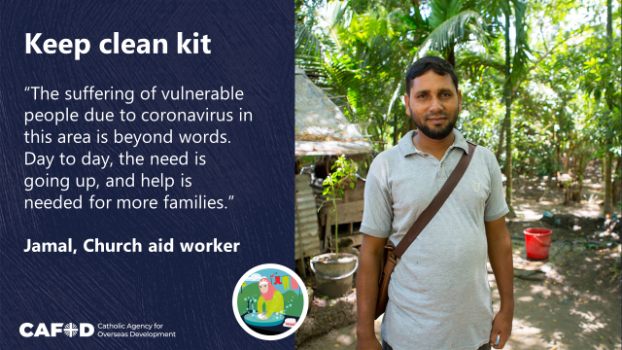 |  | Slide 10:  Jamal is an expert working alongside CAFOD in Bangladesh. He has distributed essential hygiene items to vulnerable families in his local area.
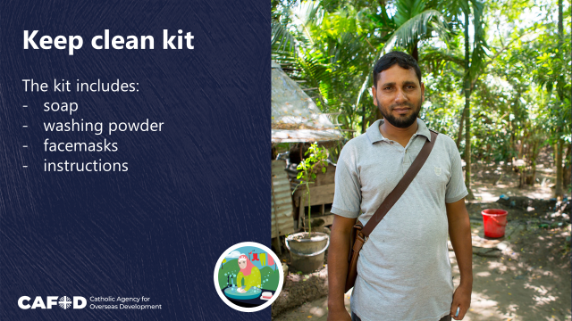 |  | Slide 11:  Each kit includes soap, washing powder, five reusable, locally-made facemasks, and instructions for proper washing. It offers people a chance at normality, allowing them to go back to work or school, or to shop for food safely.
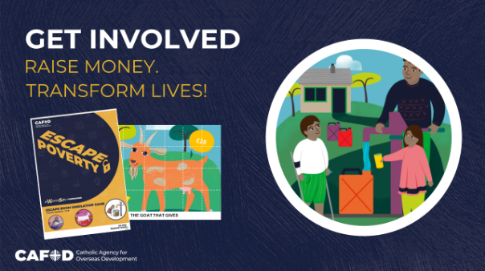 |  | Slide 12:  We challenge every class to choose a World Gift and find ways to raise money for it – by the most creative fundraiser you can come up with!  Think of ways that you can work together to make a difference. CAFOD has World Gifts resources on its secondary pages that can help.
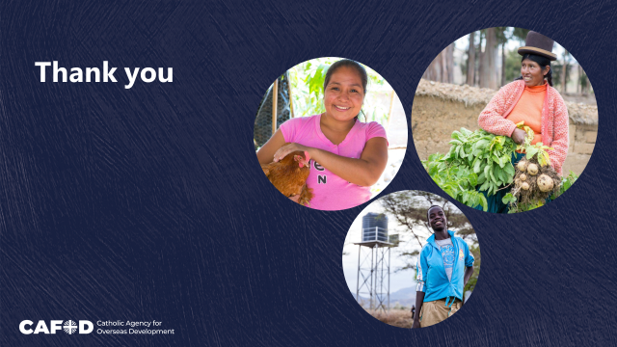 |  | Slide 13:  Thank you for listening, and thank you on behalf of the people around the world who will receive your gifts.
More World Gifts resources can be downloaded free from:
cafod.org.uk/Education/Secondary-and-youth-resources/World-Gifts

