Holy Week and Easter
We can lead this too!

Theme: Holy Week and Easter
Purpose: to help children understand the events of Holy Week and celebrate the resurrection of Jesus and the new life and hope this brings us.
Liturgical colour: white
Materials Required: accompanying PowerPoint, copy of prayers/script for readers
Suggested hymns: Sing Hosanna,The Servant King, Were you there (when they crucified my Lord), Alleluia, alleluia, give thanks to the risen Lord
Time allocation: 15-20 minutes (optional slides)

We gather: We come together as part of God’s family.
Slide | Script | Ideas
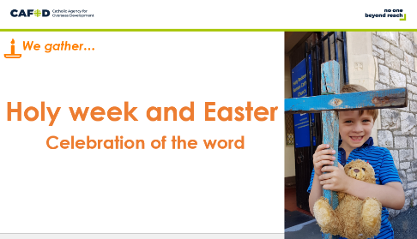 | Reader: Welcome to our time of prayer | Play quiet music  Light a candle
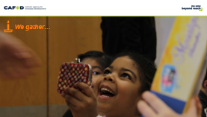 | Reader: Have you ever had a wonderful surprise?  (Children could be asked to reflect quietly or you may choose to allow them to share answers in pairs or to the wider assembly. You may wish to share a story of a surprise you had)  Reader: Today we’re going to hear a story about some people who had an amazing surprise.  We are going to think about what happens during Holy Week and what it means for us.
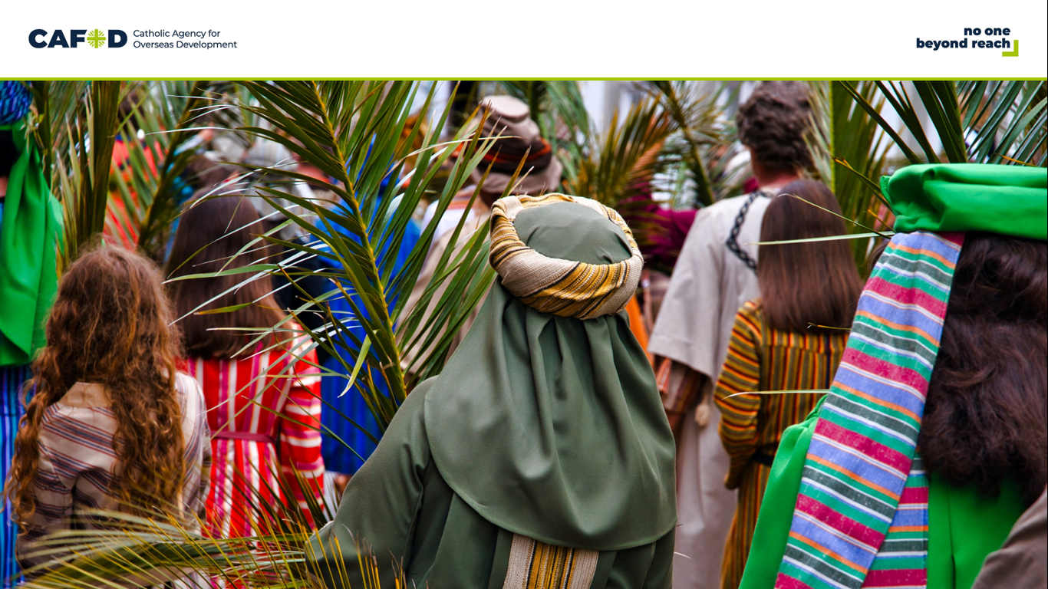 | Reader: Jesus rode on a donkey into Jerusalem on Palm Sunday. The people waved branches at him, shouting, “Hosanna”. | This would be an appropriate point for the hymn Sing Hosanna if you are including music
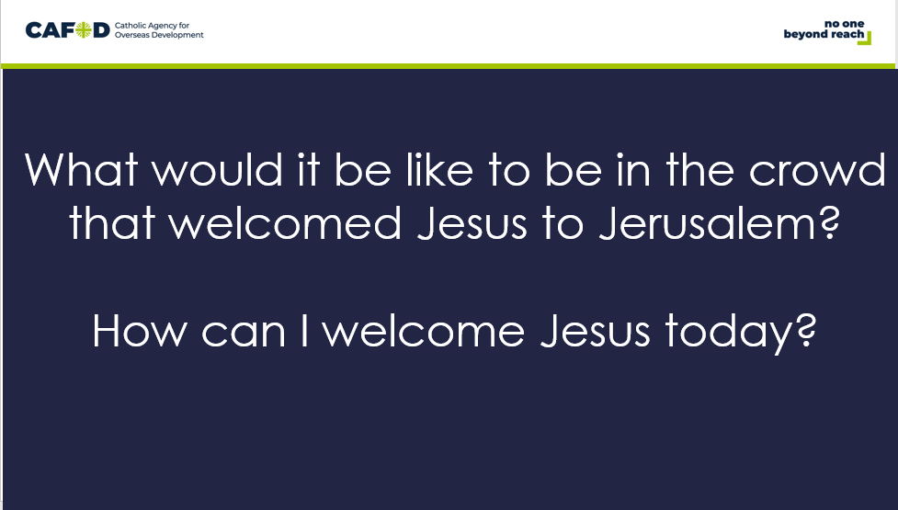 | Reader: Let’s reflect quietly:  What would it be like to be in the crowd that welcomed Jesus to Jerusalem?  How can I welcome Jesus today? (pause)
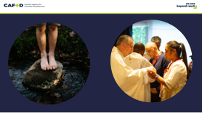 | Jesus celebrated the Last Supper with his friends. He washed their feet which was usually the job of a servant. Then he broke bread saying ‘This is my body’ and shared wine saying ‘This is my blood.’  This was on Maundy Thursday.  Reader: Jesus told his followers to do this in remembrance of him and we continue to do so when we celebrate the Eucharist together. | This would be an appropriate point for the hymn The Servant King
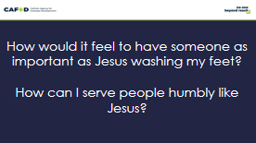 | Reader: Let’s reflect quietly:  How would feel to have someone as important as Jesus washing my feet?  How can I serve people humbly like Jesus? (pause)
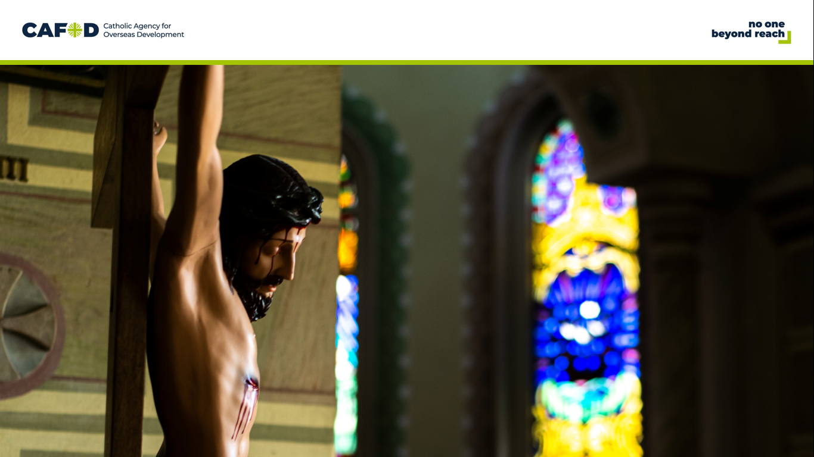 | Reader: Jesus was arrested and crucified on Good Friday.  Even on the Cross he forgave the people who were hurting him. | This would be an appropriate point for the hymn Were you there (when they crucified my Lord)
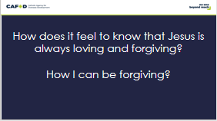 | Reader: Let’s reflect quietly:  How does it feel to know Jesus is always loving and forgiving?  How can I be forgiving? (pause)

We listen: God speaks to us and we listen

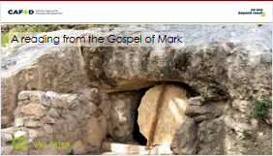 | Reader: Let’s listen now to what happened next. What was the wonderful surprise?  Reader:  After the Sabbath was over, Mary Magdalene, Mary the mother of James, and Salome bought spices to go and anoint the body of Jesus.  Very early on Sunday morning, at sunrise, they went to the tomb. On the way they said to one another, “Who will roll away the stone for us from the entrance to the tomb?” (It was a very large stone.) Then they looked up and saw that the stone had already been rolled back. So they entered the tomb, where they saw a young man sitting at the right, wearing a white robe—and they were alarmed.  “Don't be alarmed,” he said. “I know you are looking for Jesus of Nazareth, who was crucified. He is not here—he has been raised! Look, here is the place where he was placed. Now go and give this message to his disciples, including Peter: ‘He is going to Galilee ahead of you; there you will see him, just as he told you.’” | Display the Bible  (The passage is Mark 16:1-8)
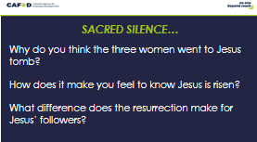 | Optional slide- Following the reading of the Word, you may wish to provide a moment for ‘Sacred Silence’ with questions for children to ponder.  Reader: Why do you think the three women went to Jesus tomb?  How does it make you feel to know Jesus is risen?  What difference does the resurrection make for Jesus followers?

We respond: We respond to the Word of God

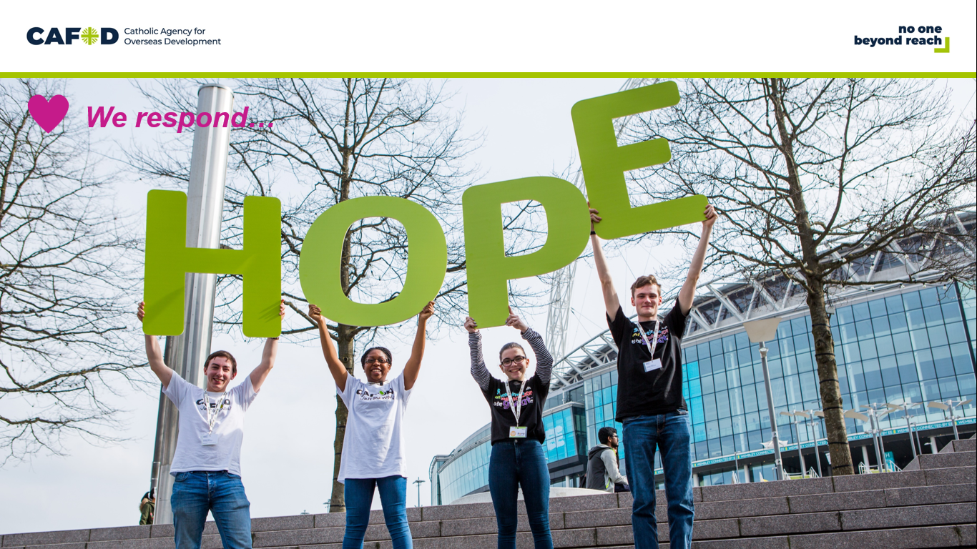 | Reader: What a wonderful surprise for Jesus’ friends to find out he had risen from the dead.  Reader: Jesus’ death show us how much God loves everyone.  Reader. His resurrection reminds us that even in the most difficult situations there is always hope.
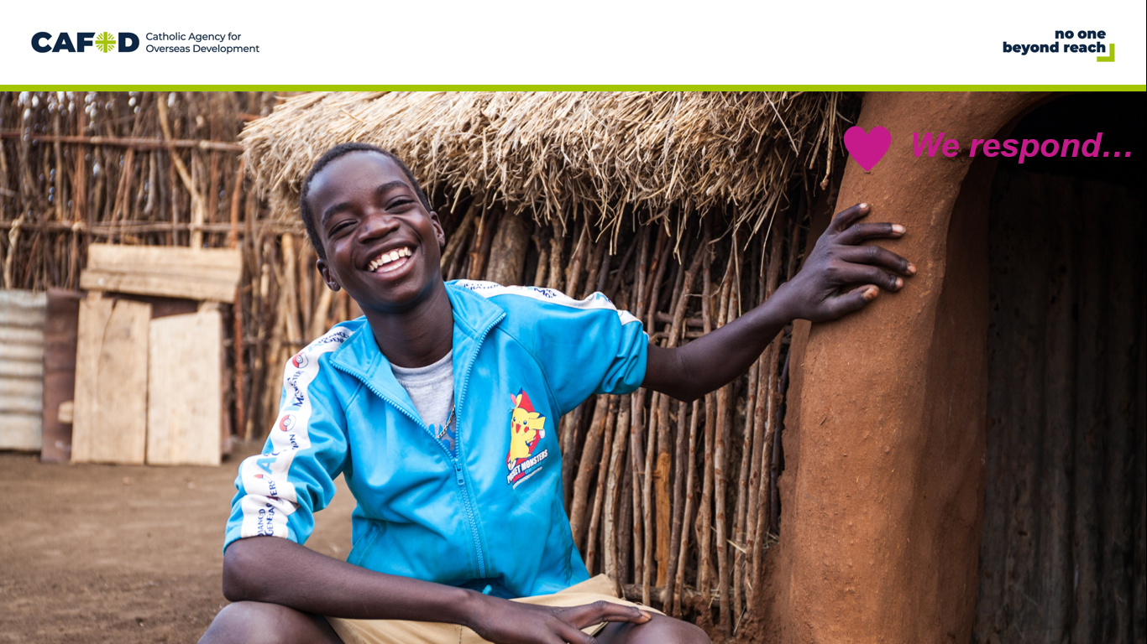 | Reader: This love and hope has led Christians to reach out to their brothers and sisters throughout the world.  Reader: It continues to inspire the work of Christian charities, like CAFOD, who work with partners around the world to try to bring hope to people in very practical ways and campaign for a fairer world.
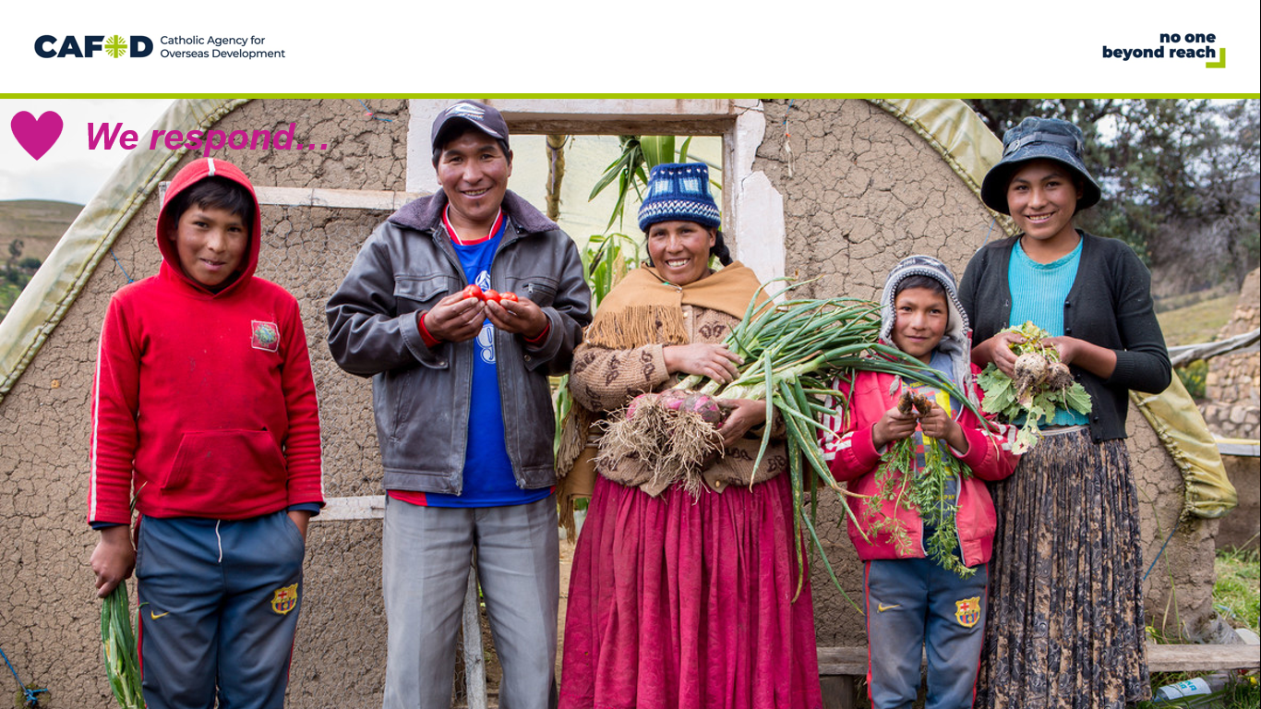 | Reader: Nicanora and her family have a new hope.  Their home in rural Bolivia has seen increasingly extreme weather as a result of the climate crisis, making it almost impossible to grow fruit and vegetables.  Reader: Thankfully, with the support of CAFOD, Nicanora and her family have built a greenhouse. So far, they have been grown lettuce, celery, maize, spinach, peppers and tomatoes.  Reader: The whole family is getting involved. The children love to plant seeds and watch them grow. Nicanora told us: “Their hands are good for growing. They have green fingers!”  Reader: Let’s pray that we will be people who share Easter joy and hope with others.

Going Forth: We want to share the Good News!

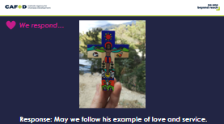 | The response to be said after each intercession is on the slide  Reader: We remember Jesus riding into Jerusalem on a humble donkey.  May we follow his example of love and service.  Reader: We reflect on Jesus washing his disciple’s feet.  May we follow his example of love and service.  Reader: We think of Jesus on the cross, forgiving others.  May we follow his example of love and service.  Reader: We rejoice in Jesus risen from the dead.  May we follow his example of love and service. | You may like to close your time with the hymn Alleluia, Alleluia, give thanks to the risen Lord
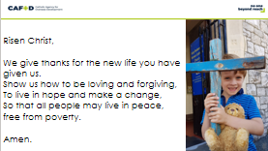 | Reader: Let us pray together.  Risen Christ,  We give thanks for the new life you have given us.  Show us how to be loving and forgiving,  To live in hope and make a change,  So that all people may live in peace,  free from poverty.  Amen.
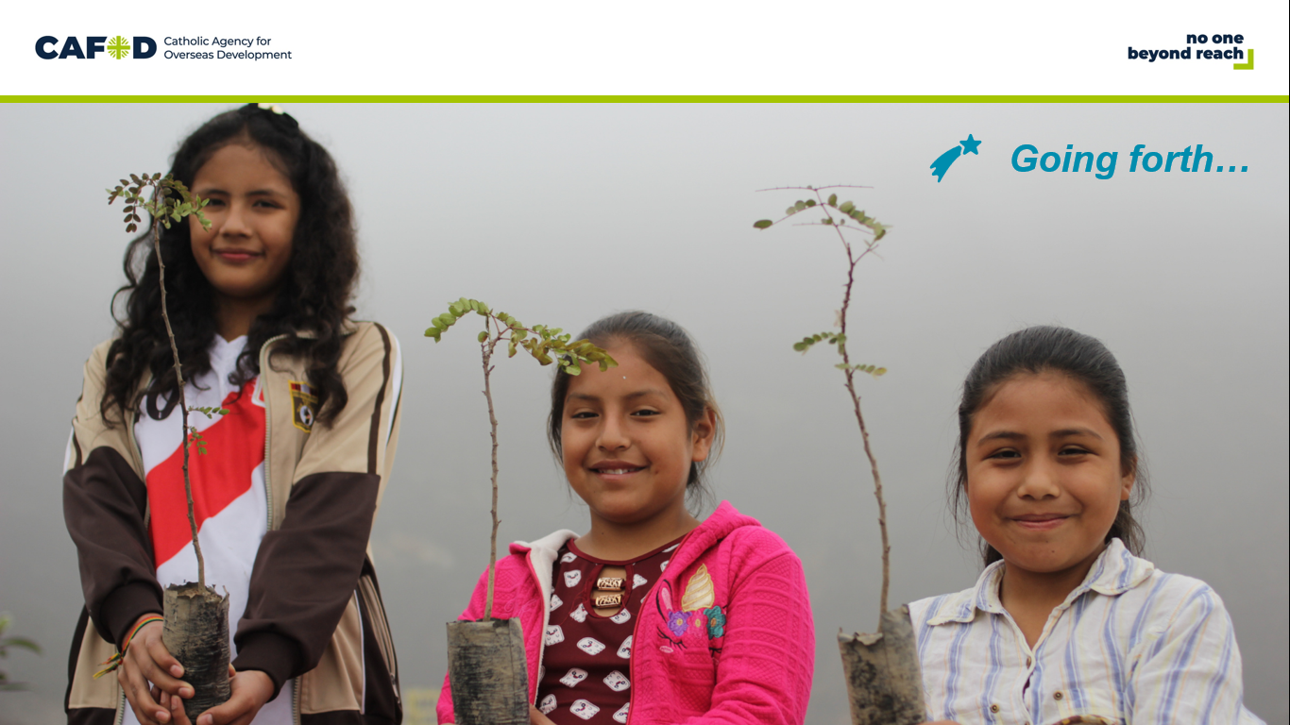 | Reader: How can each of us spread the hope that Easter brings?;.

OPTIONAL CLASSROOM ACTIVITIES:

- Use our Stations of the Cross for primary children to reflect further on the events of Holy Week.

- Download the Palm Sunday and Easter Sunday activity sheets

- Make Easter cards to take home which show the new hope brought by Jesus’ death and resurrection.

- Make a class display showing your hopes for a better world.

