We can lead this too!

Feast of the Epiphany

Theme: Epiphany (date: 6 Jan)
Purpose: to help children reflect on the Feast of the Epiphany. This resource can be adapted to use for liturgical prayer or for an assembly. It is designed so that pupils can lead.
Liturgical colour: white
Materials Required: accompanying PowerPoint, copy of prayers/script for readers
Suggested hymns: ‘One Bread, One Body’
Time allocation: 10-20 minutes (optional slides)

We gather: We come together as part of God’s family.

Slide | Script | Ideas
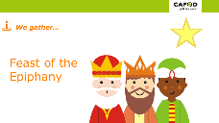 | Reader: In the name of the +Father, and of the +Son, and of the +Holy Spirit Amen.  We gather as a school family to continue our celebration of the birth of Jesus, the Light of the world, God’s gift of love to all. The name Jesus means ‘Saviour’. | Play quiet music  Light a candle
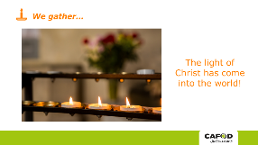 | Reader: The light has come to shine on all people throughout the world, to guide them to the new life offered by Jesus.

We listen: God speaks to us and we listen

Slide | Script | Ideas
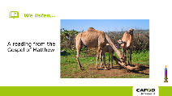 | Reader: In the gospel of Matthew, we hear the story of how some wise men from another part of the world were led by a star and travelled the long journey to Bethlehem, looking for Jesus. They found him in a stable.  Reader:  A reading from the Gospel of Matthew:  “After Jesus had been born at Bethlehem in Judaea during the reign of King Herod, some wise men came to Jerusalem from the east… And suddenly the star they had seen rising went forward and halted over the place where the child was. The sight of the star filled them with delight and going into the house they saw the child with his mother Mary and falling to their knees they did him homage. Then, opening their treasures, they offered him gifts of gold, frankincense and myrrh.”  The Gospel of the Lord  All: Praise to you Lord Jesus Christ.  (Matthew 2:1, 9-12)  Reader: The Son of God, Jesus, came into the world, to give life to every member of the human race. No matter what our race, nationality, colour or religion, each of us is made in the image and likeness of God. For all of us, this is a day of real celebration – we, too, are chosen. | Display the Bible

We respond: We respond to the Word of God
Slide | Script | Ideas
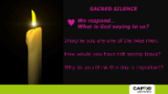 | Reader: Imagine you are one of the wise men.  - How would you have felt seeing Jesus?  - Why do you think this day is important?  Let us have a moment of silence to think about God’s words. | Sacred Silence
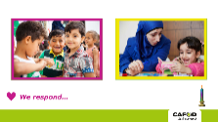 | Reader: Following the teaching of Jesus, we believe that everyone is chosen and special. That’s why we recognise all people as our sisters and brothers. CAFOD works with all people whatever their skin colour, nationality or religion. We are all equal. For example, in two of its projects, CAFOD is working in Jordan and Lebanon with children from Syria.  Reader: Mary and Joseph had to travel to Bethlehem and the wise men travelled there to meet Jesus. Why do people decide to move and live in a different country? There are many different reasons why people move. Some move out of choice but sadly some are forced to leave their homes.  Reader: What might it feel like to be forced to leave your home, to find somewhere safe to live?  CAFOD and its partners help children who been forced to leave their homes and move to new countries, like these children from Syria.
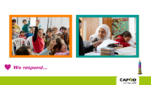 | Reader: Where do you think these children are?  Children come to a special CAFOD partner Centre to help them with difficulties they might be living through such as memories about war. They are given the chance to do fun activities such as puppet making or playing with a clown. Some of the older children learn French and adults can get medical help.
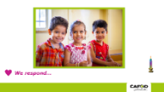 | Reader: This is Yamone, Waed and Ali. They are refugees from Syria. With CAFOD’s support, they and many other children can get help with English, Arabic and Maths classes.  Children are also given a snack and packed lunch. Layal (the Project Officer) said: “For some children it is the only meal they get. They take it home to share with their brothers and sisters”. | OPTIONAL SLIDE- additional detail for a KS2 assembly

Going Forth: We want to share the Good News!

Slide | Script | Ideas
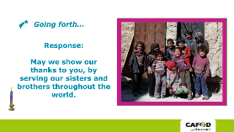 | Reader: Let us pray…  Jesus, Guide on our journey, let us see with your eyes, so that we may recognise you in every person of every race, nationality and colour.  (Response: May we show our thanks to you, by serving our sisters and brothers throughout the world)  Reader: Jesus, Light of the world, may we be a light for those whose lives we share; may our kindness and care bring courage and hope to those who are sad.  (Response: May we show our thanks to you, by serving our sisters and brothers throughout the world)  Reader: Jesus, bringer of comfort, help us to realise that we have gifts to offer to you through your people every day, and these gifts are precious to you.  (Response: May we show our thanks to you, by serving our sisters and brothers throughout the world)
OPTIONAL CLASSROOM ACTIVITIES:

Younger children could take a gift to another class for their prayer table, such as a picture of a crown.

Older children could research the epiphany ritual of ‘Chalking the Door’ or the meaning of the gifts of gold, frankincense and myrrh.

You could also have an Epiphany party as a reminder that Jesus was revealed to people of every nation.

