Get Creative for Climate Justice: workshop plan
Aims:
- To understand how climate change is affecting people around the world
- To understand the difference between climate change and climate justice
- To understand how we can live out our faith by caring for our common home, and for each other

Themes:
Climate justice, global neighbours, poverty, education, stewardship, sustainability

Preparation and resources:
- Display accompanying powerpoint slides
- Children will need a sheet of paper or card to create their artwork
- Print our climate justice or climate change cards (optional activity)

Time: 45 mins

Starter activity: Save the planet! (5 mins)

This is a quick starter activity, based on the ‘Pirates’ game.

Aim: For children to understand what we can do to combat climate change.

Instructions: Children start by standing. The teacher says “Oh no! Our climate is changing! Let’s take action, quick!” Teacher then reads the actions below, and the children have to act them out.
The last pupil to do each action has to sit down. The last person standing has adapted very quickly to climate change and wins!

Actions:
- Stop wasting energy! Turn off the lights and close the doors – Reach up and flick a switch
- We need more green energy! Build a wind farm – Windmill arms
- Trees help the world breathe! Plant trees – Dig with a spade
- Stop polluting! Ditch the car and cycle to school – Pedal a bike
- Spend more on electric cars – Drive a car
- The sun can give us clean energy! Use more solar panels – Make a sun shape with your hands
- Tell others about climate change – Cup hands around mouth as a speaker
- World leaders make good decisions for the planet – Shake hands with yourself or others where possible

Debrief:
- What other actions would you add? Why?
- The winner was the quickest to do something about climate change. Do you think this is fair? Why/ why not? (Some countries don’t have the money to build wind farms or invest in renewable energy/ most countries who did the least to cause the crisis suffer most etc). Let’s find out more…

Case studies – Our global neighbours and climate justice (10 mins)
Pupils will now find out how climate change is affecting real people around the world and how we call this climate justice.

Share powerpoint slides with the following script:

Burkina Faso is a country in West Africa.  It has always experienced dry weather and hot temperatures.  Today Burkina Faso is in the front line of the climate crisis. A lengthy drought made worse by climate change means that farmers cannot feed their animals.  You can see their completely dry pastures in the photograph.  The average person in the UK emits twenty eight times more greenhouse gases than the average person in Burkina Faso.  Therefore, people in Burkina Faso are experiencing a crisis they did not cause.  This is the idea of climate justice. The people who have done the least to cause the climate crisis are the people who are the most affected by it. | 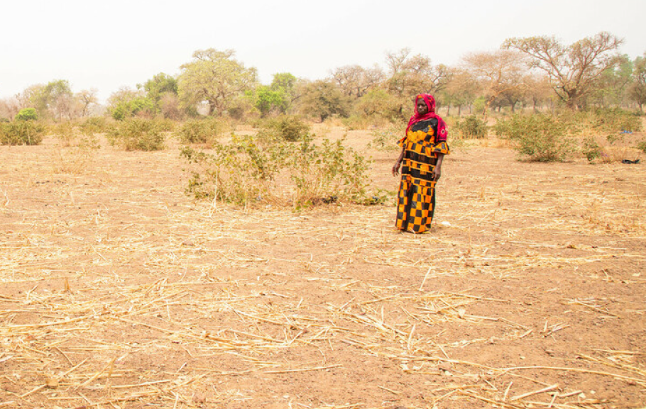
During Lent, we met Dristy in Bangladesh. She and her family have had to change the way they grow plants in their garden.  Rising sea levels and extreme weather caused by the climate crisis destroyed their crops. | 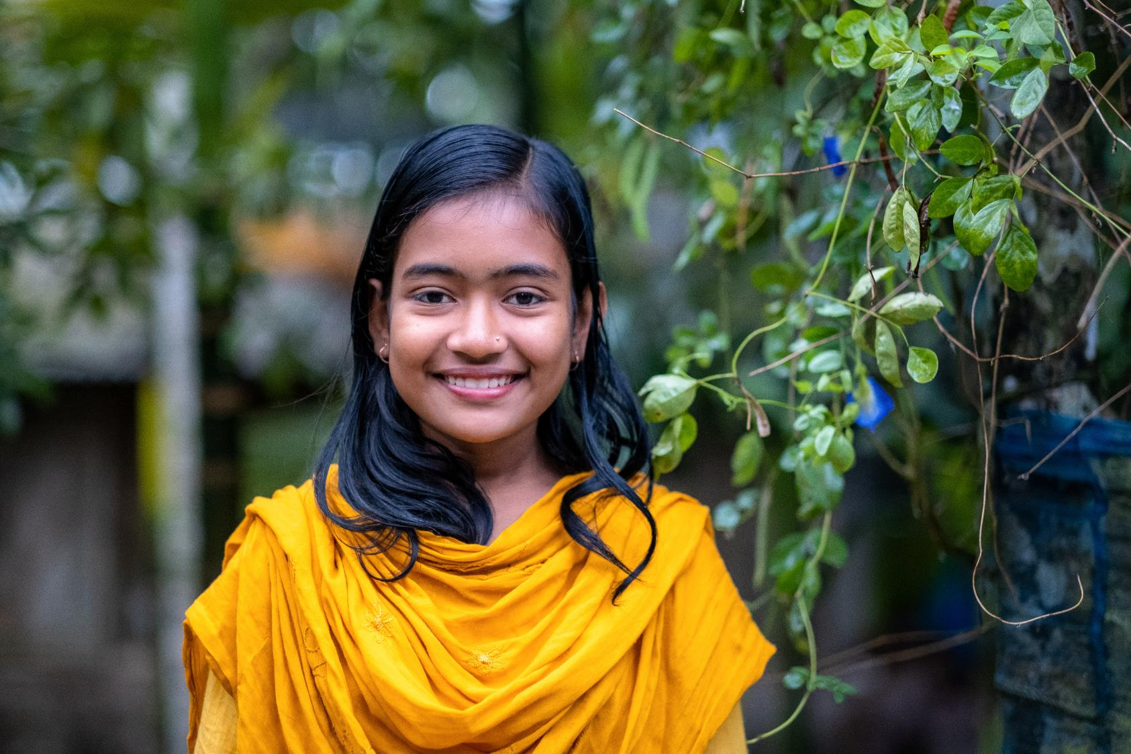
There is usually a connection between burning fossil fuels and a country's wealth. And although inequalities exist in every country, overall the wealthy countries that have been burning the largest quantities of fossil fuels haven't yet been affected by the climate crisis as severely as the less wealthy countries who haven't.  This is an injustice. A fairer future would see wealthy countries reduce their carbon emissions fastest and first. | 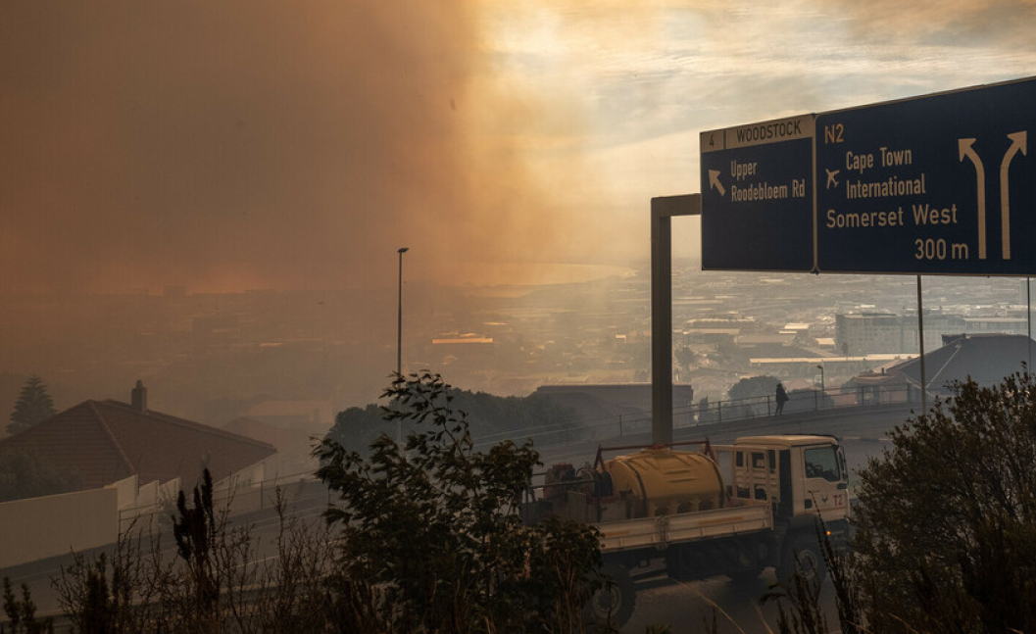

Card sort activity – climate justice or climate change (optional – 15 mins)
Children decide which cards are about climate justice and which are about climate change

How we can get involved – get creative!

Ask children to think about the world they would like to see. What would be the same? What would be different? How does this link to our faith?
Ask children to think about our global neighbours and how the climate crisis is affecting them. Is this fair or just?

One way to take action on climate justice is to get creative – create a piece of art about your thoughts on climate justice to show to your local Member of Parliament.

In order to take part in the final showpiece exhibition at the Houses of Parliament, there are some quick and simple guidelines:

- It should be produced on paper or card.
- It could be created using paint, ink, pastels, pencils or screen print, or be a print of digital artwork or a photo.
- It should be accompanied by a brief caption or title outlining the thinking behind it, and the first name of the child and the school.
- It must be respectful and inclusive.

For a further artistic guide check out the facilitation guide at cafod.org.uk/education/campaign-in-your-school/get-creative-for-climate-justice-primary-schools

How we can get involved 2 – tell us and your MP

Please tell us you have taken part!
In order to have the chance to be part of the exhibition at the Houses of Parliament, take photographs of the climate justice artwork you'd like to submit and send the images to schools@cafod.org.uk
You may send us as many or as few images as you wish.
Unfortunately we cannot promise to feature every artwork you send in an exhibition. However we'll do our very best.
The deadline for sending us your images is Friday 26 October 2024.

We aim to feature as many pieces of young people's climate justice artwork in the exhibition in the Houses of Parliament as possible. In addition, we hope to display artwork at the COP29 climate conference in Dubai and in offline and online exhibitions organised by the partner organisations. Our aim is for as much of the young people's artwork as possible to be seen and to have influence.

Find out more about the exhibition at cafod.org.uk/education/campaign-in-your-school/get-creative-for-climate-justice-primary-schools

Closing prayer

Creator God,

Your world is a wonderful and beautiful place, full of variety, full of wonder, full of life.

Teach us to care for the earth and help us to build a world that is filled with your goodness.

Amen.

What is COP29 and why is it important?
2024 is an important year for action on the climate crisis. World leaders are coming together in Baku, in Azerbaijan for the United Nations COP29 climate conference to make decisions that will shape the future of the world, and the future of our global family.

Go further – create a display in your school to show your MP
Creating a climate justice display in school is another way to show your elected representative that you care about our global neighbours and climate justice.
Your display could be a board in a classroom or corridor, or it could be a more ambitious display in the school foyer, atrium or other similar space.
However you decide to organise your school exhibition, we'd like you to invite your elected representative to view the young people's art work.
You may do this by inviting your elected representative to school or by emailing them photos of your exhibition with a covering letter.
Find an example letter here at cafod.org.uk/education/campaign-in-your-school/get-creative-for-climate-justice-primary-schools

