We can lead this too!

Corpus Christi

Themes: Corpus Christi; the Body and Blood of Christ
Purpose: to help children reflect on the Solemnity of the Body and Blood of Christ. This resource can be adapted to use for collective worship or for an assembly. It is designed so that pupils can lead.
Liturgical colour: white
Materials Required: accompanying PowerPoint, copy of prayers for the readers
Suggested hymns: ‘One Bread, One Body’
Time allocation: 10-20 minutes (optional slides)

We gather: We come together as part of God’s family.

Slide | Script | Ideas
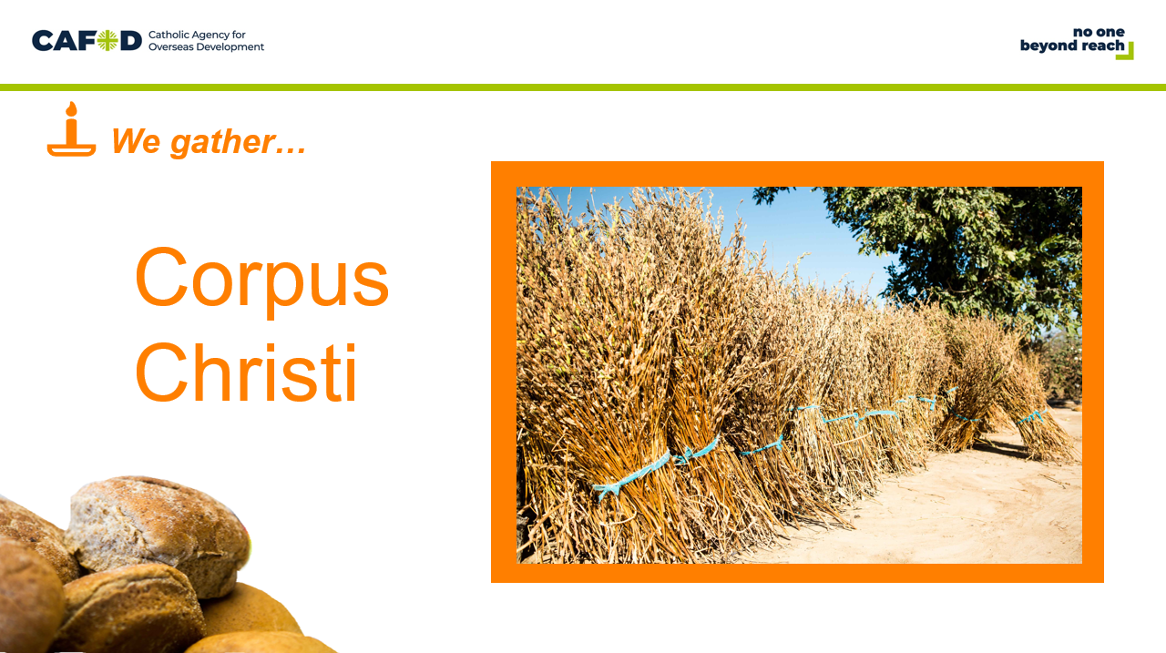 | Reader: In the name of the +Father, and of the +Son, and of the +Holy Spirit Amen.  Today we celebrate the Feast of Corpus Christi. Just as one loaf of bread is made with many grains of wheat, so there are millions of people around the world, but we are all joined together as one family.  Reader: When we gather as a church or school family to receive the Body of Christ, we show that we are united as the Body of Christ. When we share with our neighbour, we become sisters and brothers in Jesus, and bring his life and love into the world. | Play quiet music  Light a candle

We listen: God speaks to us and we listen

Slide | Script
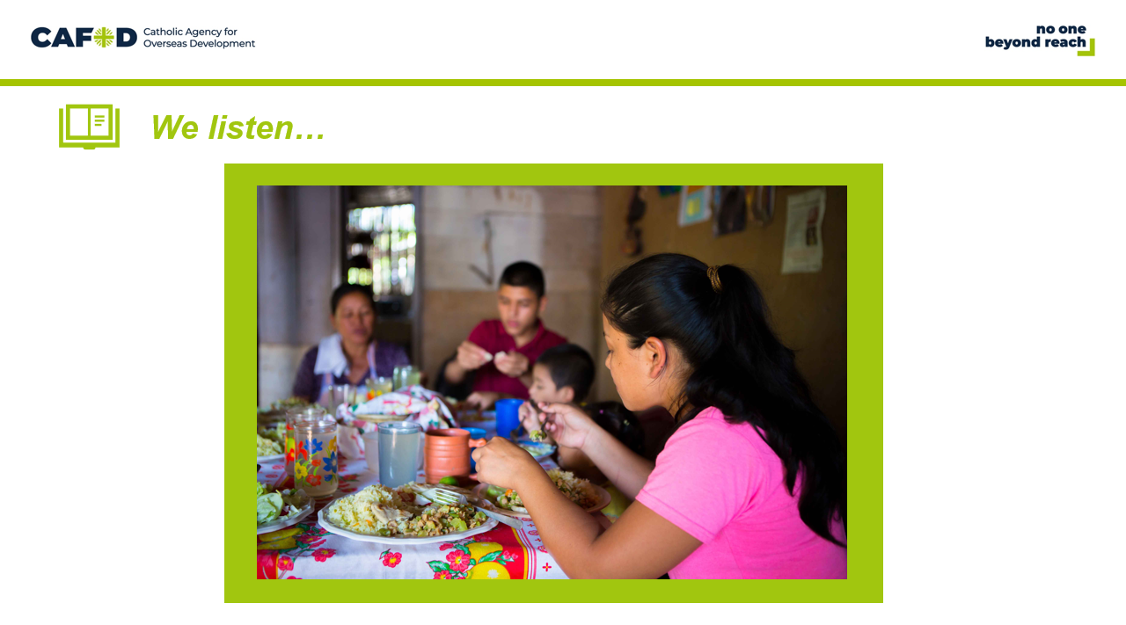 | Reader: In the New Testament we hear about the importance of the Body and Blood of Christ.  Narrator: Jesus and His disciples gather around a table to share their last meal together.  Jesus: I am the living bread which has come down from heaven. Anyone who eats this bread will live for ever. The bread I shall give is my flesh, which I give so the world may live.
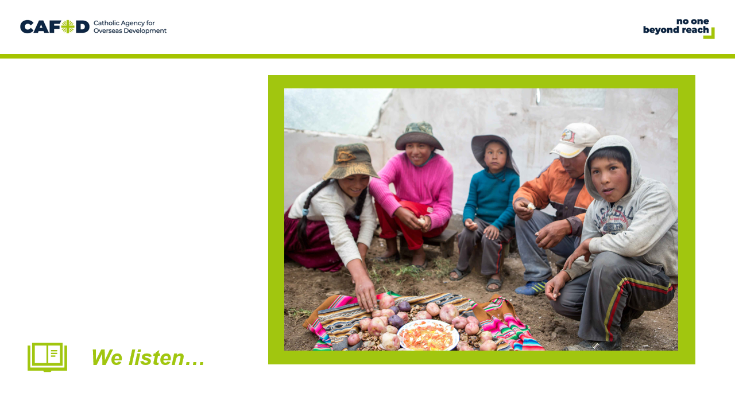 | Narrator: Jesus took the bread and when he had given thanks he broke it and gave it to them.  Jesus: This is my body which is given for you. Do this in remembrance of me.  Disciple 1: Because there is only one loaf of bread, it means that though there are many of us, we form one body with Jesus.  Reader: Church is a place where rich and the poor are all called to gather together around the altar table. At the Eucharist there are to be no rich and no poor, only one equal family praying together.  Reader: Let us have a moment of silence to think about God’s words.
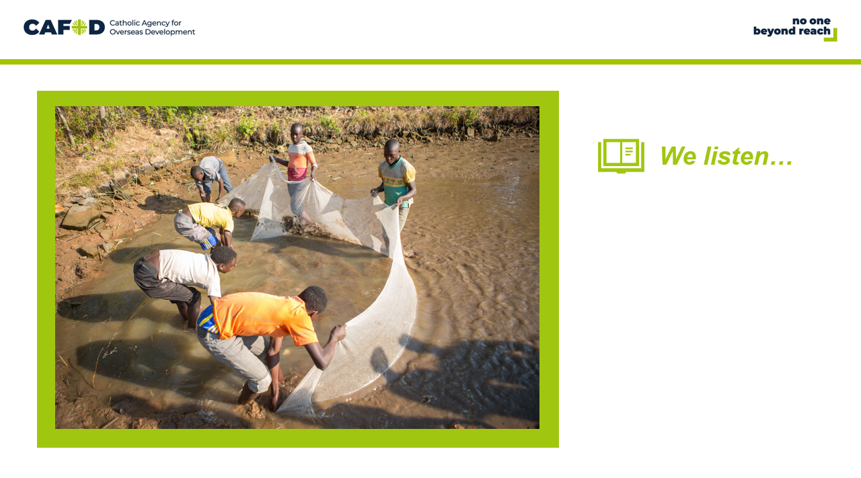 | Reader: Who brought a packed lunch with them this morning?  Imagine you have a packed lunch for school one day and you're the only person with a lunch.  What thoughts might go through your mind? What would you do?  Reader: In the Gospel of Matthew, we hear the story about when Jesus had to feed over 5,000 people. The story is one of Jesus’ most famous miracles.
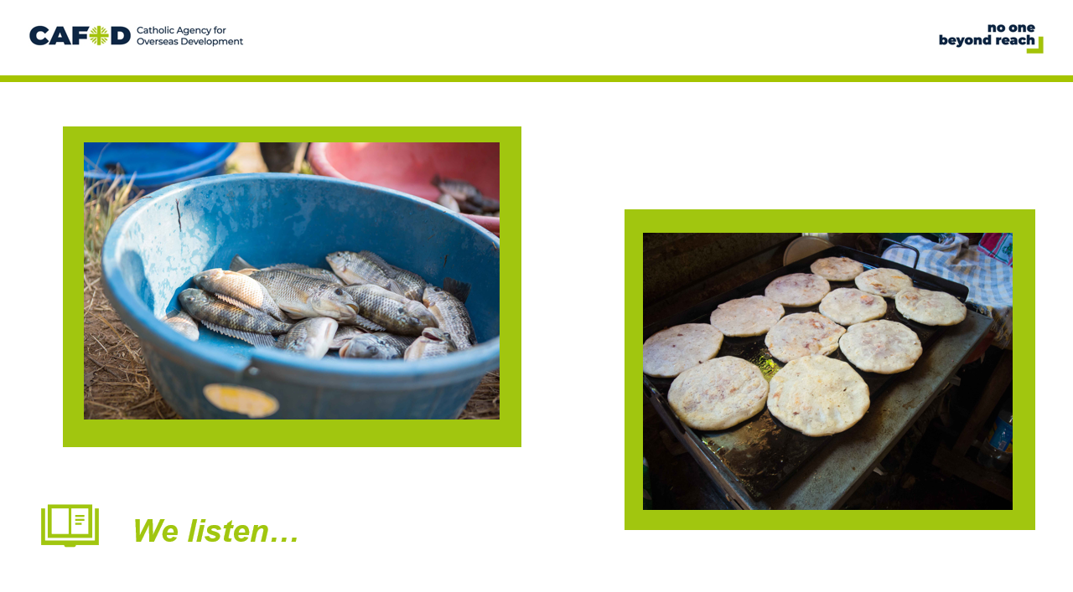 | Reader: A reading from the Gospel of Matthew  “As Jesus stepped ashore he saw a large crowd; and he took pity on them and healed their sick.  When evening came, the disciples went to him and said, 'This is a lonely place, so send the people away, and they can go to the villages to buy themselves some food.'  Jesus replied, 'There’s no need for them to go: give them something to eat.’  But they answered, 'All we have with us is five loaves and two fish.'  So Jesus said, 'Bring them here to me.’  He took the five loaves and the two fish, raised his eyes to heaven and said the blessing.  And breaking the loaves he handed them to his disciples, who gave them to the crowds.  They all ate as much as they wanted, and they collected the scraps left over, twelve baskets full.  The Gospel of the Lord  All: Praise to you Lord Jesus Christ. (Matthew 14: 14-21)

We respond: We respond to the Word of God
Slide | Script | Ideas
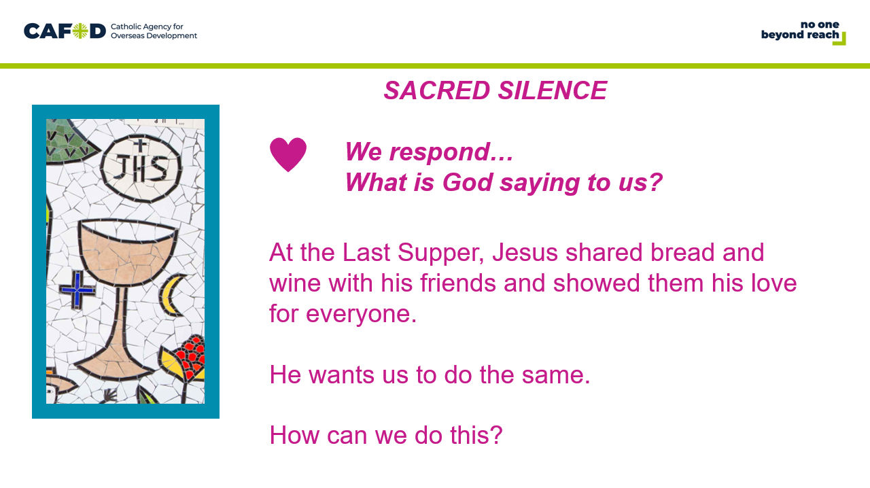 | Reader: At the Last Supper, Jesus shared bread and wine with his friends and showed them his love for everyone – and he wants us to do the same. How can we do this?  Reader: Let us have a moment of silence to think about God’s words. | Optional slide- Sacred Silence
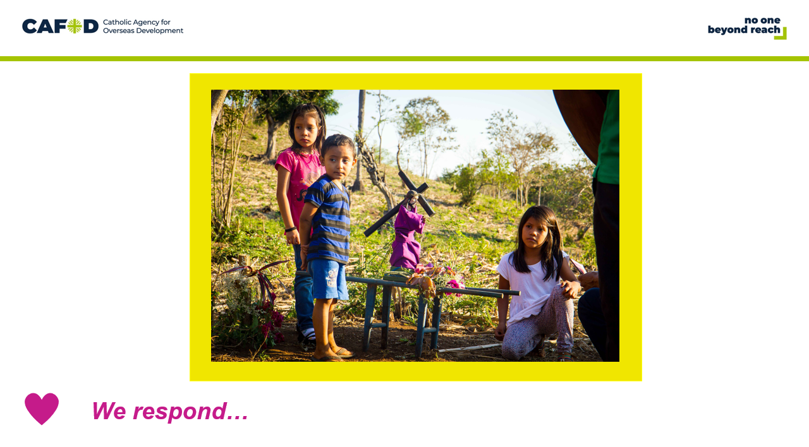 | Reader: Following the teaching of Jesus, we believe that everyone is chosen and special and a valuable part of the family of God. We believe that God created our beautiful world; a world where everyone should have the basic things we need in life.  Reader: What do you think these children are doing? These children are from El Salvador and they are taking part in Stations of the Cross. One of CAFOD’s partners has helped some of their families to learn skills for farming. This has meant that they can grow more food so they don’t go hungry but also means they can sell some. The family can then buy shoes, clothes and medicine. The family have also trained others in their community.
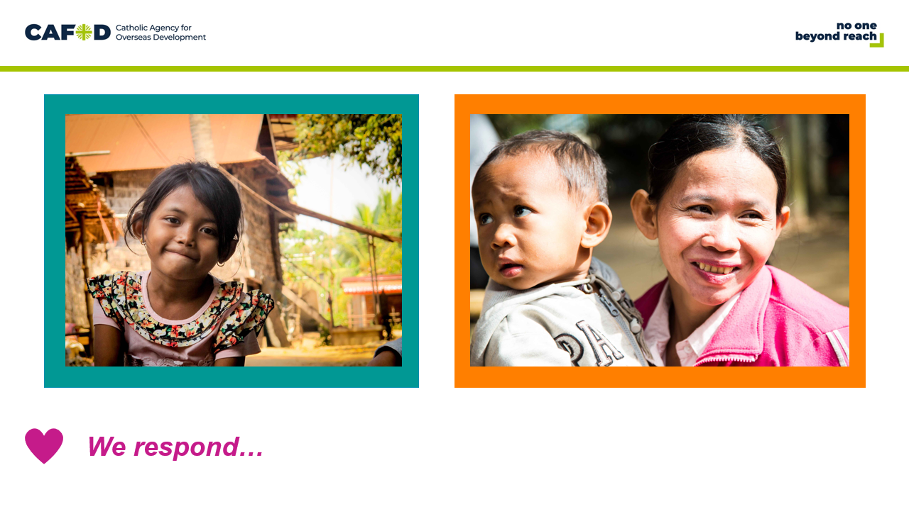 | Reader: CAFOD works with all people whatever their skin colour, nationality or religion because we are all equal.  Reader: Like we all do, CAFOD believes in a better world, where no one lives in poverty and each of us can become the best person we can be. CAFOD works together with poor communities to end poverty in more than 40 countries around the world.
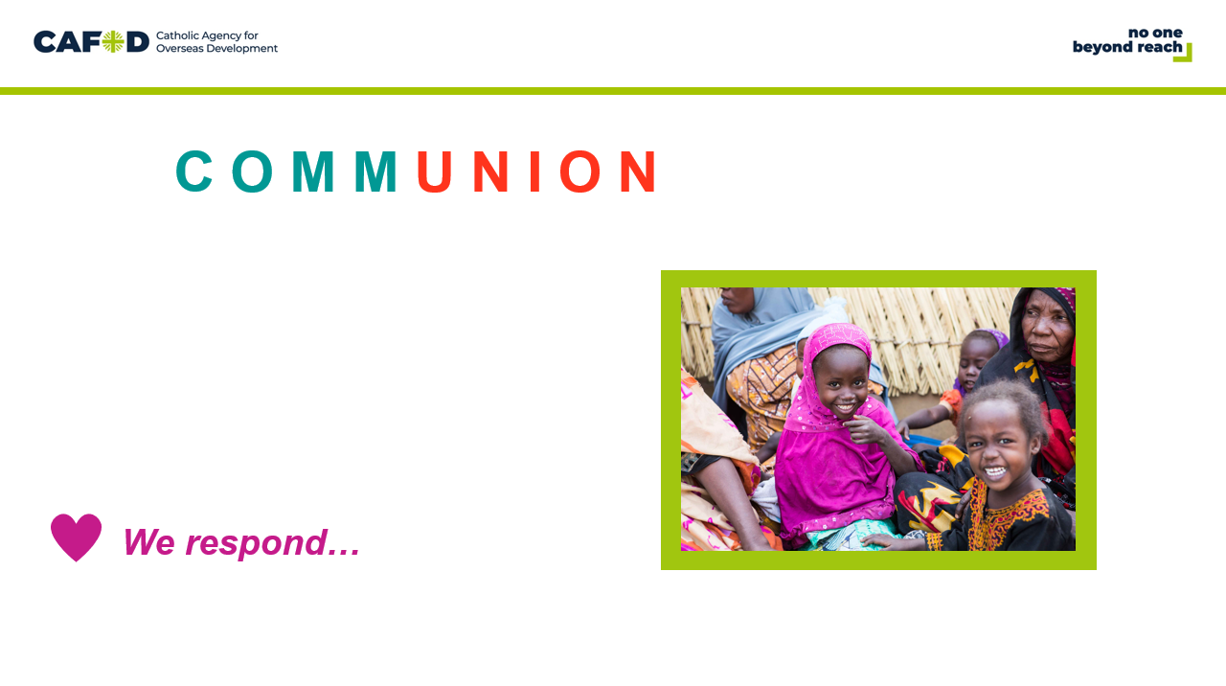 | Reader: The Eucharist is a sacrament of love and a sign of unity. The word communion reminds us of union and community. We celebrate our union with Christ and our community with people locally and globally. | OPTIONAL SLIDE- additional detail for a KS2 assembly

Going Forth: We want to share the Good News!
Slide | Script | Ideas
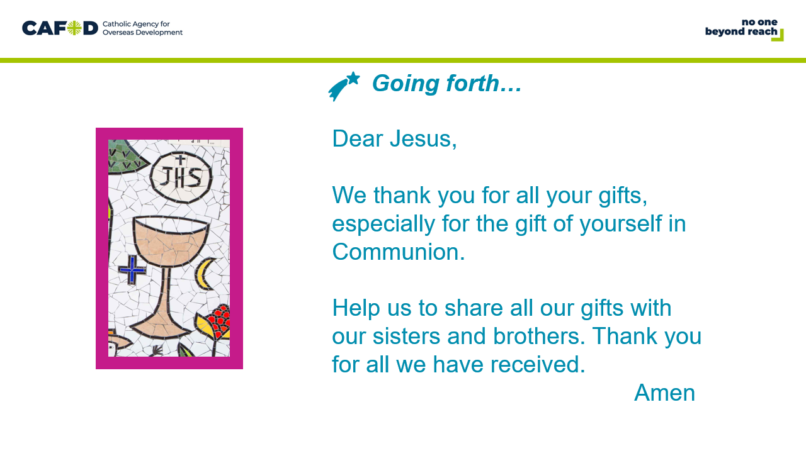 | Reader: Let us pray…  All:  Dear Jesus, we thank you for all your gifts, especially for the gift of yourself in Communion.  Help us to share all our gifts with our sisters and brothers.  Thank you for all we have received. Amen
OPTIONAL CLASSROOM ACTIVITIES:

Children could design their own monstrance using paper plates. On one side they could draw a picture of the Eucharist and on the other side a picture of the world to remind them that we are one family and Jesus brings his love to the whole world.
Jesus wants us to do all we can to make sure that everyone, whoever they are, wherever they live, have what they need. Think of ways we can help people living in poverty to have what they need.
Help change a life by fundraising for a World Gift, such as a solar lamp. With a solar lamp children without electricity can do their homework in the evening after dark, which helps them build a brighter future:
https://worldgifts.cafod.org.uk/

