A guide to using the Fratelli Tutti animation for Primary Schools
We have produced an animation with accompanying resources to support children’s exploration of Fratelli Tutti, and to inspire them to take action.
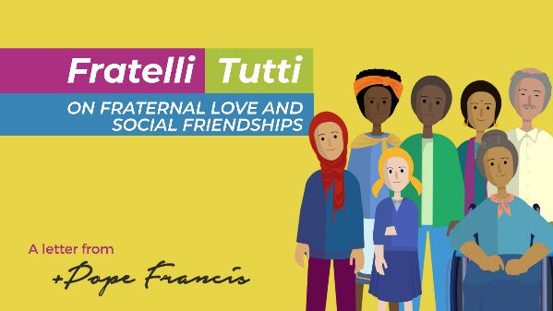
- Animation film and script for KS2
- Slides and script for KS1
- Pledge action sheet for KS1 and KS2
- Good Samaritan PowerPoint
    - Catholic Social Teaching worksheets on Common Good and Human Dignity

The animation can be used in an assembly or class reflection, to explore key principles of Catholic Social Teaching and to support RE lessons and Universal Church Units. Cross curricular links: English, PHSE/PSED, RSE Geography, Science.

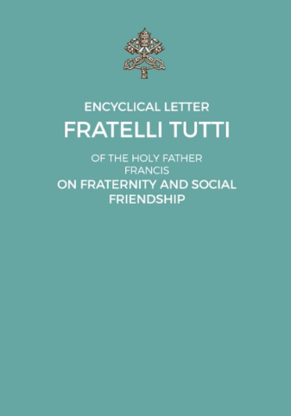
Background information about Fratelli Tutti
Fratelli Tutti is an encyclical, or open letter, written by Pope Francis. It was published on October 4 2020. In the encyclical Pope Francis asks us to reach out to our sisters and brothers in need, whoever they are, wherever they may come from. We are challenged to turn outwards and think of ourselves as one global family, becoming neighbours to all. Fratelli Tutti is a new dream for a world after coronavirus. It turns the world upside down, placing human dignity at the centre.

Introducing the animation
Play the animation in full, then ask the children key questions:
- What is the Pope asking us to do in his letter?
- What does the Pope say at the start of the letter about what is starting to happen to our world?
- What has happened to our relationships with each other because of this?
- What does a ‘culture of encounter’ mean?

Play the animation for a second time, stopping to ask critical questions:
- Why do you think Pope Francis wrote this letter?
- What do you think a ‘new dream’ for the world could look like?
- How do you think we can we ‘bend down to heal the wounds of others’?
- What do you think Pope Francis means when he writes we need to ‘change the conditions that cause so much suffering’?
- Pope Francis asks us to think of ourselves as ‘a single family living in a common home.’ What do you think ‘common home’ means?

Show the CAFOD national assembly on Fratelli Tutti
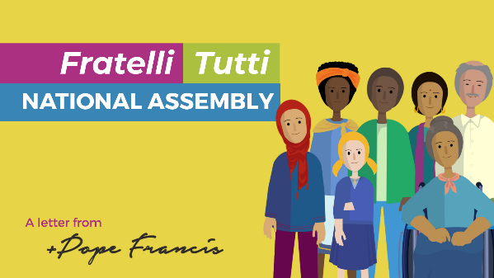
Children around England and Wales came together to hear about Pope Francis’ message and to share how they are living the gospel.
Watch the assembly together and ask children to listen carefully to the clips from the different schools. Make a short film or presentation to show how your school puts love into action.

Introducing Catholic Social Teaching principles
Pope Francis asks that we work for the good of everyone and respect the human dignity of every person. Use our CST resource for an explanation, key statement, scripture, CST quotes and CAFOD links to explore Common Good and Human Dignity.
Invite a CAFOD trained visitor into your school to run a session on Catholic Social Teaching with your pupils. Email schools@cafod.org.uk

Take action
Download and share the Fratelli Tutti pledge action worksheet.
Pope Francis asks us all to be global neighbours. How will you be a global neighbour?
- Create a list of actions you could do at school
- Create a list of actions you could do at home
Create a display using the Fratelli Tutti images from the animation and photos of children taking action.

More activity ideas
- Visit KidzZone on CAFOD’s website and learn more about our global neighbours
- Download the Good Samaritan PowerPoint to further explore Jesus’ message about loving our neighbours
- Use the animation script as a starting point for writing reflections, poems, prayers and letters
- Use the KS1 PowerPoint slides and the KS1 script to explore the key messages with younger pupils
- Pope Francis asks us to ‘change the conditions that cause so much suffering.’ Look at CAFOD’s website to join our latest campaign calling on the Government to support our brothers and sisters around the world
- Set up a fundraiser at your school to show love for our neighbours. Visit CAFOD’s website for resources
- CAFOD clubs are a great way for your pupils to lead the way, put their faith into action and strongly support the Catholic life of your school. Register for a starter pack and help your pupils find ways to put their faith into action

