Terrific toilets

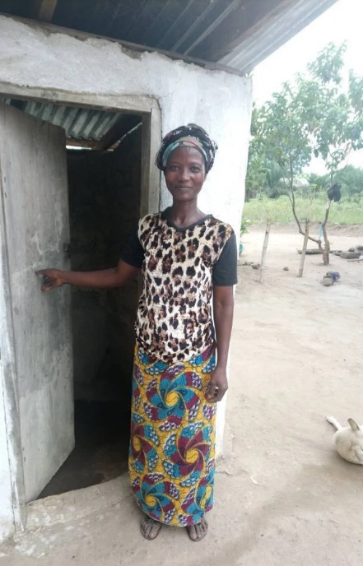
“I pray that this project will be extended to other communities.” Gbessay, Sierra Leone

Sierra Leone
Sierra Leone, on the west coast of Africa, has a tropical climate. It is a fertile country with beautiful beaches, mountains and jungles. It is rich in natural resources, especially diamonds, but is one of the poorest countries in the world.

Sierra Leone endured a civil war from 1991 to 2002. A generation of children missed out on an education and families lost everything as they fled to temporary camps. Homes, schools, clinics and farmland were burnt to the ground. The economy is still recovering.

The capital, Freetown, is a bustling city and there are large towns elsewhere, but in rural areas the roads are poor and travel is difficult. Most villages have no piped water, gas or electricity.

Gbessay
Gbessay lives with her family in a small village in a rural area.

Without a toilet at home, Gbessay and her children were forced to use the bush. Every time they went, they risked deadly diseases, worms and even snake bites – especially at night.

Gbessay knew that her family needed a toilet, but what could she do? Building a toilet costs a lot of money and Gbessay urgently needed to buy food, clothing and medicine for her children who were often sick.

Building a toilet
CAFOD has worked in Sierra Leone since the 1970s. Thanks to the Catholic community in England and Wales, CAFOD was able to work alongside local experts to give families in Gbessay’s community the tools and training to build a working toilet.

As toilets are being built, the local experts also provide health and hygiene training to the whole community, so that everyone can benefit.

A healthier community
Gbessay’s children can now go to the toilet safely. She has noticed that fewer people in her community are getting sick and dying from infectious diseases and diarrhoea. She told us: “I am very happy and proud of CAFOD’s work. I pray that this project will be extended to other communities around us.”
World Gifts
The World Gift “Terrific toilet” respects human dignity, gives people security and comfort when they need the toilet, and helps to stop the spread of serious diseases, keeping communities healthy and safe.
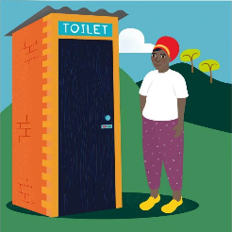
£85
Find out more at https://worldgifts.cafod.org.uk

