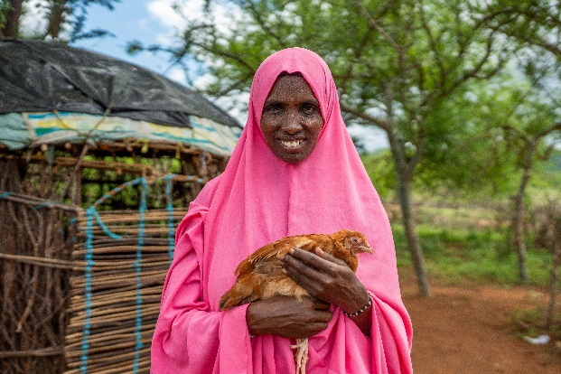
Lent 2025 Liturgy for primary schools
This liturgy can be used on Ash Wednesday or at another time to mark the season of Lent. It can be used as a whole-school liturgy or by individual classes.

You will need:
- A table, crucifix, candle and Bible to create
Khera is part of the Glitter Group poultry farmers in Kenya.
a central focus point
- Music or hymns
- Readers
- Paper (to write or draw Lenten promises and prayers)
- Baskets
If this liturgy is to be used as your Ash Wednesday service, you will also need:
- Ashes
- Volunteers trained to distribute the ashes
Suggested hymn: Hosea (Come back to me) (842, Laudate)

Gather
Opening Hymn

Play some music or a hymn as pupils enter.
Sign of the Cross
Leader: We begin our worship with a reminder that Jesus died and rose again for us and so we gather in the name of the Father, and of the Son, and of the Holy Spirit.
All: Amen
Lent explained
Leader: Lent is a time when we pray, do kind things for other people, give up things and give to others, as we prepare to celebrate the great feast of Easter.
For forty days, we accompany Jesus on his journey to Calvary and we see the mercy he shows towards others, despite his suffering. Just as God shows mercy towards us, like Jesus, we try to show mercy to others.
In this Jubilee Year, Pope Francis has asked us to celebrate with deep faith, lively hope and active charity. This means he wants each one of us to celebrate this year by trusting in God, looking forward with hope, and showing love to others through kind and caring actions. So, this Lent, we are also making our journey alongside families around the world living in poverty, especially those who are suffering because of climate change.
Opening prayer
Loving and compassionate God,
teach us to show love and mercy to each other.
As we begin our journey through Lent, inspire us to be generous and kind.
Through our joy, patience and kindness, may we help to build a better world.
Amen.

Word
Scripture reading: Joel 2:12-13
Leader: Let’s listen to our scripture reading.
Reader: A reading from the prophet, Joel (2:12-13)
‘Now, now – it is the Lord who speaks – come back to me with all your heart, fasting, weeping, mourning.’ Let your hearts be broken, not your garments torn. Turn to the Lord your God again, for he is all tenderness and compassion, slow to anger, rich in graciousness, and ready to relent
The word of the Lord.
All: Thanks be to God.
Response
Leader: In our reading, the Lord calls us to return to him with sorrow for the ways we have failed to act as we ought to have done. And God is always merciful, not wishing to punish us but to love us. Joel says “Let your hearts be broken, not your garments torn.” In other words, let your heart be opened; it’s not about how you look on the outside, it’s all about what your heart is doing inside. God is full of love and wants us to have hearts filled with love because we have experienced his mercy.
The reading also asks us to fast. Fasting is one way to let God love others through us. When we give up fast food, snacks or some other treat, we stand in solidarity with people living in poverty. It’s like saying, “I want to stand beside you in your hunger”. During Lent, CAFOD invites us to support those who live in extreme poverty. CAFOD can turn the money we raise into something amazing that helps communities transform their lives.
As we continue our liturgy, let’s remember our sisters and brothers living in poverty.
CAFOD story
Show the schools Lent video to share this year’s story about Khera and her community in Kenya
cafod.org.uk/primary/lent
Receiving of the Ashes and/or Lenten promises
Leader: We will have a minute or two for reflection when you are invited to write or draw your Lenten promise or a prayer for those who are experiencing poverty. (These could be prepared in class beforehand, cut out, and decorated.)

Quiet instrumental music can be played during this time.

If ashes are being distributed:  You’re now going to receive your ashes. Please wait in silence until you are called forward and take this opportunity to speak and listen to God in your heart.  After receiving the ashes, place your piece of paper into the basket. Later, they will be added to our CAFOD display as a sign that, this Lent, you want to help build a better world.  Have a basket on each side of the ashes. Pupils line up to receive ashes on their foreheads then place their paper into the basket. | If ashes are not being distributed:  Please wait in silence until you are called forward to place your piece of paper in the basket and take this opportunity to speak and listen to God in your heart.  Later, your prayers and promises will be added to our CAFOD display as a sign that, this Lent, you want to help build a better world.  Have two pupils holding baskets at the front. Pupils line up to place their paper into the basket.

Prayers
Each prayer can be read by a different person. The response is: Hear our prayer.
Loving God, we pray for our school family as we begin this season of Lent. Help us to be generous in our actions.
Lord, in your mercy: Hear our prayer.

Caring God, we pray for families who are experiencing drought. Through our fundraising, help us to support more families and help to build a better world.
Lord, in your mercy: Hear our prayer.

Gentle God, we pray for those who work for justice all over the world. As we support the work of CAFOD in this Jubilee Year, let us never lose hope for a fair and just world.
Lord, in your mercy: Hear our prayer.

Wonderful God, we pray for one another as we journey through Lent. As we pray, give things up, fundraise and think of others, inspire us to be kind and show mercy in our actions.
Lord, in your mercy: Hear our prayer.

Send
Final prayer

Loving God,
Help us to work together
to share what we have
so that everyone has what they need.
Help us to build a better world
where each of us can become
the best person we can be.
Amen
Leader: In the name of the Father, and of the Son, and of the Holy Spirit.
All: Amen

Closing hymn
Invite everyone to leave quietly.

To find out more about this year’s story and to join the Big Lent Walk, visit cafod.org.uk/primary/lent

