All Saints Day
We can lead this too!

Celebration of the word

Theme: All Saints Day, saints, love of neighbour, global family, Catholic Social Teaching principles of Common Good and Option For The Poor.
Purpose: For children to learn about and celebrate All Saints Day, reflect on the Sermon on the Mount and consider how Jesus asks us to live our lives. This resource can be adapted to use for liturgical prayer or for an assembly. It is designed so that pupils can lead it too.
Materials required: Accompanying PowerPoint, copy of prayers/script for readers
Suggested hymn: Seek ye first the kingdom of God (633, Celebration Hymnal for Everyone)
Time allocation: 20 minutes
We gather: We come together as part of God’s family.

Slide | Script
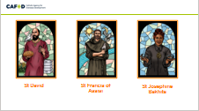 | Reader: In the name of the +Father, and of the +Son, and of the +Holy Spirit Amen.  Today is All Saints Day when we remember all those who have lived their lives really well and have died and gone to Heaven.  Some of these people have been given the title ‘Saint’ by the Church, and their own special Feast Day in the Church's calendar like St David, St Francis of Assisi or St Josephine Bakhita.  But anyone who has gone to Heaven is a saint, and All Saints Day is their feast day.  Can you name any saints?  Today is also a day when we remember that we are all called to be saints.

We listen: God speaks to us, and we listen

Slide | Script
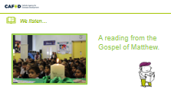 | Reader:  Jesus saw the crowds and went up a hill, where he sat down. His disciples gathered round him, and he began to teach them:  “Happy are those who know they are spiritually poor; the Kingdom of heaven belongs to them!  Happy are those who mourn; God will comfort them!  Happy are those who are humble; they will receive what God has promised!  Happy are those whose greatest desire is to do what God requires; God will satisfy them fully!  Happy are those who are merciful to others; God will be merciful to them! Happy are the pure in heart; they will see God!  Happy are those who work for peace; God will call them his children!  Happy are those who are persecuted because they do what God requires; the Kingdom of heaven belongs to them!  Happy are you when people insult you and persecute you and tell all kinds of evil lies against you because you are my followers.  Be happy and glad, for a great reward is kept for you in heaven. This is how the prophets who lived before you were persecuted.  The Gospel of the Lord.  All: Praise to you Lord Jesus Christ.

Slide | Script
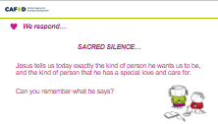  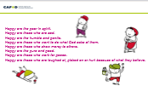  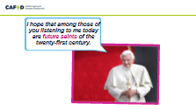  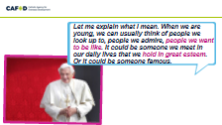 | Reader  Today we hear Jesus telling us exactly what kind of person he wants us to be, and the kind of person that he has special love and care for. Can you remember what he says?  Here’s the list again. Listen carefully. Can you think of anyone who these remind you of?  Let’s think quietly about them for a moment.  Today on All Saints Day we celebrate people who have lived their lives really well following Jesus and serving others.  Did you know that we are all called to be saints too?  Pope Benedict was the Pope before Pope Francis.  During a visit to the UK, Pope Benedict spoke to all children in England and Wales and Scotland who go to Catholic schools.  He said, “I hope that among those of you listening to me today are future saints... Let me explain what I mean. When we are young, we can usually think of people we look up to, people we admire, people we want to be like. It could be someone we meet in our daily lives. Or it could be someone famous.”  Then the Pope asked all the children a question:  “What kind of person do you really want to be?”
We respond: We respond to the Word of God

Going Forth: We want to share the Good News!
Slide | Script
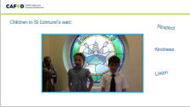  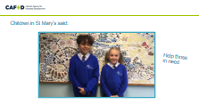  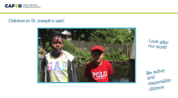  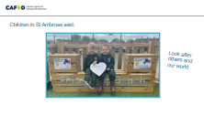  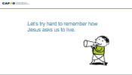 | Reader:  What can we do to follow Jesus, live our lives well and be saints ourselves?  Let’s hear from children in schools like ours:  [There are four film clips in the next four slides. You may wish to choose one or two, depending on time.)  Children in St Edmund’s said:  “To be a good friend I need to listen to other people and before I say anything I always check, is it kind? Is it true? Do I need to say it? To be a good friend we need to respect others and treat others as you would like to be treated yourself. Because kindness can spread around you forever.”  Children in St Mary’s school said:  “During Harvest time we dress up in bright colours and donate money to help the poor around the world. All the money donated helps to support CAFOD. During Lent we have different themes each Friday, such as wearing green for St Patrick’s Day, Silly Hair Day and Pyjama Day. Throughout the year we collect donations for the local foodbank so that we can help those in need.”  Children at St Joseph’s said:  “We are inspired by Christian values to look after our world of today and tomorrow. We encourage everyone to be active and responsible citizens to take care of our community and the environment. We have done things to help CAFOD, and the wildlife around us, by doing a school run, Mufti Day, and planting all these flowers for wild bees. We have also been using recycled plastic to make projects to help the earth and to help with all this pollution to stop it.”  Children in St Ambrose said:  Jesus wants us to love one another and care about each other. How have we done this? We became Wombles by looking after our planet by recycling and saving water and saving energy. We looked after those less fortunate than ourselves by giving food to local foodbanks. During lockdown we worked hard in our hub and at home to look after God’s wonderful world. We planted trees in our school fields so that more clean air and oxygen can be created. Each year we watch Pope Francis’ Laudato Si’ message in assembly. He asked us to care for our common home, which is something we do here in St Ambrose.  Let’s try hard to remember how Jesus asks us to live. Perhaps we could try to be one of the types of people that Jesus says will be happy: gentle and humble, merciful, pure and good, peaceful, doing what is right.  Or perhaps we can show special care for people and our planet, just as the children showed us in the film clips.

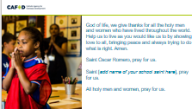 | Reader: Let us pray together to God, who loves and cares for each one of us:  God of life, we give thanks for all the holy men and women who have lived throughout the world.  Help us to live as you would like us to by showing love to all, bringing peace and always trying to do what is right. Amen.  Saint [add name of your school saint here], pray for us.  Saint Oscar Romero, pray for us.  Saint Teresa of Calcutta, pray for us.  Saint Josephine Bakhita, pray for us.  All holy men and women, pray for us.

ADDITIONAL CLASSROOM ACTIVITIES:
- Think about all the people you know who have died. Write their names and collect them into a book of remembrance to be displayed for the whole of November.
- Share the lives of some more of the saints– either those canonised by the Church, or people who have lived their lives very well. You could focus on local saints or those who had a special interest in helping people who live in poverty. You can find some CAFOD resources about saints at cafod.org.uk/saints
- Learn more about St Oscar Romero who spoke out for people living in poverty. cafod.org.uk/primary/romero

