Laudato Si’ liturgical prayer
We can lead this too!

Theme: Creation, caring for the earth.
Purpose: To help children reflect on Pope Francis’ message about looking after the world. This resource can be adapted to use for liturgical prayer or for an assembly. It is designed so that pupils can lead it too.
Liturgical colour: Green
Materials Required: Accompanying PowerPoint, copy of prayers/script for readers, music, candle, map or globe, paper and pens, Laudato Si animation for children
Optional: Order Laudato Si’ postcards and a poster from shop.cafod.org.uk, downlod a Laudato Si colouring sheet from cafod.org.uk/primary/laudato-si
Suggested hymn: ‘He’s got the whole world in his hands’ or ‘Everywhere Around me’ by Out of the Arc music (on YouTube)
Time allocation: 20 minutes

We gather: We come together as part of God’s family.

Slide | Script | Ideas
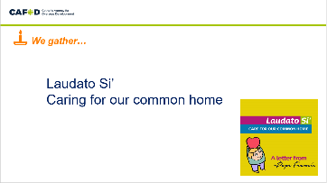 | Reader: In the name of the +Father, and of the +Son, and of the +Holy Spirit Amen.  We gather as a school family to give thanks for the beautiful world we live in. | Play quiet music  Light a candle
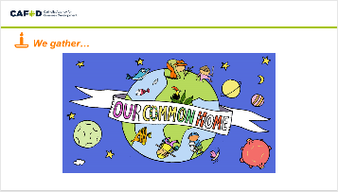 | Reader: God has given us the earth as our home. It’s our common home because we share it with everyone. We are a family, and like every family we need to work together to look after our home.  Let us begin our time of prayer by listening to some words from the very first story in the Bible. | Display a globe or world map

We listen: God speaks to us and we listen

Slide | Script | Ideas
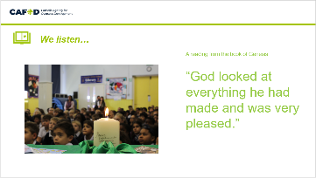  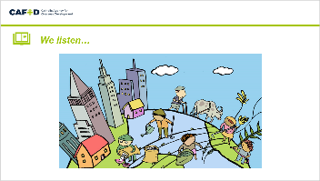 | Reader:  A reading from the book of Genesis:  “Then God commanded ‘Let the earth produce all kinds of plants, those that bear grain and those that bear fruit.’  Let the water be filled with many kinds of living beings, and let the air be filled with birds.  Let the earth produce all kinds of animal life, wild, large and small.  And now we will make human beings; they will be like us.  God looked at everything he had made and was very pleased.”  The word of the Lord.  All: Thanks be to God.  Reader: In the first book of the Bible we hear how God made the whole world, from the stars in the sky to the deepest oceans. People, creatures, land, water and mountains are all part of God’s wonderful creation and we have a responsibility to look after it all.  Reader: The earth is God’s gift to us, it’s full of beauty and wonder. And it belongs to everyone on the planet to share. | Display the Bible

We respond: We respond to the Word of God

Slide | Script | Ideas
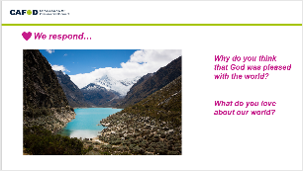 | Reader: Let’s look at this picture and reflect for a few minutes in silence.  What do you love about our world? Why do you think it’s important to look after the world? | Picture
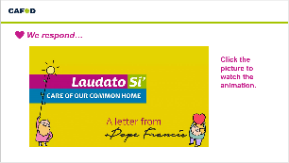  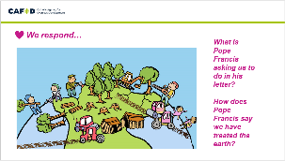  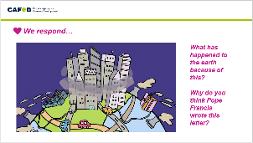  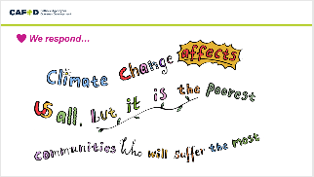 | Reader: Pope Francis reminds us that we need to look after the world. He wrote a letter called Laudato Si’, addressed to everyone in the whole world, asking us all to take care of our common home.  Let’s watch the animation together.  https://cafod.org.uk/Education/Primary-teaching-resources/Laudato-Si-animation  Reader:  - What is Pope Francis asking us to do in his letter?  - How does Pope Francis say we have treated the earth?  - What has happened to the earth because of this?  - Why do you think Pope Francis wrote this letter?  Reader: Pope Francis says that climate change affects us al, but it is the poorest communities who will suffer the most. | Reflection

Going Forth: We want to share the Good News!

Slide | Script | Ideas
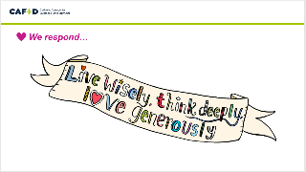  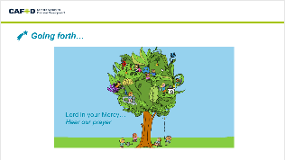 | Reader: In Pope Francis’ letter, he asks us to care for the earth by doing all three of these things.  How can we live wisely? Think deeply? Love generously?  Let us write a pledge, or draw a picture to show how we will look after the world.  Reader: Let us pray together using a prayer based on St Francis’ words.  Reader: We thank you Lord for the earth which is our home [pause] Help us to work together to protect the planet from harm [pause] Lord in your Mercy…Hear our prayer  Reader We thank you Lord for water which gives us life [pause] Help us to not to waste this precious resource [pause] Lord in your Mercy…Hear our prayer  Reader: We thank you Lord for all the plants and creatures you have given us [pause] Help us to not do anything which causes them harm [pause] Lord in your Mercy…Hear our prayer  Reader: We thank you Lord for all the people we share the world with [pause] Help us to work together to take care of each other and our home, so that no one suffers [pause] Lord in your Mercy…Hear our prayer | Action  Hand out the Laudato Si postcards, or scrap paper to write messages, or draw a pictures of creation and display these
OPTIONAL CLASSROOM ACTIVITIES:

Create a class list of actions to live wisely, think deeply and love generously this month.
At the end of the month ask the children to write a letter to Pope Francis explaining the ways they live wisely, think deeply and love generously.

Create a classroom display using drawing or photographs to show different aspects of the letter, such as a scene of beauty from nature, a scene of pollution. Invite the children to speak about each image as they reflect on the words of Pope Francis in Laudato Si’.

Watch David Attenborough’s Wonderul World film together.

