Feast of the Saints Peter and Paul
We can lead this too!

Theme: Ss. Peter and Paul (date: 29 June)
Purpose: to help children reflect on the lives and example of Saints Peter and Paul.This resource can be adapted to use for liturgical prayer or for an assembly. It is designed so that pupils can lead.
Liturgical colour: red
Materials Required: accompanying PowerPoint, copy of prayers/script for readers
Suggested hymns: Follow me, follow me; Seek ye first the Kingdom of God; City of God
Time allocation: 10-20 minutes (optional slides)

We gather: We come together as part of God’s family.

Slide | Script | Ideas
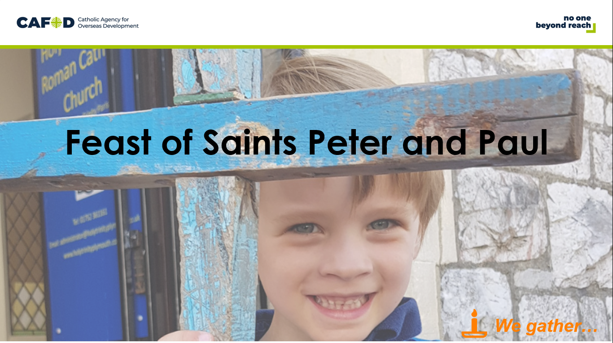 | Reader: We gather as a school family to celebrate the feast of Saints Peter and Paul.  Reader: Saint Peter and Saint Paul both had a great love for Jesus and spent their lives sharing his good news with as many people as they could.Both of them were killed because of their faith in Jesus.
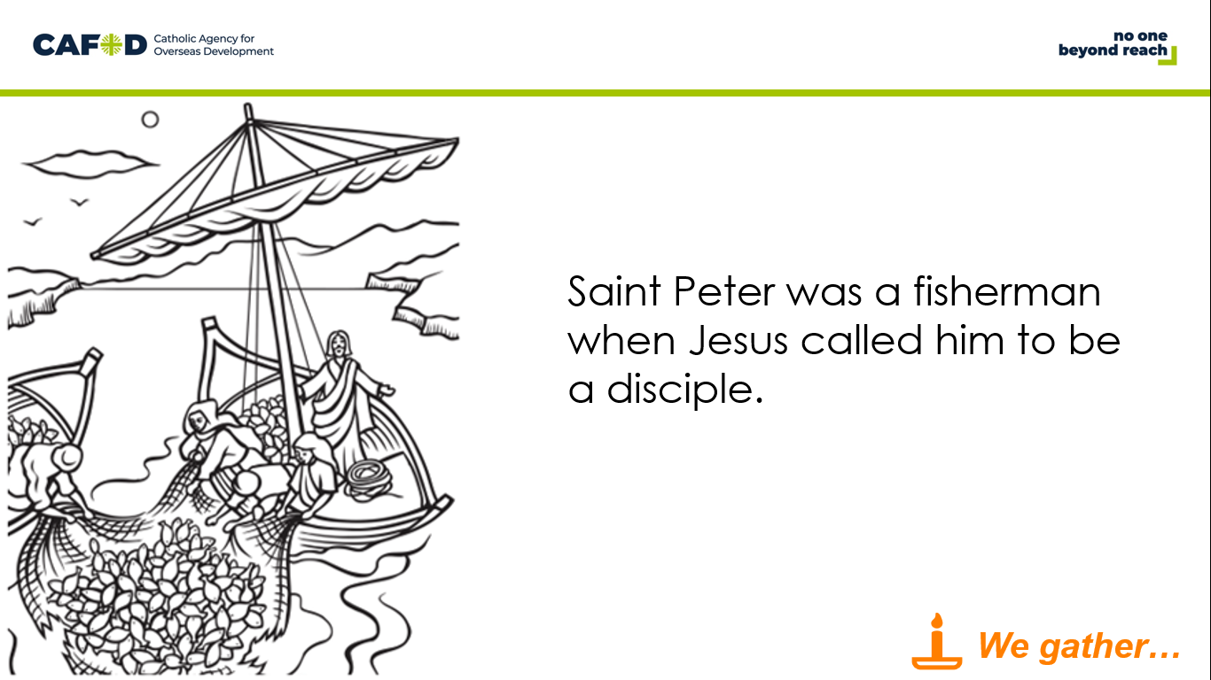 | Reader: Saint Peter was a fisherman when Jesus called him to be a disciple. He was a great friend of Jesus and, although he sometimes made mistakes, became an important leader of the very first Christians.
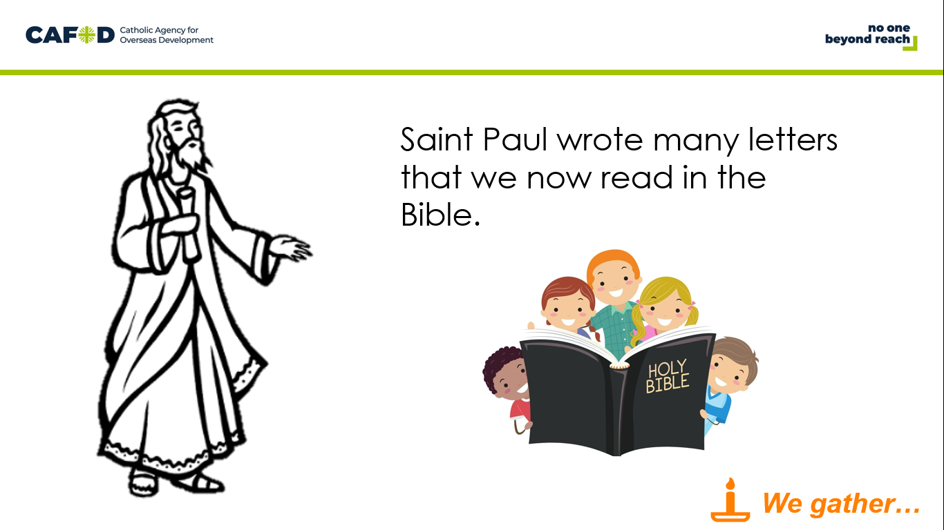 | Reader: Saint Paul was originally called Saul. At first he hated Jesus’ followers. He tried to find them so he could have them put in prison or even killed.  One day he had a vision of the risen Jesus and everything changed. He travelled many thousands of miles to share the message of Jesus. He also wrote many letters that are now in the Bible.
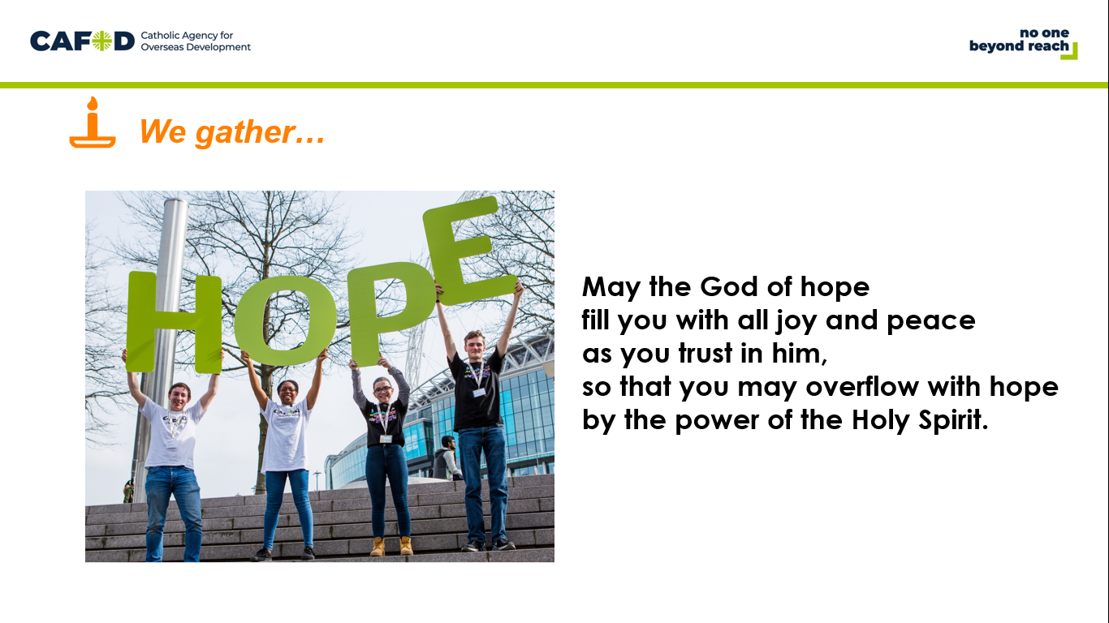 | Reader: We begin with a prayer that Saint Paul wrote in his letter to the Christians in Rome.  May the God of hope fill you with all joy and peace as you trust in him, so that you may overflow with hope by the power of the Holy Spirit. Amen. | (The prayer is from Romans 15:13)

We listen: God speaks to us and we listen

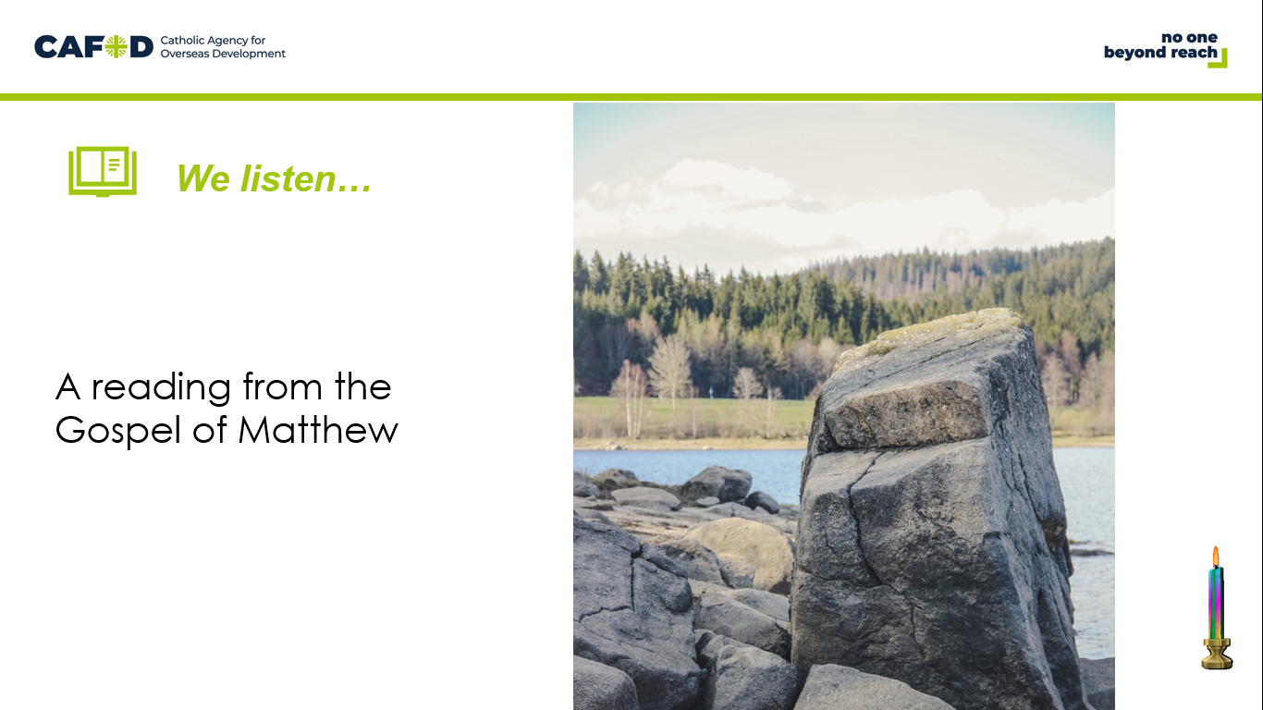 | Reader: Let’s listen to a story that tells us why Jesus chose Peter to be a leader in the Church.  Reader:  Jesus went to the territory near the town of Caesarea Philippi, where he asked his disciples, “Who do people say the Son of Man is?”  “Some say John the Baptist,” they answered. “Others say Elijah, while others say Jeremiah or some other prophet.”  “What about you?” he asked them. “Who do you say I am?”  Simon Peter answered, “You are the Messiah, the Son of the living God.”  “Good for you, Simon son of John!” answered Jesus. “For this truth did not come to you from any human being, but it was given to you directly by my Father in heaven. And so I tell you, Peter: you are a rock, and on this rock foundation I will build my church, and not even death will ever be able to overcome it. I will give you the keys of the Kingdom of heaven; what you prohibit on earth will be prohibited in heaven, and what you permit on earth will be permitted in heaven.” | Display the Bible  (The passage is Matthew 16:13-19)

We respond: We respond to the Word of God

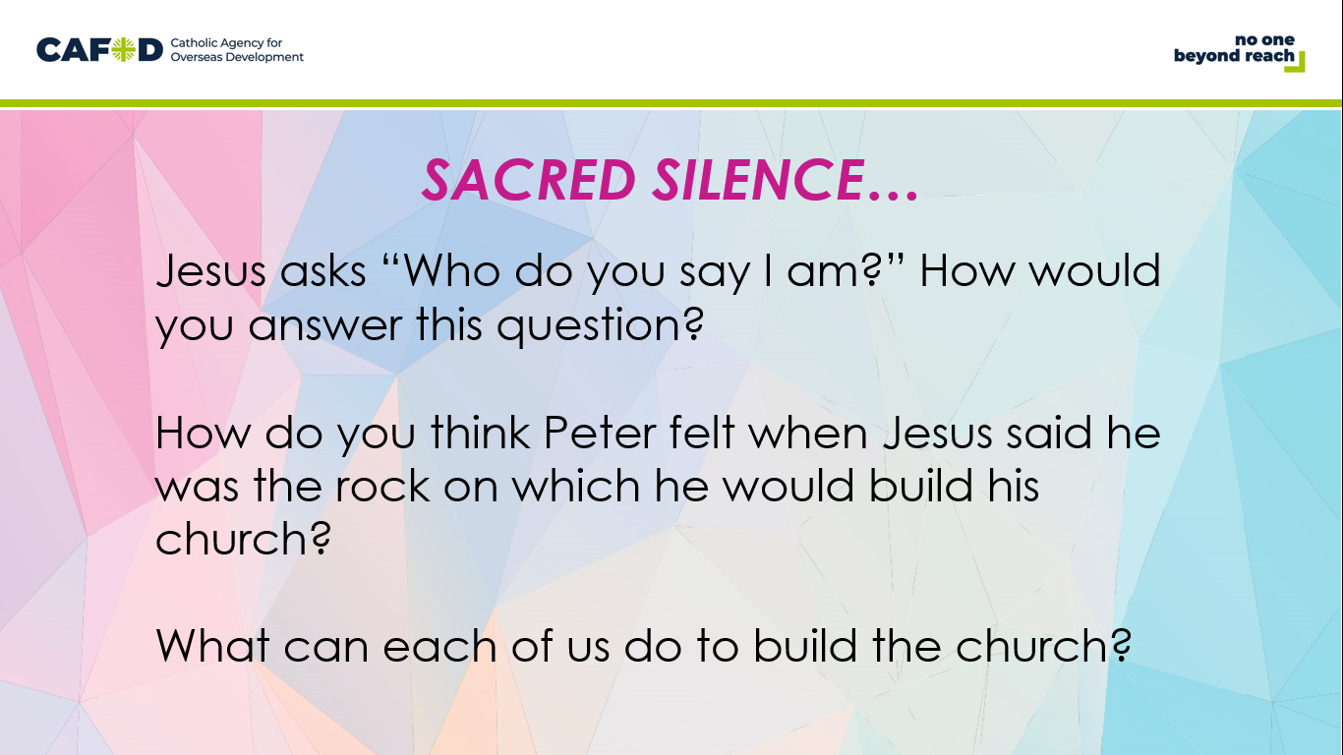 | Optional slide- Following the reading of the Word, you may wish to provide a moment for ‘Sacred Silence’ with questions for children to ponder.  Reader:  - Jesus asks “Who do you say I am?” How would you answer this question?  - How do you think Peter felt when Jesus said he was the rock on which he would build his church?  - What can each of us do to build the church?
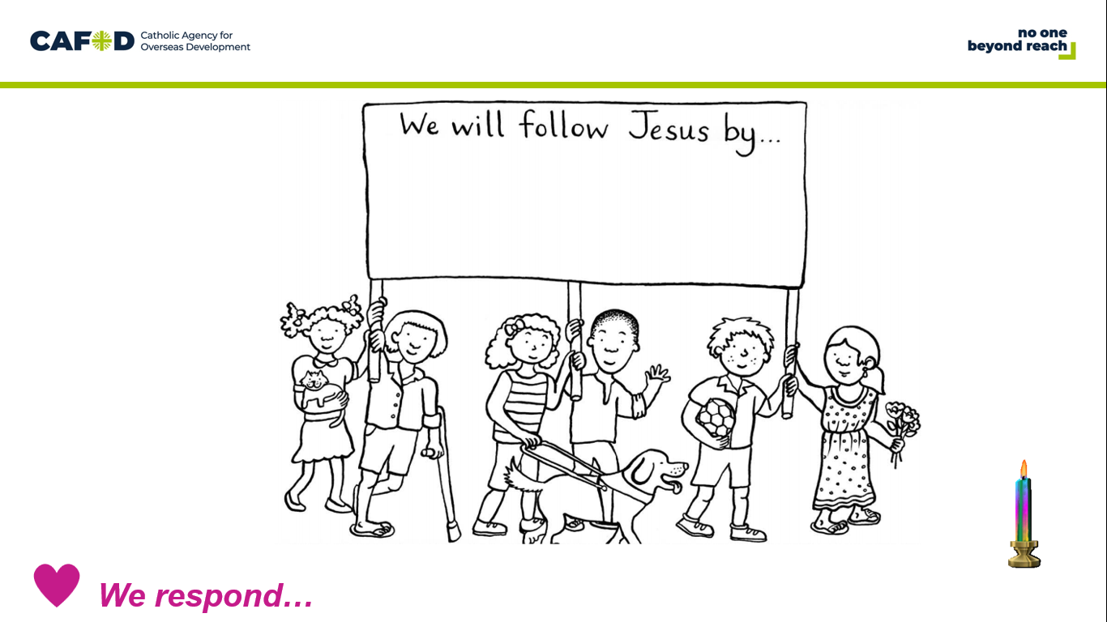 | Reader:  You may have noticed that in the reading Peter is also called Simon. This was his name before Jesus changed it. Jesus changes his name to Peter which means rock.  Reader:  Jesus says that he will build his Church on this rock. Peter will become the strong foundation for the community of the Church that we belong to.  Reader:  Peter and Paul were ordinary people, who had made mistakes but who listened to and followed Jesus. They dedicated their lives to sharing his message of love and forgiveness.  Reader:  We may be ordinary people too. But we can also try to follow Jesus and share his message of love.
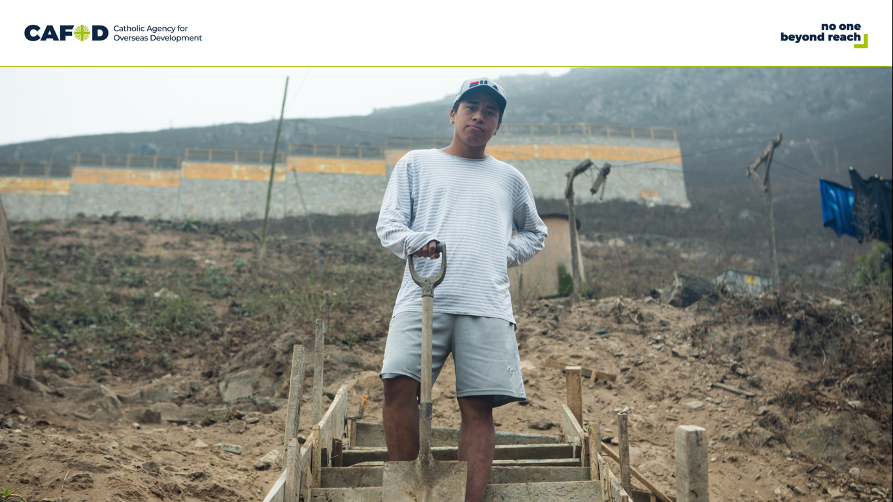 | Reader:  Paolo from Peru shows us what following Jesus and sharing his message of love looks like. The settlement where he lives is built high into the steep hillside of southern Lima, the capital city.  Reader:  At age 19 Paolo volunteered his time to help build a staircase down the hill so that his neighbours will be safe, especially in an emergency. He said:  "For me, community service is really important. It is something that you do to improve your community to help it to grow and develop.”

Going Forth: We want to share the Good News!

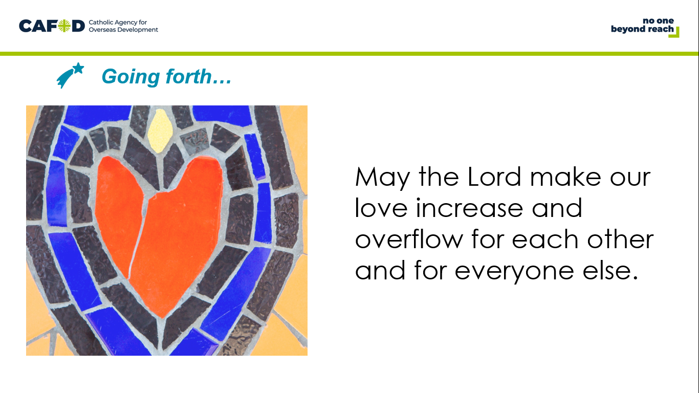 | Allow a short pause after each section so people can reflect and pray.  Reader: Lord we thank you for all the people who have shared the good news of love and forgiveness with us We think quietly for a moment of those people.  (pause)  Reader: Lord, you call us to share the good news with others.We think quietly for a moment of how we might do this and we ask for your help.  (pause)  Reader: We pray together in the words of St Paul displayed on the screen.  May the Lord make our love increase and overflow for each other and for everyone else. | The prayer on the slide and at the end of this section is from 1 Thessalonians 3:9

OPTIONAL CLASSROOM ACTIVITIES:

- St Peter’s new name means rock. Paint some rocks to take home as a reminder of today’s gospel story.
- Paul wrote lots of letters to encourage people and let them know about God’s love. Write some letters to let people know they are loved. Pupils could write to family members and friends or you could arrange to write to residents of a local nursing home.
- St Peter was the first Pope. The Pope is the leader of the Roman Catholic Church. Our Pope now is called Pope Francis. Use CAFOD’s resources (https://cafod.org.uk/Education/Fratelli-Tutti-for-schools) to find out more about Pope Francis latest letter Fratelli Tutti.

