Jubilee Pledge Day for schools
Suggested plan for the day
In June or July all Catholic schools are invited to make a Jubilee Pledge to live out Catholic Social Teaching, to stand in solidarity with communities experiencing poverty, advancing justice and harmony locally, nationally, and globally.
Celebrate your Pledge Day and make it a day to remember that involves the whole school community.
Planning your Pledge Day in June or July
There are many ways to celebrate your Pledge Day as a school community. Watch our film, download our Pledge Guide and run our CPD session to help you write your Jubilee Pledge and plan your Pledge Day. See our suggested plan for the day overleaf.

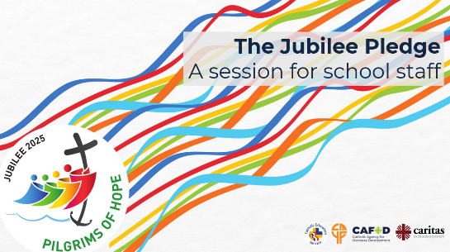


A few words that you could use to introduce the day:
Pope Francis leaves a legacy of love, justice, and compassion. As Pilgrims of Hope we have made a Pledge, a long-term commitment to build a better world, just as Pope Francis asked us.
As a school we have thought about all the ways we can be signs of hope both now and in years to come. We pledge to care for creation, walk alongside people experiencing poverty, build peace, and believe in the power we have as children and young people to change the world.
Here is our Pledge:
We are pilgrims of hope. We walk in solidarity with our sisters and brothers, worldwide, sharing challenges and celebrating joys. We promise to be agents of change, working together or justice, love and peace, locally and globally. We want to build a fairer world where every person, and the earth, can flourish.
[Read out what your school has pledged]
If you have 30 – 45 minutes…
Reflect and celebrate together:
- Watch the Pilgrims of Hope film for primary and secondary pupils.

- Share the Jubilee Prayer of Hope with pupils.
- Hold a Jubilee Celebration of the word with primary pupils
- Use your Jubilee map to reflect on your Jubilee journey so far.

- Complete the form to add your school to the map of Jubilee Pledges around England and Wales, and we will send you a certificate by email.

- Download and print individual pledges for your pupils to share with families.

- Watch the Remembering Pope Francis reflection film to think about how he inspired us all to build a better world.

Make a day of it!
Reflect and celebrate together:
- Organise a pilgrimage around your school, setting up prayer stations and sharing stories from children and young people around the world.
- Think about creative ways to celebrate making the Pledge, eg fingerprint displays, signing it, displaying it.
- Invite your local parish to join Pledge Day. Look at our 10 ideas for parishes and schools to join together
- Join the Jubilee Debt campaign. Learn about global debt and take action to call for a fairer world for all.
- Sing the Jubilee song together as a whole school.
- Invite your local MP into your school to celebrate. Use our guidance and template letter.
- Explore our range of Jubilee films
- Share our Pledge worksheet to help children draw or write how they will live out the Pledge.
- Display your Jubilee Pledge certificate as a sign of your commitment to work for the common good.

