What makes a good leader?

There are many ways to be a leader. Here are two leaders with different talents.
Rosana, 16, Colombia
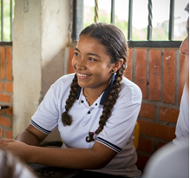
For many years, Colombia has seen lots of violence and conflict. Children like Rosana are trying to change this. She says:

“Young people have such an important role to play. We are not only the future, we are the present too. We are the generation of peace.”

Rosana and her community want to leave violence behind. A peace deal in Colombia has given people a chance to build peace in their communities.
A CAFOD-supported project is running peace-building workshops in schools, teaching children and young people how to avoid a life of violence. They are also taught how to share all they have learnt with their families and neighbours. Rosana and her friends are educating and empowering other young people to resolve conflict peacefully.
Nelson Mandela, 1918-2013, South Africa
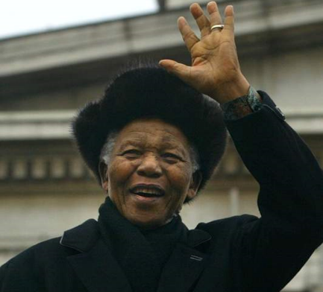
Nelson Mandela was President of South Africa from 1994 to 1999, and he worked hard to end apartheid in South Africa. Apartheid meant black and white people could not mix together. Black and white children went to separate schools and hospitals and could not play on same sports team together. Mandela believed that everybody should be treated equally and he campaigned to end apartheid.
He was arrested in 1962 and went to prison for 27 years. He left prison in 1990 and continued to work hard for equality in South Africa. Mandela worked hard to bring people together to live in peace. He inspired many people to make the world a fairer and more peaceful place. He said:
“Sometimes it falls upon a generation to be great. You can be that great generation. Let your greatness blossom.”

Good leaders are…
inspiring
welcoming
Team players
Good listeners
creative

Who do you admire?
Think about someone you look up to or admire (e.g. celebrities, sports professionals, family members and teachers).

- What are the qualities you like in this person?
- Is it something they were born with, something they developed, or both?
- Design and make a Book of Inspirational People for your club. In this book, record qualities you admire in other people

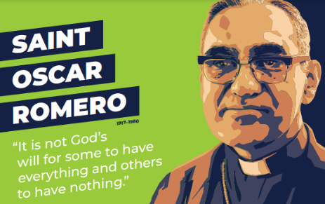
Find out about St Oscar Romero
St Oscar Romero was a special man who stood up for poor communities in El Salvador. He spoke out against inequality. He was killed saying mass in 1980.
Research St Oscar Romero to find out why he is admired and loved by so many people.

What qualities do we need to live a good life?
Gather a selection of images of the people your club members say they admire. On a star template, write down one word to describe a quality they admire in someone else. One by one, invite others to share their word. Why not make a display?

Increase your leadership skills
Decide what you want to achieve in your club. Get creative together; it’s the best way to get ideas, and great ideas can lead to great change!
- Why not start with this term’s CAFOD activities? There are lots of ideas every term for your club to lead global activities
- Organise a Collective Worship
- Plan a fundraiser for CAFOD
- Find out how to join a campaign and speak out for others

