Primary Schools Assembly
World Gifts

Themes: Poverty, food, emergencies, education
Materials Required: Assembly PowerPoint

Desired learner outcomes:
For pupils to learn about their global neighbours around the world.
For pupils to understand how CAFOD is working with communities around the world to end poverty and build a brighter world
For pupils to see the relationship between fundraising and supporting communities overseas
Time allocation: approx 20 mins.
Date:
Note: This assembly is aimed at KS2 but can be adapted for use throughout the school.

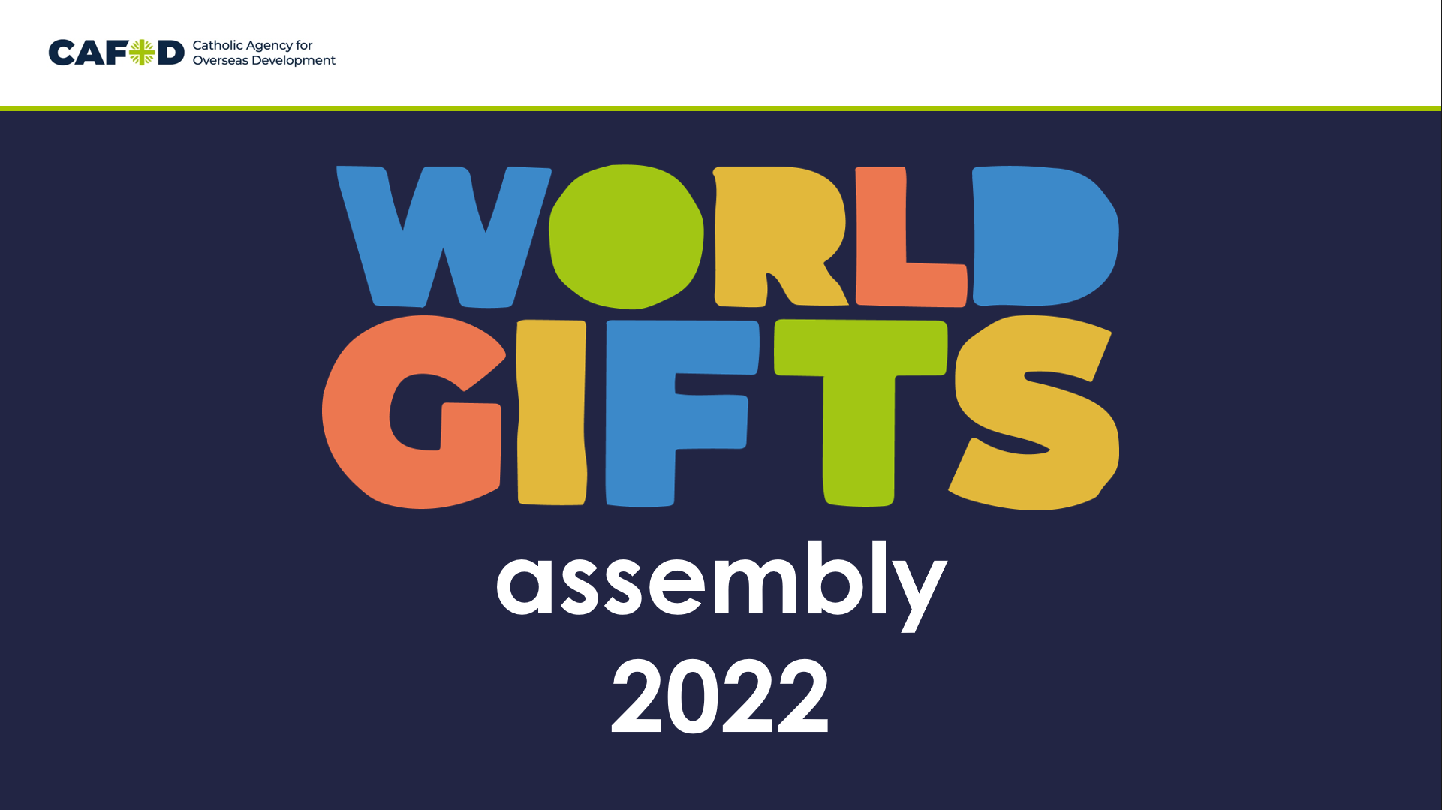 | Good morning/afternoon everyone and welcome to our World Gifts CAFOD assembly.  World Gifts are a great chance to learn about our global neighbours, and how we can help them by working together to build a brighter world.
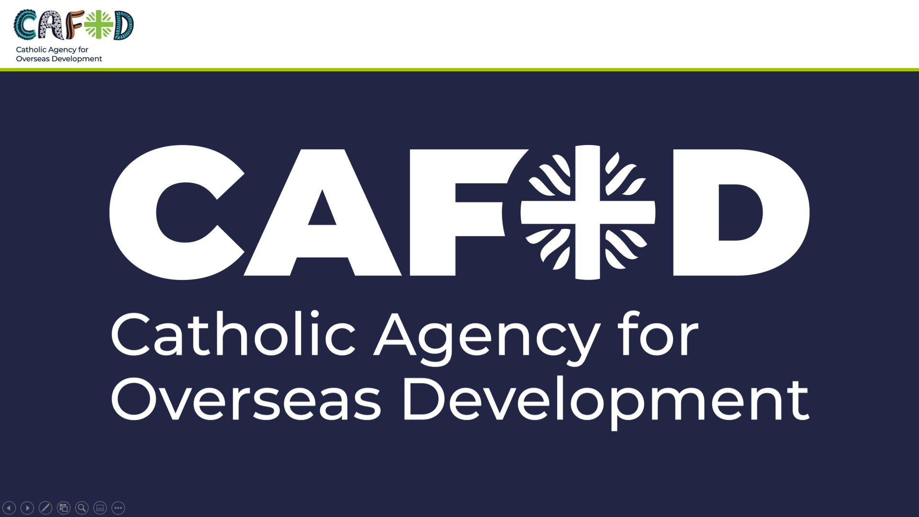 | Who can remind me what CAFOD stands for?  At CAFOD, we believe in a better world, where no one lives in poverty and each of us can become the best person we can be.  In a world without poverty, people have clean, safe water to drink and enough food to eat. Everyone has a safe home, children can go to school, and anyone who is sick can visit a doctor or nurse.
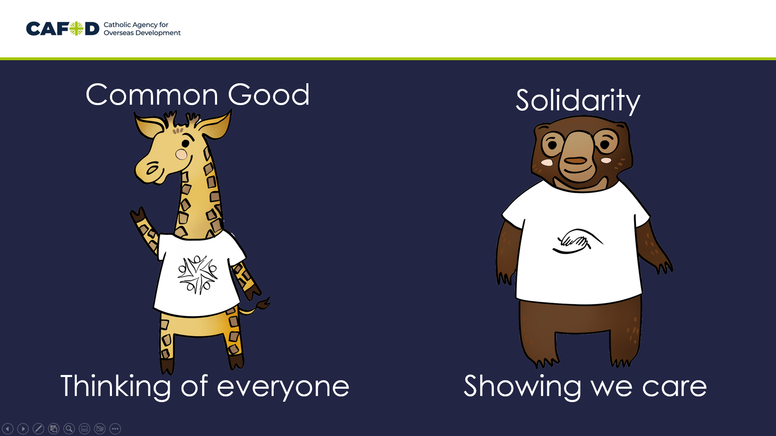 | Catholic Social Teaching, or CST, is at the heart of what we do and who we are. Today we will be thinking about two of the principles in particular: the Common Good (or thinking of everyone, as Chikondi the Giraffe says) and Solidarity (or showing we care, as Shristi the Sun Bear says).
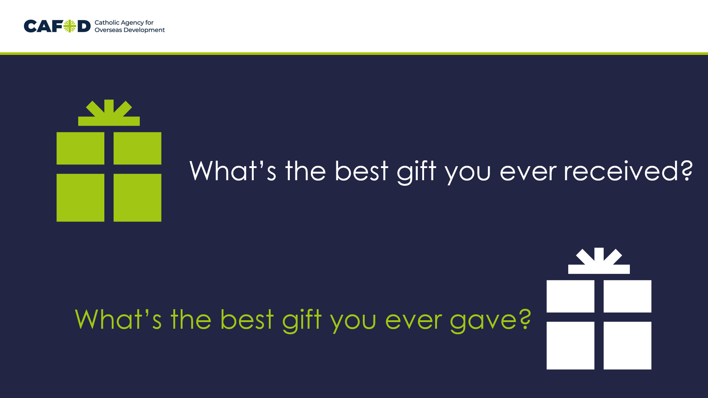 | Today we are going to think about gifts. Can anyone tell me what a gift or a present is?  I’d like you to think about the best gift you ever received. How did you feel?  Now, how about the best gift you ever gave to someone. How did that make you feel? Was it the same? Or better? (Tell the person next to you/the other person on your table).
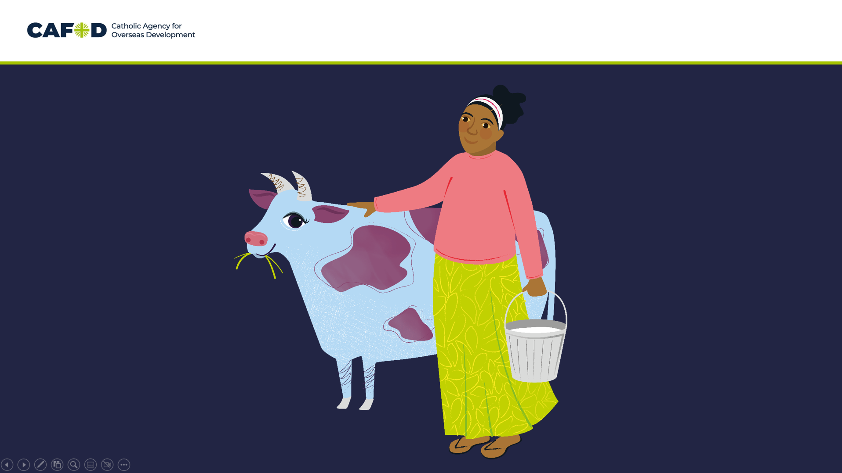 | Has anyone ever given or received a cow?! This marvellous moo cow is one of CAFOD’s World Gifts, that you can give to someone in another part of the world.
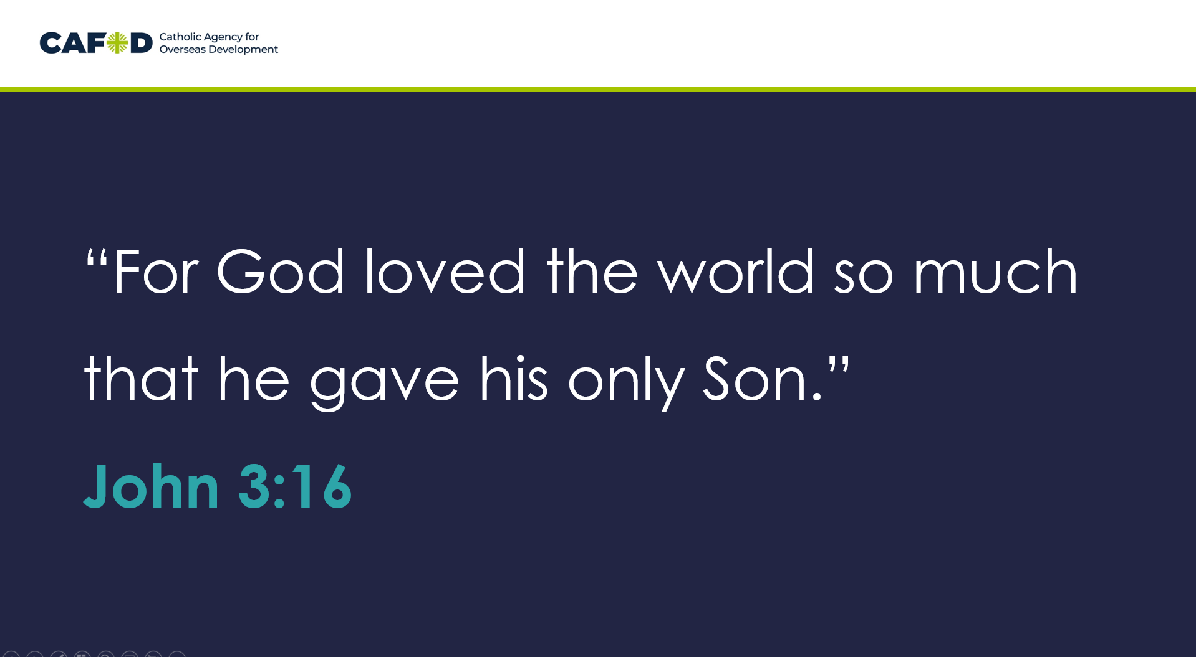 | World Gifts help to support our global neighbours.  As we know ‘God so loved the world so much that he gave his only Son’.  God gave us the most precious gift of his son Jesus. We make a difference too, by having fun together and raising money for a world gift.
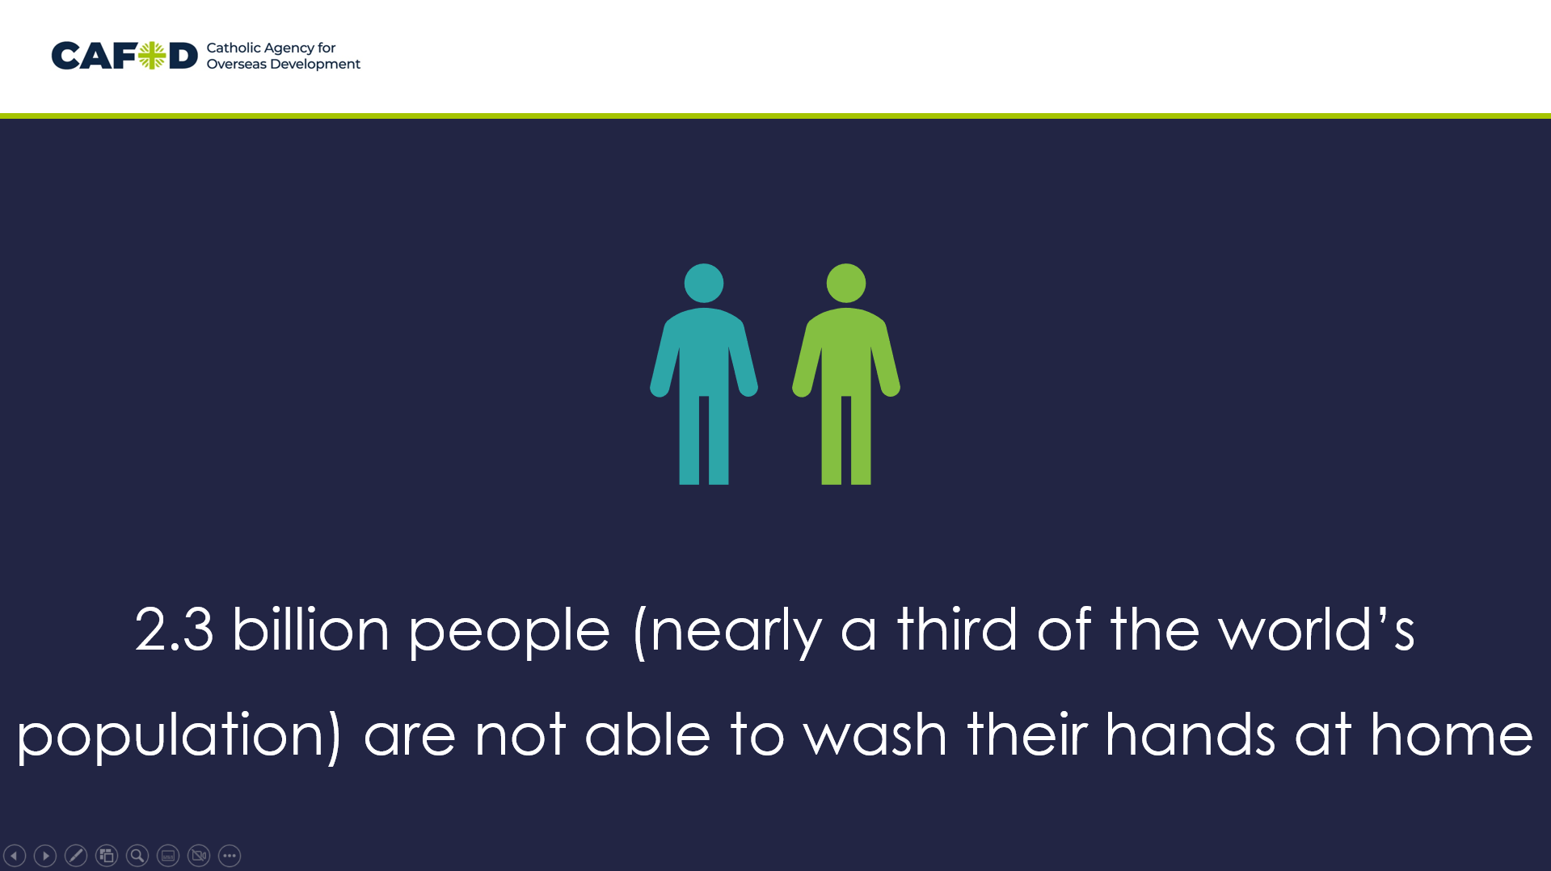  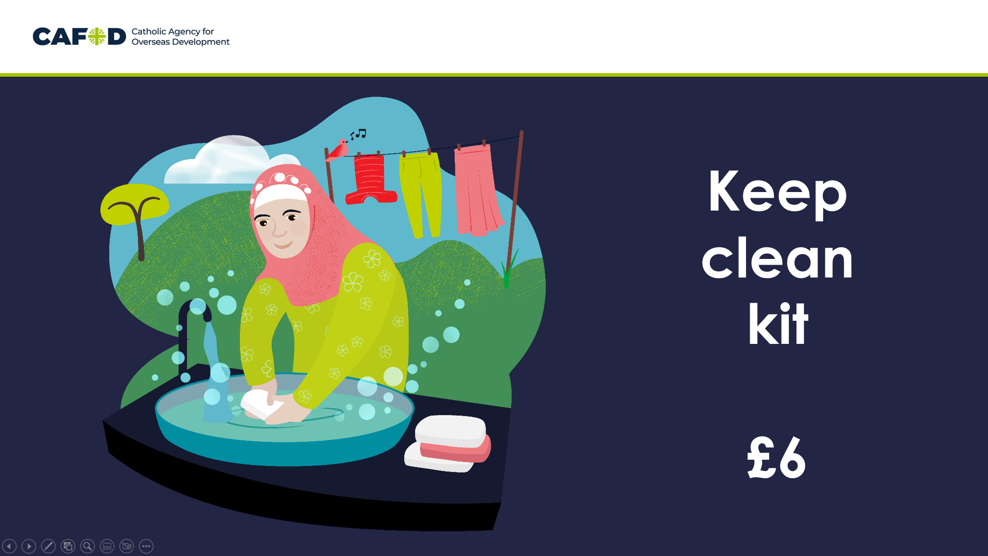 | Let’s find out about some of the challenges our global neighbours face around the world, and how World Gifts can help.  2.3 billion people (nearly a third of the world’s population) are not able to wash their hands at home  Keep clean kit £6  Bangladesh  Bangladesh is a country is Asia. It has some big cities, some areas with farms, and lots of flat land near rivers. This means it is sometimes hard for people to get around quickly, and to find the supplies necessary to stay clean and healthy.  Jamal lives in Bangladesh. He helps families get the soap, masks and washing powder they need.  Each pack costs just £6.
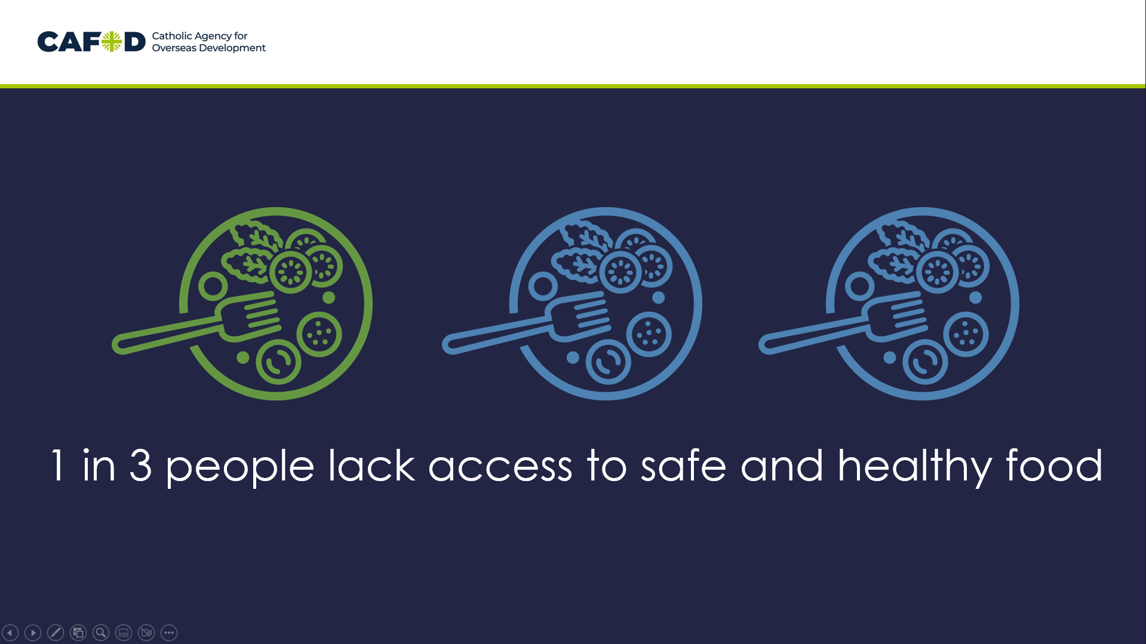  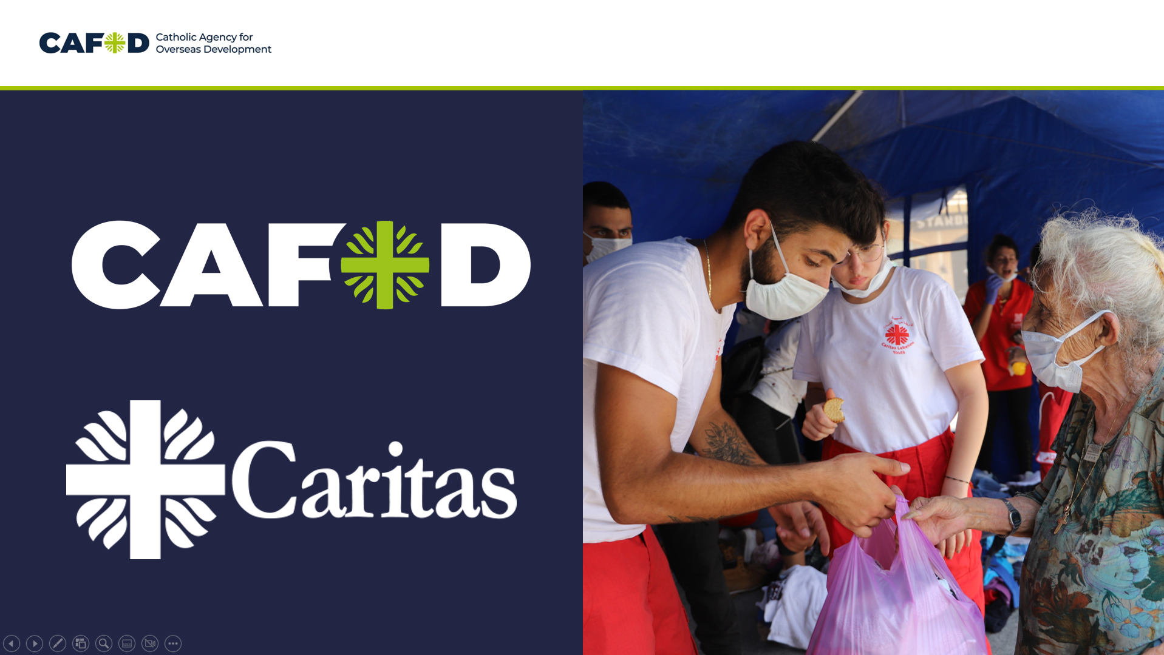 | 1 in 3 people around the world lack access to safe and healthy food  Emergency food £50  Beirut is the capital of Lebanon. In 2020 there was an explosion in the city. This caused an emergency and a need for food to get to people quickly.  The explosion damaged half the city. Thousands of people were left homeless and unable to access even the basic things they needed.  But thanks to CAFOD’s work with local experts – who were already there as part of the Caritas family – we were able to instantly help people by cooking and distributing 2,300 hot meals on day one alone.
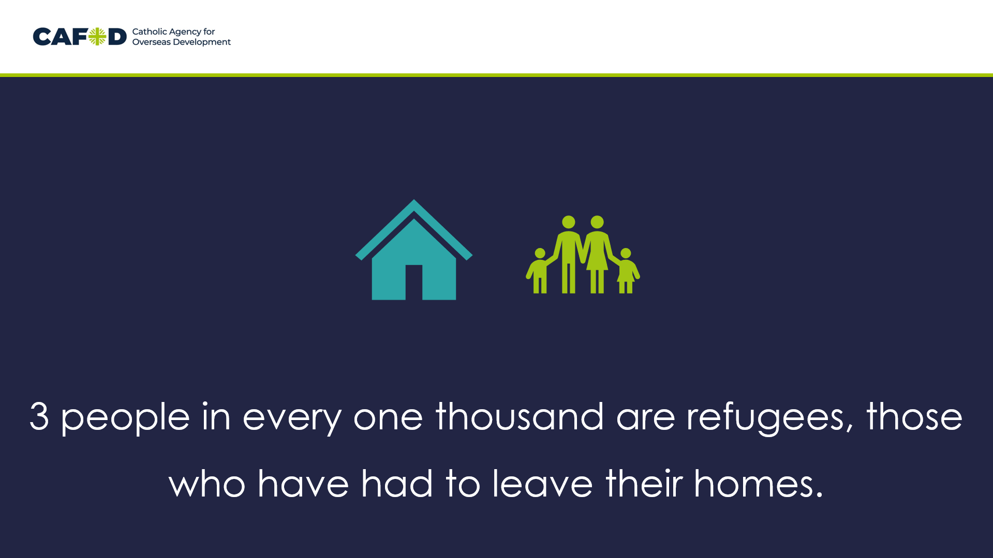  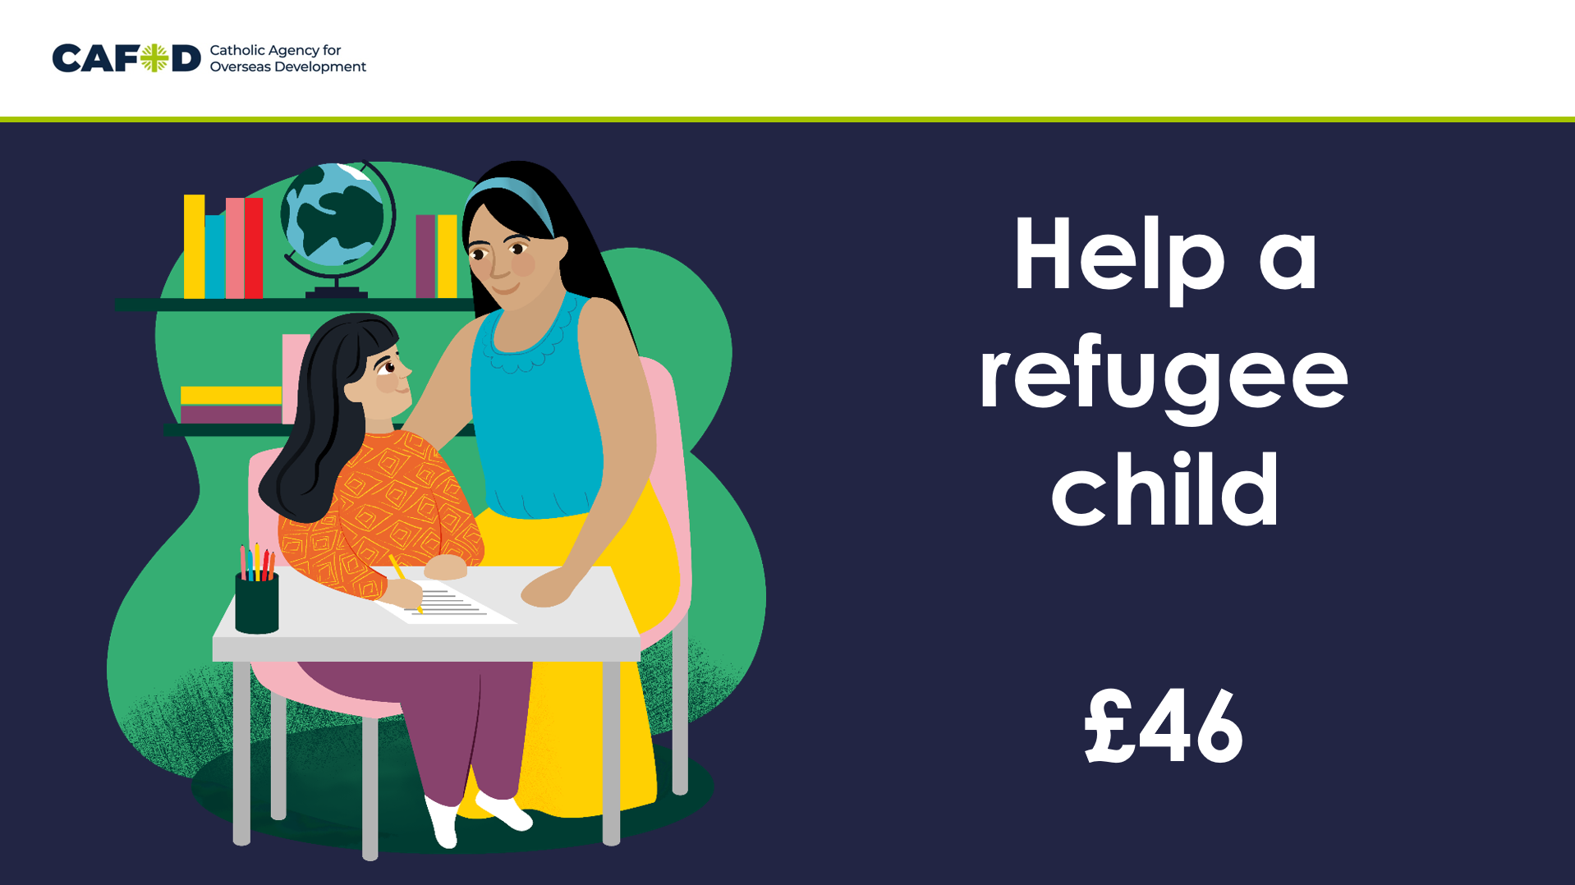 | Around the world, and average of 3 people in every one thousand are refugees, those who have had to leave their homes.  £46 help a refugee child  Sami is nine years old and lives in Syria. He has been through so much. His sister, Maysara, was killed when a bomb hit their school. Sami was devastated and was scared to go to school.  Sami has worked closely with his teachers to overcome his fears. With this support and with CAFOD-funded classes, Sami has been able to return to school. He is doing well, and when he is older, Sami wants to help rebuild Aleppo and create a better future for himself and his country.
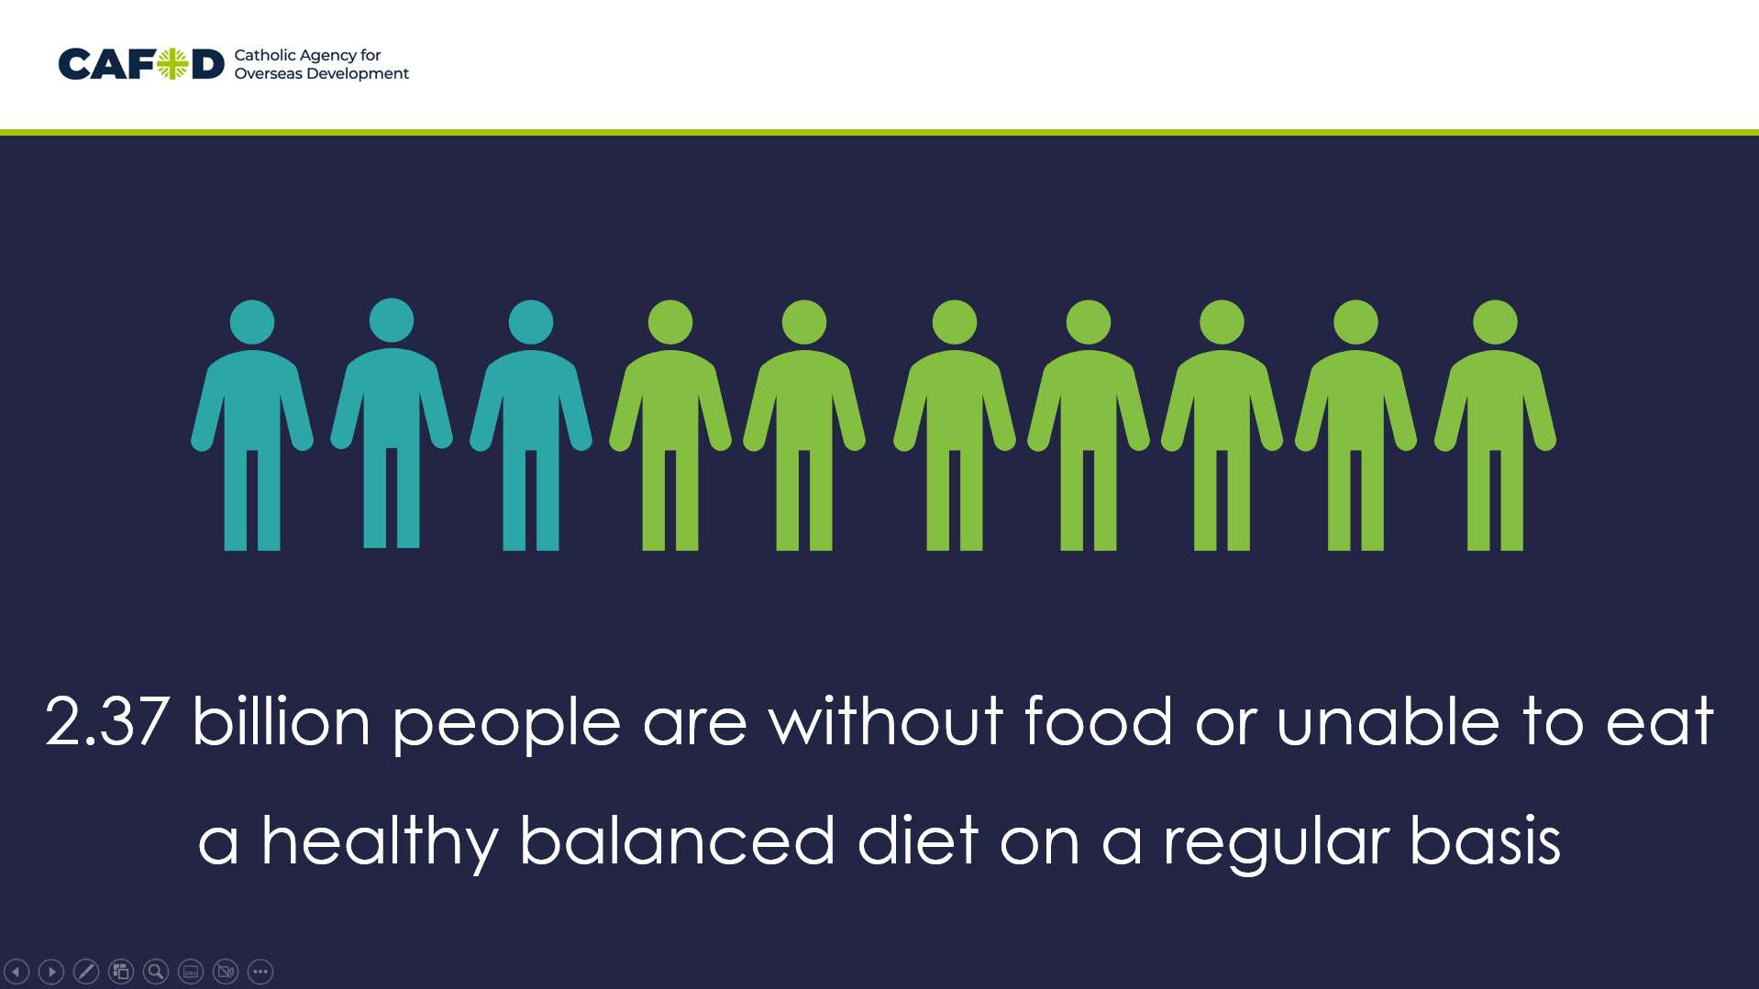  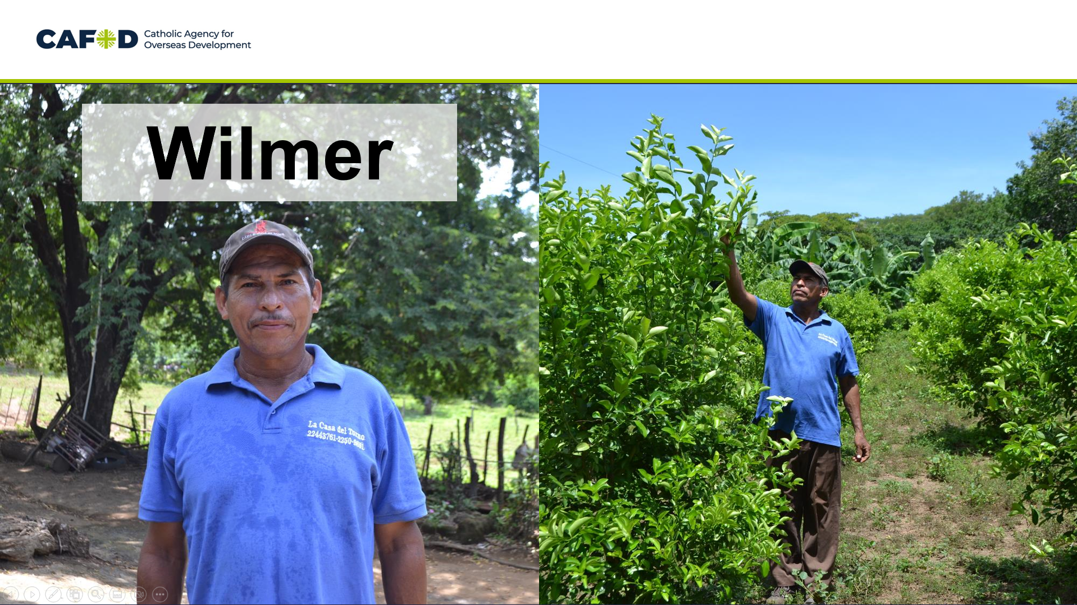 | 2.37 billion people are without food or unable to eat a healthy balanced diet on a regular basis – that’s about 3 people out of every 10 around the world.  We’ve already talked about how emergencies affect people’s access to food, but we can support our global neighbours for the longer term as well.  Marvellous Moo Cow £150  Finally we are going to Central America, to Nicaragua. Nicaragua is a country with coast on both the Pacific Ocean and the Caribbean sea. It has high mountains and the two biggest lakes in Central America. There are cities and there is countryside.  Wilmer lives with his wife and two children in the countryside in Nicaragua. Climate change is making life hard where they live. With ever increasing extreme weather, local farmers like Wilmer struggle to produce enough food to feed their families or make savings.  Wilmer has received training on how to look after cattle, as well as how to keep cows healthy so they produce more milk.  For now, the one cow produces enough milk for Wilmer and his family, but he hopes to be able to raise more cows in future so he can sell extra milk and cheese for a profit. “For the moment the cow’s milk is just for our own family but if the farm grows, we can also sell milk to others”.
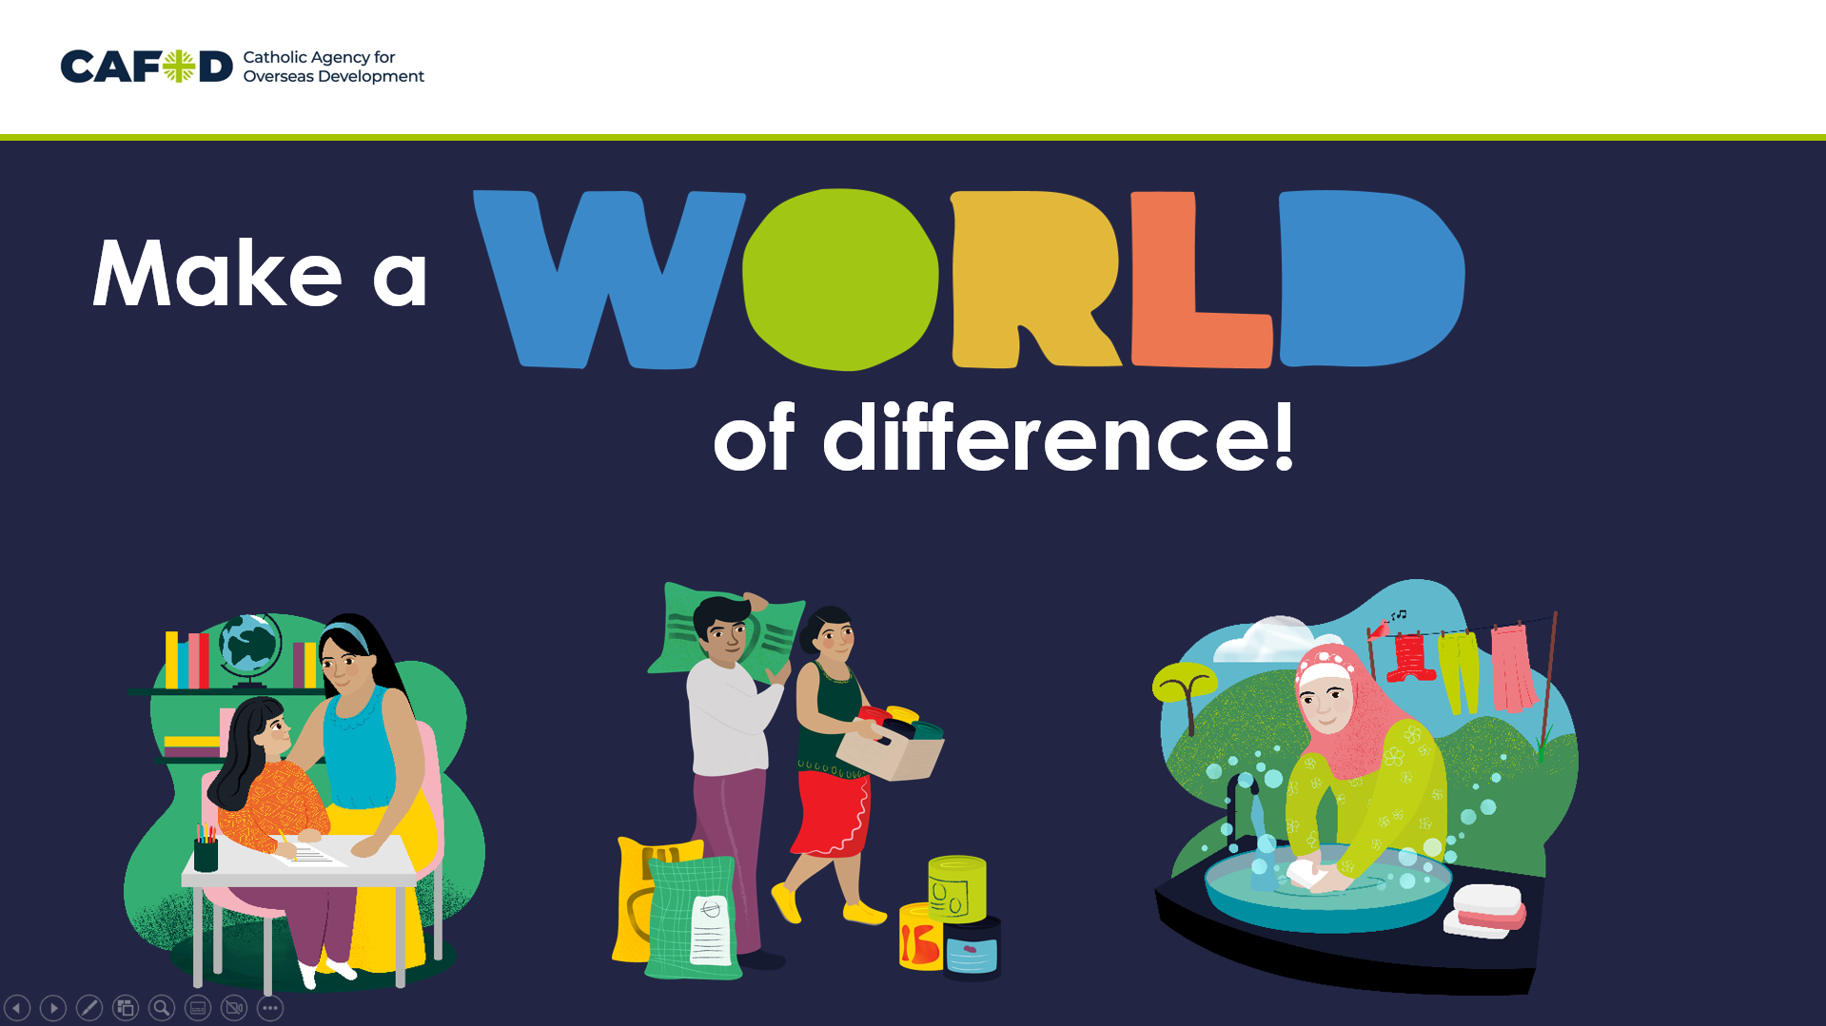 | So you can see how much difference you can make to our global neighbours. There are even more available at worldgifts.cafod.org.uk  These gifts can change lives.
There are lots of ways you can work together to raise money for a World Gift. You could do a Brighten Up fundraiser. You could do sponsored events. Or you could collect money over the weeks, or the even the whole term to save up for a big gift.

Grid posters to track progress available at cafod.org.uk/primary or cafod.org.uk/schoolfundraising
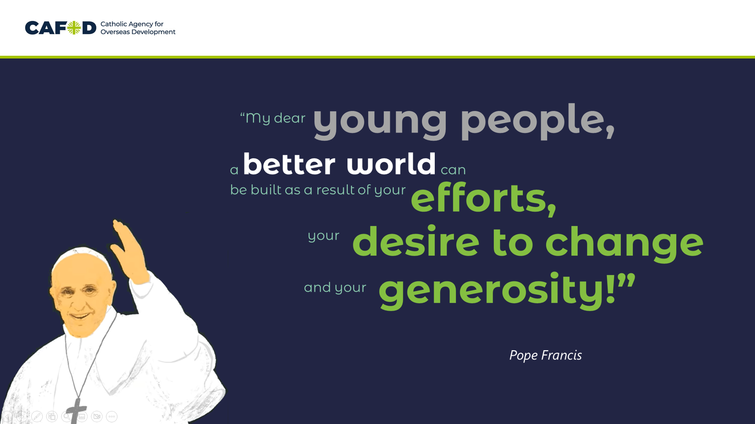 | However much you raise will make a difference and as Pope Francis says:  “My dear young people, a better world can be built as a result of your efforts, your desire to change and your generosity!”
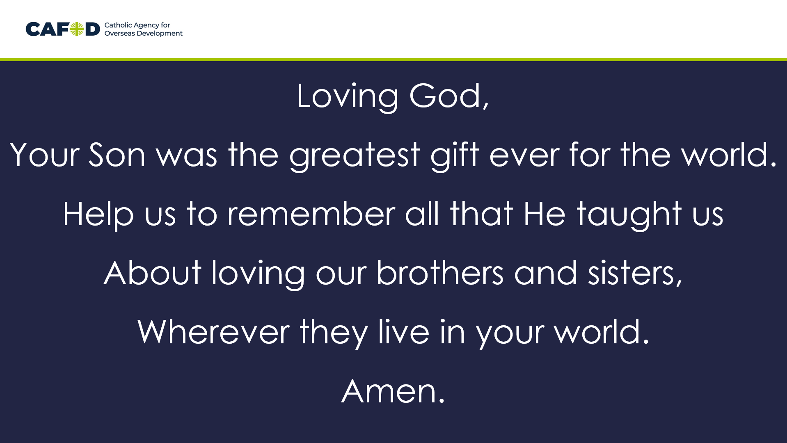 | Let’s finish with a prayer, let us pray:  Loving God,  Your Son was the greatest gift ever for the world.  Help us to remember all that He taught us  About loving our brothers and sisters,  Wherever they live in your world.  Amen.

