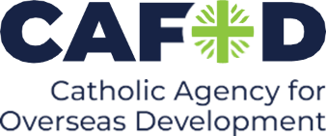

Announcement for parish newsletters, websites and/or social media

CAFOD DEC Middle East Humanitarian Appeal
The conflict in the Middle East is getting worse and the families affected need our help. Please donate today to the CAFOD-DEC Middle East Humanitarian Appeal and support our local Caritas partners in Gaza and Lebanon as they continue to provide essential food, water and shelter: cafod.org.uk/give

