Early Years
UNIVERSAL CHURCH – WORLD
Teacher’s page

EXPLORE
For many people, some places in the world are special. For others the whole world is special. We all feel a need to look after what is special to us. Sometimes it is easy to explain why things are special. At other times it might be difficult to put into words why something is special.

- What are your special places and why?
- Can you recall an occasion when you were hurt or angry by the way your special place was treated by others?
Why were you hurt or angry?
What did you do?
- Do you know any groups who campaign because of the way people or our world are being treated today?

REVEAL
Christians believe that the diversity of the world and its people is God’s gift. Jesus in his life and gospel, challenges people to appreciate diversity and to create with it a harmony that reflects the unity of Father, Son and Holy Spirit. This is reflected in the work of CAFOD.

Catechism of the Catholic Church
“God created the world to show forth and communicate his glory: that his creatures should share in his truth, goodness and beauty – this is the glory for which God created them.” (CCC319)

“The Church is the people that God gathers in the whole world.” (CCC752)

Word of God
“See, the body is one, even if formed by many members, but not all of them with the same function. The same with us; being many, we are one body in Christ, depending on one another. Let each one of us, therefore, serve according to our different gifts. Do you have prophecy? Let the deacon fulfil his office; let the teacher teach, the one who encourages, convince. You must, likewise, give with an open hand, preside with dedication, and be cheerful in your works of charity. Let love be sincere. Hate what is evil and hold to whatever is good. Regarding brotherly love, have love for one another. Regarding respect, judge others as more worthy. Regarding your duties, do not be lazy. Be fervent in the Spirit and serve God.” (Romans 12: 4-11)

RESPOND

- How can children be encouraged to value and care for creation?
- Why do we, as adults and children, need to work towards justice for all?

Prayer and Reflection

Creator God,
in your hands you hold the depths of the earth
and the heights of the mountains,
for all creation belongs to you.
Grant us grace to cherish your world
and wisdom to nurture its resources.
Save us from the desire to control what is not ours
and the impulse to possess what is not ours
and the impulse to possess what is there to share.
Amen.

(Annabel Shilson-Thomas/CAFOD)
TEACHERS’ NOTES
Christians believe that life is God’s gift. all that makes up life – people, the earth, places, things – are part of that gift. we appreciate and wonder at the understanding that all is gift. there are two concepts of wonder,
in reference to thinking and the wonder of our world. Both are necessary but worth noting as a possible area of misconception for the children. some children’s knowledge/experience of our world may only be their immediate surroundings ( i.e. home/street etc.).
Scripture: Proverbs 8:23−25 From everlasting, I was firmly set, from the beginning before earth came into being. The deep was not, when I was born, nor were the springs with their abounding waters. Before the mountains were settled, before the hills, I came to birth.
Catechism of the Catholic Church 2415: The seventh commandment enjoins respect for the integrity of creation. Animals, like plants and inanimate beings, are by nature destined for the common good of past, present and future humanity.
ABOUT THE TOPIC
Prior learning: we can make friends and Jesus had good friends
This Topic: learning outcomes
Know and understand:
• what we love and wonder about our world – Explore
• God gave us this wonderful world – Reveal
acquire the skills of assimilation, celebration and application of the above – Respond
SCRIPTURE | TRADITION
Genesis 1: 3, 9, 20, 24−26, God’s Story 1, pages 4-7  (teachers’ notes, page 42)  Psalm God’s Story 1, pages 8-11  (teachers’ notes page 42) | God made the world, everyone shares the world  Church’s Story 1 pages 14−15 (teachers’ notes, page 51)
SOME QUESTIONS OF MEANING & PURPOSE | CORE VOCABULARY
The wonder of the world  Who made the world?  How can I take care of the world? | world, wonder, wonderful, care, love, share, work/play together
STANDARD INDICATORS | AREAS OF LEARNING
Learning about religion  i beliefs, teaching & sources  ii celebrations and ritual  iii social and moral practices and way of life  Learning from religion  i engagement with own & others’ beliefs & values  ii engagement with questions of meaning | Personal, social and emotional development communication and language  Literacy  Understanding the world  Art and design  Creative development (Wales)
RESOURCES
Church’s Story 1, God’s Story 1, God’s Story 2
CAFOD website https://comeandsee.cafod.org.uk/EYFS-resources
Small World Play
http://www.widgit.com/resources/classroom/i_call_you_friends
RE CURRICULUM DIRECTORY | LITURGICAL/PRAYERS LINKS | SONGS/  HYMNS TO SING
Area of Study 1: Knowing and loving God, the scriptures, creation, the trinity, Jesus Christ, Son of God, the Holy Spirit  Area of Study 2: Mission  Area of Study 3: Prayer  Area of Study 4: The dignity of the human person, the human community, love of neighbour |  | He’s got the whole world in his hands  Praise him, praise him Louis Armstrong: What a wonderful world!
UNIVERSAL CHURCH – WORLD: OUR WORLD – TOPIC OVERVIEW
NURSERY & RECEPTION 4 WEEKS | God’s wonderful world

EXPLORE
What we love and wonder about our world

AREAS OF LEARNING

- Personal, social and emotional development communication and language
- Literacy
- Understanding the world
- Art and design
- Creative development (Wales)

STANDARD INDICATORS

- Some children will be able to talk about their own experiences of the world and that they love about our world.
- Some children will be able to wonder about what makes people friends.
- Some children will be able to say what fills them with wonder about the world.

KEY WORDS

world, wonder wonderful, love

RESOURCES

- CAFOD Global A-Z slideshow or picture pack
- Globe of the world or map
- Paper bricks for a wall
- Digital camera or video camera
- Small World Play, people and animals
- Widget symbol supported text http://www.widgit.com/resources/classroom/i_call_you_friends

ICT

- CAFOD website cafod.org.uk/comeandsee for resources and images

NURSERY FOCUS: What we love about our world.

WHOLE CLASS CORE INPUT

Use the CAFOD Global A-Z photo pack or display the slideshow on the second page, showing the whole alphabet (available at cafod.org.uk/ comeandsee). Individual children to come up and click on a letter (or choose a card). Share the slide to match this letter (e.g. A is for animals). If using the slideshow, return to the homepage each time for children to choose the next letter.

SOME KEY QUESTIONS
- Tell me about this picture.
- What do you like about this photograph?
- Invite the children to share their ideas of wonderful things in our world. Have a simple world/globe in the middle of a display. Model how the children could draw or cut out pictures of animals, plants or people to stick on the globe.

RECEPTION FOCUS: What we love and wonder about our world.

WHOLE CLASS CORE INPUT

Use the CAFOD Global A-Z photo pack or display the slideshow, showing the whole alphabet (available at cafod.org.uk/ comeandsee). Individual children to come up and click on a letter (or choose a card). Share the slide to match this letter (e.g. A is for animals). If using the slideshow, return to the homepage each time for children to choose the next letter.

SOME KEY QUESTIONS
- Tell me about this picture?
- After showing the slides/photos, encourage the children to draw upon their own knowledge and experience by asking:
What do you love about our world?
- Tell me what you think is wonderful about our world? Children to record responses by drawing or writing on paper hearts (see cafod.org.uk/comeandsee).
Set up a Wonder wall. Children share what they wonder about the world with an adult to scribe questions on paper bricks or paper to stick on wooden construction blocks and build the wall. Continue to add to this throughout the topic. Explain that some questions have no answers and we just need to keep “wondering”.

NURSERY & RECEPTION

ADULT DIRECTED GROUP ACTIVITY

- Use CAFOD Global A-Z photo pack. Children take turns to choose a card and the group complete the activity on the back of the card. Take photographs of the children working together.
- Children to go on a senses walk outside. What do they see, hear, smell, and touch? Record in pictures, photographs or video. Add to display.
- Widget symbol supported text of creation and favourite animals for matching games or general communication of the concept.

CONTINUOUS PROVISION

Small world play:
- People, animals.
- Climates – desert or Arctic.
- Under the sea.

REFLECTION ON SIGNIFICANCE
Core for both Nursery and Reception F1 and F2

Gather around the display and include items such as an inflatable globe, pictures of people and animals from Small World Play. Play some quiet music and appreciate our wonderful world. Play CAFOD PowerPoint of images of God’s wonderful world and quiet music to accompany it. Include personalised extra slides with images of the children playing or the local environment.

Invite the children to choose a small world figure and hold it. Ask them to think about our wonderful world when they next play with this item.

REVEAL
God gave us this wonderful world

CONTENT: – scripture – tradition – prayers

AREAS OF LEARNING

- Personal, social and emotional development communication and language
- Literacy
- Understanding the world
- Art and design
- Creative Development (Wales)

KEY WORDS

care, God, wonderful, world fair, share, work together
Reception: praise

ICT

- CAFOD website for resources and images cafod.org.uk/comeandsee

STANDARD INDICATORS

- Some children will recognise some words and phrases from the Psalms.
- Some children will recognise that people want to take care of the world and share with others because they believe that God said, “Take care of my world!”
- Some children will be able to say what they wonder about and how we can all work together to care for the world

RESOURCES

- Church’s Story 1 pages 14-15
- God’s Story 1 pages 4-5
- Church’s Story 2 page 28
- Fairtrade fruit, biscuits, chocolate
- Materials for collage and role-play

NURSERY FOCUS WEEK 1: God created the world and said, “Indeed it is very good”.

WHOLE CLASS CORE INPUT

Explain to the children that God created the world.
Show the pictures from God’s Story 1, pages 4−5 (from Genesis).

SOME KEY QUESTIONS:
- What do you notice about the people in this picture?
- What else can you see in this picture?
- How do you think the people are feeling?
- Why did God say “it is very good?”

Demonstrate the CAFOD Interactive World Activity – God’s wonderful world, see cafod.org.uk/comeandsee. Play together.
Talk about Church’s Story 1 pages 14−15, Everyone shares God’s world.

SOME KEY QUESTIONS:
- What can you see in the picture?
- Who is there?
- What do you share at home?
- What do we share in our nursery/class?
- How can we share in a fair way?

Share some (Fairtrade) snack bar or fruit with the children (don’t forget to check for allergies). Emphasise the act of sharing.

ADULT DIRECTED GROUP ACTIVITY
- Decorate in collage or paint the quote, “Everyone shares God’s world” to add to the display.
- Listen to and sing together ‘What a wonderful world’ or John Burland’s Early Years CD2, track 22 ‘the wonder of God’.
- Discuss the basic concept of Fairtrade: We share so that we give people a fair price for their produce so that they have enough money to feed themselves and their families. Make a Fairtrade fruit salad or fruit smoothie, see cafod.org.uk/ comeandsee
- CAFOD Interactive World Activity – God’s wonderful world.
- Children to print their own version of the activity to take home and share with their families, see cafod.org.uk/ comeandsee

CONTINUOUS PROVISION
Role-play:
- Provide a variety of material (e.g. blue fabrics for water, natural/yellow fabrics for sand, green for land, rainbow colours) to enable children to create a world scene.

NURSERY FOCUS WEEK 2: Taking care of God’s world.

WHOLE CLASS CORE INPUT

Introduce God’s Story 1, pages 6−7. Display the picture and talk about it.

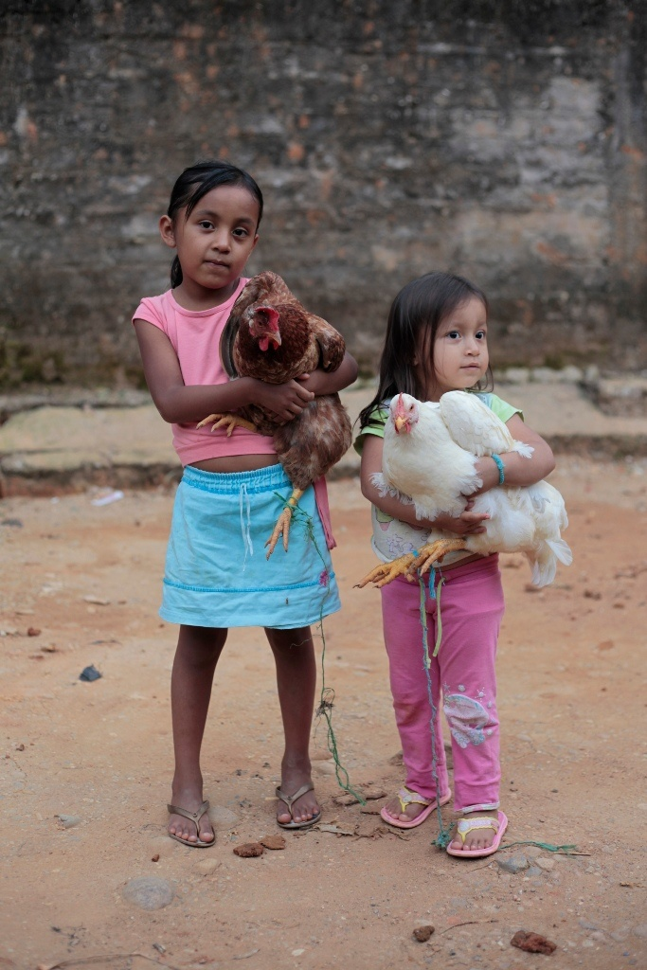
Some key questions
- What can you see in the picture?
- Who is there?
- What else might be in the picture?
- What do you think the words mean?
- How can we take care of God’s world?

Show picture of children from Florencia in Colombia (available at cafod.org.uk/comeandsee)

SOME KEY QUESTIONS
- What can you see in this picture?
- How are these girls helping to take care of God’s wonderful world?

ADULT DIRECTED GROUP ACTIVITY

- Plant something or maintain an existing garden. Focus on how this is part of God’s wonderful world and why we need to take care of it. Take photographs to show the children nurturing God’s creation.
- Fold several pieces of paper into a long zig-zag shape. Each child to draw or glue a picture of something in God’s world on a section. Pass the pieces of paper around the group so that each child contributes to each piece of paper. At the end, open up the zig-zags to reveal the variety of wonderful things in God’s world.
- Widget symbol supported text of nature and favourite animals, for matching games or general communication of the concept.

CONTINUOUS PROVISION

- Snack: Fairtrade fruit or other Fairtrade products.
- Construct interesting places in God’s world, use Small World Play or other materials to make a scene in the world.
- Watering, planting and growing outside: Create opportunities to draw pictures of interesting places in God’s world.

RECEPTION FOCUS WEEK 1: Everyone shares in God’s world.

WHOLE CLASS CORE INPUT

Explain to the children that God created the world. Share God’s
Story 1, pages 4−5. And God said, “Indeed it is very good!”

SOME KEY QUESTIONS
- What is good?
- Why do you think God said this?
- Why do you think the world is very good?
- What could we do to make it even better?

Talk about Church’s Story 1, pages 14-15 (Everyone shares God’s world).

SOME KEY QUESTIONS
- Can you tell me what this means?
- What could we do to help each other to share God’s world?

Sit the children in a circle and give every other child two (Fairtrade) biscuits or two pieces of (Fairtrade) fruit. Ask them to share it equally with the person next to them so that they both have the same amount.

SOME KEY QUESTIONS
- What would have happened if some children ate both biscuits/pieces of chocolate/fruit?
- How did we make it fair?
- Why do you think it is important to share and be fair?

ADULT DIRECTED GROUP ACTIVITY
- Make a world frieze on long sheets of paper, either outside or inside the classroom. One for land and another for under the sea. Children add in paint, crayon or collage different people, plants or animals in God’s world.
- Bake or make something using some Fairtrade ingredients.
Discuss basic concept of Fairtrade (people gaining a fair price for their produce so that they have enough to feed themselves and their families).
- CAFOD Interactive World Activity – God’s wonderful world (see cafod.org.uk/comeandsee). Children to print their own version of the activity to add to the display.

CONTINUOUS PROVISION
Role-play:
- Provide a variety of material (e.g. blue fabrics for water, natural/yellow fabrics for sand, green for land, rainbow colours) to enable children to create a world scene.
Creative:
- Paint wonderful things in God’s world.
- Collage using natural materials (inside or outdoors, small or large scale). Add a caption to the picture.

RECEPTION FOCUS WEEK 2: Praising God for our Wonderful World.

WHOLE CLASS CORE INPUT

Read God’s Story 1, pages 6-7.
God said, “Take care of the world”
Continue to read God’s Story 1, pages 8-11 (based on the
Psalms, see teacher’s notes on page 42).
Let’s sing to God
Let’s praise God together!

Show picture of Azmera from Ethiopia collecting water with her mother (available at cafod.org.uk/ comeandsee).

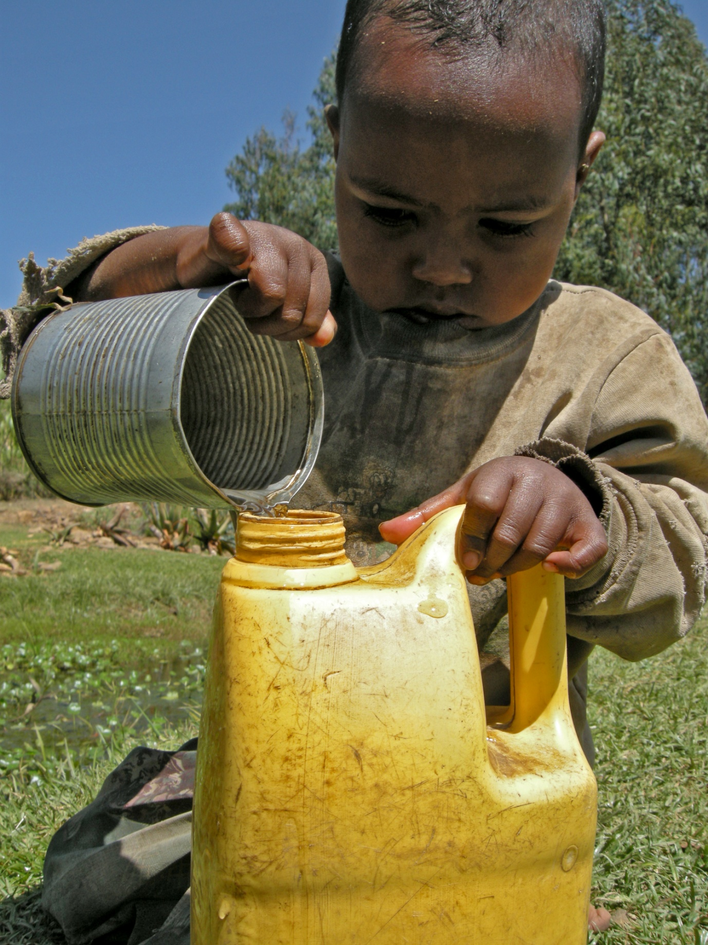
SOME QUESTIONS TO ASK THE CHILDREN:

- What is Azmera doing?
- How is Azmera taking care of the world?
- How do we take care of the world?
- What does it mean to praise God?
- How can we work together to praise God’s wonderful world?

Explain that one of the wonderful things we praise God for is water. It is a precious gift from God and we need to use it well and not waste it.

SOME QUESTIONS TO ASK THE CHILDREN:

- Why is water so precious?
- What can we do to help save water?

Explain that every time you use water in school this week, we will put a cube or counter in a tub or jar (e.g. flushing the toilet, washing hands, playing in the water tray). At the end of the week, count up the cubes to show how often we use water.

Share the Let’s praise God together PowerPoint presentation (available at cafod.org.uk/comeandsee). Talk about how we are all part of God’s global family. Explain that CAFOD works with all people because God made all people equal. We all share
in God’s wonderful world and should take care of it together, remembering to praise God.

Put this prayer on the display (see Let’s praise God together PowerPoint available at cafod.org.uk/comeandsee) and say it together:
Loving God, we praise and thank you for your wonderful world. Amen

ADULT DIRECTED GROUP ACTIVITY

- Sing: praise him, praise him, praise in the morning .... (Byron Cage lyrics). Add percussion instruments to sing along.
- Talk with the children about how it’s good to use water to keep us healthy and clean but explain how we might waste water. How might we save water?
- Make a sign for home as a reminder not to waste water.
- Write a class litany using the words: Praise God for....
- CAFOD Interactive Jigsaws (cafod.org.uk/comeandsee).

CONTINUOUS PROVISION

- Creative: Use malleable materials to create different parts of God’s wonderful world.
- Sand and water: Different animals in God’s world.
- Snack: World foods.

RESPOND
Remembering, celebrating and responding to what we love and
wonder about our world; God gave us this wonderful world

Remember
Start the session with a moment of quiet reflection. Provide each child with the opportunity to engage with questions of meaning and purpose related to Our World.
Using the display, children may be able to contribute to the following by use of discussion,
role-play, drama, art, cue cards etc.

Ask the children if there is anything they wonder about
- How wonderful is our world?
- How could we make God’s world even more wonderful?
- What would happen if we did not look after our world?

Provide the opportunity, possibly by one of the means above, for the children to remember
- What we love about our world.
- What fills us with wonder about our world.
- God created the world.
- God was pleased with the world.
- Everyone shares God’s world.
- How we would feel if we did not work together to share God’s world.
- Ways that CAFOD helps to make a fairer world.

Rejoice
Remember to plan. (Download the Rejoice and Gather Form on the Come and See website.)

Renew
The teacher helps each child to make an individual response, hold on to and make their own
what they have understood of their own experience and of the experience of the Church community.

Apply their learning
How can I take care of God’s wonderful world?

Some suggested ideas
- Look round the classroom or playground. Discuss what we can do to take care of it. For example, bringing flowers, picking up litter etc.
- Each child could plant a small flower pot with quick growing seeds in it to take home for the holidays.
- On a World template, under the heading God’s wonderful world, draw a picture of something that is wonderful in our world e.g. animals, flowers, friends, family. Teacher/adult writes underneath the template what the child says in response to “How can you take care of God’s wonderful world? Send home for child to share with their family.
Teacher evaluation
This is ongoing and will inform future teaching and learning, which will include assessment for learning.
SUMMARY

- Some children will recognise some words and phrases from the Psalms and recognise that people want to take care of the world and share with others because God said, “Take care of my world!”
- They will be able to say what they wonder about the world and how we can all work together to care for the world and will be able to talk about their own experiences of the world and what they love about our world.

CHURCH TEACHING

This is an outline of the teaching of the Church covered in OUR WORLD:
- God created the world and it was good.
- Everyone shares God’s world.
- We share in taking care of the world.
- the implications of being part of God’s global family.
- Praising God by praying a psalm.

