Jubilee Year 2025: Pilgrims of Hope
A reflection on the Jubilee icon
There are two films available to watch as part of any session on the Jubilee icon:
- About the artist https://www.youtube.com/watch?v=3ciUSeWlH_U
- Meaning and symbolism https://www.youtube.com/watch?v=b55k2uV7bu8
An icon is a visual aid for reflection and discernment, inspiring prayer and devotion. CAFOD commissioned an icon, depicting Luke 4:16-21, from Mulugeta Araya, an Ethiopian artist, to commemorate and celebrate the Jubilee Year 2025. Ethiopia was chosen because of its strong tradition of iconography, but also because of the Jubilee’s focus on liberation for those facing poverty, captivity, oppression or inequality.
Take some time to remind yourself of Luke 4:16-21
Jesus came to Nazareth, where he had been brought up. And as was his custom, he went to the synagogue on the Sabbath day, and he stood up to read. And the scroll of the prophet Isaiah was given to him. He unrolled the scroll and found the place where it was written,
“The Spirit of the Lord is upon me,
because he has anointed me
to proclaim good news to the poor.
He has sent me to proclaim liberty to the captives
and recovering of sight to the blind,
to set at liberty those who are oppressed,
to proclaim the year of the Lord’s favour.”
And he rolled up the scroll and gave it back to the attendant and sat down. And the eyes of all in the synagogue were fixed on him. And he began to say to them, “Today this Scripture has been fulfilled in your hearing.”
Pause for a moment of quiet reflection in front of the icon. You could consider the following questions:
- What do you notice?
- What draws you in?
- Does the icon help you to see the story of the Gospel in a different way?
The icon portrays Jesus faithfully in the Northern European tradition and is full of meaning. Turn over to find out more or visit cafod.org.uk/icon
Once you have read the information, or watched the films, consider these questions:
- Does the knowledge of the artist’s intentions change anything about how you view the icon?
- Do you notice anything new?
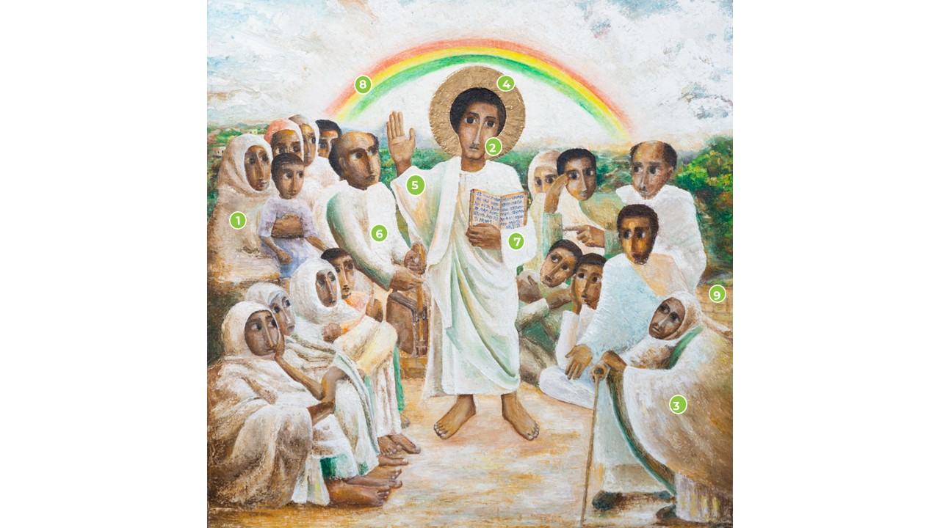
- What thoughts or feelings does the icon bring up for you about Jubilee

- The crowd gathered to listen to Jesus includes men, women and children. Old and young. Their eyes are fixed on Jesus, they are engaged with the Word of God.
- Jesus looks out into the world. His gaze encompasses all people, not just this crowd, and his teaching is for all time.
- The woman with a stick at the front shows Jesus’ concern for those who are often overlooked in our society, such as the elderly, vulnerable and those living with a disability.
- The golden halo shows that Jesus is divine and the Son of God. It was not possible to obtain gold leaf in Ethiopia because of the fragile state of the area in which the artist lives. Paint was used instead. The challenge of painting an icon in such turbulent times inspires us to reflect again on the Jubilee message.
- Jesus’ right hand is raised to show that he is teaching.
- This man holds a leather bag used to carry and protect the Holy Bible in Ethiopia.
- The words of the Scripture are written in Ge’ez, an Ethiopian liturgical language.
- The rainbow is a symbol of hope and of God’s covenant with all people, bridging the Old and New Testaments and which will lead to liberation.
- The brick wall shows the separation between God’s house – the Synagogue – and the outside world. In this icon, Jesus has come into an open space where the crowds can gather together on equal terms, unlike the required segregation in the Synagogue and the Temple of the original story. This is to show that the Good News and the Jubilee liberation are for the whole world.

