Year 4

UNIVERSAL CHURCH – WORLD

Teacher’s page

EXPLORE
For many people, some places in the world are special. For others the whole world is special. We all feel a need to look after what is special to us. Sometimes it is easy to explain why things are special. At other times it might be difficult to put into words why something is special.

- What are your special places and why?
- Can you recall an occasion when you were hurt or angry by the way your special place was treated by others?
Why were you hurt or angry? What did you do?
- Do you know any groups who campaign because of the way people or our world are being treated today?

REVEAL
Christians believe that the diversity of the world and its people is God’s gift. Jesus in his life and gospel, challenges people to appreciate diversity and to create with it a harmony that reflects the unity of Father, Son and Holy Spirit. This is reflected in the work of CAFOD.

Catechism of the Catholic Church
“God created the world to show forth and communicate his glory: that his creatures should share in his truth, goodness and beauty – this is the glory for which God created them.” (CCC319)
“The Church is the people that God gathers in the whole world.” (CCC752)

Word of God
“See, the body is one, even if formed by many members, but not all of them with the same function. The same with us; being many, we are one body in Christ, depending on one another. Let each one of us, therefore, serve according to our different gifts. Do you have prophecy? Let the deacon fulfil his office; let the teacher teach, the one who encourages, convince. You must, likewise, give with an open hand, preside with dedication, and be cheerful in your works of charity. Let love be sincere. Hate what is evil and hold to whatever is good. Regarding brotherly love, have love for one another. Regarding respect, judge others as more worthy. Regarding your duties, do not be lazy.
Be fervent in the Spirit and serve God.” (Romans 12:4-11)

RESPOND
- How can children be encouraged to value and care for creation?
- Why do we, as adults and children, need to work towards justice for all?

Prayer and Reflection

Creator God,
in your hands you hold the depths of the earth
and the heights of the mountains,
for all creation belongs to you.
Grant us grace to cherish your world
and wisdom to nurture its resources.
Save us from the desire to control what is not ours
and the impulse to possess what is not ours
and the impulse to possess what is there to share.
Amen.

(Annabel Shilson-Thomas/CAFOD)

TEACHERS’ NOTES
“Communion of Saints” is the collective name given to all members of the Church community, whether living or dead. Some members of the Church family are named as martyrs or saints. Martyrs are people who have given their lives for their faith. Saints are people who have lived in God’s way. They show us what God is like – loving, faithful, forgiving, caring for others and God’s world.
Scripture: Romans 12: 4−5 We have only one body, but we are made up of many parts, and all these parts have different functions. In the same way, though there are many of us, we are one body in union with Christ and we are all joined to one another as different parts of one body.
Catechism of the Catholic Church 2013: All Christians in any state or walk of life are called to the fullness of Christian life and to the perfection of charity. All are called to holiness: ‘be perfect as your heavenly Father is perfect’. In order to reach this perfection, the faithful should use the strength dealt to them by Christ’s gift, so that… doing the will of the Father in everything, they may wholeheartedly devote themselves to the glory of God and to the service of their neighbour. Thus the holiness of the people of God will grow in fruitful abundance, as is clearly shown in the story of the Church through the lives of so many saints.
ABOUT THE TOPIC
Prior learning: special places for Jesus and the Christian community
This Topic: learning outcomes
Know and understand:
• Ordinary people who do extraordinary things – Explore
• Different saints show people what God is like – Reveal
Acquire the skills of assimilation, celebration and application of the above – Respond
SCRIPTURE | TRADITION
1 John 3: 1−3 – God’s Story 3, page 149  Colossians 3: 12−13 God’s Story 3, page 147  1 Corinthians 12: 4−30 | Communion of Saints − Church’s Story 3, page 33  Saints and martyrs  Feast of All Saint
SOME QUESTIONS OF MEANING & PURPOSE | CORE VOCABULARY
What makes a person do extraordinary things? What does God want Christians to do? | ordinary, extraordinary, admire, saint, martyr  Communion of Saints, peace, justice
RESOURCES
Church’s Story 3, God’s Story 3
CAFOD website see cafod.org.uk/comeandsee
Recent Friends of Jesus Victoria Hummell ISBN: 978-0855976675
CROSS CURRICULAR LINKS | STANDARD INDICATORS
Literacy, art, ICT | Learning about religion  i beliefs, teaching & sources  ii celebration and ritual  iii social & moral practices & way of life  Learning from religion  i engagement with own & others’ beliefs & values  ii engagement with questions of meaning
RE CURRICULUM DIRECTORY | LITURGICAL/PRAYERLINKS | SONGS/  HYMNS TO SING
Area of Study 1: Knowing and loving God, the Scriptures, the Trinity, Jesus Christ, Son of God, the Holy Spirit  Area of Study 2: What is the Church? One and holy,  Catholic, Mission  Area of Study 3: Prayer  Area of Study 4: The dignity of the human person, freedom, responsibility and conscience, the human community, love of God, love of neighbour | Feast of All Saints
POINTS TO REMEMBER
Varying reasons why children look up to people. Some saints can be ordinary people we meet in our everyday lives
UNIVERSAL CHURCH - WORLD: GOD’S PEOPLE – TOPIC OVERVIEW
YEAR 4 - 4 WEEKS | Different saints show people what God is like
EXPLORE
Ordinary people who do extraordinary things

STANDARD INDICATORS

- Children will be able to ask and respond to questions about their own and others’ experiences and feelings of ordinary people doing extraordinary things.
- Children will be able to ask questions about what they and others wonder about ordinary people doing extraordinary things and realise that some of these questions are difficult to answer.
- Children will be able to make links to show how feelings and beliefs affect their behaviour and that of others, using the example of Eric or other examples.
- Children will be able to compare their own and other people’s ideas about the question of what makes a person do extraordinary things and find it is difficult to answer.
- Children will be able to show how their own and others’ decisions about actions in life are informed by beliefs and values.

KEY WORDS

ordinary, extraordinary admire, qualities

ICT

CAFOD website cafod.org.uk/comeandsee for resources and images.

RESOURCES

- Children bring in photographs/a magazine cutting of someone they admire
- scissors
- glue

LEARNING INTENTION: Ordinary people who do extraordinary things.

CONTENT

Ask the children to bring in a photograph, picture or magazine-cutting of someone they look up to or admire (e.g. celebrities, sports professionals, family members, and teachers). Invite the children to share their pictures and state why this person is their role model.

- What are the qualities you like in this person?
- Is it something they were born with, something they developed, or both?

Eric’s Story: explore the PowerPoint of Eric’s Story (see CAFOD website at cafod.org.uk/comeandsee) Think, pair, share…

SOME KEY QUESTIONS
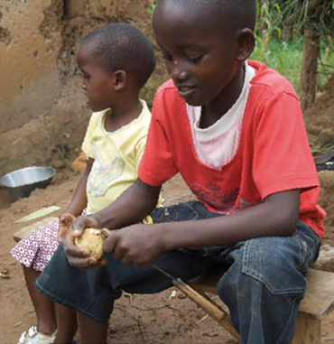
- How is Eric similar to you?
- How is Eric different from you?
- Is Eric extraordinary in any way?
- What do you feel about Eric?
- How do you think Eric feels about himself?
- Why do you think Eric helps his family?
- What do you think makes someone extraordinary?

SOME SUGGESTED ACTIVITIES

- Using the pictures of their role models, ask the children to write about them. Who is your person? What do they do? What are the qualities you like? Which of these qualities do you have? (You could use these to start a display.)
- Share ideas, comparing their own and other people’s ideas.
- How are this person’s decisions informed by their values or beliefs?
- How are the decisions you make informed by your values and beliefs?
- Using pictures, begin to make a frieze of God’s people on a large world outline. This can be added to throughout the topic as the children learn about different ‘saints’. They may also include drawings/photos of themselves.
- Invite the children to design and make their own Book of Qualities. In this book, the children will begin to record qualities that they admire in other people. They may continue to add to these throughout the topic. They may want to place themselves in the book. (this could be used in LF1 in Reveal)
- Reflect on the qualities we need to live a “good life”. Ask others for their ideas about these qualities and respond to their answers.
- Complete the worksheet at cafod.org.uk/comeandsee.
- Compare ideas with a partner about what makes a person do extraordinary things. They may find these questions difficult to answer.
Eric’s Story, My Story (see cafod.org.uk/comeandsee).

REFLECTION ON SIGNIFICANCE

Gather the children in a circle and play some quiet music.

Have a selection of images on view of the people the children have said they admire. On a star template, children write down one word to describe a quality they admire in someone else. One by one, invite the children to share their word. Add it to the centre of the circle.
(You may wish to keep these words to add to a display or to build upon as the topic progresses).

With the music still playing, invite the children to quietly go and write more admirable qualities in their Book of Qualities.

REVEAL
Different saints show people what God is like

CONTENT: – scripture – tradition – prayers

STANDARD INDICATORS

- Children will be able to retell some special stories about religious events and people who show what God is like.
- Children will be able to describe some ways in which religion is lived out by different saints.
- Children will be able to give reasons for
- certain actions by those people they have studied.
- Children will be able to make links between scripture and the action and beliefs of followers of God’s way.
- Children will be able to show understanding of how religious belief has shaped the way some people live out their lives.
- Children will be able to describe and show an understanding of scripture, beliefs, ideas, feelings and experience, making links between them.

KEY WORDS

Communion of Saints, Saint, martyr, sacrifice

RESOURCES

- God’s Story 3
- Church’s Story 3
- Box of chocolates
- Recent Friends of Jesus Victoria Hummell

ICT

- CAFOD website see cafod.org.uk/comeandsee for resources and images.

LEARNING FOCUS 1: The Communion of Saints:
showing people what God is like.

CONTENT

We have just heard about Eric and the kindness he shows to his family. He is part of the worldwide community we all belong to.

Christians, whether they are living on earth or in heaven, belong to what is called the Communion of Saints. Communion means to belong together and saints are those who follow God’s way. They show us something about God. They may be kind, generous, loving, faithful, forgiving and caring. (See Church’s Story 3, page 33.)

In the first letter of St John, where he is encouraging his readers to follow God’s way, he offers some ideas about how we can all become a bit more like God, a saint:

See what great love the Father has for us,
that we should be called children of God!
And that is what we are!

Dear friends, we are already children of God,
we know that when Christ appears, we shall be like him,
because we shall see him as he is.

Everyone who has this hope in Christ,
will try to be loving and kind and keep away from anything that is wrong.
1 John 3:1−3

See God’s Story 3, page 149.

We are all called to be saints and there are some people who are given a special title of saint because of the life they have led. These saints may have a special feast day during the year like St Andrew, St David, St Francis or St Margaret. On 1 November every year the Church celebrates the Feast of All Saints, that is all the holy women and men who have followed God’s way. (See Church’s Story 3, page 119, top section.)

SOME KEY QUESTIONS

- What do you think ‘Communion of Saints’ means?
- What saints do you know about: is your school or parish church dedicated to a particular saint? Do you have saint’s name?
- What advice does St John have for us?
- What advice would you have for someone who wants to follow God’s way?

SOME SUGGESTED ACTIVITIES

- Individually, with a partner or in a group, invite the children to research a saint: it might be a saint of their school, parish church, their name or the name of someone in their family. They could use the internet or books. (The Friends of Jesus series may be helpful).
Share the findings with the class. Encourage the children to discover some of the ideas and beliefs particular to the saint of their choice.
- Hot-seating activity – encourage the children to prepare some questions to ask “a saint” which will help them develop a deeper understanding of the beliefs/life of the saint.
- Invite children to take out their Book of Qualities or look at the collection of words from the Reflection on Significance in Explore. Can these qualities be matched to the profile of any of the saints they have learnt about?
Ask the children to add further qualities.

LEARNING FOCUS 2: Christians are invited to be saints.

CONTENT

Look at the PowerPoint presentation of Pope Benedict XVI’s Big Assembly (see CAFOD website at cafod.org.uk/comeandsee). Talk about what the Pope said.

- Does anything surprise you?
- What do you like about it?

SOME KEY QUESTIONS

(As referred to by Pope Benedict XVI:)
- What are the qualities you see in others that you would most like to have yourself?
- What kind of person would you really like to be?
- How did Sorcha use money for a good purpose?
- How can you become holy, as the Pope suggests you can?
- Why does Pope Benedict say that some people do not find true happiness? Compare thoughts and ideas.

SOME SUGGESTED ACTIVITIES

- Invite the children to produce a mind map on paper or using mind mapping software – “What kind of person would I really like to be?”
- A question for the children to work with, “If you were the Pope, what messages would you give to children?” Prepare a speech to give to your class. In it make a link to one of Jesus’ stories or explain why it is important to follow God’s way.
- Create a class collage display, which can be added to as the topic progresses – “Living a saintly life” – include pictures, drawings, poems, prayers, recent events etc.

LEARNING FOCUS 3: Oscar Romero –
a recent martyr showing us what God is like.

CONTENT

Blessed Oscar Romero of El Salvador
Talk about where El Salvador is in South America: look at a map. Explain what a martyr is – that it is someone who dies for what they believe.

Engage the children with the PowerPoint presentation about Oscar Romero on the CAFOD website at cafod.org.uk/comeandsee.

After discussing the key questions below, collate key facts about Oscar Romero’s life.

SOME KEY QUESTIONS

- What made Oscar Romero extraordinary?
- Why do we call Oscar Romero a martyr?
- Why does CAFOD look to Oscar Romero as an example?
- How does Romero’s story help to show us what God is like?

SOME SUGGESTED ACTIVITIES

- Ask the children to design a memorial for Oscar Romero.
They may wish to include a quote from Oscar Romero, or a poem to sum up his life. Show them some examples of memorials and look at the murals in the PowerPoint presentation at cafod.org.uk/comeandsee.
- Invite the children to work individually or in groups to answer two contrasting questions:
- How would you like to be remembered?
- How and why is Oscar Romero remembered include a brief description of his life and work, giving reasons for his words and actions?
- Hot-seating activity – one child plays the role of Oscar Romero. The children ask questions relating to his life, his words and actions, exploring reasons for these.

LEARNING FOCUS 4: An ordinary person showing us what God is like.

CONTENT

Nitu’s Story
With the children, read Nitu’s Story from the CAFOD PowerPoint and engage the children with the thought- provoking questions in the story. See cafod.org.uk/ comeandsee.
Read one of the following letters of St Paul with the children:

Either Colossians 3:10−11 God’s Story 3, page 147, or the text below:

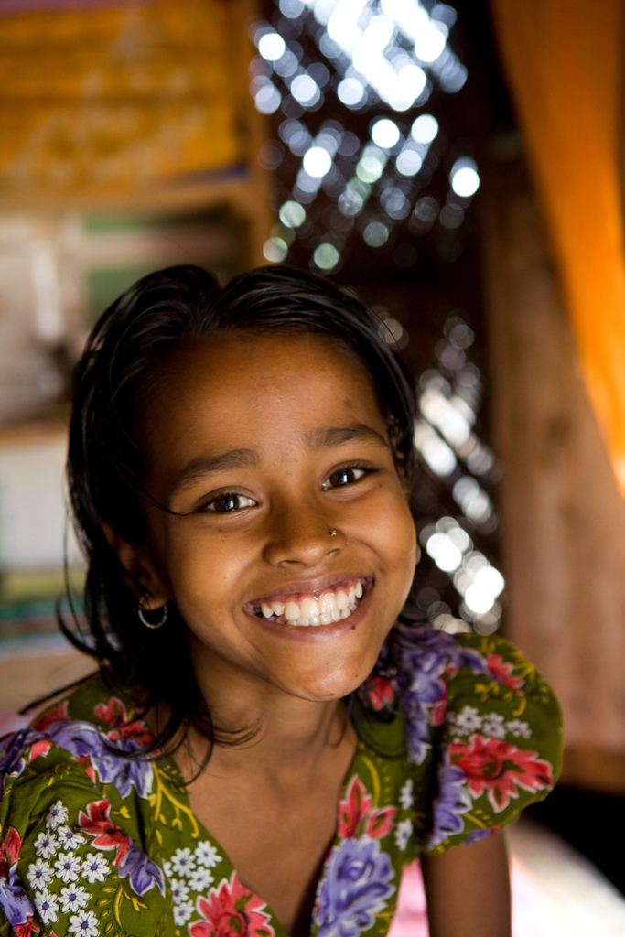
Paul was always writing letters to the friends he had made all over the world. In one letter to the Christians in Colossae he said:
“You are created by God, to be like God.
You are God’s people, his saints. He loves you. You are all different.
You come from different places,
speak in different ways, have different customs.
But the important thing is that you are God’s children.
So love one another, help one another, be at peace with one another.
And let the love of Jesus fill your hearts and minds.”
(based on Colossians 3:10−11)

Or, in another letter to the Christians in Corinth, Paul talked about the different gifts that people are given by God (1 Corinthians 12:4−30, adapted).

There are many different gifts. There are all sorts of things to be done for others. God gives each of us different gifts. Some are wise; some can explain things well; some can make people better; some can make people happy. It’s like your body. Different parts have a different job to do. Each part is different and important. Your body needs all the parts to work well together. You need a head to think, eyes to see, hands to hold, feet to walk, ears to hear. If your whole body was just an eye, how would you hear anything? If your whole body was just an ear, how would you smell anything? Each part is put there by God for a special purpose. Just as each gift is given to us by God for us to use, we need one another so that everything that needs to be done is done.

Show the children a box of chocolates and explain that, although each one looks and tastes different, they all contribute to the whole package – just as we all have a place in this world and we rely on one another.

SOME KEY QUESTIONS

- What impressed you most about Nitu?
- How does she show what God is like?
- What do you think keeps her cheerful?
- Paul says we are all different. How might people be different from one another?
- Why is it good to be different?
- What is the important message in Paul’s letter?
- What does Paul consider to be important? Would you agree with him?
- How can you live your daily life really well?

SOME SUGGESTED ACTIVITIES

- Using Colossians 3: 10-11 (God’s Story 3, page 147) design a phrase or motto to live by (or a brief mission statement), giving reasons for their choice and show how they would live it out in daily life. Add to the class display and share these with your class/school.
- Discuss with a partner or in a group the different gifts the other person or people have (for example, they may be good at maths; can play the recorder; listen to others; can offer good advice; can write interesting stories etc.) Create a mind map of ‘Our Gifts’ How can these gifts be used to help others in our school, our local area and our sisters and brothers around the world? How does this show us what God is like?
- Invite the children to write a letter to a younger child in the school, telling them what they have been learning about saints and, in particular, how they can live their lives to show what God is like and why it would be good to do so.
- Invite the children to convey the gifts/qualities they have through a piece of writing, music, picture or dance/movement.

LEARNING FOCUS 5: Saint Teresa of Kolkata (Calcutta )
living out what she believed.

CONTENT

Read the story of Blessed Teresa of Kolkata.

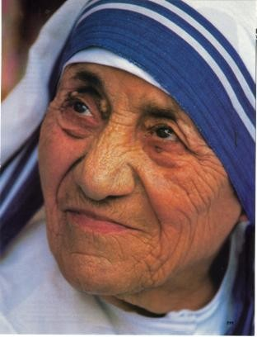
Mother Teresa, who before she became a nun was called Agnes, was born in Macedonia in
1910. Her family were happy and united. When she was just twelve years old, she felt that Jesus was asking her to be his special friend. She had heard about the work of missionaries in India and she thought she would like to go there to spread the good news of Jesus as a sister. She thought and prayed about it for the next six years.

When Agnes was eighteen, she left her family and her country and went to Ireland to join the Loreto Sisters. It was a big sacrifice to give so much. After six weeks she was sent to India to join the novitiate to train to be a nun. It was there that she was given the name Teresa.

For twenty years Mother Teresa taught in schools in India. She loved teaching and was very happy. One day in 1946 as she was travelling by train through India, she had an experience of God speaking to her in her heart. God’s message was very clear: it was to leave the convent and go and live with the poor and help them. There were, and still are, many poor people in India.

In 1948 Mother Teresa left the Loreto sisters. This was a very hard sacrifice to make for Teresa had been very happy there and she knew she was going to have a hard life ahead of her.

Mother Teresa had no home or helpers or money. She spoke often to Jesus and she told him that she trusted him to help her. After a while, twelve students she had taught in school came to join her in her mission. They changed their rich silk saris for poor cotton ones. Mother Teresa started a new group of sisters called Missionaries of Charity.

At first, Mother Teresa started a school for poor children in the slums of Calcutta. As she walked through the streets, she felt so sad to see homeless people lying in the streets, dying, with no one to care for them. In 1952, she opened a hospital for the dying and she called it the Nirmal Hriday (or “Pure Heart”) Home for the Dying. She took in the people no one else would look after and she and her sisters washed and fed these poor people and treated them with great love. Mother Teresa knew that Jesus loved the poor very specially. Later on, she cared for those with leprosy. Mother Teresa could not resist helping anyone who was in need, so today, 4000 of her sisters run centres all over the world.

Mother Teresa was awarded many prizes, including the Nobel Peace Prize in 1979. She was not proud of the prizes, but she was glad that it was recognised that it is important to care for the unwanted, unloved and uncared for. The prize money was useful to help run more centres.

Sometimes when good people try to help others, they get criticised. Mother Teresa was sometimes criticised, but she was not put off. She said that you have to accept unkind comments with a smile and get on with doing what you know is right.
When Mother Teresa died in 1997, everyone was very sad. Many of the poor of India went
to her funeral. They knew she loved them all and had treated them with respect and dignity. Mother Teresa’s sisters still carry on her good work today. They see the face of Jesus in the poor.
(taken from Recent Friends of Jesus: Victoria Hummell)

In 2003 Pope John Paul II announced the first step to Mother Teresa being named by the church as a saint. She is beatified; this means that she is now called Blessed Teresa of Calcutta.

SOME KEY QUESTIONS

- It was hard for Agnes to leave her home and family. Have you ever done anything that was a sacrifice for you, which means giving up something special for a good cause?
What was it?
How did you feel?
How do you know it was right?
How do you think other people felt when you made this sacrifice?
- What do you think of Blessed Teresa’s attitude to those who criticised her?
- What do you usually do when anyone criticises you?
- Describe Blessed Teresa’s qualities.
- How can you show these qualities in your life?

SOME SUGGESTED ACTIVITIES

- Hot-seating Blessed Teresa – one child plays the role of Blessed Teresa. The children ask questions about why she acted as she did and the effects of her actions on others.
- Look at the CAFOD website (cafod.org.uk/comeandsee) to find out more information about the latest emergencies that CAFOD is supporting. Why is CAFOD involved in emergency work? Discuss how your school could help. Design an action plan for the school to be shared with your headteacher; explaining why you think your school should support CAFOD’s emergency work, referring to Christian values, Paul’s advice and the example of Blessed Teresa.
- Create a series of scenarios which involve having to make a decision/choice. “Freeze frame” these so the children can provide suggestions for what to do next, in the light of what they have been learning. Give reasons for your decisions/actions.

LEARNING FOCUS 6: Martin Luther King –
showing the love of Jesus in his life and actions.

CONTENT

Read the story of Martin Luther King.

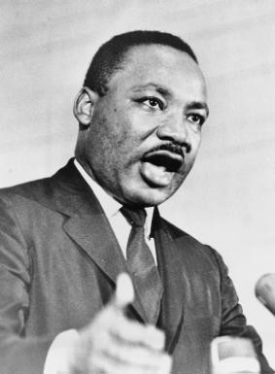
Many years ago, white men went to Africa and captured black people to use as slaves. These African women, men and children were crowded together on slave ships and transported to the West Indies and the south of the United States of America, where they were sold to work on the sugar and cotton plantations. Slavery was banned in 1808 but it still continued until 1860. The African slaves were eventually freed, but they could only get poorly paid jobs and were treated badly by some white people.

Martin was born in Atlanta, Georgia, one of the southern states of America in 1929. He was the eldest son of a Baptist minister. Martin was a descendent of African slaves. He was brought up to know and love Jesus. He knew that God, our creator, had made all human beings in love and had given them dignity and honour no matter what colour they were or family group that they belonged to. Martin was a gifted student. He worked hard at his studies and became a Baptist minister like his father and grandfather. During his studies at Boston University, he read about an Indian man named Mahatma Gandhi. Gandhi believed in equality and love for all people and that injustice and wrong could be changed by non-violent methods.

Martin married and became a minister of a Baptist church in Montgomery, Alabama. In this part of America, some people still treated black people badly. They wanted to have schools for white people only and special ‘whites only’ seats on buses. One day, a black lady called Rosa Parks got onto a bus and sat in a whites-only seat. She refused to give up her seat to a white person who was standing. Rosa was arrested. Her friends went immediately to Martin to tell him what had happened. He was very sad about it and organised a boycott of the buses to protest against the segregation and treatment of black people. Many people, black and white, joined him. The protest lasted for 381 days. During that time Martin and his family had a very difficult time. His life was threatened, his home bombed and he was arrested. Martin never returned violence with violence: all his protests were peaceful and respectful of others. He remembered that Jesus’ friends continue to love others whatever happens. Eventually the peaceful actions won. It became illegal to have whites-only seats on buses. Everyone was entitled to sit where they liked.

Martin’s work was very successful because it was based on how the friends of Jesus would act. Like Jesus, he told people to love their enemies. Martin’s message to those who hated him and made him suffer was that no matter what they did to him he would continue to love them.

Martin became the leader of Christians who were working for the rights of all people. This was called the Civil Rights movement. In 1963 he led a big campaign in Alabama for black voting rights, for better housing and education for black people and to get rid of any segregation of black and white people. It was not easy as the attitude of some white people in that part of America made them treat black people as lesser than white people. He made a speech in Washington which became very well known, he began by saying:

‘I have a dream that my four children will one day live in a nation where they will not be judged by the colour of their skin but by the content of their character. I have a dream today.’

In 1964 he won the Nobel Peace Prize for all he had done to help others.

Martin’s life had often been threatened and he had a feeling that his death was going to be quite soon. On 3rd April 1968 he said to his friends that he felt he had been to the top of the mountain and had seen the Promised Land. He meant that he knew heaven was near. The very next day he was shot dead. Thousands of people went to his funeral and remembered how Martin showed the power of Jesus’ love in his life and actions.
(taken from Recent Friends of Jesus: Victoria Hummell)

SOME KEY QUESTIONS

- Why was Rosa Parks arrested?
- Have you sometimes had the experience of someone leaving you out or making fun of you for some reason? It makes you feel very sad when that happens. How did you react?
- How could Martin Luther King’s example help you?
- Think of a time you may have been nasty to someone because they were different from you.
If something similar happened again, how do you think you should react?
- How can you include others and make them feel loved and wanted?

SOME SUGGESTED ACTIVITIES

- Ask the children to record in thought bubbles their dreams for the world (for example, ‘I have a dream that one day people will no longer be poor’). Create a class collage/display using these. The children could write their ideas in a poem, prayer or speech.
- Study some images or archive footage. Imagine you are a reporter at the time. Record your feelings/opinions in the form of a diary extract or newspaper report. Try to include quotations from those who were there. Create “mock” interviews within the classroom.
- Hold a class discussion: “How can I/we follow the example of Blessed Teresa or Martin Luther King?” Think about our thoughts, actions and daily lives.

RESPOND
Remembering, celebrating and responding to ordinary people
who do extraordinary things and different saints who show us what God is like

Remember
Start the session with a moment of quiet reflection. Provide each child with the opportunity to engage with questions of meaning and purpose related to the experience of God’s People. Using the display, children may be able to recognise the following by use of discussion, role-play, drama, art, cue cards etc.

Ask the children if there is anything they wonder and ask questions about:
- What makes a person do extraordinary things?
- What does God want Christians to do?
- What are the qualities you admire in others?
- How do you think true happiness can be found?
- How can you do extraordinary things

Provide the opportunity, possibly by one of the means above, for the children to remember
- Which of the people you have learnt about shows you most what God is like and why?
- What is the Communion of Saints?
- What is a martyr?
- Something of the life and work of Oscar Romero, Nitu, Blessed Teresa or
- Martin Luther King and how their religious belief shaped their lives.
- How ordinary people do extraordinary things.

Rejoice
Remember to plan. (Download the Rejoice and Gather Form on the Come and See website.)

Renew
The teacher helps each child to make an individual response hold on to and make their own, what they have understood of their own experience and of the experience of the Church community.

Apply their learning
How can you live your daily life really well?

Some sample ideas
After a time of quiet reflection and prayer; invite the children to:
- Think of one extraordinary thing they can do this week which will bring happiness to someone. Write it on a star shape.
- The children may also complete their Book of Qualities to take home as a reminder of the many different attributes that can contribute to showing people what God is like in our everyday lives.

Teacher evaluation
This is ongoing and will inform future teaching and learning, which will include assessment for learning.

SUMMARY

Children will be able to ask and respond to questions about their own and others’ experiences and feelings of ordinary people doing extraordinary things and be able to ask questions about what they and others wonder about ordinary people doing extraordinary things and realise that some of these questions are difficult to answer.

They will be able to retell some special stories about religious events and people who show what God is like and will be able to describe some ways in which religion is lived out by different saints.

Children will be able to give reasons for certain actions by those people they have studied and be able to make links between Scripture and the action and beliefs of followers of God’s way. They will be able to make links to show how feelings and beliefs affect their behaviour and that of others, using the example of Eric or other examples and compare their own and other people’s ideas about the question of what makes a person do extraordinary things and find it is a difficult question to answer.

Children will be able to show how their own and others’ decisions about actions in life are informed by beliefs and values and describe and show an understanding of Scripture, beliefs, ideas, feelings and experience, making links between them.

They will be able to show understanding of how religious belief has shaped the way some people live out their lives.

CHURCH TEACHING

This is an outline of the teaching of the Church covered in GOD’S PEOPLE:
- The Communion of Saints.
- The call to holiness.
- What a martyr is.
- Examples of holy people including Blessed Teresa of Calcutta.

